**Date: 27th Dec 2022**

 **Helpdesk Management System**

**Introduction**

As organization grows, the information technology department meets extremely difficult responsibilities. Without a good helpdesk system, information technology employees start to lose their ability to work effectively and it cause effect to the goodwill of the company. **IC Ticket management** application provides a new way of collecting information about problems and also a new way of distributing work to the Staff members will bring benefits not only to the IT Sector but also to the employees which this supports sector. Especially when there is a problem with the company's product or service, the ticket management system helps the users for their quick response and problem resolution.

A ticket management system is a service department in a company that gives information, administrative support, and technical support to users in order to address issues they may have experienced while using the company's facilities or resources.

**Admin Dashboard:**

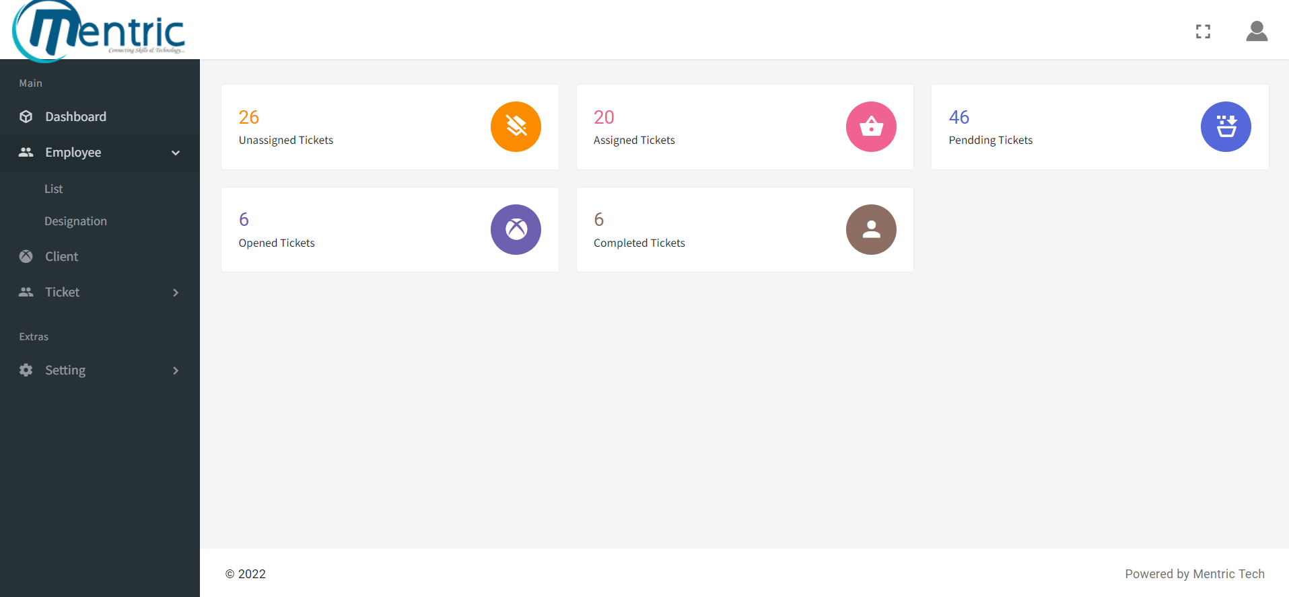

Website: <https://support.infraconnect.in/admin/>

**Sub Admin Dashboard**:

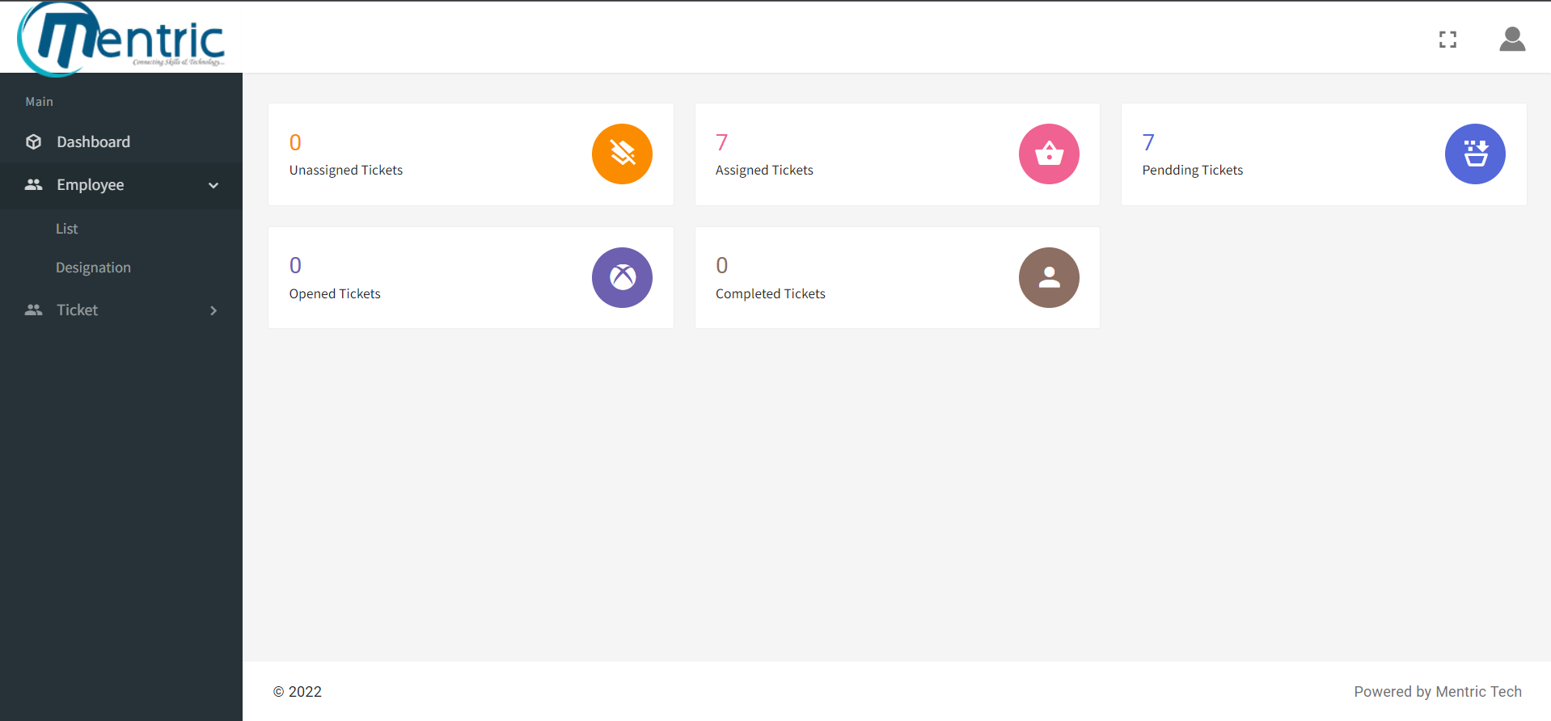

Website: <https://support.infraconnect.in/admin/>

**User’s Page:**

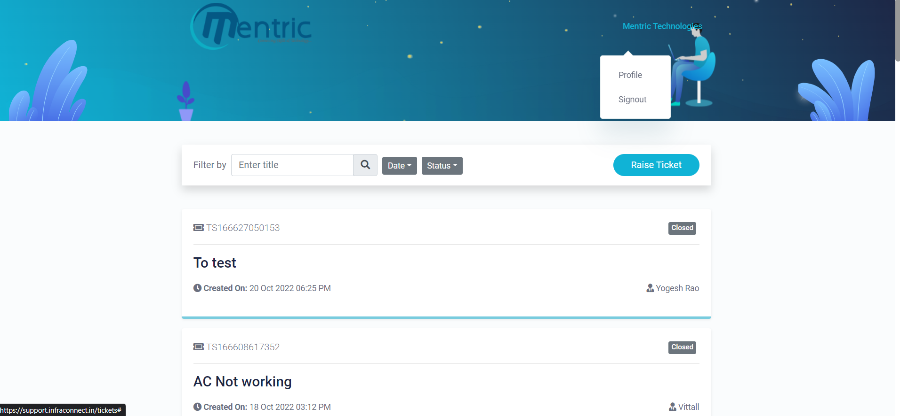

Website: <https://support.infraconnect.in/>

**Objective**

* Handle a high volume of requests in a centralized system.
* reduce the possibility of errors and resolution times
* Saving the customer’s time.
* Maintain customer service standard.
* Improved communication with customers.
* Easy and efficient team collaboration.
* Automated Process and workload management.
* Speed up responses and internal management work using automation.

**Stakeholders**

* **Admin**
* **Sub Admin**
* **Employees**
* **Users**

1. **Admin:**

Admin control and manage all the activities of the system, they have greater authority to direct and coordinate this process. Admin has the authority to add employee and sub admin, and also in any case ticket has elapsed then admin assign the escalated ticket to the escalation team.

**Functional specification – Admin**

1. **Log in:**

The admin can log in by using their username and password, It must be very confidential otherwise may have a chance to misuse it. In any case, admin forget his password then they can reset the password with the help email and mobile number.

1. **Dashboard:**

Check all the relevant ticket information, including unassigned, unassigned, pending, opened, and finished tickets.

1. **Employee:**

Displays all of the employee information in the organization, including name, email, mobile number, designation, ticket status, and the date the ticket was created. Additionally, this function offers a way to customize an employee’s information. It also enables the creation of new employees and sub-admin accounts also can create new designation.

1. **Client:**

Displays all of the client's details, such as name, email, mobile number, ticket status, creation date, and action, which aids in the customization of client details. Additionally, this function enables the creation of new clients.

1. **Tickets:**

Full access to view and edit the entire list of tickets issued by the client. It shows all the details of the ticket like ticket no, title, client, the status of ticket, date of the ticket created and action. Admin can create comments based on the ticket and also make the report. Additionally, this function shows the escalated ticket and also displays ticket status based on color and priority.

1. **Settings:**

Settings provide mainly three functions website settings, email settings and ticket settings.

**Flow chart:**

Settings

View & edit tickets

View and edit employee and their designation

View tickets based on status

Ticket based

Email based

Web based

View escalated tickets

View ticket priority

Update comment

Add designation

Add employee

Log in

Admin

**No**

**Yes**

**2. Sub-admin:**

The ticket issued by the client is directed to the sub-admin and the ticket status will be unassigned, then the sub-admin will change the ticket status into assigned, pending, in progress and completed based on the ticket state. Sub-admin has access to several features that are similar to those of the admin because they are in charge of overseeing all functionality in their domain.

**Functional specification – Sub-admin**

1. **Log in:**

The sub-admin can log in by using their username and password, It must be very confidential otherwise may have a chance to misuse it. In any case, the admin forget his password then they can reset the password with the help email and mobile number.

1. **Dashboard:**

View all the relevant information related to tickets in simple representation. It includes unassigned tickets, assigned tickets, pending tickets, opened tickets and completed tickets. Additionally, sub admin has the option to create clients.

1. **Employee:**

In the employee function sub-admin can create employees in the database and they have the option to edit or delete an employee from the database. Employee function shows the information of the employee like name, email, mobile, designation, ticket status and created date. In the employee function there is an additional feature called designation and sub admin can examine, create and change the employee’s designation based on ticket raised by the client.

1. **Tickets:**

Sub-admin gets access to the entire list of tickets submitted by the client and can read and edit. This feature displays the ticket number, title, name, status and created date. Sub-admin has the option to change status; every ticket initially will be in unassigned format, and based on verification of sub-admin it can change into different states like assigned, progress, etc.

**Flow chart:**

Sub admin

Log in

No

Yes

Create & view employee

Create & view designation

View tickets & update status

Create & view clients

Employee

Tickets

**3. Employees:**

The admin/sub-admin assigns employees a specific designation based on their role and every single ticket that the admin or sub-admin assigns is directed at the staff, and it is up to them to resolve it. Employees play a very important function in the application by handling tickets that the sub-admin is unable to handle.

**Functional specification – Employees**

**1. Login:**

The employee will have a login with basic credentials like username and password. In any case, admin forget his password then they can reset password with the help email and mobile number.

**2. My Tickets:**

View all the specific tickets assigned to them and there will be an option called action, by clicking that employees can check the information regarding the client and their ticket.

**3. Change Status:**

Every ticket that is initially received from a sub-admin is given as an assigned ticket, which the employee then verifies ticket and changes the status into in-progress or if the employee required additional information then the ticket status changes into pending. If an employee is unable to resolve the problem, they may take it further and ask the other team members for assistance.

**Flow chart:**

View Ticket

Change status

Update comment

My Tickets

Log in

Employee

**4**. **Client:**

Clients are individuals or companies who need services, and they are the major source of concern when a problem or issue occurs. So the helpdesk management system providing clients with a log-in to this program will allow them to submit a ticket and direct it to the appropriate employee who will handle the issue.

**Functional specification – Client**

**1. Login:**

The client will have a login process with credentials like username and password. In any case, admin forget his password then they can reset password with the help email and mobile number.

**2. Create Ticket:**

When a client has a problem, he can create a ticket by completing the required fields, such as the issue title and description, assigning a priority, and uploading an image. The created ticket will be forwarded to the appropriate sub-admin, who will check it out and assign it to the appropriate employee, then take the required action.

**3. View Ticket:**

Customers have the option to check the history of their tickets, including who handled them, their status, and any actions taken.

**4. Comments:**

Customers also have the ability to leave comments about their tickets. To submit a comment, customers must give their name and mobile number.

**Flow chart:**

Client

Log in

No

Yes

Comments

View History Tickets

Create Tickets

**Evaluation of Product**

**IC Helpdesk Management System** is a web and mobile based support system, and this application is easy to use and has a wide range of capabilities. It is an effective ticket management application solution that offers a unified resource for answering inquiries, resolving issues, and facilitating solution to issues that have already been identified. This product helps to indicate the priority level of the ticket and it will help the employees for their job. This application identifies the issues through tickets and assigns them to a qualified expert is the first step in the ticket system. The IC Helpdesk Management System provides a straightforward and interactive metric for the smooth functioning of the application. By using this system administratively every activity that occurs can be documented the results of work and the reparation is for audit purposes, and also user can monitor the progress of tickets that have already sent to the helpdesk. if any challenges are faced by the helpdesk team then they will update through comments.

**Comparison Table:**

|  |  |  |  |
| --- | --- | --- | --- |
| **Sr. No** | **Features** | **IC Helpdesk Management System** | **Competitor’s (Domestic & International)** |
| 1 | Human interaction | Minimize human interaction. | Minimize human interaction. |
| 2 | Method of ticket issue | Through the client application interface | Through the client application interface |
| 3 | Safety & Security | Providing secure contact with the customer. | Providing secure contact with the customer. |
| 4 | Time duration for replay from staff | Quick update about complaints and provide the necessary solution. | Quick replay from staff. |
| 5 | Ticket tracking | Live tracking of the ticket by sub-admin. | Live tracking |
| 6 | Access of the system | Admin and sub-admin have very high-level access to the data and employees have access to their tickets only. | Admin has full access to the system. |
| 7 | Dashboard | Provide a user-friendly dashboard with a clear view of ticket status. | Provide a user-friendly dashboard with more visualization. |
| 8 | Designation | Provide adding multiple designations with its staff for helping customer support from different problems or needs. | Provide adding multiple departments with its staff for helping customer support from different problems or needs. |
| 9 | Communication | This product provides a specific application for communicating clients with wanted staff. | Provide communication through various channels like email, phone, live chat, etc. |
| 10 | client track | Staffs provide live update about customer’s tickets through changing status and comments, so the client can easily understand. | Staffs provide updates on the tickets. |
| 11 | Ticket Verification | Sub-admin finds the customer ticket matter and assigns it to the corresponding staff. | Client tickets will automatically assign to the corresponding staff based on the keywords in the tickets. |
| 12 | Ticket priority level | Providing an additional option to customers to choose the priority level of their tickets. | These applications provide an option for choosing their complaint priority level |
| 13 | Customer handling | Handle multiple clients at the same time. | Handle multiple clients at the same time. |
| 14 | Knowledge management system | Clients have the option to share their experiences, and this feature will help staff improve their working methods. | Clients have the option to update their review regarding their experience and this will help to company improve its working method. |
| 15 | Client’s ticket history. | A client can view the details of their past tickets | A client can view the details of their past tickets |
| 16 | Complicate tickets | Tickets that can’t handle by the staff will mark as escalated tickets and the admin will assign suitable technical staff for that ticket and solve. | Complicated tickets will solve by the corresponding staff. |
| 17 | Chat | Provide live chat for small clarification. | Provide live chat for small clarification. |
| 18 | Report & analytics | Offers clear reports of the data that help to handle the business flow. | Offers a completely self-reliant way of analyzing and handling business data. It gives a comprehensive view of different facts and metrics affecting the company. |
| 19 | Data storage | This product provides a cloud-based-storage facility so administrators can access any time anywhere. | This product provides a cloud-based-storage facility so administrators can access any time anywhere. |
| 20 | Customer satisfaction survey (CSAT) | Available | Available |
| 21 | Budget | The product provides customization based on organizational needs, so the budget is comparably low. | Comparatively little high budget. |

**Latest helpdesk software trends:**

Artificial intelligence, social media, and mobile access lead the latest trends on how help desk software is predicted to evolve in the next few years. These are some of the trends to look out for in the industry:

**Multi-channel support in sync:** Aside from social media, customers use different channels to push their conversations with companies. They may post a general query on Facebook, follow it up through email, and then finally call you. Help desk solutions are developing multi-channel communication platforms that can simultaneously track email, apps, live chat, calls, and other customer touch points coming from a single customer.

**Mobile compatibility:** More and more customers are accessing the internet through mobile devices. Customers expect to be able to reach your company through their mobile phones or they’ll be frustrated.

**Social media support:** Social networks like Facebook and Twitter are becoming the first-touch points for many customers. Hence, help desk solutions are integrating these channels to let agents participate in conversations and direct comments to the knowledge base where necessary.