## **Lab 2**

## **Overview of Logic Gates on Circuit Maker and Explorer Board**

**Equipment/Components**

**Software:** Circuit Maker

**Hardware:** Explorer Board

**Objective**

* To learn a software for the virtual hardware implementation to test a circuit before implementing it practically.
* To Learn how to use Circuit Maker for simulation
* To implement circuit on Explorer board.

**Lab Tasks (Circuit Maker)**

**Task 1:** Draw the given circuits on Circuit Maker. Simulate and fill the table for each combination of inputs.

1. (A+B)”

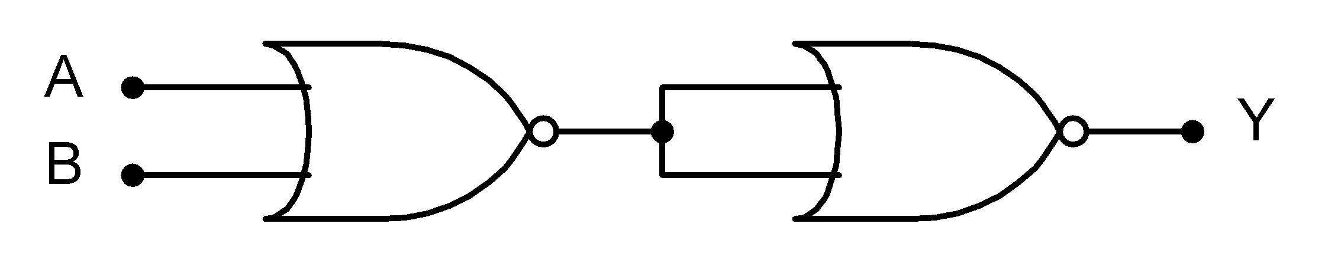

|  |  |  |
| --- | --- | --- |
| Inputs | | Output |
| A | B | Y |
| 0 | 0 | 0 |
| 0 | 1 | 1 |
| 1 | 0 | 1 |
| 1 | 1 | 1 |

B)

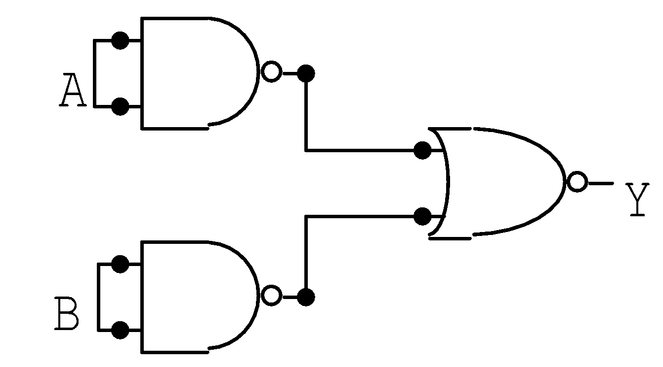

|  |  |  |
| --- | --- | --- |
| Inputs | | Output |
| A | B | Y |
| 0 | 0 | 0 |
| 0 | 1 | 0 |
| 1 | 0 | 0 |
| 1 | 1 | 1 |

C)

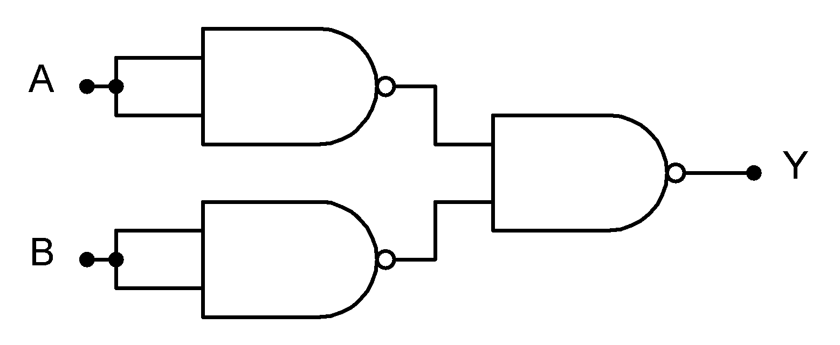

|  |  |  |
| --- | --- | --- |
| Inputs | | Output |
| A | B | Y |
| 0 | 0 | 0 |
| 0 | 1 | 1 |
| 1 | 0 | 1 |
| 1 | 1 | 1 |

D)

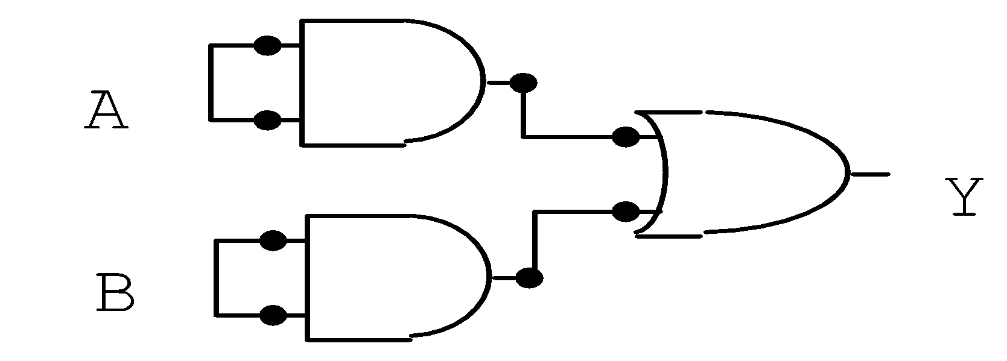

|  |  |  |
| --- | --- | --- |
| Inputs | | Output |
| A | B | Y |
| 0 | 0 | 0 |
| 0 | 1 | 1 |
| 1 | 0 | 1 |
| 1 | 1 | 1 |

E)

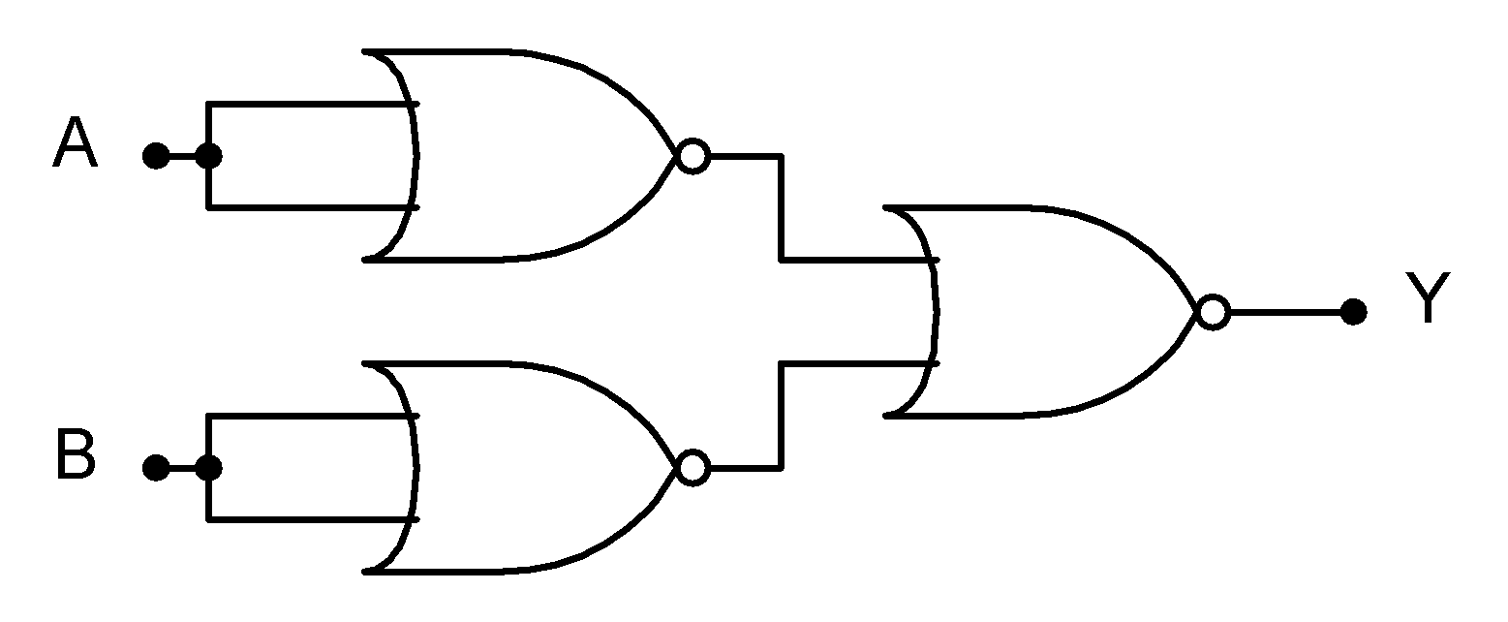

|  |  |  |
| --- | --- | --- |
| Inputs | | Output |
| A | B | Y |
| 0 | 0 | 0 |
| 0 | 1 | 0 |
| 1 | 0 | 0 |
| 1 | 1 | 1 |

**Task 2:**

**Explorer Board:**

Implement Part C and Part E on Explorer Board. Compare your software and hardware truth table and verify your results.