SoftSpace
  - Headphones for sound sensitive autistic people
Current update on 24 October 2026: V24 adds four finer joint reference calculations. All numerical consistency checks pass, but only 2 of 16 refined stress comparisons meet the chosen limit. Reliable whole part strength is still unproved. The main CAD readers now work with verified D drive sources, and four exact historical CAD versions were restored. Both products still have open design and input gates. Read the final V24 chapters.
We are developing a low-cost passive over-ear defender for India. The aim is to make loud surroundings easier to manage while keeping the device comfortable, easy to remove and simple to use. Autistic users are our first priority; other sound-sensitive people may also find the idea useful.
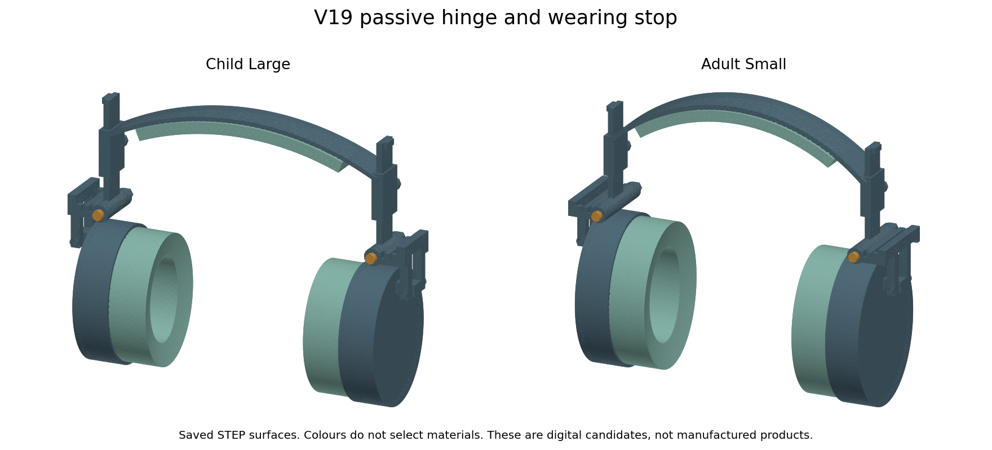
V19 child large and adult small final local STEP prototype assemblies. Physical validation remains open.
Where we are now: Six sizes and sliding adjustment are saved. Some geometry and numerical checks passed. Comfort, sensory acceptance and real sound reduction have not been proved.
V19 is our latest six size local STEP prototype. It adds a parallel disc spring pair, longer pin proposal and second nut. The coupled 3D joint calculation has recorded failed solves and mesh limits. This is a prototype handoff, not a finished product or complete validated simulation phase. Real materials, exact Sony mounting dimensions, acoustics and voluntary wearer feedback remain necessary. Native editable Fusion archives remain V10.
This document explains the user need, selected market options, every development stage and what our tests actually mean. Read it alongside SoftSpace Flex for the replacement-pad project. That separate route now targets the Sony WH-CH720N, chosen by the user. Sony confirms replaceable pads, but mounting measurements and host-specific results are still missing. [17]
Competing WH-CH720N replacement pads are already listed by Crysendo and Geekria. The companion report records current and older indexed price evidence separately. Our softer glasses zone still needs a measured advantage; it is not enough to offer memory foam or claim local availability. [18, 19]

What autistic people may need
There is no single headphone preference shared by all autistic people. Some are very sensitive to noise, touch or heat; others enjoy sound or firm pressure. Preferences can change with the environment. Our design choices must come from the people who will wear the product, not only from our calculations. [1]
Sound sensitivity is not just a rare exception. A 2021 research review estimated current hyperacusis, or reduced tolerance to sound, at about 41% using interviews and questionnaires and 27% using observational or objective measures. The estimates varied a lot. These figures do not describe every autistic person and do not tell us what headphones they prefer. [2]
What we should ask about | What we are trying to design
Loud or sudden sounds | Useful reduction without added playback, beeps or electronic hiss
Pressure and glasses arms | A softer contact area and several adjustable fit choices
Heat and sweat | Materials we can test in warm and humid conditions
Texture and rubbing sounds | Smooth seams and a cover the wearer can choose or reject
Bulk and weight | Enough ear space with as little unnecessary material as possible
Control and removal | Easy removal and adjustment; wearing remains the user’s choice
Communication | Check whether important voices and everyday cues remain usable

These are design questions and hypotheses, not a proven preference ranking. If someone removes the headphones, we should investigate discomfort or their wish for a break. Keeping them on at all costs is not our goal.
A small 2019 study followed six children aged 8 to 16 using in-ear and over-ear noise-attenuating headphones. It provides early evidence worth exploring, but its small sample cannot establish a universal winner or validate our product. [3]

What the market already offers
People use child earmuffs, industrial hearing protection, ordinary ANC headphones and earplugs. A product does not need an autism label to be useful. Some are inexpensive; others add electronics, premium materials or specialist fittings.
Example | Observed price | What the source shows | What is still unknown
Robustt earmuffs [4] | INR 808 for 2  INR 404 each | Adjustable passive earmuffs; claimed NRR 21 | Delivery, fit and sensory comfort; test report not reviewed
SYGA child earmuffs [5] | INR 699 | Child earmuff listing | Page gives conflicting stock messages; no matched tests
Alpine Muffy Kids [6] | Indian delivered price not verified | Child passive defender aimed at focus and hearing protection | Local supply and fit for our users
boAt Nirvana 751 ANC [7] | INR 5,099  INR 3,099 with listed coupon | ANC audio headphone; page says restocking soon | Coupon, stock and comfort for our audience
Sony WH CH720N [8,9] | INR 6,990 listing | ANC and music; specified mass 192 g | Local delivery and our matched wearer results
Noisefighters Sightlines [11] | USD 60 before shipping and imports | Replacement gel and foam pads with glasses relief | Confirmed Indian stock and total delivered cost
Our defender | No verified price yet | Six-size digital passive concept | All physical benefits and production cost

This is a selected sample from our 29-entry market review, not every product sold. Prices were checked on 13 October 2026 and are not guaranteed checkout prices. We cannot say all existing options are expensive. The opportunity must include a clear benefit beyond price.

Side by side with ordinary headphones
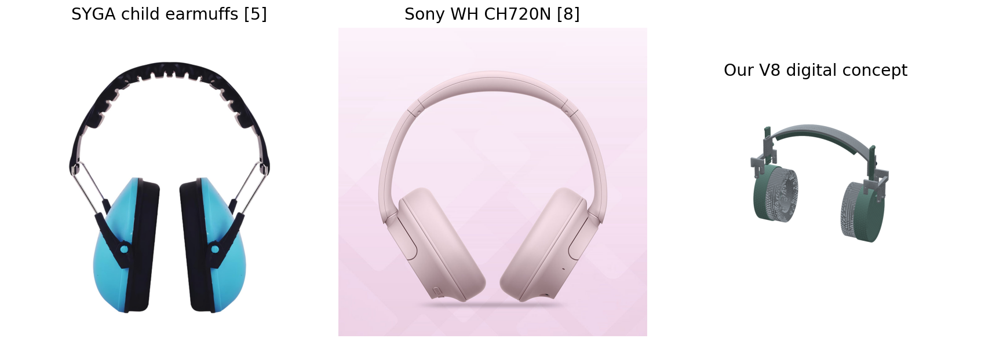
Seller photos identify the SYGA and Sony products. Our image is CAD. The photos do not establish a performance comparison.
Feature | Passive market earmuffs | Ordinary ANC audio headphones | Our planned defender
Main purpose | Reduce outside sound | Music and calls with electronic noise cancellation | Reduce outside sound for sensory use
Battery or charging | Usually unnecessary | Needed for active features | No electronics planned
Music playback | Usually absent | Available | Absent in this concept
Added sound | No electronic hiss generator; rubbing still possible | Prompts or hiss depend on the model and settings | No electronic prompts planned; rubbing untested
Fit choice | Adjustment varies by model | Adjustment and pads vary by model | Six synthetic widths and 30 mm sliders
Glasses relief | Depends on the product | ProSpecs exists on selected gaming products [10] | Softer local zone under continuous cover
Heat and texture | Depends on materials and wearer | Depends on materials and wearer | We plan material choices and wearer checks
Evidence | Some products publish hearing-protection ratings | Specs and tests vary; ANC claims are not NRR | Geometry and limited numerical studies only
Is ours better | No matched comparison yet | No matched comparison yet | Not established

ANC means active noise cancellation. Passive reduction relies on the cup, cushion and seal. ANC does not need white noise playback to work. Our passive route avoids electronics, but it has not been shown to reduce every kind of noise better than ANC.
NRR and SNR are ratings from different hearing-protection test systems. An advertised ANC dB number or our cavity calculation cannot be compared directly with either. We need the same test setup for every product before ranking sound reduction. [14]

Problems we want to address
Possible problem | Our proposed change | What would prove it helps
Pads squeeze a glasses arm | Local softer zone under a continuous cover | Pressure mapping plus wearer feedback
One fit does not suit the wearer | Several widths and sliding height adjustment | Fit measurements and voluntary trials
Hot or sweaty contact | Test cover and foam choices for Indian conditions | Heat and humidity measurements
Bulky or tiring assembly | Remove unused parts and measure weight | A weighed prototype and movement trials
Poor seal around glasses | Conforming pad without an open groove | Measured isolation with multiple frames
High replacement cost | Model-specific replaceable pad and local supply | Supplier quotes and replacement-fit tests

These are problems to investigate, not confirmed defects in every competitor. A softer pad can also compress too far or change the seal. A cooler fabric can let sound through. Every change needs a comparison with the original pad.

How to read our tests
CAD checks look at geometry. Simulations calculate behaviour from assumed inputs. Physical tests measure a made object. Wearer feedback tells us whether someone accepts the feel and sound. These four kinds of evidence answer different questions.
A mesh is the small pieces used in a numerical calculation. We refine the mesh to see whether the answer settles down. A pass means the selected calculation changed less than our chosen limit; it does not mean the product is safe, comfortable or certified.
V1 and V2 are the early screening stages described in the saved reports. Their pictures show the available cushion and cover snapshots. They should not be read as a fully tested V1 or V2 manufactured headset.

V1 First cushion and glasses zone
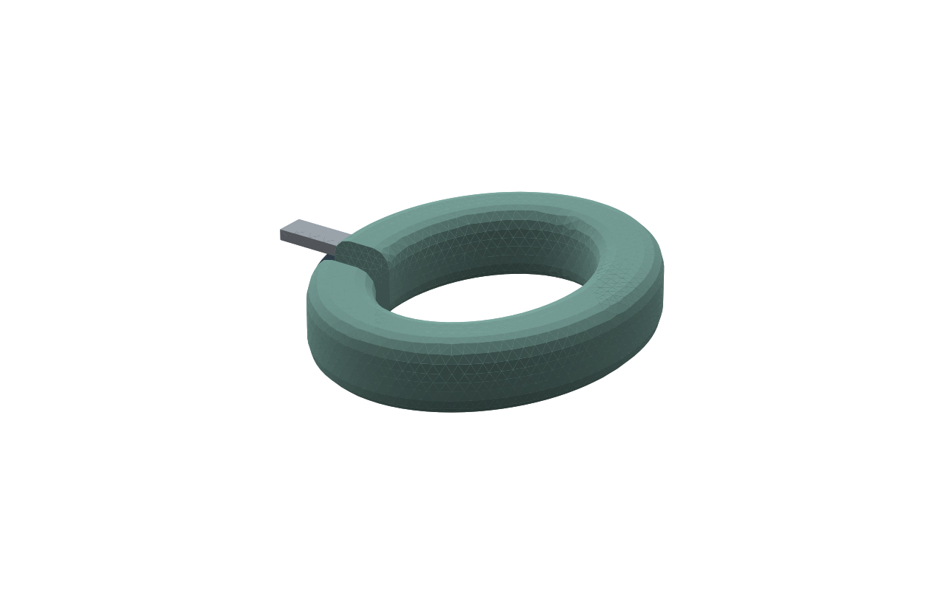
Saved cushion snapshot with simplified glasses arms. The original hand-built oval cushion came first; the saved file adds the frame references.
What changed: We made an oval pad with a separate softer area where the glasses arm rests. We also added simple thin, standard and thick arm shapes to explore the idea.
Tests and checks: The first screening study ran 3,240 contact cases and 81 heat and humidity cases. A separate 18-case band-force screen used a prescribed spring law, not force calculated from the CAD headband.
What passed: The basic compression equation and force balance checks passed for the chosen inputs.
What failed or remained open: Contact coverage changed when the grid was refined. Gaps remained. One warm and humid example reached 100% humidity. There was no real seal or comfort pass.
Real world meaning: This tested a simplified idea. It did not compare our pad with a real market headphone or prove pain relief.
Evidence files: cad_build_report.json; screening-results/report.md; screening-results/summary.json

V2 Trying shapes and a continuous cover
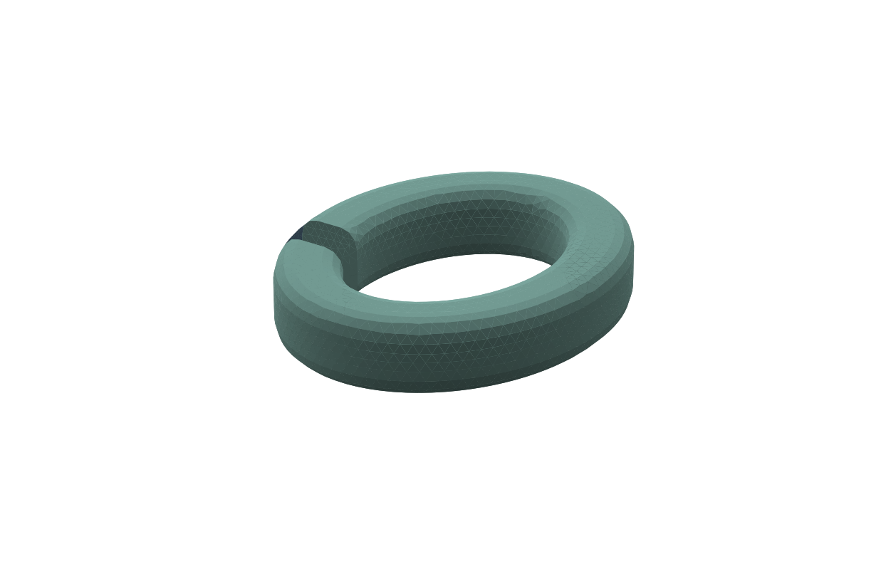
Saved flat cover surface prototype. The shaped pads in this study were numerical candidates, not this exact CAD surface.
What changed: We compared flat and curved contact faces, smaller edge rounding, and ideal cup alignment. We also made a connected cover surface so the pad would not expose a gap between materials.
Tests and checks: The V2 shape screen ran 9,216 assumption-based cases. The cover CAD was checked for one connected surface body. It was not a solid cover with tested strength.
What passed: The cover faces connected. In one ideal reference case, the curved face reached 100% calculated contact.
What failed or remained open: The cover was only a surface. Its 0.2 mm thickness was metadata. There was no seam, side wrap, fabric tension or measured leakage result.
Real world meaning: A perfectly matched synthetic head is easier to seal than a real head. The 100% result is not an airtight-pad claim.
Evidence files: shape-study-results/report.md; cover_prototype_report.json

V3 Curved pads and a more complete defender
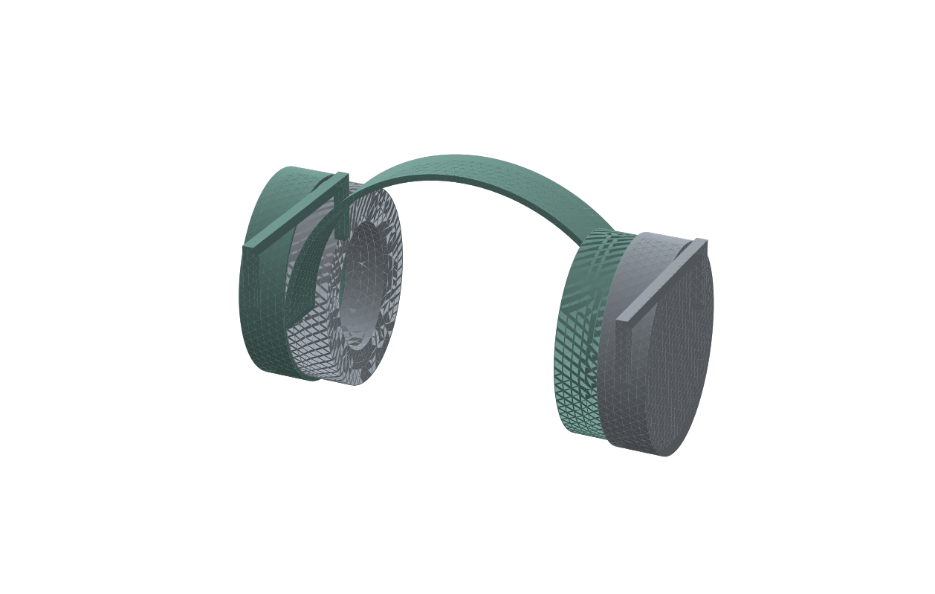
Actual saved adult V3 assembly. Colours only help distinguish parts. Surface triangles show the display mesh, not fabric texture.
What changed: We added curved adult and child pads, a solid cover envelope, carrier blanks, closed cups and a fuller standalone defender. The child now had a separate scaled pad.
Tests and checks: The contact model used a simple tensioned cover over compressible foam. It ran 48 cases. A nonlinear planar band model and 36 coupled band and pad cases replaced the earlier prescribed force.
What passed: Solver checks included basic compression, mesh area and force balance. Separate child geometry was generated.
What failed or remained open: Pressure peaks still needed refinement. Cover seams, skin friction, real foam and acoustic ratings were missing. The CAD cover did not have uniform normal thickness.
Real world meaning: A manufacturer can sell a finished headset; ours was still imported concept geometry with assumed material values.
Evidence files: cad_v3_report.json; engineering-v3-results/contact_summary.json; band_summary.json; coupled_summary.json

V4 Cup movement and three height positions
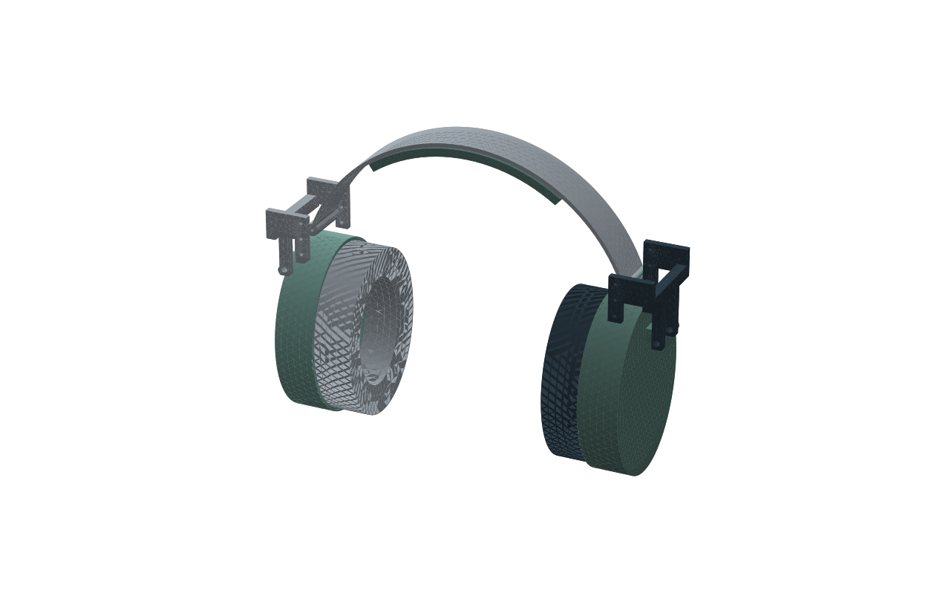
Actual saved adult V4 assembly with pinned forks and crown padding. Surface triangles show the display mesh, not fabric texture.
What changed: We added pinned forks, retained pin placeholders, exterior cup bosses, 5 mm crown padding and three pin heights. The cups could turn slightly to help align with the head.
Tests and checks: CAD checks sampled cup rotation from minus 8 to plus 8 degrees and pin heights of 55, 65 and 75 mm. The numerical work included band and pad coupling and 216 one-hour heat and moisture cases.
What passed: The recorded cup and pin-position clearance checks passed. The solver balance checks passed.
What failed or remained open: The final pressure peak changed by 15.2% with finer meshes. Several cover scenarios still saturated. Threads, retention, fatigue, drops and scalp contact were untested.
Real world meaning: Movement clearance only means the selected CAD parts do not overlap at those positions. It says nothing about real joint friction or whether a child can adjust it safely.
Evidence files: cad_final_report.json; engineering-final-results/REVIEW.md

V5 Six sizes and sliding adjustment
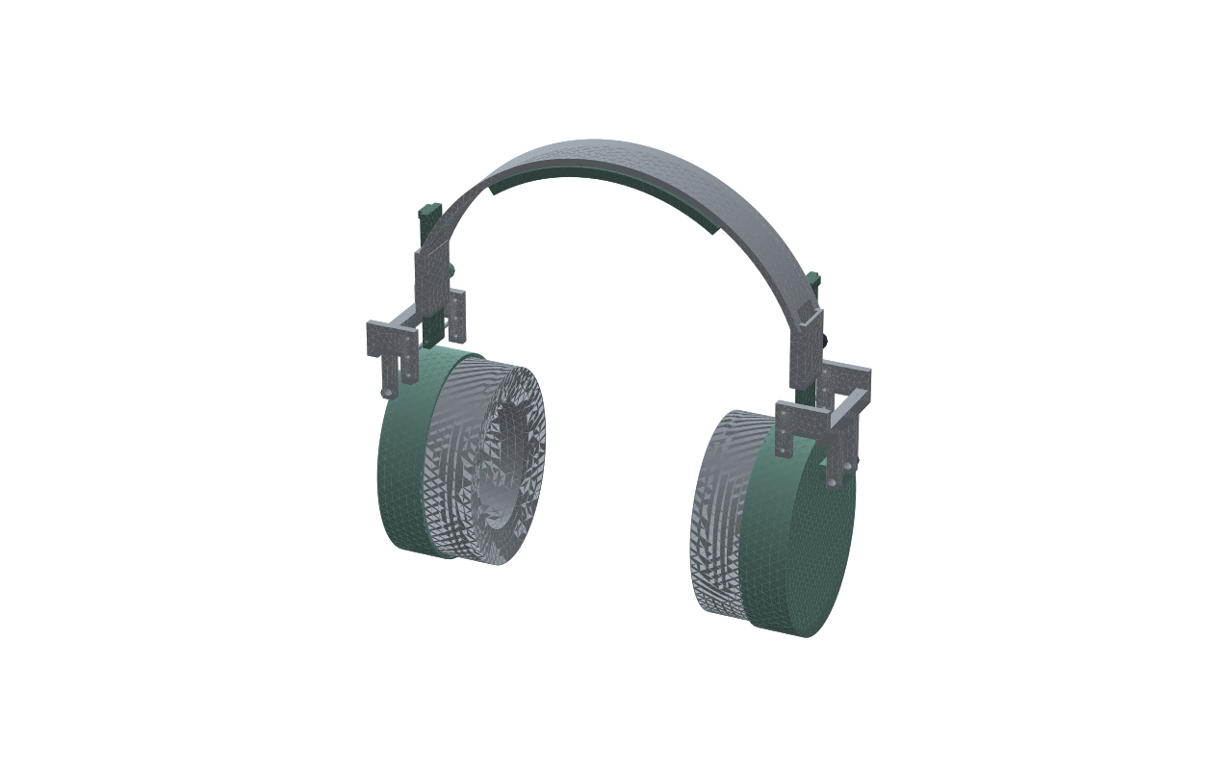
Actual saved adult medium V5 assembly. Each side has 30 mm of slider travel. Surface triangles show the display mesh, not fabric texture.
What changed: We introduced three child and three adult widths, 30 mm sliders, 4 by 16 mm tongues and clamp knobs. We chose a more curved pad after comparing candidate shapes.
Tests and checks: The study ran 72 cushion comparisons, 54 coupled force and compression cases, 12 nearby head-width cases and 81 additional moisture cases. A simple acoustic model used 48 parameter combinations at 48 frequencies from 31.5 to 250 Hz.
What passed: Sampled slider clearance and beam force-balance checks passed. Pressure averaged over a 6 mm virtual sensor changed by less than 5% in both nominal family cases. The low-frequency acoustic code checks passed.
What failed or remained open: Point pressure peaks did not converge. At the assumed middle water-vapour transmission level, 3 of 27 conditions saturated. Twelve end-position STEP files were later found empty because their components were hidden.
Real world meaning: No physical market headset was tested alongside these cases. The empty exports were an output failure and were corrected in V6.
Evidence files: cad_v5_report.json; engineering-v5-results/REVIEW.md

V6 Cleaner geometry and checked exports
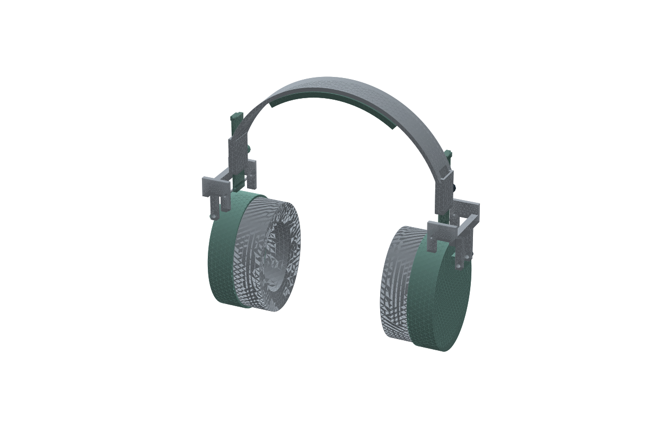
Actual saved adult medium V6 assembly after overlap corrections. Surface triangles show the display mesh, not fabric texture.
What changed: We moved the carrier behind the cover, cleared the cup seat, removed unused fork holes and softened some hard edges. We also repaired the hidden end-position exports.
Tests and checks: All six assemblies had an overlap audit. All 24 STEP files were imported independently. A 3D band and guide model and a 3D acoustic cavity model were added.
What passed: The nominal overlap check passed for all six. All STEP imports passed. Band deflection was stable. A separate beam code check differed by 2.47% from its reference equation.
What failed or remained open: Small-child stress changed by 7.42% on further refinement. The first acoustic model changed by up to 2.95 dB at higher frequencies. Both exceeded the chosen checks.
Real world meaning: Passing a solver check is not the same as passing a commercial hearing-protection rating. The geometry still had no measured material data.
Evidence files: cad_v6_report.json; cad_v6_audit.json; engineering-v6-results/REVIEW.md

V7 Rounded entries and a better acoustic calculation
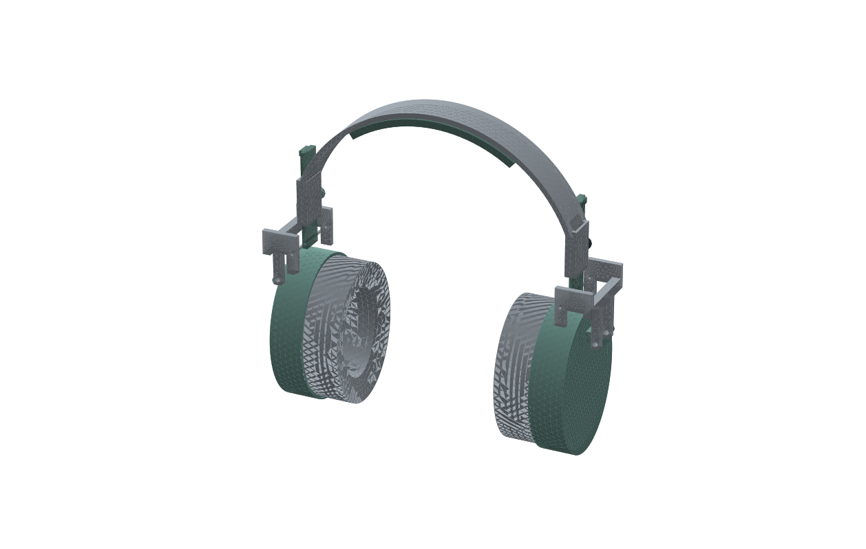
Actual saved adult medium V7 assembly. The taller crown was later reconsidered. Surface triangles show the display mesh, not fabric texture.
What changed: We rounded four arc-shaped slider entries by 0.5 mm. We also improved the acoustic calculation using curved quadratic elements and an area-averaged receiver.
Tests and checks: All six structural cases were refined. Eighteen defender STEP files were checked. The acoustic model compared 6 and 4.5 mm meshes at 48 frequencies from 31.5 Hz to 8 kHz. A separate vertical-fit screen compared 90 synthetic head and extension cases.
What passed: All six recorded stress and deflection comparisons passed 5%. Defender STEP imports passed. Acoustic mesh differences were 0.113 dB for child and 0.067 dB for adult. The tube code check had 0.442% maximum complex-pressure error.
What failed or remained open: The tall crown missed the synthetic scalp in 78 of 90 vertical comparisons; 8 suggested a rigid intersection. A stress pass did not fix that fit issue.
Real world meaning: We did not prove a stronger or more comfortable product. The acoustic model still omitted real glasses leakage, porous liners and actual ear shapes.
Evidence files: cad_v7_report.json; engineering-v7-results/solid_v7_summary.json; acoustic_p2_summary.json; vertical_fit_summary.json

V8 Lower crown foundation
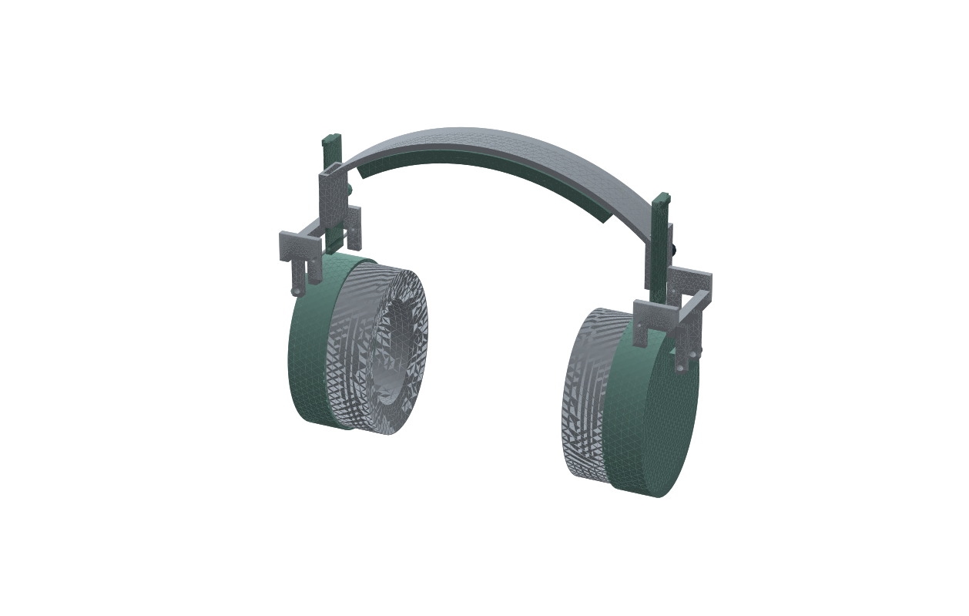
Actual saved adult medium V8 assembly. This lower-crown design is the foundation for the later V9 and V10 revisions. Surface triangles show the display mesh, not fabric texture.
What changed: We lowered the arch to 40 mm for adults and 25 mm for children, added an assumed 8 mm crown pad and recalculated all six widths. The sliders still travel 30 mm per side.
Tests and checks: There are 30 CAD files: six Fusion archives and 24 STEP exports. We checked overlap, slider travel and cup movement. The current force study ran 54 cases across three assumed band stiffness values and three extension settings.
What passed: All 24 STEP imports and six nominal overlap audits passed. Recorded slider and cup clearance checks passed. All six deflection comparisons and four stress comparisons passed.
What failed or remained open: Adult-small stress changed by 12.72% and adult-large by 10.84% with mesh refinement. They failed the chosen 5% check. Full scalp pressure, materials, locking and actual sound reduction remain untested.
Real world meaning: The 54 cases predict 1.01 to 3.80 N per side and 3.49 to 5.87 mm maximum pad compression across the cases. These are calculations, not comfort limits. The design has not beaten any real headset.
Evidence files: cad_v8_report.json; cad_v8_audit.json; engineering-v8-results/REVIEW.md

V9 Native corner refinement and digital checks
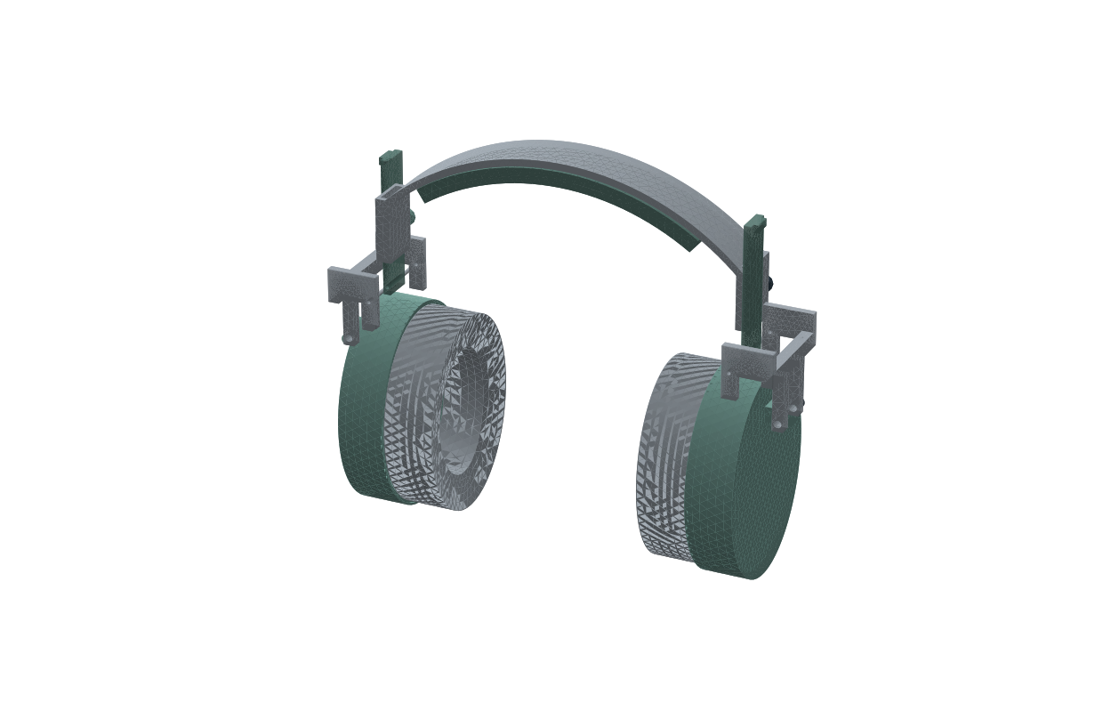
Actual native adult-small V9 STEP render. Its matching local Fusion archive has now been exported. Surface triangles show the display mesh, not fabric texture.
What changed: The earlier local corner experiment is retained as a failed trial. Fusion then rounded eight internal guide corners by 0.5 mm in 6 of the six sizes. V9 was the native band candidate before the wider audit. V8 retains the replacement cushion and earlier screening evidence.
Tests and checks: Native build records check the changed band against the static assembly and sampled slider positions. Independently imported 18 available native STEP files. Structural calculations refine the actual native band geometry. The local Fusion archives were exported but have not been reopened for a separate check.
What passed: All available native STEP imports contain 28 solids. The earlier selected-body motion checks passed, but the wider audit below found missed clashes. All six stress comparisons are within our 5% limit. See the next page for the size-by-size results. These are digital checks, not a strength or comfort pass.
What failed or remained open: A later all-body audit found clashes in all six shortest-setting exports. Both slider pivot pins intersect the guides. Child thumb knobs also intersect the forks. The earlier motion check omitted those parts. Real material strength, full joint contact, retention, sound reduction and wearer acceptance remain untested.
Real world meaning: The V9 nominal structural results remain recorded, but its shortest setting is not geometrically acceptable. The earlier package must not be treated as a cleared full-travel design. The replacement cushion is unchanged; no real leakage or wearer result has been added.
Evidence files: engineering-v9-results/native_verification.json; solid_v9_summary.json; numerical_audit.json; nominal_force_screen.json; export_audit.json; engineering-v9-local-results/summary.json; engineering-v9-results/all_pose_pairs.json

V9 structural comparison across sizes
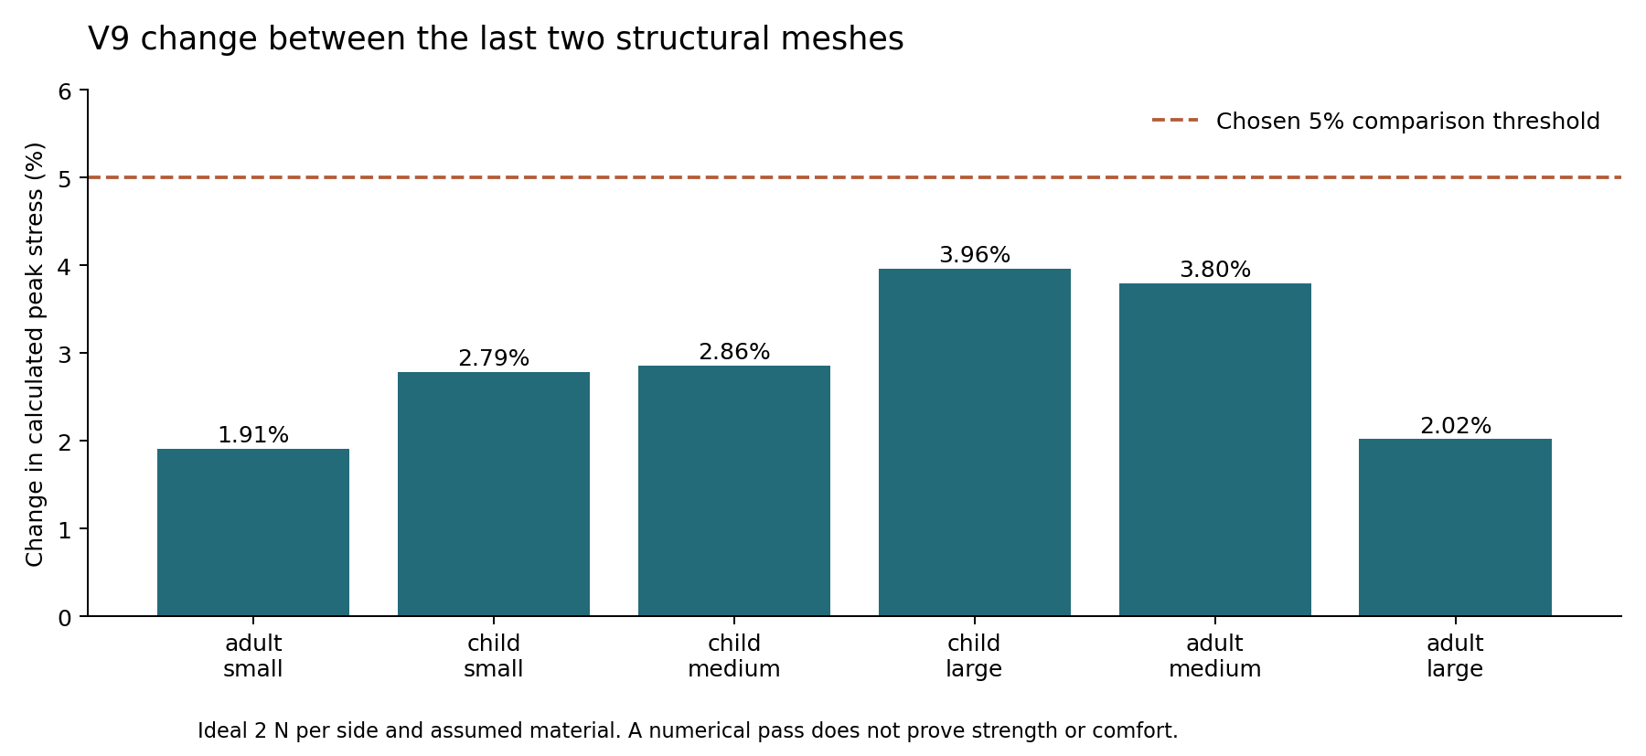
Change between the last two meshes. This does not measure comfort or prove physical strength.
Size | Last mesh mm | Stress change | Guide change
adult small | 1.25 | 1.91% | 0.017%
child small | 1.25 | 2.79% | 0.015%
child medium | 1.0 | 2.86% | 0.023%
child large | 1.0 | 3.96% | 0.020%
adult medium | 1.5 | 3.80% | 0.012%
adult large | 1.5 | 2.02% | 0.014%

These comparisons use the actual saved band geometry, an ideal 2 N force per side and an assumed elastic modulus of 2000 MPa. They omit worn-head contact, foam, joint friction and locking. We still need measured materials and prototype tests.
We also coupled the calculated V9 band stiffness with our simplified pad model for 18 cases at the middle slider setting. With the chosen head sizes and assumed band moduli, force ranged from 2.27 to 3.52 N per side. Maximum foam compression ranged from 4.11 to 5.70 mm across those cases. These values are predictions, not comfort limits.
This force screen combines a linear 3D band calculation with a scalar pad calculation. It assumes an ideal mounting offset and does not solve the whole worn assembly, scalp contact or slider locking. The earlier V8 force screen covers other extension settings using a different beam model; its numbers are not V9 measurements.

V10 Guide and knob clearance candidates
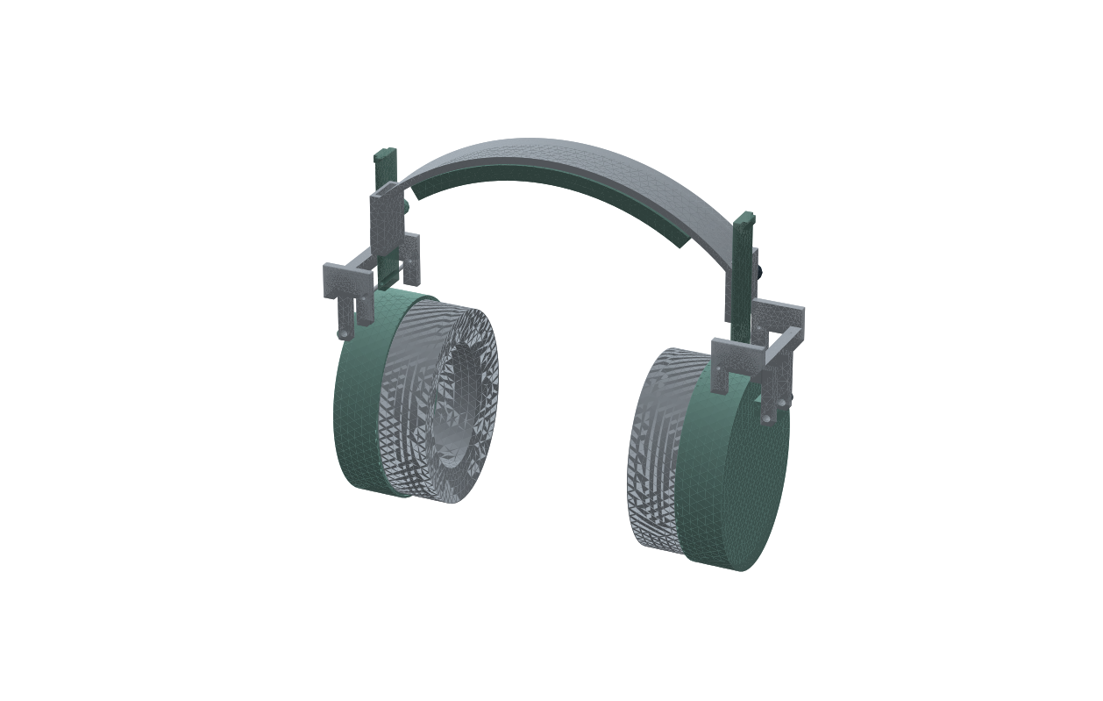
Actual adult-small V10 native Fusion STEP export. Surface triangles show the display mesh, not fabric texture.
What changed: We shortened the guide bottoms by 2 mm and moved the clamp bores and knobs upward by 4 mm. The crown, cushion, pins, forks and intended 30 mm slider travel are retained.
Tests and checks: Native Fusion exported all six sizes, 18 STEP poses and six Fusion archives. The local and native bands agree within the 0.01 cubic mm volume comparison tolerance. The wider all-body overlap audit covers every pair of solids. Changed guide geometry receives fresh structural calculations.
What passed: All 18 local poses pass the recorded all-body overlap checks. 6 of 6 recorded stress comparisons pass 5%.
What failed or remained open: The first adult-large 1.25 mm mesh was rejected for an invalid element and replaced with an optimized mesh that passed the validity check. Locking, measured materials and physical product validation remain open.
Real world meaning: This revision addresses actual CAD interference, not autistic sensory acceptance or glasses sealing. Those remain separate test questions.
Evidence files: engineering-v10-results/cad_local_report.json; all_pose_pairs.json

Why the shortest setting changed
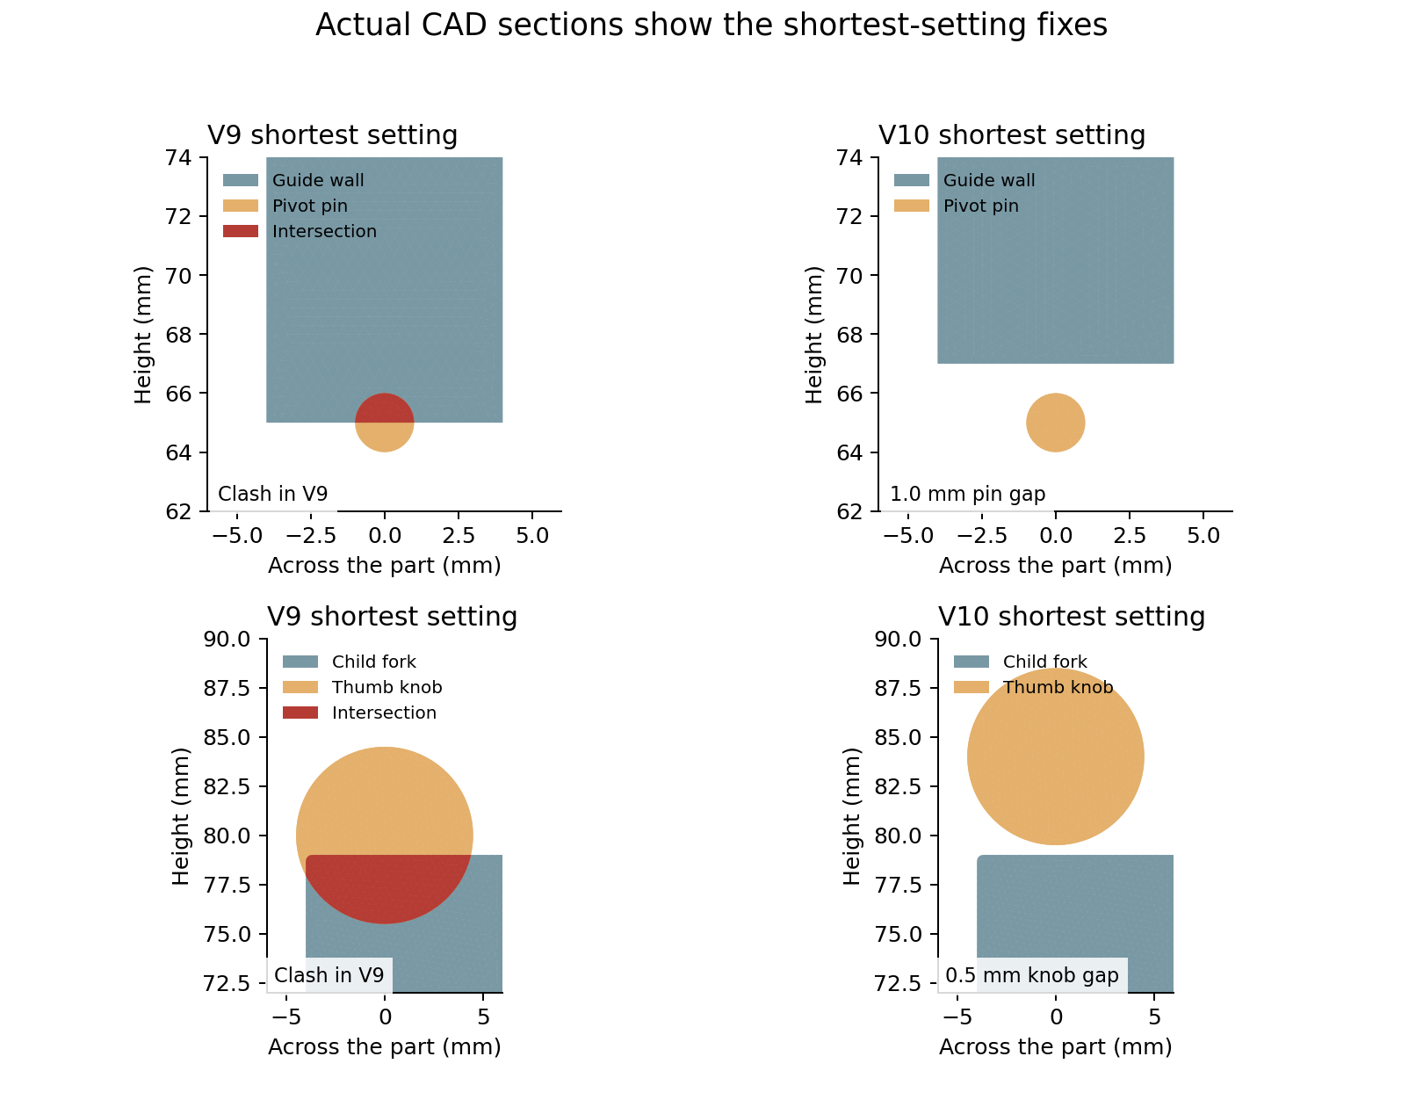
Sections cut from the actual saved V9 and V10 STEP files. Red shows intersecting material. The CAD slices are 0.2 mm thick; these are not physical measurements.
The minimum calculated nominal distances are 0.22 mm from guide to tongue, 1.00 mm from guide to pivot pin and 0.50 mm from knob to fork across the saved poses. These are undeformed CAD distances.
If two matching parts each differ by 0.2 mm in a direction that closes the gap, their combined variation could use 0.4 mm. The approximately 0.22 mm minimum gap would then have no guaranteed clearance. This is an example tolerance budget, not a measured factory capability or a proved jam. Roughness, heat, loads and friction still need checks.

V10 structural results across sizes
Size | Final mesh mm | Stress change | Displacement change | Stress check
adult small | 1.5 | 3.72% | 0.017% | Pass
child small | 1.0 | 3.38% | 0.016% | Pass
child medium | 1.0 | 2.51% | 0.021% | Pass
child large | 1.0 | 2.62% | 0.022% | Pass
adult medium | 0.8 | 0.24% | 0.012% | Pass
adult large | 1.25 | 4.12% | 0.010% | Pass

All six guide-displacement comparisons meet the chosen 5% limit. 6 of 6 recorded stress comparisons pass 5%. Earlier adult-medium comparisons changed by 8.37% and 18%; the final 0.9 to 0.8 mm comparison is recorded in the table. These are numerical comparisons, not physical strength tests. Saved curved-element coordinates passed an adaptive check for inverted elements.
The earlier band calculation uses mirror symmetry across its width. The real clamp bore is only on the front wall. Mirroring that half gives the model an extra rear bore. The separate actual-width fixture study below keeps the real single bore, but changes the fixture and loading too. A matched comparison that changes only symmetry is still needed; neither study solves the complete worn assembly.
The exposed slider segment was calculated at 0, 15 and 30 mm adjustment. All three displacement comparisons passed 5% after applying the load consistently over its surface. Earlier equal-node-load trials are not used. One finer long-slider trial ran out of memory; the accepted study uses meshes that passed numerical checks and records that failed trial separately.
The 54-case adjustment screen predicts 2.34 to 3.72 N per side and maximum foam compression of 4.14 to 5.86 mm across the selected assumptions. We combine the band and slider stiffness estimates with the simplified pad model. These values are not comfort limits.
The slider fixture is idealized and the band uses the symmetry approximation explained above. This screen does not solve real clamp friction, pin bearing, guide rotation, scalp contact or the complete worn assembly. It uses the same synthetic head width at each extension, assumed materials and a 35 mm mounting offset per side. Pressure peaks and actual sealing remain unvalidated.
Native V10 rebuilding is complete. All 18 native STEP poses independently passed the all-body intersection check and contain 28 solids each. Source hashes remain recorded. Geometry agreement does not remove the quarter-width modelling limitation. All six saved Fusion archives were reopened and their V10 components contain 28 solids each.
File hashes also match across 42 current native and local CAD files. This ties the files to the recorded checks; it adds no physical performance result.
The clamp tips also reach their sliding tongues in 84 checked left and right positions across the intended 0 to 30 mm range. This is geometric contact only. Actual threads, torque, friction, holding force, stop retention and wear remain untested.

V10 actual width band results
A separate adult-small calculation keeps the actual full front-to-rear width and its single front clamp bore. Guide compliance is 1.552 mm per N; two meshes differ by 0.03%. This meets the chosen 5% displacement comparison. The earlier finer run exhausted memory; the solver now assembles the same equations in smaller batches, checked against the original solver on the same beam mesh. It uses an ideal crown fixture and uniform surface load, different from the quarter model. This adult-small result is part of the size study below. It is not a worn-assembly validation or an isolated symmetry comparison. The quarter-force screen is retained separately.
Actual width size | Final mesh mm | Guide compliance mm per N | Compliance change | Sampled stress change
adult small | 1.5 | 1.552 | 0.027% | 4.95% / Pass
child small | 1.25 | 1.725 | 0.015% | 2.07% / Pass
child medium | 1.25 | 1.826 | 0.016% | 0.11% / Pass
child large | 1.25 | 1.921 | 0.010% | 3.10% / Pass
adult medium | 1.25 | 1.661 | 0.009% | 1.91% / Pass
adult large | 1.25 | 1.770 | 0.007% | 1.58% / Pass

The sampled peak-stress comparison meets our chosen 5% limit in 6 of 6 recorded actual-width sizes. Earlier larger peak changes remain in history. Stable guide displacement alone does not establish stable peak stress. Even a final peak comparison pass is not an absolute error bound or physical strength result.
This fixture study currently covers 6 of the six sizes. All recorded displacement comparisons meet the chosen 5% limit. It retains the actual front-to-rear band width, but still omits scalp, joint, clamp and worn-head contact. The different fixture and load distribution mean it does not isolate symmetry error against the old quarter model.
The first child-medium 1.5 mm run also ran out of memory while extracting the constrained matrix. Direct assembly of that matrix and its reaction rows matched the original solver on the same verification beam; the table records the completed runs and later refinements. Resource failures remain in the project history.
Using the actual-width fixture stiffness in the same reduced series model gives 54 assumed-input cases with 2.34 to 3.72 N per side and maximum pad compression of 4.14 to 5.86 mm. The older quarter-model screen is kept for comparison. These are different ideal models, not measured forces. Material, cover, head and mounting assumptions remain; guide moments, pin bearing, friction and sensory acceptance are not solved.

What the numerical comparisons show
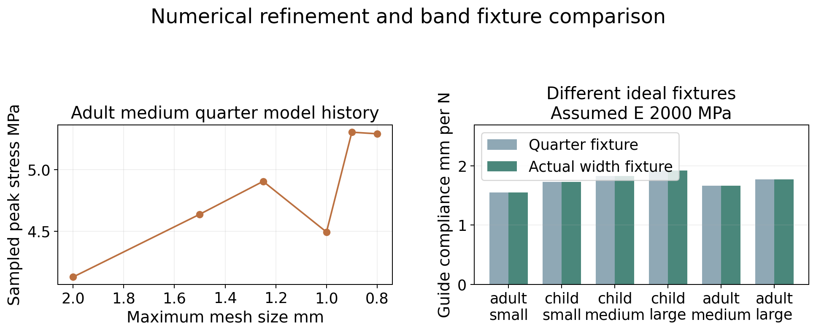
Saved numerical results. The two band fixtures have different restraints and loading. This is not a measured headphone comparison.
The left plot keeps the adult-medium stress history, including changes above our chosen limit before the final smaller change. A final mesh comparison pass does not make the maximum stress exact.
The right plot compares guide compliance: how far the guide moves for one newton in each ideal fixture. Higher compliance means a more flexible response under that fixture. The values use an assumed elastic modulus of 2000 MPa. They do not rank comfort, real band force or sound reduction.

V10 conditional material requirements
We also scaled the ideal band stress to the predicted nominal-setting force in 36 cases. Under these assumptions, a material strength of at least 28.61 MPa would be needed for a margin of 3 across those cases. This is a conditional requirement for this fixture, not a measured material property or product strength result. Margins of 2 and 3 are illustrative targets, not a claimed product standard.
Assumed strength MPa | Cases meeting margin 2 | Cases meeting margin 3
5 | 0 of 36 | 0 of 36
10 | 10 of 36 | 0 of 36
20 | 36 of 36 | 29 of 36
30 | 36 of 36 | 36 of 36
40 | 36 of 36 | 36 of 36

This screen uses the largest recorded stress sampled at element centres across the accepted meshes. It is not a proven upper bound on the actual maximum stress: earlier mesh changes include an 18% adult-medium change before the final 0.243% comparison. The calculation does not include measured yield strength, fatigue, creep, print defects, pin bearing, clamp torque, drop impacts or full worn contact. We have not chosen a material from this table or proved that a prototype is strong enough. Each fixture retains its own force and modelling assumptions.

Current results in plain English
Question | Current answer
Can the saved CAD be opened as solids | All 24 V8 and 18 V9 STEP exports passed. V10 has 18 local STEP poses with 28 solids each.
Do the checked parts overlap | The 18 saved V10 poses pass all-body overlap checks. Earlier V9 shortest-setting clashes are documented.
Does the band calculation settle down | 6 of 6 recorded stress comparisons pass 5%. V10 guide-displacement comparisons are recorded separately.
Is the acoustic calculation stable | The improved cavity model is stable at the sampled frequencies. It does not include a measured glasses leak.
Have we fixed heat and sweat | No. Earlier model scenarios still reached saturation.
Will autistic people like wearing it | Unknown. No participant trials have been done.
Is it better than a market headphone | Unknown. No matched physical comparison has been done.
Can we sell it as a finished product | The current evidence does not establish that.

The earlier V8 CAD mass was estimated at about 166 to 250 g for adults across the size and density assumptions; child mass about 131 to 196 g. These are not measured weights. Sony specifies 192 g for the WH CH720N, so our design is not automatically lighter. Shape and pressure also matter. [9]
V8 had two stress comparisons above the chosen limit. V9 rounded internal guide corners and its six recorded comparisons passed, but later adjustment checks found clashes. V10 fixes those clashes. 6 of 6 recorded stress comparisons pass 5%. The actual-width fixture result and any remaining refinement limits are recorded in the V10 section. Measured material strength and a full worn-assembly test are still missing.

How we will compare real products
Test | Compare under the same conditions | Current status
Outside noise reduction | Our defender, budget earmuff and selected ANC model; with and without glasses | Not performed
Pressure and band force | Same measured head sizes, pad compression and extension settings | Simulation only
Heat and moisture | Same room conditions, wear duration and cover material measurements | Assumption-based screening only
Fit and movement | Same head and ear measurements; walking, bending and easy removal | Not performed
Sensory acceptance | Voluntary feedback on texture, pressure, rubbing sound and control | Not performed
Retention and durability | Slider pull-out, adjustment cycles, drops, cleaning and pad attachment | Not performed

For acoustic tests, measure levels near the ear under a repeatable sound field across frequencies. Compare models at the same fit, glasses and test settings. Do not rank products using marketing numbers from different test methods.
We first need measured foam compression and recovery, cover stretch and friction, band stiffness and creep, liner sound properties and shell damping. Those values will make the calculations more realistic. We can then build a bench prototype and compare predictions with measurements.
The wearer should be free to remove the device and say what feels wrong. Child fit, retention, small parts and pinch points need their own assessment. Success should include useful noise reduction and willingness to wear, not just a high dB number.

Sources and project records
[1] Sensory differences and individual needs
[2] Williams and colleagues 2021 sound sensitivity review
[3] Pfeiffer and colleagues 2019 six child headphone study
[4] Robustt Indian earmuff listing
[5] SYGA Indian child earmuff listing
[6] Alpine Muffy Kids manufacturer page
[7] boAt Nirvana 751 ANC Indian listing
[8] Sony WH CH720N Indian store price
[9] Sony WH CH720N specifications
[10] Turtle Beach adjustable ProSpecs glasses relief
[11] Noisefighters Sightlines gel relief pads
[14] 3M X4A UK rating
[15] Udaipur adult ear to crown height study
[16] JBL Tune 770NC manufacturer specifications
[17] Sony WH CH720N pad replacement instructions
[18] Crysendo indexed Sony replacement pad listing
[19] Geekria Sony cooling gel replacement pads
Web information was checked on 13 October 2026. Prices, coupons and stock can change. Links are evidence sources, not buying recommendations. CAD images were rendered from our saved STEP files; they are not manufactured product photos. SYGA and Sony photographs came from the linked seller pages and are used only to identify the compared products.
Detailed market background is in engineering-v6-results/market_sample.csv and MARKET.md. Geometry and simulation evidence are in the V1 screening, V2 shape study and V3 to V10 result folders. EarDefender_V8_Review_and_Simulations.zip retains earlier evidence. EarDefender_V10_Native_CAD_and_Recorded_Checks.zip contains the current native candidates and recorded V10 checks. These packages are not finished product validation.

What we update next
Next priorities are selecting and measuring real materials, extending the joint and worn-fit model, finishing retention and manufacturing details, and measuring sound reduction with glasses. No comfort or attenuation claim should be added until the relevant evidence exists.
Update date | Design status | Change to this document
13 October 2026 | Initial living reports | First living Word edition. Added needs, selected market comparisons, CAD pictures, V1 to V9 history and clear evidence limits.
13 October 2026 | V9 native candidates | Updated native V9 export and structural evidence for 6 sizes. The replacement pad has no new physical leakage or comfort evidence.
13 October 2026 | V10 clearance candidates | Wider audit found missed V9 shortest-setting clashes. Added V10 guide and knob candidates. Replacement cushion unchanged.
15 October 2026 | V10 actual width fixture study | Actual-width fixture checks completed for 6 of six sizes. Updated refinement and conditional strength evidence, solver failure history and Sony pad competitors. No measured cushion benefit.
15 October 2026 | V12 local folding candidate | Added wider guide channels, a folding lock candidate, component calculations, revised motion checks and unresolved assembly and product-validation requirements. Replacement Sony cushion compatibility is still untested.
15 October 2026 | V14 rear cap candidates | Retained the failed V13 assembly path and added the rear cap candidate with explicit test status. Sony mount and physical benefits remain untested.
15 October 2026 | V15 retention and packing experiments | Added one adult small threaded knob and jam nut experiment, a child packing search on unchanged V14 parts and conditional retention load calculations. No physical or Sony pad pass is added.
15 October 2026 | V16 indexed folding candidates | Added folded-position index holes, recessed rivet retention, different child and adult layouts, retained failures, material-reference calculations and blank physical-test records. Sony fit and physical benefit remain untested.
15 October 2026 | V17 two size entry pilots | Larger index holes and entry cones tested on child large and adult small. V16 remains the six size candidate.
16 October 2026 | V18 passive hinge and wearing stop | Six sizes and component checks retained. Added final material, pivot clearance, CAD stack and handling load screens. Retention risk and missing physical inputs are recorded.
16 October 2026 | V19 prototype handoff | Six sizes revised. Added two disc springs, longer pin envelopes, second nuts, coupled joint development, retained failures and measurement forms. No physical validation or manufacturing release.

Both project documents share the same evidence date and design status. After a meaningful design or test change, update both: replace obsolete results, add failures as well as passes, refresh pictures and explain the effect on the other product route. Preserve earlier document editions. The documents do not update while no work is being run.

Additional travel and tolerance checks
We checked 42 standalone V10 poses: all six sizes at 0, 5, 10, 15, 20, 25 and 30 mm extension. All sampled poses passed the nominal rigid-body overlap check at a 0.01 cubic mm threshold. This covers more positions than the earlier endpoint audit. It does not prove continuous clearance between samples or clearance when the band bends.
The band, crown pad and two clamp knobs moved as one group. All 28 solids were covered. Pairs within the same rigid group were checked once per size and reused because their relative positions do not change. The CAD source hashes are recorded. The results use local geometry calculations on the native STEP exports; no new Fusion simulation or physical test was run.
Pair | Smallest gap | Remaining gap with 0.2 mm error per part
guide to pivot pin | 1.000 mm | 0.600 mm
guide to tongue | 0.217 mm | -0.183 mm
knob to fork | 0.500 mm | 0.100 mm

The expanded tolerance budget has 1296 calculations over 12 assumed error levels. It reuses the recorded minimum distances. For the guide and slider tongue, equal errors must each stay below 0.109 mm to guarantee any positive gap under this simplified rule. At 0.2 mm per part the gap budget is negative. This means manufacturing clearance is not established; it does not prove that every real slider will jam.
An illustrative 0.2 mm error per part plus a 0.1 mm remaining gap would need at least 0.500 mm nominal clearance. The current minimum would need about 0.283 mm more. This is a design input to investigate, not an approved production tolerance. Increasing the gap also needs checks for play, alignment, strength and locking. The CAD has not been changed by this test.
Native Word page layout remains unverified. These results are separate from real comfort, sensory acceptance, sound reduction and leakage tests.

Tests that still need inputs or physical samples
Test group | What is still needed | Current outcome
Foam and cover | Compression and recovery curves, cover stretch, friction and seam construction | Assumed models only
Worn contact and fit | Measured heads, glasses paths, joint behaviour and nonlinear contact | No validated worn assembly result
Band and locks | Material strength, creep and fatigue; real clamp threads, friction and torque | Conditional strength screen only
Adjustment and retention | Clearance specification, stops, pull-out and repeated adjustment tests | Sampled rigid travel passes; retention open
Heat and moisture | Measured material data and timed warm humid wear trials | Earlier model cases saturated
Sound and leakage | Real cup, seal and material properties; acoustic fixture and repeated fitting | No measured attenuation or leakage pass
Sony WH CH720N | Original pad mount, cup, vent and frame measurements | User will measure later
Wearer feedback | Voluntary trials with autistic users and glasses wearers | Comfort and acceptance untested
Manufacturing and cost | Supplier samples, dimensional capability and quotes | Production readiness and price unproven

The saved test register separates finished calculations from tests needing inputs. We cannot complete the physical tests in CAD. We will use the measured inputs to replace assumptions and compare the original, uniform and softer-zone pads on the same headphone. Until then there is no claim that our product is better than a market product.
Shared update on 14 October 2026: added intermediate slider positions and the expanded tolerance budget to both reports. Earlier failures remain recorded. Source records: intermediate_travel_audit.json and tolerance_budget_expanded.json.

Slider stop contact and unfinished validation
The native V10 slider already has an outboard shoulder that obstructs the guide during overtravel. We removed the two clamp knobs in the numerical model to represent an unlocked assembly, then imposed six axial positions from 30 to 75 mm in each size. These are diagnostic poses outside the intended range, not positions we recommend using.
Check | Recorded finding | Meaning
36 overtravel poses | Guide and tongue overlap at imposed 40, 50 and 60 mm settings in all six sizes | The existing shoulder creates a rigid geometric obstruction
12 contact onset searches | Contact begins near 31.000 mm on both sides of every size | About 1 mm beyond the intended 30 mm range
Numerical bracket | Contact threshold located within 0.001 mm intervals | Numerical location only; not manufactured accuracy
Imposed 70 and 75 mm poses | Shapes are beyond the stop and separated axially | Not a reachable pull-out path: intervening positions clash
Stop strength and retention | Not tested under load | No pull-out force or durability rating

The contact search used exact CAD minimum distances. It did not solve the stress or deformation when the shoulder is pulled against the guide. The stop can exist geometrically and still need strengthening. We need the chosen material, manufacturing method and proof-load requirement before validating this part.
Locking remains separate. The saved clamp knobs are shape placeholders. A loaded clamp test needs the final thread and insert geometry, tightening torque, contact friction and wear behaviour. Full worn-contact work also needs measured foam and cover properties, head shapes and the real glasses contact path. The earlier ideal headband-force studies do not replace those inputs.
For the replacement pad route, these are standalone defender results. Sony WH-CH720N mount fit, original clamp force, acoustic response and ANC behaviour remain untested. Its original pad and groove still need measurement. The current generic cushion has not been changed by these checks.
Physical validation remains unfinished: real compression and recovery, locking and pull-out, repeated adjustment, drops, cleaning and ageing, timed heat and moisture, incoming noise, outgoing playback and voluntary comfort trials. The test register identifies these as open. No software run can establish a real material curve or a wearer preference without measurements.
Shared update on 14 October 2026: added stop geometry and overtravel evidence to both reports. Sources: overtravel_audit.json and stop_onset_audit.json. The CAD revision remains V10; no geometry was edited in this batch.

V11 Material and folding study
We expanded the search after the request to consider ordinary and unusual materials, folding and resistance to breakage. The current native CAD is still V10. V11 records material calculations and folding poses made from those saved solids. It is not a new finished hinge assembly or a physical durability test.
The register contains 70 candidate families: 32 for the band and hardware, 20 for cushioning, and 18 for covers and liners. Ten specific material references have numerical band screens. The other families are ideas awaiting grade data, not tested winners. A material family can contain many formulations with very different behaviour.
Band and hardware: ABS, PC ABS blend, polycarbonate, polypropylene, HDPE, PA6 nylon, PA66 nylon, PA12 nylon, POM acetal, PBT, PET, PETG printed prototype, PLA printed prototype, TPU flexible carrier, TPE overmould, PEEK, PEI, glass fibre nylon, carbon fibre nylon, glass fibre epoxy laminate, carbon fibre epoxy laminate, flax fibre composite, bamboo laminate, wood laminate, 301 spring stainless strip, spring carbon steel strip, aluminium 6061, aluminium 7075, magnesium alloy, titanium alloy, superelastic NiTi, spring steel core with polymer shell.
Cushion and compliant zone: conventional flexible PU foam, high resilience PU foam, slow recovery memory PU foam, microcellular PU PORON, silicone foam, soft solid silicone gel, encapsulated gel insert, natural latex foam, synthetic latex foam, EVA foam, expanded PE foam, expanded PP foam, expanded TPU beads, printed TPU lattice, silicone lattice, 3D spacer textile, cork rubber composite, air bladder, water or hydrogel pouch, phase change insert.
Cover and liner: PU coated polyester, PVC synthetic leather, microfibre synthetic leather, woven polyester, polyester velour, cotton jersey, bamboo viscose knit, wool blend, nylon spandex knit, 3D spacer face fabric, silicone skin, breathable monolithic TPU film laminate, ePTFE laminate, thin natural leather, cork fabric, recycled PET knit, removable washable textile sleeve, melamine acoustic liner.
The aim is to identify useful combinations, not to find an unusual material at any cost. No Indian supplier prices, production yield or novelty search has been completed. Comfortable, cheap and hard to break remain design goals.

Specific band material calculations
Published material reference | Modulus MPa | Yield or proof MPa
TECARAN ABS grey | 1700 | 32.0
TECAFORM AH natural POM C | 2800 | 67.0
TECAMID 66 natural PA66 | 3500 | 84.0
TECARAN ABS natural ASTM | 2758 | 40.0
TECADUR PET natural | 3300 | 91.0
TECAPEEK natural | 4200 | 116.0
Makrolon 2458 PC | 2400 | 65.0
Moplen HP500N PP | 1480 | 34.0
301 stainless annealed reference | 193000 | 205.0
301 stainless full hard reference | 193000 | 965.0

The screen has 60 size and material combinations and 240 imposed-load calculations at 2, 5, 10 and 20 N per side. It rescales the existing linear band fixture; it is not 240 new nonlinear simulations. The Poisson ratio stays at the earlier assumed 0.35. The imposed loads are comparison inputs, not a product test standard.
At fixed load and fixed Poisson ratio, changing only the modulus changes displacement but not the linear elastic stress field. At fixed displacement, force and stress scale with modulus. A higher coupon strength alone does not prove the finished headset will survive a fall. Large deformation, yield, creep, fatigue and joints remain outside this screen.
The PP value is a published flexural modulus used only as a stiffness proxy. The 301 references use published wire data for two tempers; a selected strip still needs qualification. Other properties are manufacturer typical coupon values, not allowable stresses for our moulded or printed parts. Test method, moisture and manufacturing differences matter.
Using the same 3 mm section in the referenced steel makes the ideal band 96.5 times as stiff in this linear comparison. An equal bending stiffness strip estimate gives about 0.65 mm steel thickness for a 3 mm, 2000 MPa reference strip. This is an EI estimate only. Guides, inserts, bends and hinge loads would need a new design and analysis.
Two routes remain worth investigating: a thin spring core with separate polymer guides, and a tough polymer band with reinforced joints. Neither route has passed fatigue, drops or manufacturing tests. Printed plastics and fibre composites need directional property data before receiving a material model.
Material data ensinger catalog
Material data abs natural
Material data pet
Material data peek
Material data pc
Material data pp
Material data steel301

Cushion and cover material findings
Published foam reference | Reference point | Flat ring force N
PORON 4701 30 240 kg/m3 | 25 percent compression | 89.5
PORON 4701 30 320 kg/m3 | 25 percent compression | 149.1
PORON 4701 30 400 kg/m3 | 25 percent compression | 264.2
BISCO BF1000 | CFD test point | 70.3
BISCO BF2000 | CFD test point | 42.6
Infinergy 230 at 10 percent | 10 percent compression | 106.5
Infinergy 230 at 50 percent | 50 percent compression | 1065.2

These 14 calculations cover adult and scaled child projected rings at individual published stress points. They do not model our curved cushion, actual contact area, cover tension or a real glasses arm. The forces in the table are what uniform compression across the entire flat ring would require at that point. They are not measured headband forces or a comfort ranking.
The industrial foam examples need much more force at their reported points than our earlier few-newton band estimates. That is a warning against substituting a foam because it is called soft. The test conditions differ, and the low-load compression curves are still missing. The cited PORON sheets are also much thinner than our pad; a 20 mm layered pad is not validated by those data.
A continuous breathable TPU film under a soft textile face is a useful cover experiment. Covestro describes Platilon M as wind tight, water vapour transmitting and low noise. Baltex describes spacer fabrics for airflow and cushioning. We infer that a thin film plus textile may help us study moisture and surface feel while retaining a continuous layer. Neither source proves headphone isolation, lower ear temperature or autistic acceptance.
Keep flexible PU and memory foam as comparison samples. Investigate softer silicone or a TPU lattice for the local glasses region only after obtaining its compression curve. Lattice shape, rubbing noise, recovery, seam life and sealing need tests. No material is selected as a final winner yet.
Material data poron
Material data silicone
Material data silicone soft
Material data etpu
Material data film
Material data spacer

Folding results across six sizes
Size | Best sampled angles | Envelope change
adult large | 75 and 60 degrees | 23.5 percent smaller
adult medium | 75 and 60 degrees | 23.6 percent smaller
adult small | 75 and 45 degrees | 12.3 percent smaller
child large | 60 and 45 degrees | 3.5 percent smaller
child medium | 60 and 45 degrees | 3.5 percent smaller
child small | 75 and 45 degrees | 5.2 percent smaller

These poses use the existing fork pins as rotation axes. Before folding, the left side is set to 0 mm extension and the right to 30 mm. Both cups and their forks then rotate inward in sequence. The comparison is with each original nominal V10 bounding box, not with a market headset or a carrying case.
The first symmetric folds, direct cup-pivot folds and some 75 or 90 degree staggered attempts collided. Those failures are saved. Two child sizes needed a shallower first rotation. A final pose is counted only when its preceding sampled sequence is also clear. Packing volume alone does not establish ease of carrying or protection in a bag.
The finer check covers 150 poses at 5 degree intervals. All recorded samples passed the 0.01 cubic mm intersection threshold. 6 candidate STEP files were exported from passing size sequences. This remains sampled rigid motion; it does not prove continuous clearance or clearance under tolerances and loads.
Rigid when worn and foldable for carrying require a controlled joint. The saved model still lacks a validated angular latch, rotation stops, friction specification and protection against pinching. The earlier intact-band stress results do not certify these joints. No drop, repeated folding or bag compression pass is claimed.

Folding CAD and the next durability checks
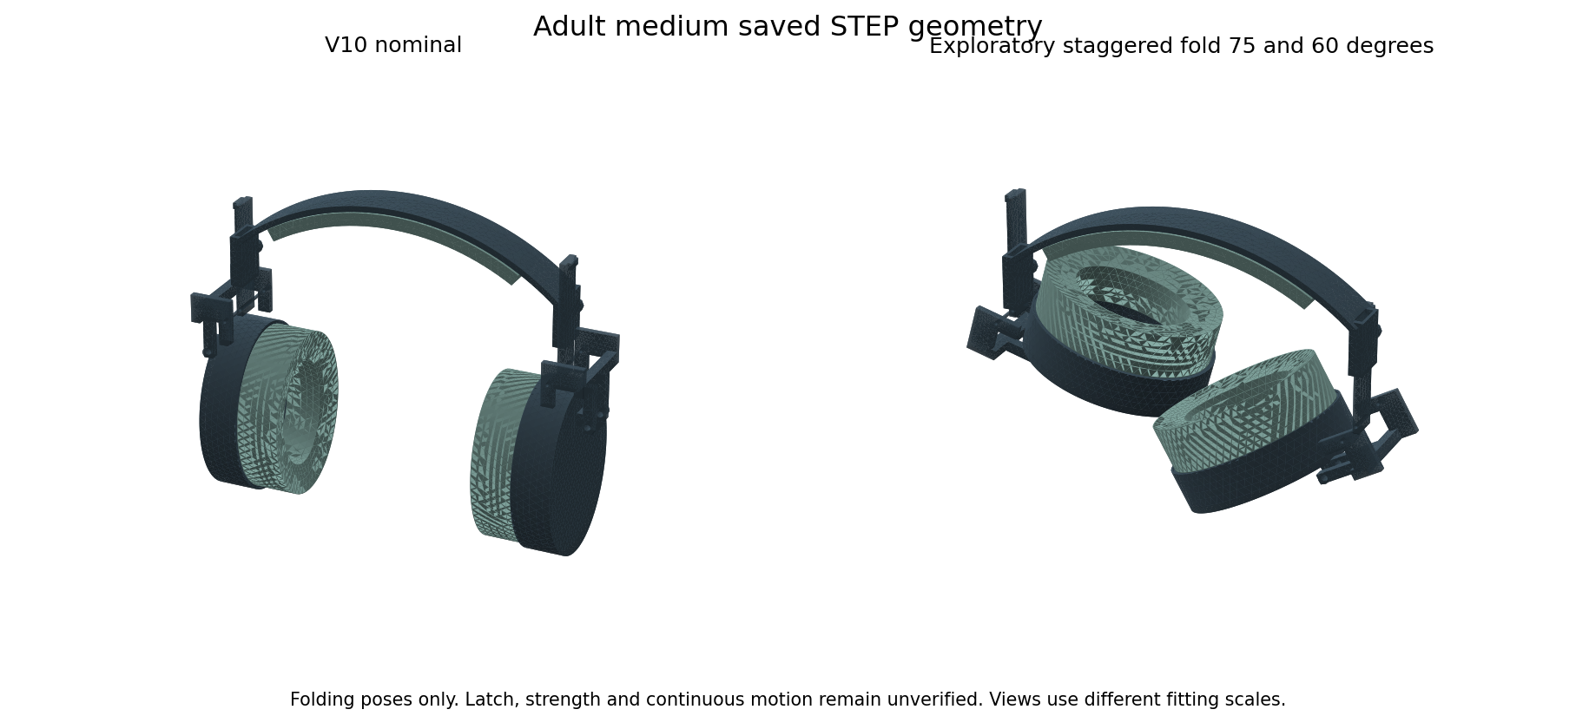
Actual adult medium STEP geometry before and after an exploratory fold. Views fit each shape independently. The triangles are display tessellation, not the cover texture. This is not a manufactured headset or a native Fusion hinge simulation.
Goal | Required validation
Rigid in use | Final latch geometry, bending and torsion stiffness, joint play and release force
Not easily broken | Material curves, stress at pins and stops, large deformation and physical overload tests
Repeated folding | Hinge cycles, fastener loosening, cracks, wear and force drift
Easy to carry | Continuous folding path, hand access, folded dimensions and real bag fit
Transport survival | Defined drop orientations, packed compression, crush recovery and repeat function
Comfort after ageing | Foam recovery, cover damage, sealing and voluntary wear feedback

All material data in this study were checked on 14 October 2026. They supplement the market review dated 13 October. The next engineering step is to specify and model the latch and final materials, then use samples to calibrate compression, friction, fatigue and acoustic inputs. These results do not establish an unbreakable product, zero leakage or a universal sensory preference.
Both living reports were updated together with the 70 family register, grade calculations, foam point screens and folding passes and failures. Primary local records are in engineering-v11-results. The Sony pad geometry and its untested compatibility status are unchanged.

V12 Folding lock and wider guides
V12 adds a folding lock candidate in all six sizes. The fixed tongue has a blind hole. A captive pin in the fork engages this hole in the worn position and pulls back by 6 mm to allow folding. The fork crossbar is offset to clear the new tab. A spring space is reserved inside the housing; it is not an actual coil or a selected production spring.
The guide to tongue gap increases from about 0.217 mm in V10 to 0.6 mm nominally. Under the same assumed 0.2 mm error on each opposing surface, 0.2 mm clearance remains. This corrects that particular arithmetic shortfall. It does not establish factory capability or clearance with dirt, heat, coatings, misalignment and wear.
Six local STEP candidates have 32 solids each, including two spring space envelopes. V10 remains the latest native Fusion archive. Fresh band fixture calculations are recorded below when complete. Earlier V10 band stresses and worn-force estimates are not automatically V12 results.
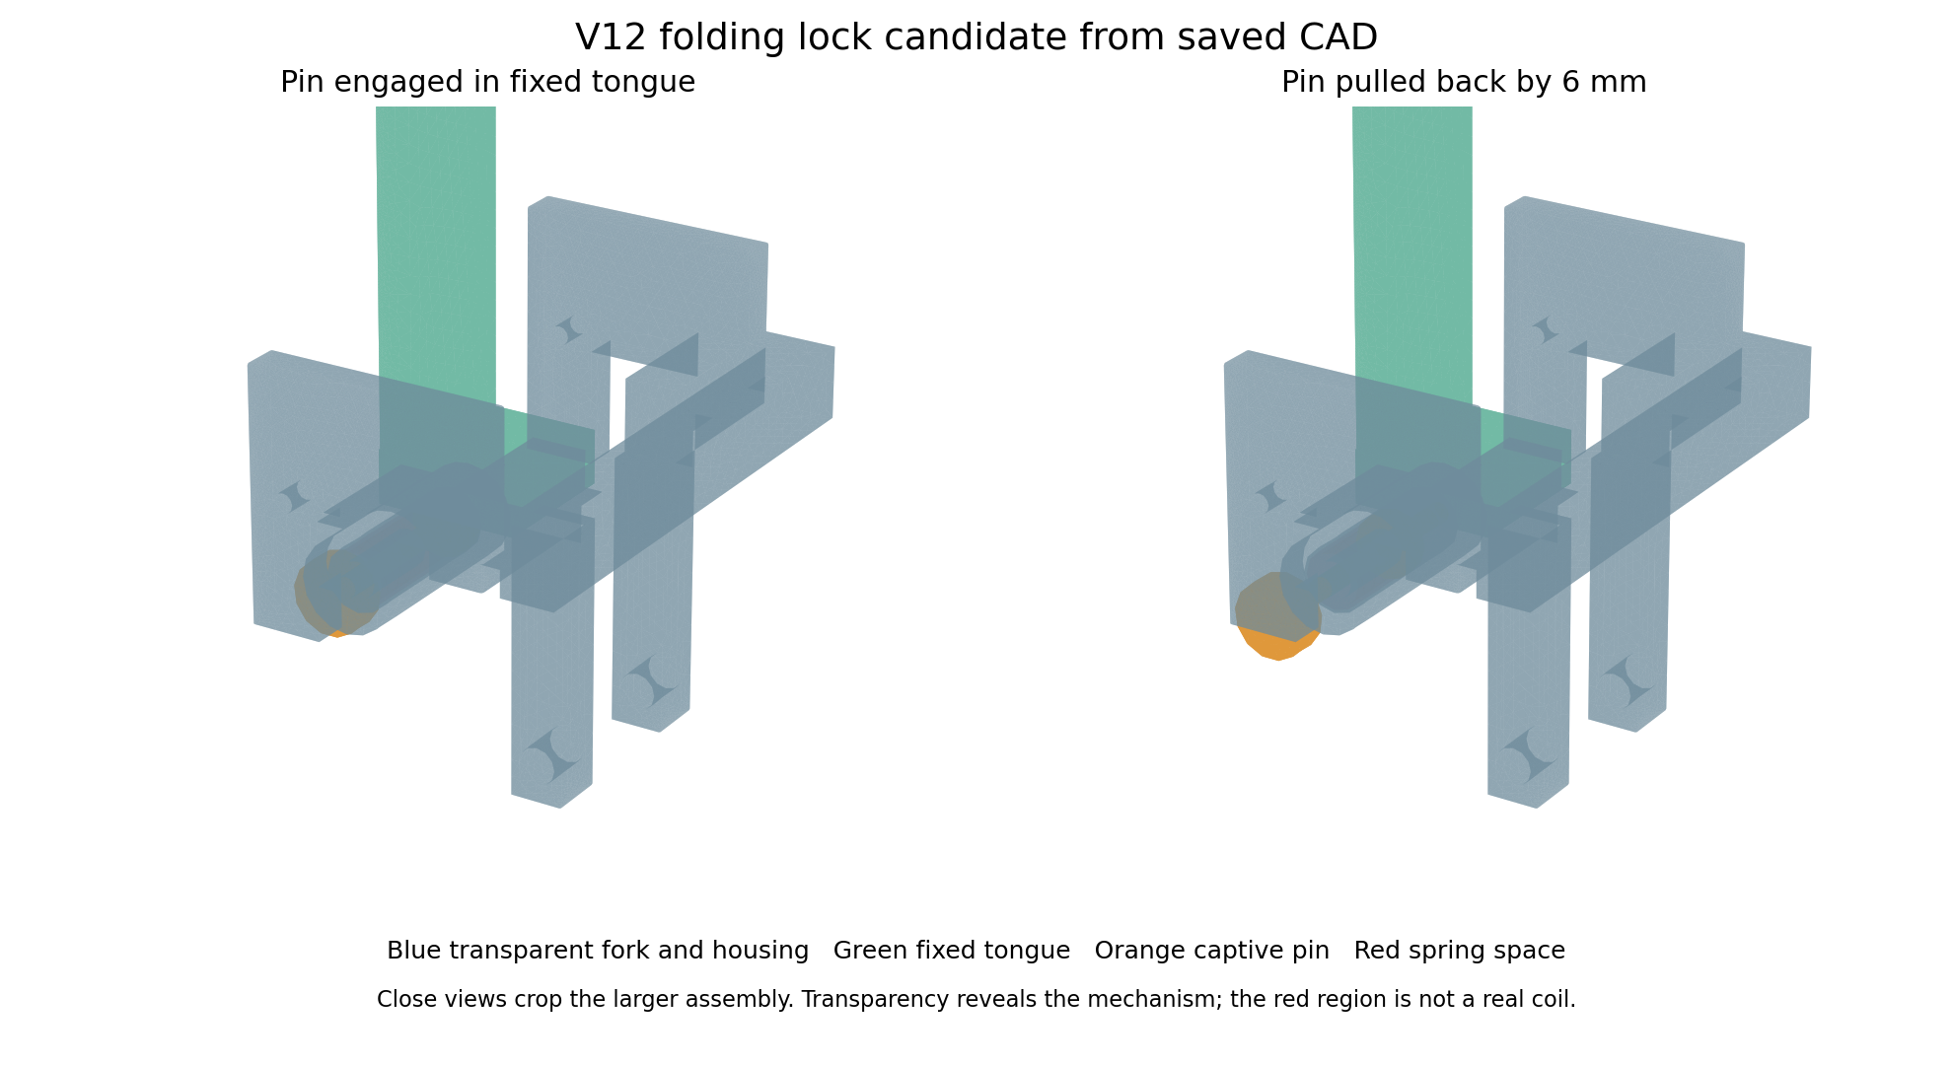
Actual V12 adult small STEP surfaces. Transparent blue shows the fork and housing; green is the tongue and orange is the pin. The two views show engagement and nominal release. The larger assembly is cropped and colours do not specify materials.

V12 Motion checks and CAD reliability
A positive control exposed a problem in the first motion-check method: two deep geometric copies of the same imported fork returned an empty intersection. A clearance pass from that method alone is not reliable. The original solids pass a separate validity check. The independent OCP audit therefore uses the original geometry with location transforms, avoiding deep geometric copies.
Check | Recorded result | Limit
Slider samples | 42 samples and 0 failures | Rigid discrete positions only
Pin release samples | 24 samples and 0 failures | Rigid discrete positions only
Folding samples | 150 samples and 0 failures | Rigid discrete positions only

The independent audit covers 216 poses across six sizes. All recorded poses passed the 0.01 cubic mm overlap threshold. At each phase start every body pair is considered. Later pairs within the same unchanged rigid group are invariant. Spring envelopes are checked separately. These samples are not a continuous sweep or a loaded contact solution.
The first compressed spring-space exports also failed the expected volume check by about 0.994 cubic mm per assembly. Anisotropic dilation had converted the cylindrical surfaces. The revised export reconstructs the annulus from exact cylinders at each length. The initial files and failed checks are kept in the evidence history.
The independent collision-query controls include 18 known embedded and disjoint cube cases, including rotated pairs. They all pass. A one cubic mm cube placed inside a known fork prong must return one cubic mm of overlap; an outside cube must return zero. Coincident independently imported or deeply copied fork comparisons remain unreliable, so no six-size fork-equivalence pass is claimed.
The lock is still an engineering candidate. The integral housing, large pin collar and head do not yet have a specified assembly or servicing process. A split housing or removable retained cap and head must be designed and checked before manufacturing release. Finger access, pinching, release under load, unintentional unlocking, threads and fastener loosening remain open.

V12 Folding size and carrying limits
Size | Folded box mm | Box volume change
child small | 218.4 by 79.6 by 185.4 | 3.3 percent smaller
child medium | 233.7 by 79.6 by 185.4 | 1.2 percent smaller
child large | 244.2 by 79.6 by 185.4 | 1.0 percent smaller
adult small | 240.9 by 90.0 by 193.7 | 12.3 percent smaller
adult medium | 254.8 by 90.0 by 170.5 | 23.3 percent smaller
adult large | 271.0 by 90.0 by 170.5 | 23.0 percent smaller

This comparison uses tight axis-aligned bounding boxes of the actual V12 CAD at its nominal setting and the final sampled fold. The left slider is set to 0 mm and the right to 30 mm before folding. These are space estimates, not a carrying-case measurement or a folded product test.
The three child examples gain only about 1 to 3 percent in this box-volume measure. Their folded boxes are slightly taller and deeper, so the present child folding arrangement offers little packing benefit. The adult examples gain about 12 to 23 percent. A clear folding path is therefore not enough to call every size easy to carry. Child portability needs further design work and real bag-fit checks.
These V12 numbers replace any attempt to carry the older V11 packing percentages straight into the new revision. V11 used a different loose bounding-box calculation. Neither study compares a physical market headphone or proves transport survival.

V12 Nominal and folded CAD
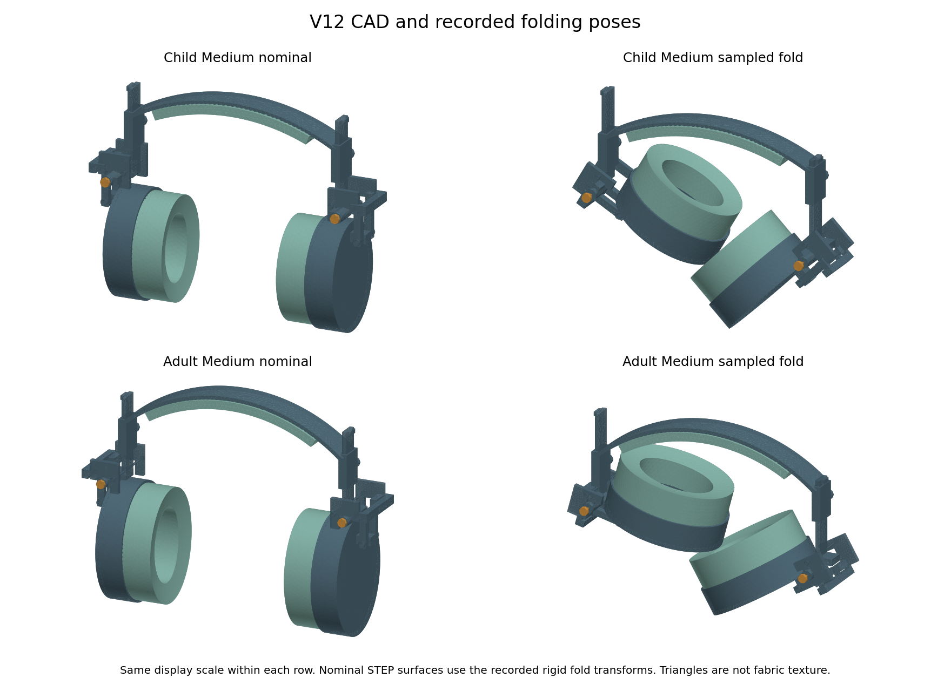
Actual child medium and adult medium STEP surfaces. Nominal and folded views use the same display scale within each row. Triangles are display tessellation, not cover texture. Colours do not select production materials.
The child example stays almost the same size in the box-volume comparison. The adult fold gives a clearer packing change. Both still need hand-access, assembly, tolerance, loaded-joint and real carrying-case checks.

V12 Assembly and servicing are still open
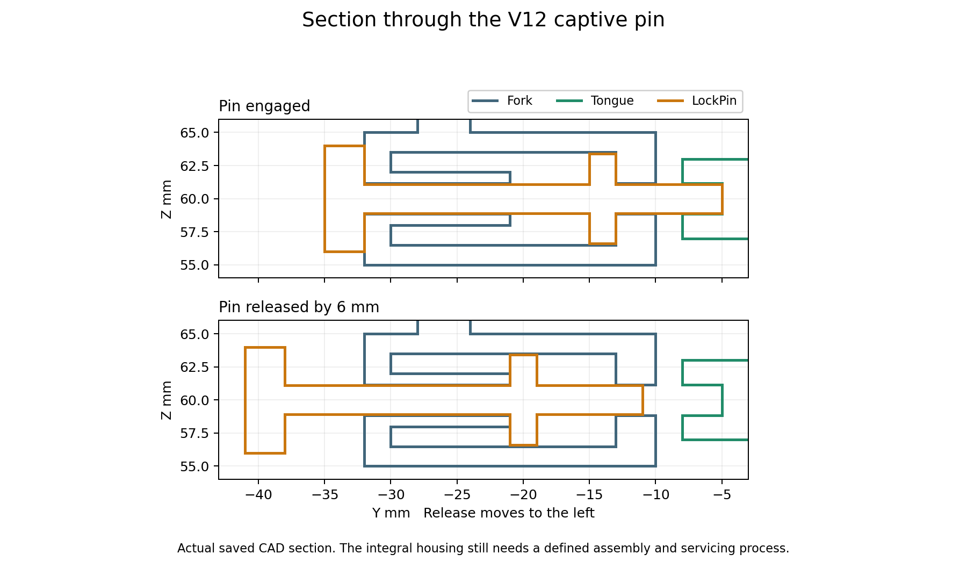
Section curves through the actual saved CAD. The blue housing captures the orange pin collar. This explains nominal retention, but it also shows why we need a defined way to assemble and service the parts. The spring itself is not drawn.
The digital pin is captive in the integral housing. We have not specified an economical process for putting the large collar and head inside it, or replacing the spring later. Overmoulding or permanently closing the housing would be a different manufacturing decision, not a tested feature of these CAD files.
Before ordering a prototype, revise the housing into parts that can be assembled, define a retained cap and pin head, and check their attachment, tolerances, release stroke and folding path. That revised joint must receive its own load analysis. V12 is not released for manufacture.

V12 Fork structural calculations
Fixture | Fine displacement mm | Fine sampled stress MPa | Mesh change
adult small | 0.1166 | 13.20 | 1.38 percent displacement and 3.10 percent stress
child small | 0.0355 | 7.48 | 0.75 percent displacement and 1.22 percent stress

Each fixture uses quadratic tetrahedra with 2.0 and 1.5 mm maximum mesh settings. The adult fine mesh has 103,869 nodes and the child fine mesh has 54,724. Both displacement and sampled peak stress changes pass our chosen 5 percent comparison. The saved equations also pass the residual, force balance, fixed displacement, positive Jacobian and work versus strain-energy checks.
The input is an illustrative 2 N side load acting through a 65 mm arm. This becomes an 11.63 N resultant at the locking bore. The pivot bore surfaces are fixed and the locking bore receives uniform traction. The material is homogeneous, with an assumed modulus of 2000 MPa and Poisson ratio of 0.35. This is an ideal fork fixture, not the complete pin, tongue, cup and scalp contact system.
The material comparison has 80 conditional grade and load calculations using ten earlier references at 2, 5, 10 and 20 N. These scale a linear fixture; they are not 80 extra finite-element solves. At 20 N the adult fixture predicts about 132 MPa sampled peak stress. This exceeds the typical yield references of all eight plastics in our table. It is a warning that the present plastic fork cannot receive that load claim from this analysis. Changing to steel is not automatically a solution: weight, processing, interfaces and production grade would need a new design decision.
A stable mesh comparison is a numerical check. It does not prove a safe overload rating, fracture resistance, fatigue life or drop survival. Corner stresses can still depend on ideal restraints, load distribution and geometry detail. The complete assembled lock still needs its own contact and load analysis. These results apply to the two simulated right-fork examples; they are not automatically six complete assembly results.

V12 Band calculations for the wider guides
Size | Fine compliance mm per N | Stress mesh change | Chosen comparison
child small | 1.737 | 0.85 percent | Pass
child medium | 1.839 | 0.11 percent | Pass
child large | 1.931 | 0.09 percent | Pass
adult small | 1.561 | 2.43 percent | Pass
adult medium | 1.671 | 1.05 percent | Pass
adult large | 1.779 | 4.57 percent | Pass

These new calculations use the actual V12 band geometry with wider guide channels in all six sizes. Each is an X half-band with its full front to rear width, the front clamp bore, an illustrative 2 N guide-bottom traction and ideal crown datum restraints. The assumed material remains 2000 MPa with Poisson ratio 0.35. Coarse comparisons that failed are retained and refined rather than renamed as passes.
The table reports only the last two available mesh comparisons for each size. A passing chosen 5 percent comparison does not bound a local corner stress or prove a finished material or worn headband force. The model omits scalp contact, actual clamp friction, the tongue, cup and folding lock. The earlier V10 equations and physical limits remain in their own revision history.

V12 Pin spring and remaining release work
Calculation | Result | What it does not prove
Lock pin | 36 ideal cases with 2.19 to 2.21 mm pin diameter | Actual bearing, wear, support flexibility or fracture
Spring | 162 parameter and compression cases | Fatigue, set, buckling, rubbing or reliable return
Nominal spring force | About 0.29 N engaged and 0.58 N released | Measured operating force or resistance to accidental release
Nominal spring reserve | 3.4 mm above solid length when released | Actual end turns, seats and manufacturing variation
Pin and bore design limits | 0.07 to 0.13 mm diametral clearance | Supplier precision or play after wear

The pin calculation uses an ideal 3.5 mm effective cantilever span. The coil calculation uses 0.35 mm wire, 6 mm mean coil diameter, 14 active turns and 21 mm free length. Published full-hard 301 wire data supply the reference properties. Those wire data do not qualify our final pin, formed coil or heat treatment. Static reference ratios are not fatigue safety factors.
Published 301 stainless steel wire reference
The remaining work has two parts. Engineering release needs an assembly and retention design, final fasteners and angular stops, complete assembly contact and tolerance checks, and calibrated foam and cover models. Product validation needs manufactured samples for folding cycles, overloads, falls, cleaning, ageing, heat and moisture, measured incoming noise and voluntary comfort feedback. These are not completed tests.
For the Sony replacement pad, measure the original mount, opening and depth first. Compare original, uniform new and soft-zone samples on the same headphone, with repeated seating and several glasses arms. Incoming sound, outgoing music, bass response and ANC behaviour need real measurements. No zero-leakage, pain-relief, universal preference or market-superiority claim follows from V12.
Both living Word reports were updated together on 14 October 2026. V12 adds local CAD and component evidence while preserving earlier failures and revision limits. It is not a finished commercial headset or an exhaustive test of every material formulation.

V13 Assembly failure and V14 rear cap
V13 tried a removable side cap. The first cap also clashed with a screw head; a clearance recess corrected that clash. The later assembly check found a more basic problem: the fixed spring guide obstructed radial insertion. Forty eight of sixty sampled cap or pin withdrawal positions failed. Passing STEP exports did not make this design ready to build. V13 was rejected as an assembly route.
The recorded V13 motion audit was stopped after this failure. Its saved samples are incomplete and are not a six size motion pass. One adult small inner fork calculation gave about 0.147 mm load direction displacement and 13.58 MPa sampled peak stress under the ideal 11.63 N locking bore load. It has only one mesh, so refinement was not established. Neither result qualifies its cap or screws.
V14 changes to a rear axial cap and a separate pull knob. The pin and collar enter from the rear. A coil can slide over the bare rod. The cap guide slides along the rod and seats the spring. Two nominal M1.6 by 6 screws and nuts retain each cap. The pull knob attaches last. Actual threads, knob retention, torque, spring ends and assembly tools still need design and qualification.
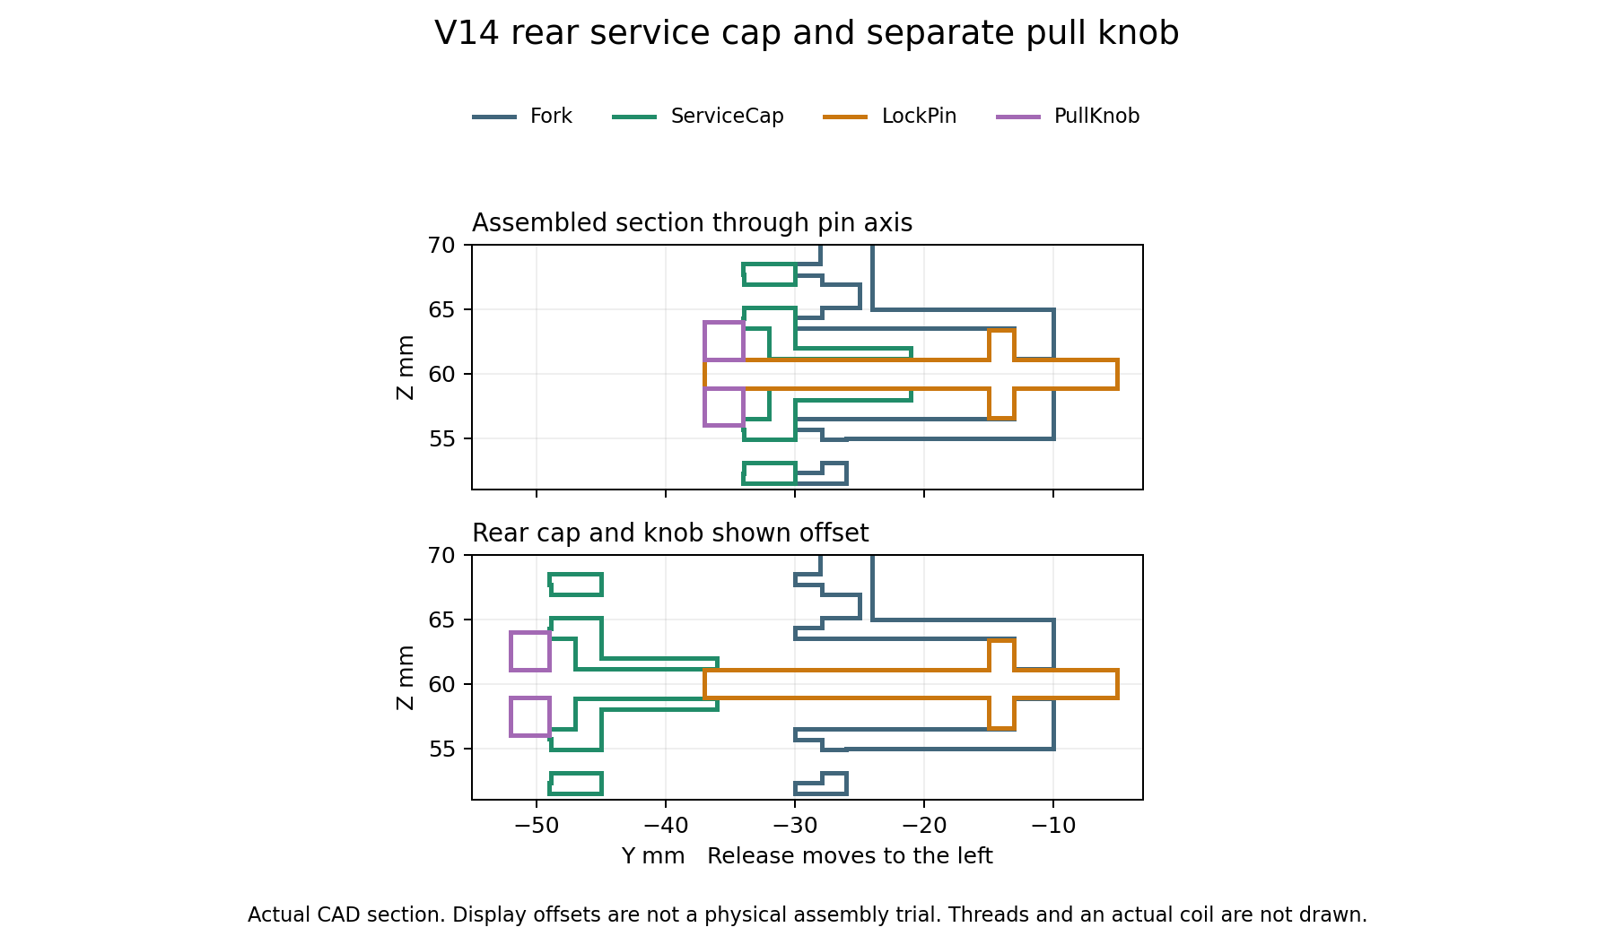
Sections through saved V14 CAD. Colours identify parts and do not select materials. The exploded offsets explain assembly; they are not a physical assembly trial.

V14 Recorded checks and open work
Check | Current record | Scope or missing input
Saved candidate sizes | 6 of six | Local STEP files with 44 solids per assembly
STEP reimport checks | 18 and pass | Counts and volumes only
Assembly path samples | 66 and pass | Discrete rigid cap and pin movement
Adjustment release and folding | 216 and pass | No continuous or loaded contact proof
New fork structural fixture | Recorded below | V12 and V13 fork stresses cannot qualify V14
Final complete joint contact | Not completed | Pin bearing cap screws knob threads torque friction and stops
Comfort heat and sensory acceptance | Not physically tested | Measured materials and voluntary wearer trials
Noise reduction and music leakage | Not physically tested | Sealed sample and repeated acoustic measurements
Drops folding cycles and ageing | Not physically tested | Manufactured samples and selected material grades

An assembly sample holds the allocated spring space at 15 mm. An actual coil would expand when released, so a suitable compression fixture and real handling trial are still needed. The CAD does not model thread helices, nut installation tools or a verified retained connection between knob and pin. Clearance alone cannot establish a safe release control.
V12 has six completed ideal band fixtures and two completed fork mesh comparisons. Those results stay labelled V12. V14 deliberately inherits the V12 band and cushion bodies through its construction script, but coincident Boolean component comparisons were not a reliable equivalence proof. No new six size V14 material qualification or complete assembly stress pass is claimed.
One V14 calculation first stopped because its load face selection did not account for a 0.001 mm construction change. The selector was corrected against the saved surface bounds. A subsequent structural solve and a STEP export ran out of allocation space on the laptop. Those attempts are failures, not accepted results. Reruns use separate sequential processes; only completed and checked records appear as passes here.

V14 Ideal fork fixture results
Size | Fine displacement mm | Fine sampled stress MPa | Mesh comparison
adult small | 0.1147 | 12.99 | Pass

The right main fork receives the entire illustrative locking bore force with its pivot bores fixed. The cap and fasteners are excluded. This is an ideal component fixture with assumed modulus 2000 MPa and Poisson ratio 0.35. It does not solve the assembled bearing contact, cap screw preload, friction or a drop. The chosen comparison uses 5 percent changes in load direction displacement and sampled peak stress.
For adult small, the two mesh sizes are 2.0 and 1.5 mm. Load direction displacement changed by 1.07 percent and sampled peak stress by 3.05 percent. Saved result arrays also passed checks of force balance, fixed displacement, positive element Jacobians, the equation residual and external work against strain energy.
A numerical refinement pass establishes consistency of this fixture only. It cannot establish comfort, resistance to breakage, a material winner or superiority over market products. Final grades, production geometry and measured material behaviour remain required.

V14 Folding size and carrying result
Size | Folded box mm | Change from nominal box
child small | 218.4 by 81.6 by 185.4 | 0.86 percent smaller
child medium | 233.7 by 81.6 by 185.4 | 1.26 percent larger
child large | 244.2 by 81.6 by 185.4 | 1.49 percent larger
adult small | 240.9 by 90.0 by 193.7 | 12.35 percent smaller
adult medium | 254.8 by 90.0 by 170.5 | 23.31 percent smaller
adult large | 271.0 by 90.0 by 170.5 | 22.99 percent smaller

These are tight bounding boxes of the saved rigid CAD poses, including the new cap hardware and pull knobs. Child small improves by less than 1 percent. Child medium and large become about 1 to 1.5 percent larger. The child folding mechanism therefore fails our intended useful packing goal. Adult examples give about 12 to 23 percent reduction. None is a physical carrying case or transport survival test.

V14 Nominal and folded CAD
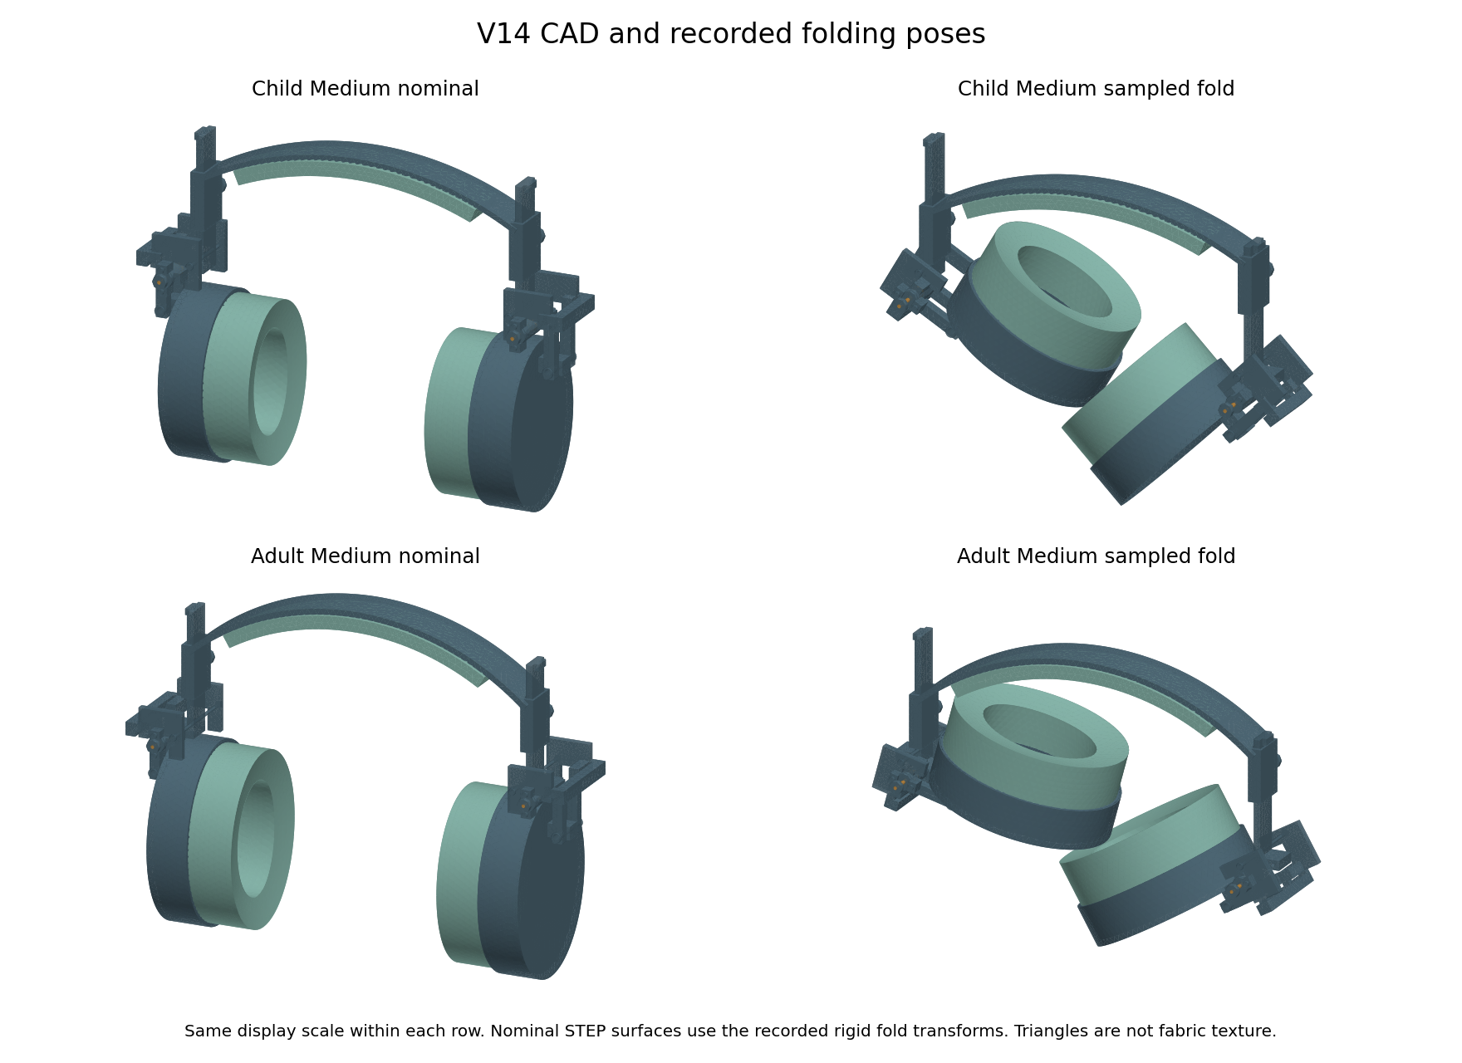
Saved V14 nominal surfaces shown with the recorded rigid folding transforms. Display scale is the same within each size row. Colours do not select materials.
Folding stops, pinching and release force for individual users remain open. The child mechanism needs redesign or comparison with a simpler nonfolding version before claiming easy carrying. A collision free sampled path alone does not satisfy the portability objective.
The nominal pin has only 0.05 mm radial clearance in its guide; the collar has 0.10 mm in the housing. These clearances need a capable process and checks for coatings, dirt, misalignment and wear. The pull knob bore currently matches the rod envelope exactly. That is not a modelled or qualified thread, anti loosening feature or pullout pass. Final retained knob and fastener specifications remain a design task.
The digital review remains separate from product validation. The 70 material families are a register with limited reference calculations, not every material tested. We have no final supplier quote, measured Sony interface, manufactured prototype, matched competitor laboratory test or wearer study. V14 is not a manufacturing release.

V15 Knob retention experiment
V15 is one adult small retention pilot. It adds an intended M2 threaded metal knob and a separate hex jam nut to the V14 release stem. The earlier knob only had an unretained matching bore. Countertightening the nut against the knob gives us a defined retention method to develop. It has not passed pullout, loosening, repeated release or child access tests.
The knob is 8 mm across and 4 mm long. Its intended thread allocation is 3 mm, with a 1 mm rear counterbore. The separate nut is 4 mm across flats and 1.6 mm long. The male thread envelope is 6 mm long. The nominal nut to shoulder and shoulder to cap gaps are each 0.4 mm. These are design dimensions, not measured manufacturing tolerances.
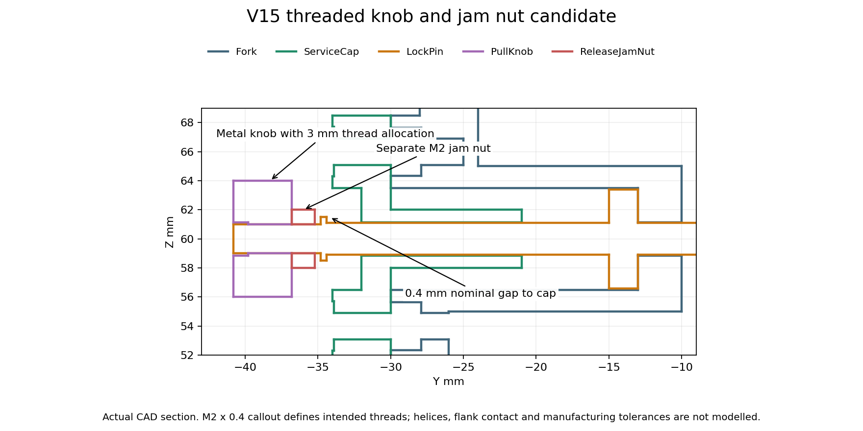
Exact section of the adult small pilot. The coloured outlines come from saved STEP geometry. Thread helices and flank contact are not modelled.
The saved pilot contains 46 solids. Its 6 recorded release and slider endpoint checks passed. These check geometric clearance outside the cosmetic thread allocations. They do not prove threaded engagement or a safe complete mechanism. No V15 six size motion pass or folding pass is inferred from them.
The intended thread is M2 with 0.4 mm pitch, using proposed 6g external and 6H internal tolerances. A Bossard technical guide lists these general tolerance fields and the M2 dimensions. A supplier drawing, thread runout, gauges, coating, final material grade, real wrench access and a controlled tightening process are still required. The smooth thread envelopes in the STEP file cannot replace these details.
Bossard metric thread dimensions and tolerances

V15 Child packing search
Size | Boxes ranked | Endpoints checked | Best recorded fold against retracted unfolded
child small | 30625 | 65 | 0.51 percent larger
child medium | 30625 | 61 | 2.66 percent larger
child large | 30625 | 53 | 3.93 percent smaller

This search moves the existing V14 parts; it does not create a new child headband. It ranks 30 625 combinations per size using two slider positions from 0 to 30 mm and two cup angles from 0 to 120 degrees. Only a finite shortlist gets actual solid intersection checks. We stop at the first clear endpoint in that shortlist. Ranking boxes is not a collision pass or a proof of the best possible fold.
We compare the first clear new endpoint with the already checked V14 folded endpoint and keep the smaller recorded box. A worse new endpoint is rejected. The fully retracted unfolded baseline is included so that retracting the sliders cannot be presented as a folding benefit. These endpoint checks do not prove a new path to the pose. The original V14 sampled path evidence remains separate. The selected child packing goal is still unresolved.
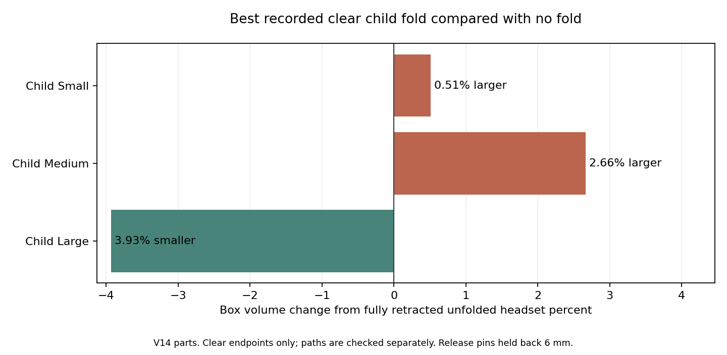
Source matched V14 clear endpoints are retained when the new search endpoint is worse. Positive bars mean more box volume than simply retracting the headset.
The fold search holds both release pins 6 mm back, as in the earlier V14 motion study. It does not show that a real spring would hold that state after we let go, or that the cups latch safely for storage. A stable released or folded storage mechanism remains a design task. A clear displayed fold is not yet a usable carrying mode.

V15 Child large folding sequence
The improved child large endpoint has 27 recorded adjustment, release and folding samples. The complete sampled sequence passed. With the headband fixed, the left slider goes to 0 mm and the right to 20 mm. Both release pins are held 6 mm back. The left cup turns 30 degrees first, then the right turns 60 degrees. This order is part of the checked sequence.
The exported box is about 247.0 by 81.6 by 171.1 mm. It is 5.24 percent smaller in volume than the nominal 15 mm slider pose and 3.93 percent smaller than the fully retracted unfolded pose. This is a modest geometric improvement for child large. Child small and medium still have no useful recorded improvement. The stable storage, pinch, physical handling and durability limits remain open.
The 2 new STEP reimports passed solid count, validity and volume checks. The improved child large export also matched the intended box dimensions. These checks cover storage of the geometry, not a physical product.
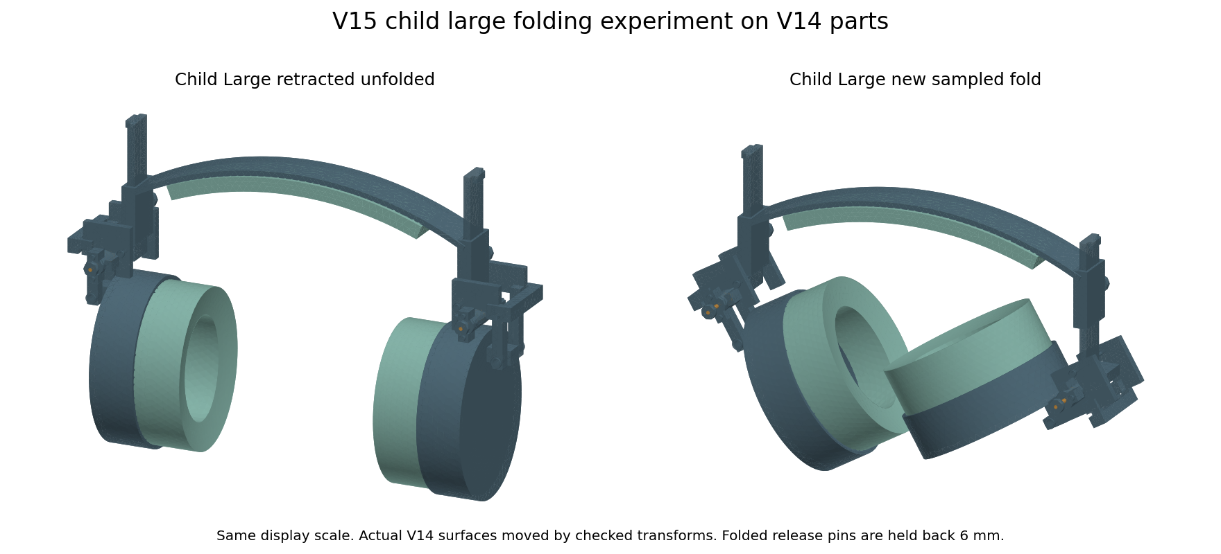
The same V14 child large surfaces before and after the newly checked rigid transforms. Equal display scale. The right picture holds the release pins back.
The retention screen calculates 72 assumed combinations of root diameter, tightening torque, nut factor and external pull. A simple solid rod model gives required yield strengths from 28.6 to 254.0 MPa for a chosen factor of two. This range is not an approved torque, material selection or thread strength rating. Thread stripping, real flank contact, stress concentration, actual jam nut load sharing, fatigue and loosening are excluded.
The new knob projects farther behind the cap and adds two separate small nuts to the headset. These changes can increase bulk and complicate assembly. The V14 folding results cannot be transferred to V15 without checking the new geometry. Child access to loose parts and pinch points remains open. We have not selected this retention pilot as a final product design.
At the V15 stage, V14 was the latest six size CAD candidate and V15 was a local STEP experiment for one size. The later V16 section records the next changes. Native editable Fusion archives remain V10. Real material data, complete joint analysis and physical comfort, acoustic and durability work are still needed.

V16 Indexed folding and rivet retention
Project status: V16 indexed folding candidates with V10 native archives.
V16 adds holes for the wearing and folded positions. The locking pins can return into the folded holes instead of staying held back. A recessed cross rivet retains each knob on its stem. This is an alternative to the longer V15 threaded knob and jam nut. It keeps the earlier 8 mm knob envelope, but servicing the pin means removing the rivet.
The selected child plate is a lower half disc with 16 mm radius and 3 mm thickness. Adult cups collided with this lower plate. The adult alternative puts a trimmed upper plate behind the guide and relocates the release housing. The child and adult fork arrangements differ and need their own strength checks.
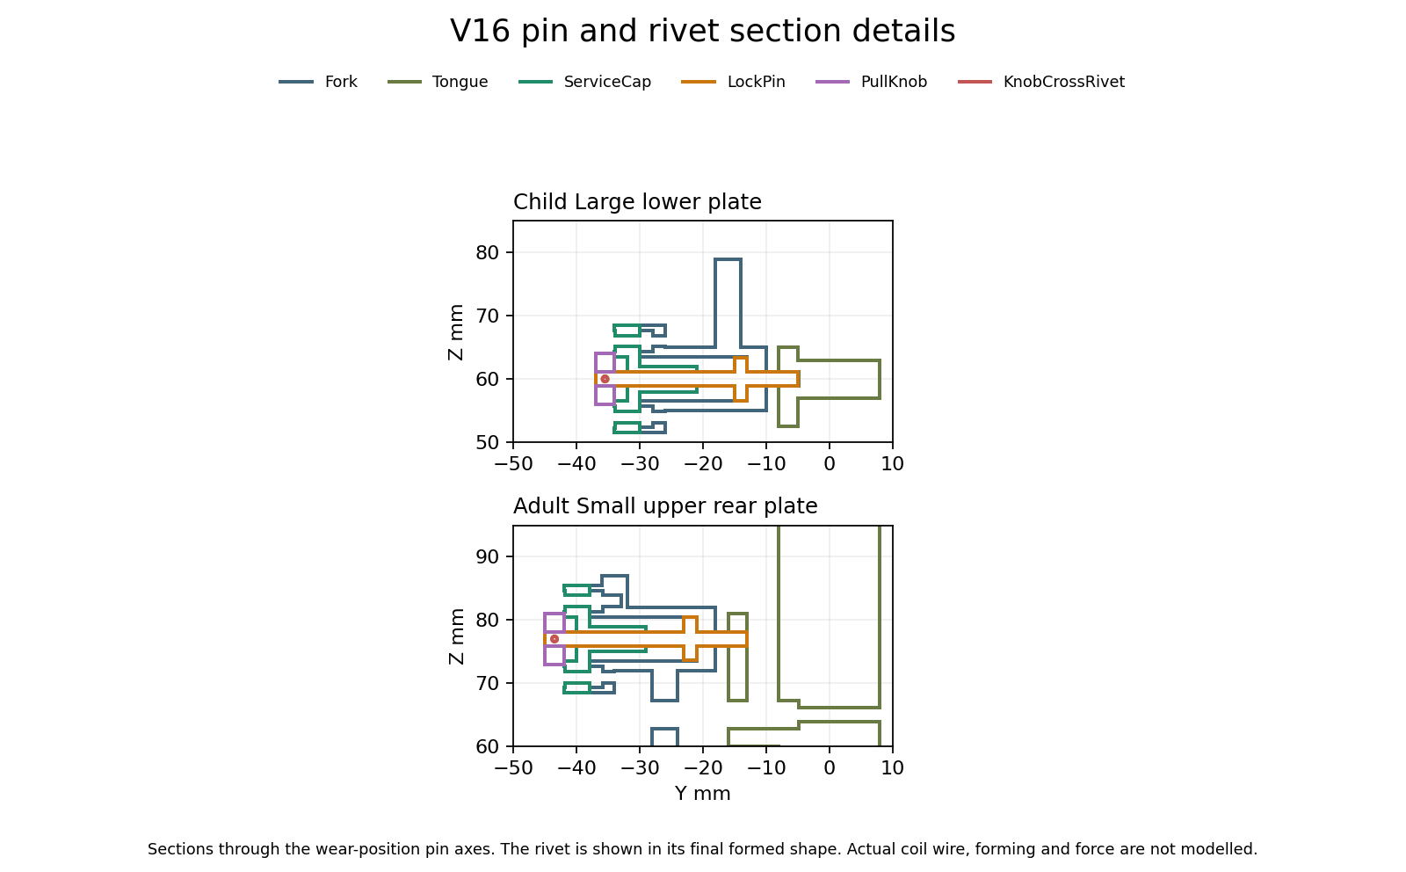
Actual sections of saved V16 wear-position geometry. Colours identify parts, not selected materials. A final formed rivet is drawn; the upsetting process and spring friction are not modelled.
The rivet shaft is 0.8 mm across, in a nominal 0.85 mm cross hole. Its formed heads are 1.2 mm across and sit in recesses. The knob bore is 2.3 mm around the 2.2 mm stem. These dimensions define positive geometric capture. Actual tolerances, metal grade, riveting tools, forming strain, wear and proof loads remain unqualified.

V16 Recorded checks and packing
Size | Sampled sequence checks | Folded box against retracted unfolded
child small | 39 | 4.88 percent smaller
child medium | 36 | 2.84 percent smaller
child large | 31 | 9.08 percent smaller
adult small | 39 | 1.61 percent smaller
adult medium | 42 | 14.60 percent smaller
adult large | 42 | 14.41 percent smaller

The six selected candidates have 229 recorded sequence samples, 276 solid-validity checks, 48 pin blocking queries and 36 rivet capture queries. The new plate query controls also use known embedded, disjoint and rotated test cubes. These are geometric checks, not force or durability results.
The sequences include slider movement, release, folding and pin return at the folded holes. At the indexed positions, an attempted one degree rotation produces pin to plate interference. Attempted rivet escape and knob withdrawal also produce interference. That supports the intended mechanical capture in rigid CAD. It does not measure holding force or prove that a spring reliably seats a real pin.
The 18 selected wear, released and folded engaged STEP exports passed independent reimport checks for solid count, validity and volume. Folded boxes were also compared with the audited poses. Native editable Fusion archives remain V10; V16 is local STEP work.

V16 Retracted and folded CAD
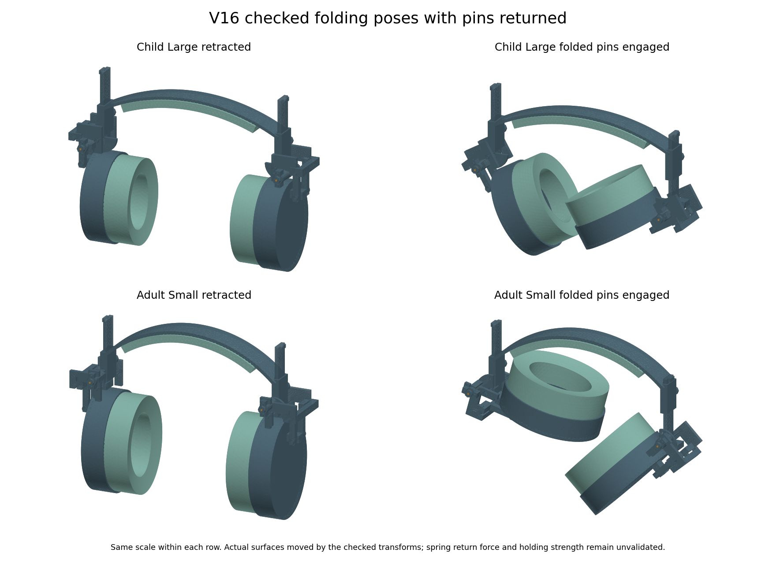
Actual selected child large and adult small surfaces with the checked rigid folding transforms. Equal scale within each row. Pins are geometrically engaged in the folded holes.
The packing figures compare a folded box with the same headset fully retracted and unfolded. They are not bag-fit or travel tests. V16 removes the held-release requirement in the checked geometry, but real spring return, finger clearance, stops outside the indexed positions and voluntary handling still need work.

V16 Component and material calculations
Fixture | Fine displacement mm | Fine sampled stress MPa | Mesh comparison
Child large lower plate | 0.5689 | 9.42 | Pass

The two final meshes change displacement by 0.23 percent and sampled peak stress by 1.95 percent. The chosen comparison limit is 5 percent. The saved-array algebra audit passed.
This child large fixture truncates the stem at the guide entrance at z 82 mm and fixes that section as an ideal rigid support. It spreads an illustrative 11.63 N tangential load over the folded hole and assumes modulus 2000 MPa and Poisson ratio 0.35. Actual guide gaps, pin bearing pressure, screw preload, friction, cap fasteners and whole joint contact are excluded. It does not qualify the different adult upper plate and support.
A first fixture fixed only the top face at z 134 mm and omitted guide support. It predicted 11.01 mm movement. That is too much bending to treat its small-displacement solution as a reliable product prediction. Its finer solve was interrupted and is not a refinement pass. The ideal guide fixture gives 0.569 mm. These different assumptions show why actual support and contact must be resolved; they are not guaranteed bounds on the real headset.
Separate adult fixture | Displacement mm | Sampled stress MPa
Adult small upper plate and neck | 0.2428 | 27.79

The adult small comparison changes displacement by 0.62 percent and sampled stress by 1.57 percent. Both meet the chosen 5 percent comparison, and the saved-array algebra audits pass. The assumed load is 10.83 N, with the same ideal z 82 support and assumed elastic material. This checks only the tongue and neck, not the relocated fork or complete joint.
Two curved high-order mesh attempts failed and are retained. The accepted adult calculations use straight-sided quadratic tetrahedra, so curved boundaries are approximated with facets. Mesh comparison does not remove that approximation or establish a product strength rating.
The first adult lower plate collided with both cup shells and liners. The first relocated housing also had its new support arm fill part of the pin and spring space. Both failures are retained. A corrected housing restores those clearances. One initial upper-plate query cube crossed an index hole, so its location was corrected before using that control. These corrections are not erased by the later passes.
Material selection still needs actual grades and samples. A BASF PA6 reference lists modulus 3500 MPa dry and 1200 MPa conditioned, with yield references 90 and 45 MPa. That is a large condition effect to account for in India; it is not a prediction for our exact weather or manufactured parts. A previously recorded POM reference is included for comparison.
BASF Ultramid B3S product data
The new screen records 45 nominal plate-load cases and 15 cross-drilled stem pull cases. The plate calculation uses bearing and a minimum-ligament proxy with chosen peak multipliers. The stem calculation uses its central remaining area and an assumed multiplier. Neither is a complete joint stress model or a qualified material rating.

V16 Cushion data and physical test records
Two published thin PORON battery-pad curves add more compression information than a single stiffness number. Only 12 of 36 assumed flat-area load cases fall within their published 20 to 70 percent strain range. We leave the other 24 without a predicted strain. These 0.85 to 3 mm grades cannot establish the behaviour of our shaped 20 mm cushion, cover, glasses seal or wearer comfort.
Rogers published compression curves
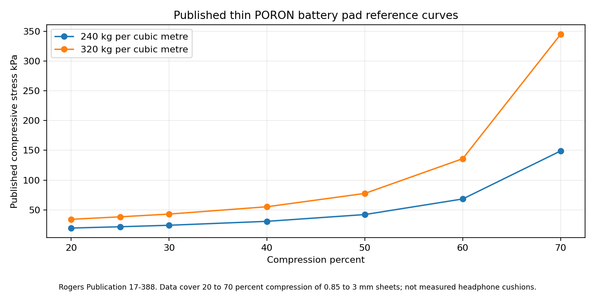
Manufacturer reference data for thin sheets. No low-pressure extrapolation or manufactured headphone result is claimed.
Seven blank CSV record templates are prepared for Sony measurements, foam and cover calibration, band and joint measurements, acoustic comparisons, wearer feedback, durability and supplier quotes. Their result cells are empty. The geometry quote BOM lists net CAD volumes and flags spring spaces as allocations that must not be priced or weighed as solid parts.
Draft durability screens include 5000 folding and slider cycles, 1 m drops in six orientations and 24 hours at 45 C and 85 percent relative humidity. These are proposed engineering targets to review before testing, not a standard, a completed test or a service-life claim. Real samples and instruments are still required.
Acoustic work must compare original and candidate seating with the same fixture and glasses frames. Incoming noise and outgoing playback are separate tests. For outgoing music, match measured internal playback level before comparing external sound and report uncertainty. No leakage or ANC benefit is established by CAD.
No physical test has been performed in this update. Comfort and sensory acceptance require voluntary wearer feedback. Production cost requires real quotes including forming, tooling, assembly, inspection, scrap, packaging and distribution. The product remains a prototype candidate, with complete joint strength, actual materials, manufacturing tolerances and physical validation unfinished.

V16 Joint clearance and manufacturing errors
The 2.3 mm index hole and 2.2 mm pin leave only 0.05 mm of radial clearance. A nominal geometry pass is therefore not enough to establish reliable assembly or spring return. Both documents now record this manufacturing constraint; the CAD has not changed in this update.
Interface | Nominal radial clearance mm
Index hole and pin | 0.050
Cross drill and rivet shaft | 0.025
Knob bore and stem | 0.050
Rivet head recess and head | 0.050
The bounded-error screen records 600 index scenarios across six sizes and 100 other interface scenarios. Only 57 index scenarios retain a positive worst-case clearance. These are deliberately chosen error combinations, not random samples, supplier capabilities or a predicted factory yield. Losing a worst-case guarantee does not mean every real part fails.
A separate check on the saved solids ran 60 pin-to-plate offset queries. At both sides of all six sizes, 0.04 mm sideways offset stays clear and 0.06 mm produces interference, agreeing with the nominal radial clearance calculation. This checks only the wearing-position pin and tongue; it excludes the guide, cap, spring and actual manufactured surfaces.
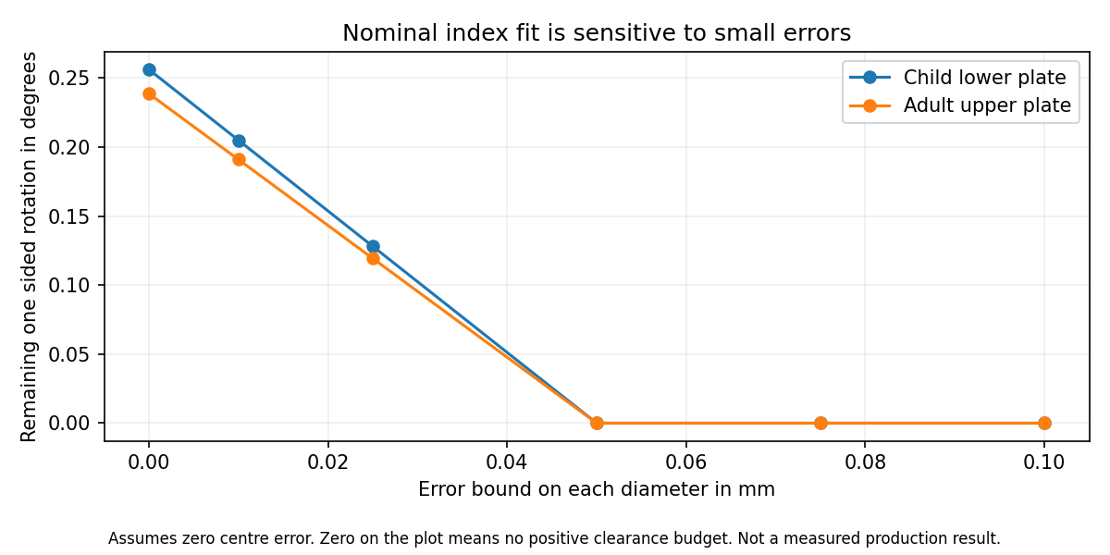
Calculated clearance budget with no centre error. The zero line includes contact and interference; it is not a measured performance curve.
With no dimensional or alignment error, the index clearance allows about 0.256 degrees of rotation each way for the child plate and 0.239 degrees for the adult plate before contact. This is only the index-hole contribution. Pivot clearance, guide play and elastic movement add their own effects.
For example, opposite diameter errors of 0.025 mm on both parts reduce the available radial clearance to 0.025 mm. A further 0.025 mm centre error uses all of it, even before angular error, surface roughness or swelling. The rivet cross hole has a smaller starting clearance and needs its own process decision.
The next mechanism change must balance easier pin entry against rotational looseness. Larger holes, an entry chamfer, a guided or compliant pin and tighter alignment control are candidates to compare. None is selected or qualified here. We still need real manufacturing capability, spring return force, friction, contamination and cycle measurements before approving tolerances.

V17 Pin entry trials
Project status: V17 two size entry pilots with V16 six size candidates and V10 native archives.
V16 exposed a small clearance budget at the locking index. V17 changes only the child large and adult small pilots. Their index holes grow from 2.3 to 2.5 mm. A 0.3 mm entry cone opens to 3.1 mm at the rear face. The straight bearing land becomes 2.7 mm long instead of 3 mm. The pin, cap, housing and spring space are unchanged.
Hole mm | Radial clearance mm | Child and adult play each way in degrees | Child and adult remaining margin mm
2.3 | 0.050 | 0.256 / 0.239 | -0.0945 / -0.0959
2.4 | 0.100 | 0.512 / 0.477 | -0.0445 / -0.0459
2.5 | 0.150 | 0.769 / 0.716 | 0.0055 / 0.0041
2.6 | 0.200 | 1.025 / 0.955 | 0.0555 / 0.0541

The comparison assumes opposite diameter errors of 0.025 mm on each part, a relative centre error of 0.1 mm and an angular error of 0.1 degrees, aligned unfavourably. These are chosen comparison inputs, not supplier capability or approved requirements. The 2.5 mm option is the smallest of the four tested diameters with positive margin in both layouts. Its remaining margin is only about 0.0055 and 0.0041 mm. It is an experiment, not an optimised final size.
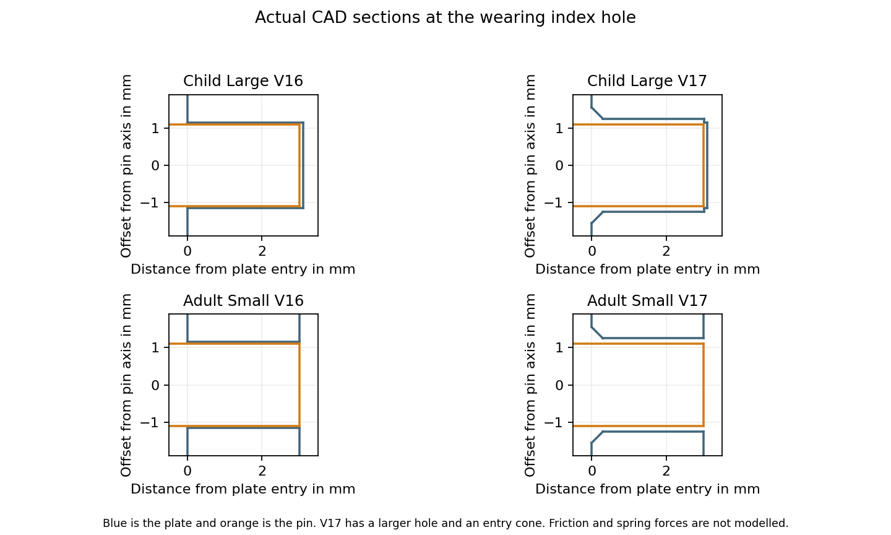
Actual sections through the wearing pin axes. The picture shows the local entry and straight land, not spring centering or a measured return force.

V17 Recorded geometry and component checks
Pilot | Sequence samples | Valid solids
child large | 31 | 46
adult small | 39 | 46

The two pilots passed 70 sampled adjustment, release, folding and pin-return poses. The records also include 16 attempted index rotations and 12 retention escape queries, which produced the intended geometric blocking. Both saved STEP files passed independent reimport and per-part volume checks. This is not a continuous motion, assembly-force or durability pass.
The 24 local entry queries agree with the intended geometry. A fully inserted pin with 0.14 mm sideways offset stays clear, while 0.16 mm causes interference. An offset tip can enter the wide mouth but then collide deeper in the cone or straight land. The chamfer does not by itself make a misaligned pin seat.
Separate tongue fixture | Fine displacement mm | Fine sampled stress MPa | Mesh comparison
child large | 0.5658 | 9.18 | Pass
adult small | 0.2408 | 27.61 | Pass

These are separate ideal component fixtures. Each stem is truncated and fixed at z 82 mm, with assumed modulus 2000 MPa and Poisson ratio 0.35. The assumed folded-hole load is 11.63 N for child large and 10.83 N for adult small. It acts only on the straight hole land. Straight-sided quadratic tetrahedra approximate curved surfaces with facets. The entry cone has no centering force or friction model. Mesh comparison and saved-array checks do not qualify the complete joint or actual material.
The wider hole triples the nominal radial clearance but also triples the index contribution to rotational play. The shorter straight land reduces the area available for bearing. The unchanged housing and cap still guide the stem through smaller clearances, and their alignment remains a separate constraint. We have not established real spring return, tolerance capability, wear, contamination resistance, pinch clearance or child access.
V17 has two local STEP pilots only. V16 remains the latest six size CAD candidate and native Fusion archives remain V10. Previous whole-headset and material screens do not automatically transfer to the changed plates. Physical sound reduction, wearer comfort, sensory acceptance, durability and cost remain unvalidated.

V17 Loaded pin contact and spring return
The latch is on hold for production. Unloaded geometry and component mesh passes do not establish reliable pin return when the joint carries a sideways load. The new calculation bends a 2.2 mm pin against two guides with a gap and elastic wall contact. It is a one plane beam model, not full three dimensional joint contact.
The guide surfaces were extracted from both saved pilot solids. In common local coordinates, the rear guide runs from y minus 32 to minus 21 mm, and the front guide from minus 12.999 to minus 10 mm. The folded hole load acts at y minus 6.35 mm. The assumed elastic modulus is 193000 MPa. Guide stiffness, clearance and external load are varied; their actual manufactured values are not known.
Ninety contact cases passed their force and moment balance checks. Controls include an exact overhanging beam example, reversed loading and three meshes for each layout. The selected mesh comparisons pass the chosen 5 percent limit. An initial mesh created a very short near duplicate interval and poor conditioning; accepted results use a corrected mesh split at each geometric boundary.
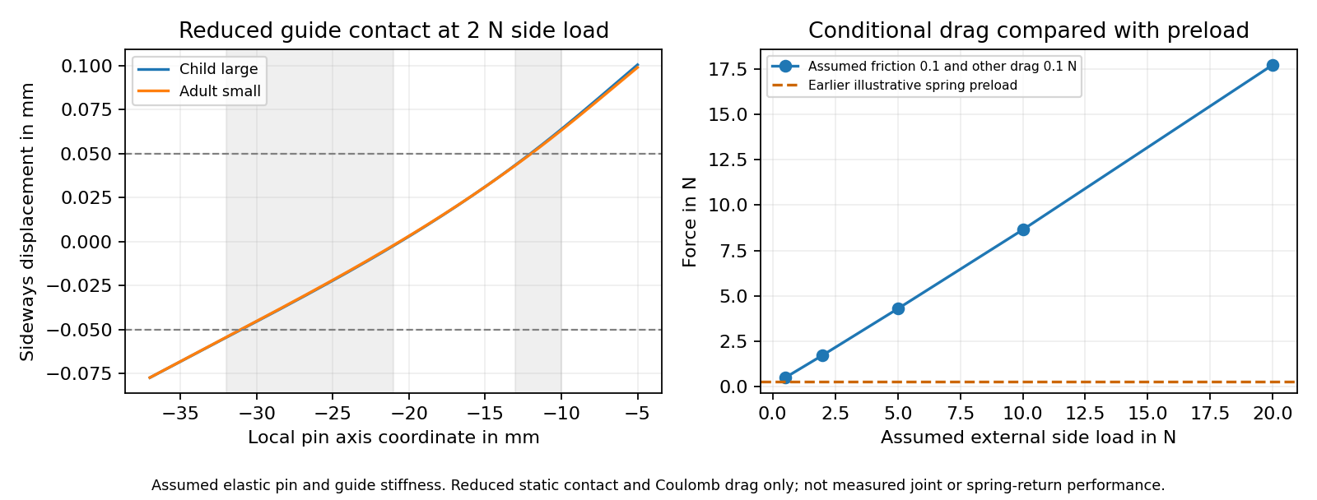
Reduced static contact and assumed Coulomb drag. The plot is a diagnostic calculation, not a measured return force or physical joint rating.
Chosen comparison at 2 N side load | Force N
Earlier illustrative spring preload | 0.290
Guide drag at friction 0.1 plus other drag 0.1 N | 1.864
Guide drag at friction 0.3 plus other drag 0.1 N | 5.391

The 1080 drag and preload comparisons have 180 positive assumed margins. That count is not a probability or a predicted factory yield. Sliding drag is estimated from static guide reactions; no actual withdrawal or return path, surface pressure, collar, cross hole or chamfer centering is solved. The result identifies a risk to measure, not a proven failure in a real product.

V17 Spring trade offs and completion decision
The 300 alternative spring designs vary wire diameter, coil diameter, active turns and free length. The screen also includes assumed dimensional errors, a 10 percent rate range, 1.5 mm permanent length loss, a 0.5 mm reserve above solid height and an approximate coil diameter increase. Typical 301 full hard wire data are a reference, not a manufactured spring allowable.
Ulbrich 301 wire reference data
Lee Spring design considerations
Sixteen designs meet the chosen envelope, static reference, return and pull criteria with zero guide friction. None meets them all at assumed guide friction of 0.1, 0.3 or 0.6 under the 2 N side load comparison. The 3 N pull limit is an illustrative engineering choice; it has not been approved by autistic users or established as a comfort or dexterity threshold. This finite search does not prove that every possible spring or latch architecture fails.
The spring CAD is still a space reservation. No actual coil ends, spring seating, lateral stability, fatigue or manufacturing process has been qualified. A coupled three dimensional joint analysis needs credible materials, friction, support stiffness, fasteners, torque and load requirements. Additional arbitrary simulations cannot establish those missing inputs.
Workstream | Current status | Evidence still needed
Six size geometry | V16 sampled checks pass | V17 is two pilots only; native Fusion remains V10
V17 component and reduced contact models | Chosen numerical checks pass | Complete joint and actual material correlation
Loaded spring return | Production hold | Measured pull, return, drag, spring rate and set
Headband and full worn fit | Conditional studies only | Actual clamp force, heads and contact materials
Foam cover and glasses zone | Reference screens only | Compression recovery, stretch, friction and actual frames
Sound reduction and outgoing leakage | No physical pass | Matched acoustic tests with repeated seating
Comfort heat and sensory acceptance | No physical pass | Voluntary feedback and climate measurements
Drop cycles cleaning and ageing | Not performed | Actual assembled samples and reviewed test loads
Sony WH CH720N fit | Measurements deferred | Original mounting dimensions and host comparisons
Manufacturing and final price | Not released | Process capability, assembly proof and supplier quotes

The package includes a 28 workstream completion matrix and blank measurement records. The recorded assessment is complete; the whole product is not. The next step is to measure pin return and guide drag with actual parts, then decide whether to change the spring, guide or latch architecture. Material calibration and Sony mounting measurements must precede model specific and physical performance claims.

V18 A different folding hinge
Project status: V18 six size passive hinge candidates with V10 native archives.
V18 is our latest six size local STEP candidate. It replaces the sliding locking pin with a passive friction hinge and a separate stop at the wearing angle. The old pin return problem is removed from this mechanism. A different set of questions now matters: actual hinge torque, stop strength, wear, creep and fastener retention. None has a physical pass yet.
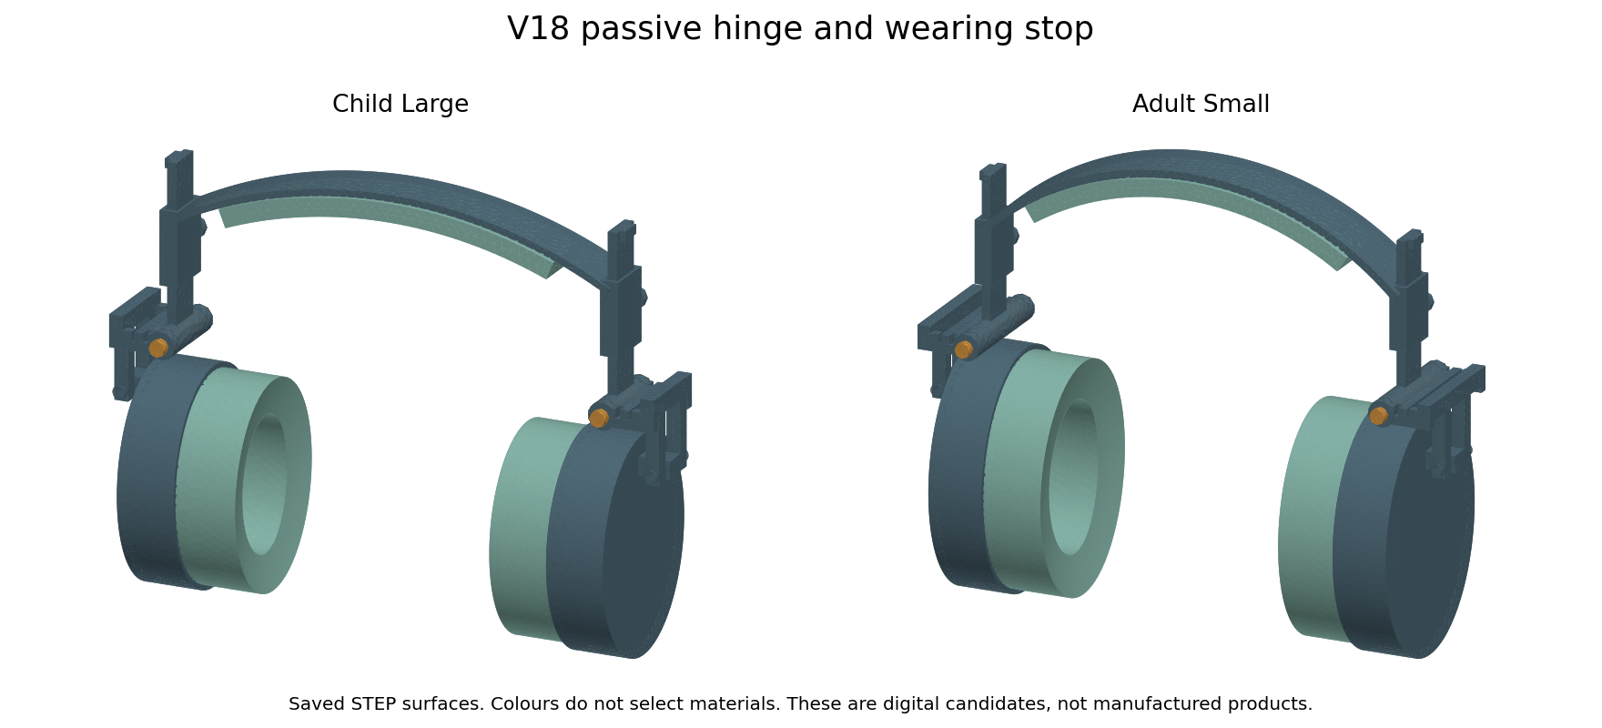
Actual child large and adult small STEP surfaces. Colours show parts, not chosen materials. Native editable Fusion archives remain V10.
The stop supports outward cup rotation at the wearing angle. Folding inward moves the fork away from that stop. Friction is intended to hold the chosen angle. This is not a positive lock against every load direction, and an inward force can still fold the cup. We must test unwanted folding and handling before calling it suitable for a wearer.

V18 Geometry and rejected trials
Size | Pose samples | Retracted box mm | Folded box mm
adult large | 35 | 276.1 x 90.0 x 191.8 | 258.3 x 90.0 x 172.0
adult medium | 35 | 259.9 x 90.0 x 191.8 | 242.1 x 90.0 x 172.0
adult small | 32 | 243.4 x 90.0 x 191.8 | 229.3 x 90.0 x 194.6
child large | 26 | 242.6 x 77.2 x 181.1 | 239.7 x 77.2 x 171.9
child medium | 29 | 232.1 x 77.2 x 181.1 | 227.6 x 77.2 x 187.1
child small | 32 | 220.9 x 77.2 x 181.1 | 211.9 x 77.2 x 187.1
All six candidates have 38 valid solids. Together they pass 189 sampled rigid poses and 24 outward stop queries. Eighteen saved wearing, retracted and folded STEP files were independently reimported and checked for solid count, validity, volume and pose bounds. These checks do not establish continuous clearance under load, safe finger gaps or durability.
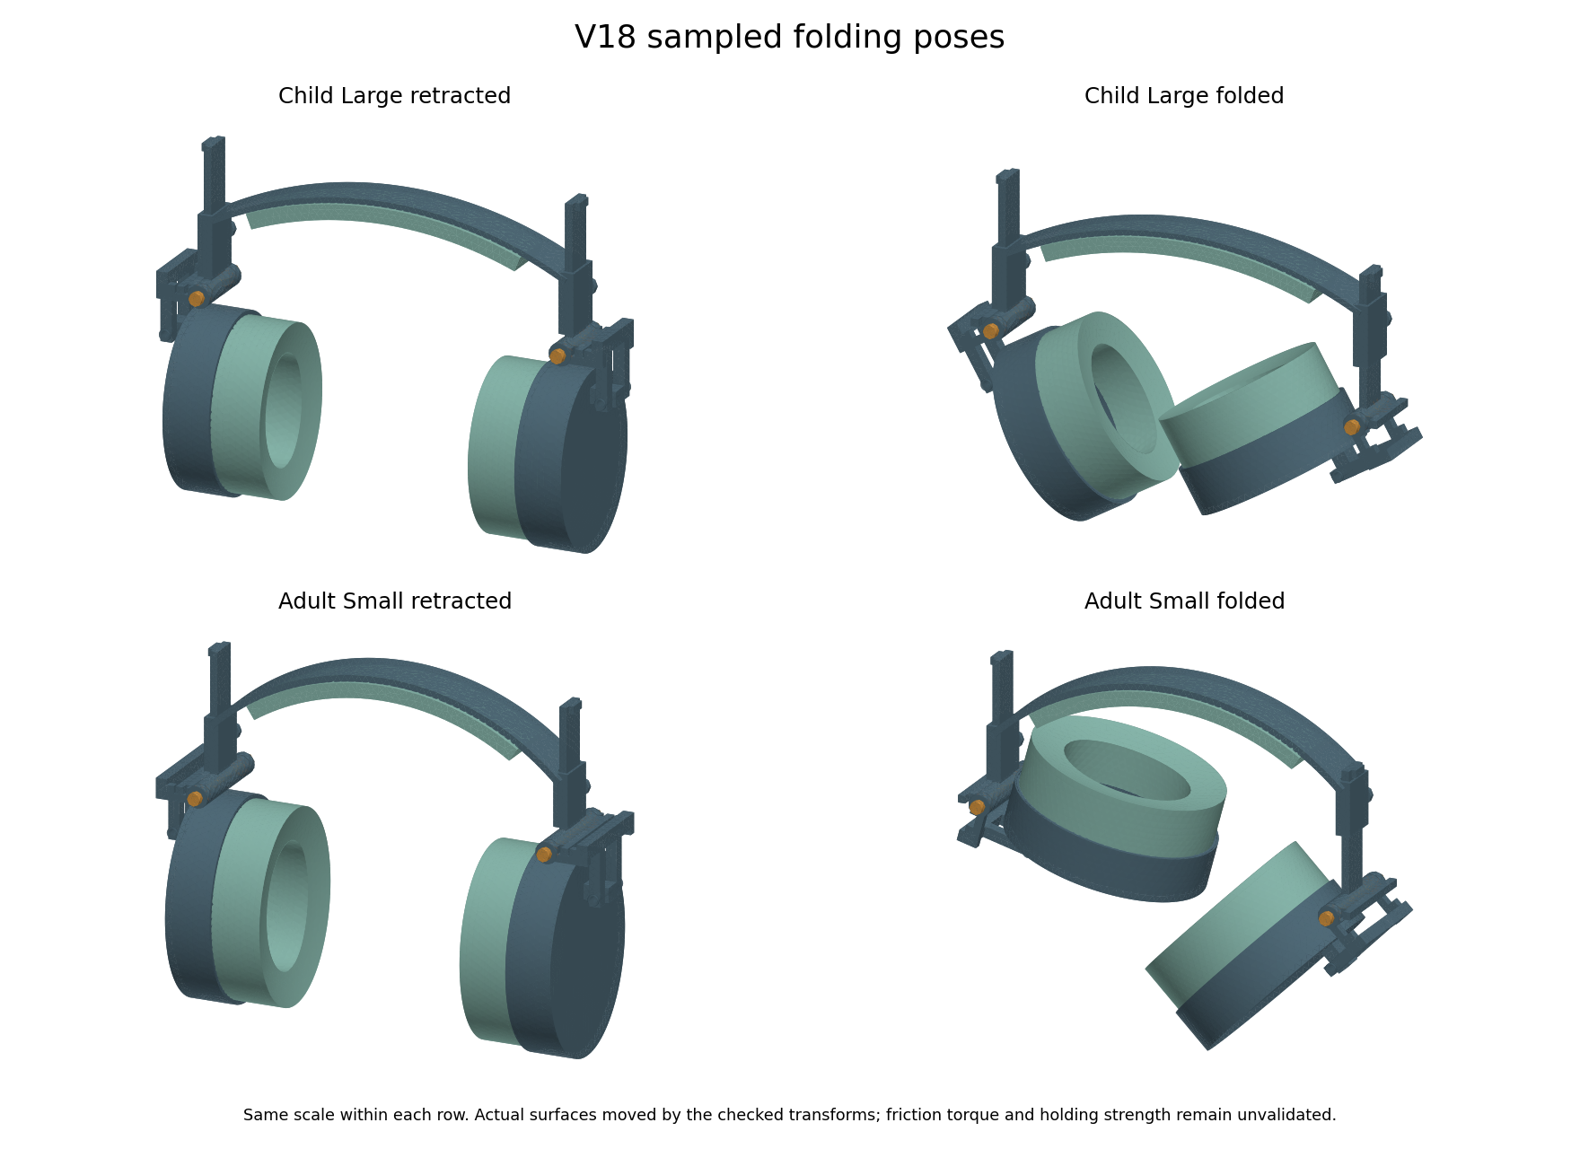
Actual saved surfaces moved by the checked transforms. Same scale within each row. Folding angles and slider positions differ by size.
The first stop relief collided after 5 degrees of folding. We retained that failed trial and widened the relief. The first adult layout also touched the cup shell; raising its hinge by 3 mm cleared the tested contact. Its guide bottom moved from z 82 to 85 mm to provide clearance at the shortest setting. The final rigid motion checks use these corrected parts.
Folding is available, but its packing benefit varies. The band and protruding sliders limit the envelope, and the smallest child version has only a small bounding box reduction. A box comparison is not a carrying test or an optimised travel design. The rigid surfaces also do not represent actual fabric texture.

V18 Torque and the wearing stop
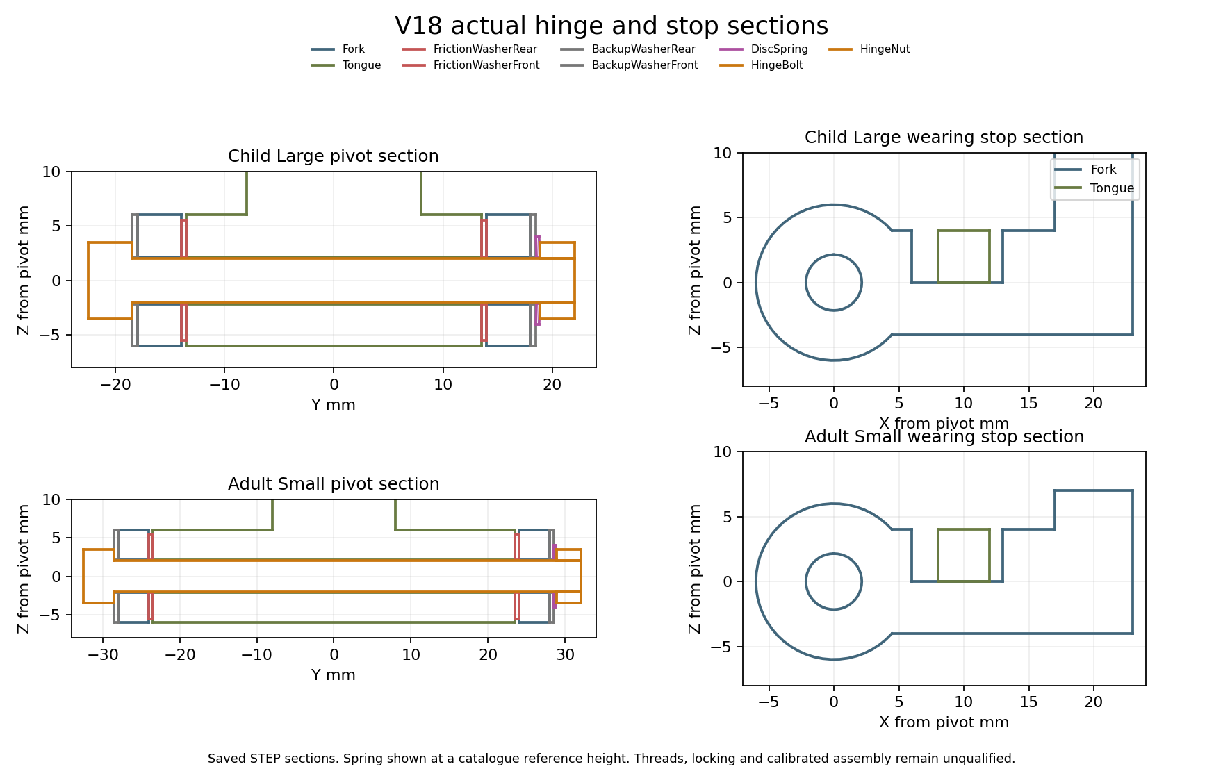
Sections of actual saved hinge and stop solids. The spring is at a reference catalogue height; the nut and bolt use thread envelopes.
Each hinge has two friction washers, backup washers, a disc spring, a bolt and a nut. The two stop patches total 32 square mm. The proposed spring reference is SCHNORR 000600 B, with 8 mm outside diameter, 4.2 mm inside diameter and 0.3 mm thickness. The catalogue gives a calculated force of 118 N at about 0.188 mm shortening. This is a reference point, not a purchased component or a measured preload.
SCHNORR manufacturer catalogue reference
A fixed nut position cannot guarantee the same hinge torque when friction changes. Our proposed assembly target is 80 Nmm with a chosen 20 percent window, or 64 to 96 Nmm. We would measure the hinge torque directly, adjust it and qualify a locking method. Tightening torque at the nut is not a substitute. No actual calibrated assembly has been made.
At a 65 mm grip lever the upper target corresponds to about 1.48 N; at 50 mm it is 1.92 N. These are engineering comparisons, not comfort or dexterity thresholds for autistic people. We have no spring force curve from which to infer the correct nut position or installed height. The CAD spring height therefore remains a catalogue reference pose.

V18 What the numerical checks mean
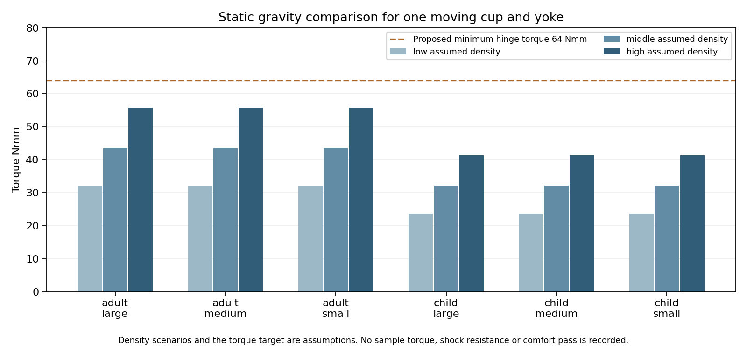
Maximum static gravity moment over orientation for each assumed density scenario. This is not a measured mass or hinge holding result.
The 18 density scenarios use the saved moving cup, pad and yoke volumes and centres of mass. Their largest calculated gravity moment is 55.77 Nmm, below the proposed minimum of 64 Nmm. With assumed friction from 0.1 to 0.3, the target preload falls within the comparison spring capacity. At friction 0.05 the comparison fails. We have not measured the friction pair, torque drift, shock resistance or resistance to accidental folding.
Ideal stop fixture | Displacement mm | Sampled stress MPa | Chosen mesh gate
child large | 0.1635 | 3.53 | Pass
adult small | 0.1787 | 3.78 | Pass

The stop fixtures apply a total of 13 N over both patches, representing an illustrative 2 N side force at a 65 mm lever and a 10 mm stop radius. Each stem is cut and fully fixed at the guide bottom. The assumed elastic modulus is 2000 MPa and Poisson ratio is 0.35. These separate fixtures omit actual pivot load sharing, guide contact, bolt preload and fork contact. They do not qualify complete joint strength.
The two tongue and fork shapes in each size family were checked for equal geometry after translation. That allows a listed component fixture to be shared within its family. A Boolean equality query did not establish child band identity, so we independently reran the band fixtures for every size instead of transferring an old result.

V18 Headband checks and the next decision
Band fixture | Guide movement mm | Sampled stress MPa | Last stress change
adult small | 2.798 | 2.52 | 3.78%
adult medium | 2.994 | 2.90 | 3.86%
adult large | 3.189 | 3.19 | 2.82%
child small | 3.473 | 2.41 | 0.99%
child medium | 3.679 | 3.47 | 0.12%
child large | 3.862 | 2.59 | 0.08%

Every band is loaded by 2 N at one guide end with ideal symmetry and crown datums. It is a separate elastic fixture with assumed modulus 2000 MPa and Poisson ratio 0.35. The selected final comparisons meet the chosen 5 percent displacement and sampled stress gates. The saved arrays also pass work and energy, force balance, fixed displacement, finite value, residual and positive element checks. Numerical datums do not model a real scalp, and sampled stress is not a material strength allowable.
Comparison | What V18 adds | What remains unknown
V17 sliding pin | Avoids the loaded pin return mechanism | Friction torque and stop retention need samples
Ordinary folding headphones | Six saved adjustable sizes and a proposed calibrated hinge | No better durability, comfort or size claim
Existing sensory earmuffs | Passive cup and soft zone concept with no generated audio | No measured attenuation or sensory acceptance advantage
Specialist glasses pads | Standalone pad learning can be shared | Sony mount and actual pressure and acoustic comparisons still needed

The digital prototype package is ready to guide the next experiments. The complete product is not finished or released for manufacturing. We still need actual foam compression and recovery, cover stretch and friction, selected structural materials, measured headband and hinge forces, assembled joint tests, drop and cycle tests, pressure and climate measurements, voluntary wearer feedback and repeated acoustic tests. Earlier finite material screens are not a test of every possible material.
For the Sony route, measure the original mount before making a model specific pad. Compare the original, a uniform new pad and our softer zone pad under the same measured conditions. No zero leakage, pain relief, universal fit, market superiority or lowest price claim is supported. Supplier quotes and verified production processes are still needed. Both reports retain the earlier results and failures and will be updated together when measured evidence is added.

V18 Final component checks
The fork between the cup and folding hinge now has its own component test. This adds evidence for a part that was missing from the earlier V18 fixtures. It does not replace the complete joint, worn fit or acoustic tests.
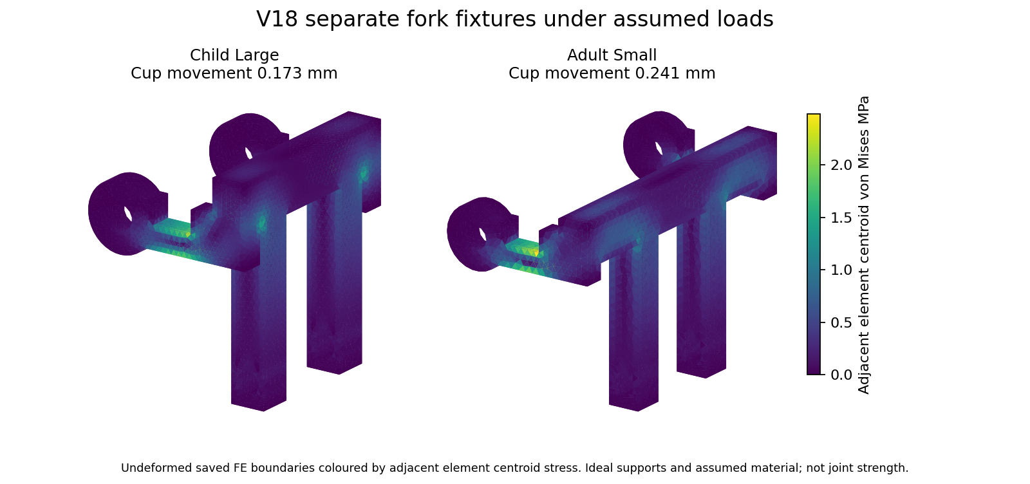
Actual saved finite element boundaries. Colours show adjacent element centroid stress on the undeformed fork; they are not measured surface stress.
Fork fixture | Cup movement mm | Sampled stress MPa | Last stress change | Chosen mesh gate
child large | 0.1727 | 2.49 | 2.37% | Pass
adult small | 0.2410 | 2.47 | 4.57% | Pass

The two pivot bore surfaces are fully fixed. A uniform total force of 2 N acts along X on the two cup pin bores. Downward forces of about 4.8 N in the child fixture and 5.4 N in the adult fixture act over the two stop patches. These loads balance the moment around the folding axis. They are a different load case from the earlier 13 N tongue stop fixture and must not be combined as if they solved one assembly.
The material is still assumed: elastic modulus 2000 MPa and Poisson ratio 0.35. Straight sided quadratic tetrahedra approximate the curved surfaces. Actual bearing pressure, bolt preload, washer friction, guide flexibility and stop contact are not solved. Numerical support reactions are not real pressure measurements.

V18 Testing decision and remaining inputs
The current V18 component assessment is recorded. There are now 30 saved solver array audits across the band, tongue stop and fork fixtures. Source hashes, work and energy, force balance, fixed displacements, finite values, residuals and positive elements were checked. A mesh comparison pass means that selected calculated outputs changed by less than our chosen limit. It does not mean that a real product passed a strength or comfort test.
The first child fork stress comparison exceeded the chosen 5 percent limit. A finer mesh was added and the final comparison is reported above. The earlier result remains in the evidence. Refinement was used to check this particular output, not to certify every local stress or remove the need for a physical test.
Work still needed | Input or test needed | Status
Complete joint contact and strength | Measured materials, friction, bolt preload and guide/pin support behaviour | Not established
Hinge torque drift and fastener retention | Actual assembled hinge and torque measurements | Not performed
Foam cover and structural materials | Actual grade-specific samples and compression recovery stretch creep friction data | Not validated
Worn force and pressure | Known head/fixture geometry and measured headband force and pad behaviour | Not validated
Incoming attenuation and outgoing leakage | Physical acoustic fixture or laboratory and repeated seating with and without glasses | Not performed
Heat humidity and sensory acceptance | Actual climate measurements and voluntary user feedback | Not performed
Durability and child handling | Reviewed loads, assembled samples, cycle/drop/cleaning/retention and pinch assessments | Not performed
Sony WH CH720N fit | Deferred original pad and mounting dimensions, then physical host comparisons | Not established
Final cost and production capability | Chosen processes, tolerances, supplier quotes and sample yield | Not established

The next useful step is a measured bench prototype, followed by corrected material models and assembled tests. We cannot honestly mark sound reduction, leakage, comfort, heat, fatigue or sensory acceptance as passed using the current unknown properties. Complete joint contact and manufacturing details also remain open. This is not a finished or released product.
Both reports share this decision. The separate Sony WH CH720N cushion remains a generic candidate until the original pad and mount are measured. No acoustic or comfort advantage over market products has been demonstrated.

V18 Final material and clearance screens
This is the final bounded screen on the current V18 geometry. It adds 500 material and load comparisons, 288 pivot clearance scenarios and 216 equivalent acceleration comparisons. These are calculated scenarios, not 1004 physical tests. All six saved CAD candidates were also measured for the hinge stack. No real part or Sony headphone was measured.
Recorded material reference | Modulus MPa | Ideal load for the reference band movement N
TECARAN ABS grey | 1700 | 1.70
TECAFORM AH natural POM C | 2800 | 2.80
TECAMID 66 natural PA66 | 3500 | 3.50
TECARAN ABS natural ASTM | 2758 | 2.76
TECADUR PET natural | 3300 | 3.30
TECAPEEK natural | 4200 | 4.20
Makrolon 2458 PC | 2400 | 2.40
Moplen HP500N PP | 1480 | 1.48
301 stainless annealed reference | 193000 | 193.00
301 stainless full hard reference | 193000 | 193.00

The ten grade records come from the saved 14 October reference study. Their source links and date are retained in the CSV. We reused the latest band, tongue stop and fork results. At the same applied force, the ideal movement changes inversely with stiffness. At the same imposed movement, the force rises with stiffness. The table uses the movement produced by 2 N in the original 2000 MPa band fixture. It is not a measured force on a wearer.
The scaling keeps Poisson ratio at 0.35 for every reference and assumes the same linear elastic geometry and supports. The PP value is a flexural proxy. The steel references concern wire data, not qualified formed strip. We did not change full assembly mass or simulate actual creep, fatigue, anisotropy, cover or foam behaviour. No material winner or manufacturing allowable is established.
The nominal 4 mm bolt in a 4.3 mm pivot bore has 0.15 mm radial clearance. The screen varies diameter error, relative axis error and radial swelling or coating. 192 of 288 scenarios retain positive calculated clearance. This count is not a factory yield or reliability probability. The other scenarios show that chosen adverse error bounds can consume the nominal clearance; supplier capability remains unknown.
All six saved CAD stacks show a nominal nut height of 3.2 mm and no bolt tip protrusion beyond the nut. Moving the nut outward as the reference disc spring relaxes gives about 3.01 mm overlap between the nominal solid envelopes. This is not a thread engagement or bolt strength pass. Real thread ends, shoulder length, locking, tolerances and calibrated spring position still need an assembly design and proof.

V18 Retention result and end of screening
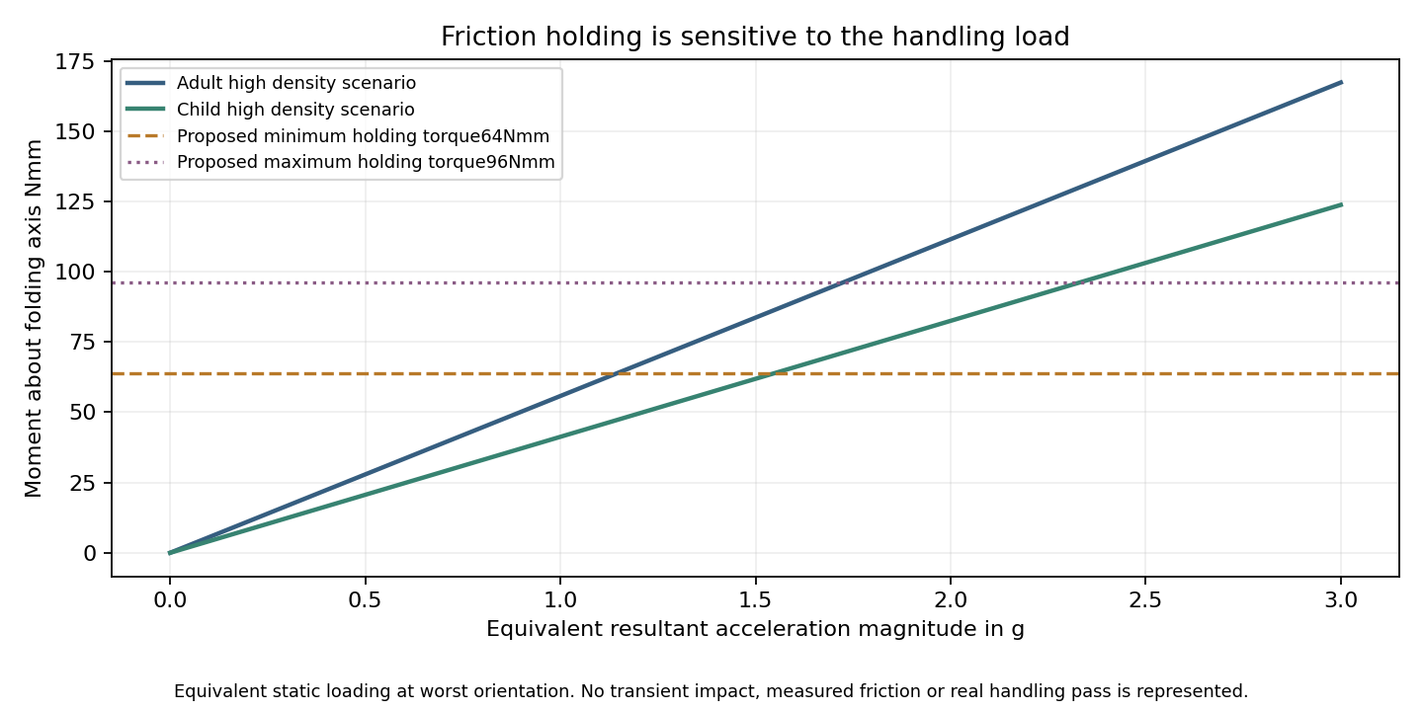
Calculated demand under equivalent static acceleration and the proposed unmeasured hinge torque targets. This is not a drop or impact simulation.
The earlier gravity check used one g. With the worst assumed moving mass and orientation, the proposed minimum torque of 64 Nmm is exhausted at about 1.15 g of equivalent resultant acceleration. Some 1.5 g scenarios therefore exceed that target. The hinge permits inward folding by design. Static gravity holding does not establish resistance to accidental folding during carrying or movement.
This is a risk found by a conditional calculation, not a measured failure of an assembled headphone. The calculation does not include a time history, inertia driven rotation, damping, friction changes or a retaining case. We need actual breakaway and running torque, ageing and handling measurements before choosing or changing the holding target. It would be misleading to call the headset durable or safely retained from these results.
Current evidence | Decision
Rigid CAD and saved poses | Recorded numerical checks completed
Band tongue and fork fixtures | Chosen component mesh comparisons completed under assumptions
Material clearance and retention screens | Completed finite scenarios with known limitations and retention risk
Complete joint contact and manufacturing | Still requires credible material contact and assembly inputs
Acoustics heat comfort and durability | Still requires physical measurements and assembled tests
Sony WH CH720N fit | Original pad and mount measurements are deferred

The available data screening is now recorded. The product validation phase has not passed. The next useful step is to select and measure actual material samples and make a bench assembly, then calibrate the models against it. More arbitrary inputs would not measure sound reduction, leakage, comfort or material life. There is no manufacturing release or demonstrated advantage over market headphones.

V19 Prototype assembly and next decision
Project status: V19 six size assembly prototype with conditional joint calculations and V10 native archives.
V19 keeps the six adjustable sizes and changes the hinge hardware. Each hinge now has two nested disc springs, a longer proposed pin and a second nut. The final local STEP assemblies contain 42 solids each. The current geometry is a prototype for review. Native editable Fusion archives remain V10. No physical material, sound, comfort or durability test has been performed.
Actual final V19 STEP surfaces for child large and adult small. Colours identify parts and do not select materials.
The exact helical thread experiment was rejected. A validity check initially passed, but the pin contained two disconnected solids and the Boolean operation lost its core. We kept the failed trial and excluded it from the final assemblies. Current fasteners use cosmetic thread envelopes and proposed M4 x 0.7 drawing callouts. Thread strength, drive, runout, tolerances and effective locking still need supplier and bench review.

V19 Folding and holding tradeoff
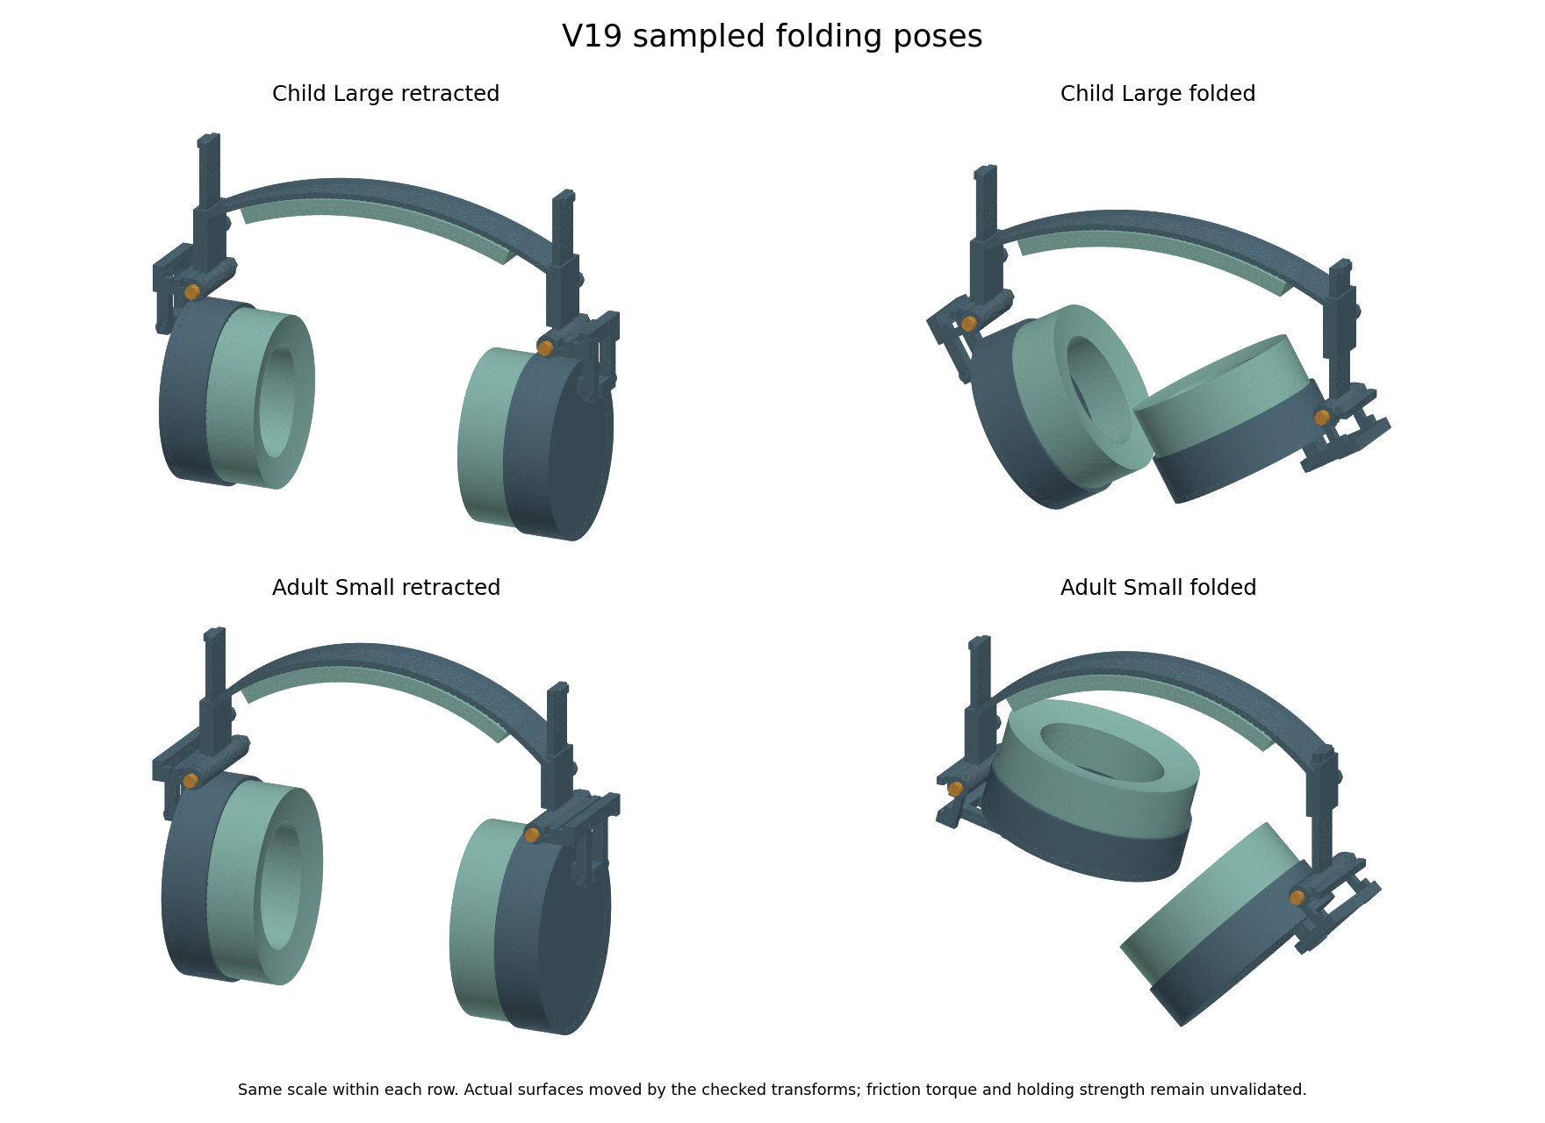
Saved V19 retracted and folded surfaces. Sampled collision checks do not establish continuous motion clearance, wrench access or handling strength.
The revised geometry has 189 recorded rigid pose samples and 24 outward stop queries across six sizes. The 18 saved wear, retracted and folded pose exports were separately reimported and checked. These are geometry checks, not wear or fatigue tests.
Prototype hinge detail | Nominal proposal
Plain pin diameter and pivot bore | 4 mm and 4.3 mm
Child pin underhead and plain shoulder | 45 mm and 37 mm
Adult pin underhead and plain shoulder | 65 mm and 57 mm
Thread callout and length | M4 x 0.7 for 8 mm; cosmetic CAD thread
Primary nut and jam nut heights | 3.2 mm and 2.2 mm; both 7 mm across flats
Nominal pin tip beyond both nuts | 1.9375 mm before tolerances
Disc pair reference height and force | 0.6625 mm and 236 N at catalogue reference shortening

Two nuts are proposed for countertightening while holding the primary nut. We still need to prove access with real tools and remeasure hinge torque after locking. The disc reference position is not a measured assembly setting. A nominal radial clearance budget leaves 0.06 mm after chosen diameter, axis and growth errors. Supplier capability has not been demonstrated.

V19 Retention and folding effort
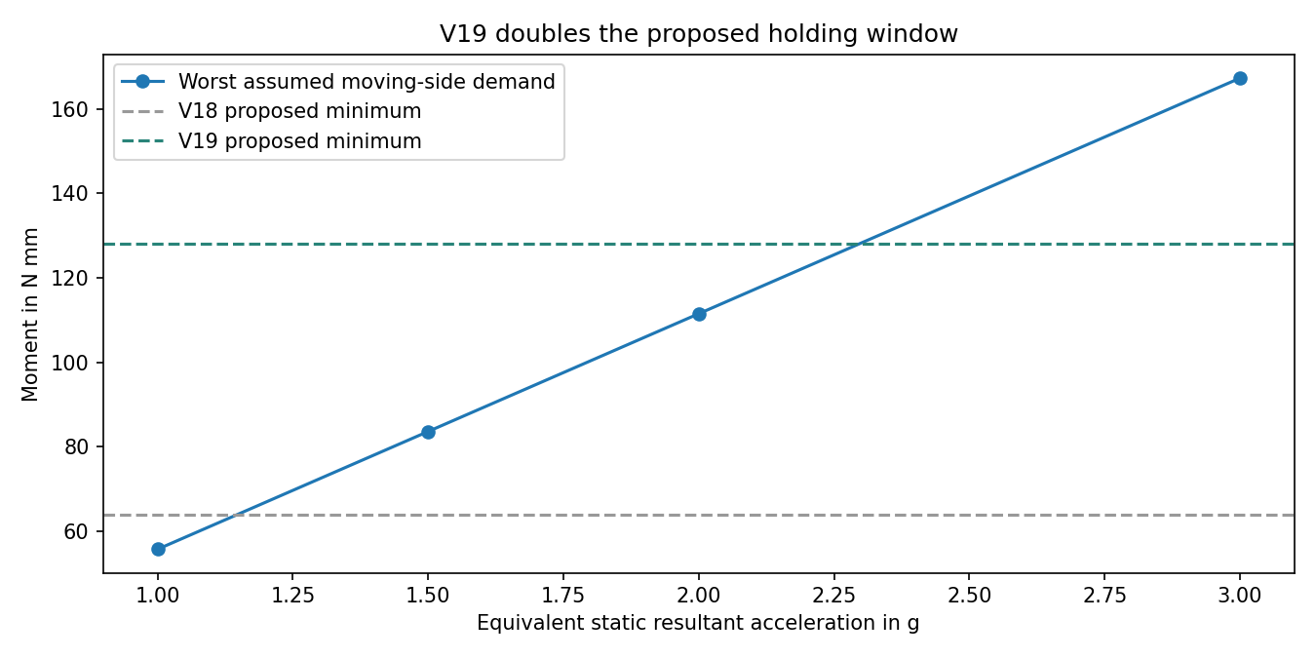
Equivalent static moment comparison. The torque lines are chosen targets, not measured hinge properties. This is not a drop or shake simulation.
The proposed target rises from 80 to 160 Nmm, with a chosen 128 to 192 Nmm comparison window. This doubles the earlier target and gives a worst assumed equivalent static threshold of about 2.30 g. All 18 assumed mass cases fall below the proposed minimum at 2 g. At higher acceleration some exceed it. The calculation inherits V18 moving cup and fork masses, which are unchanged; it does not predict impact dynamics.
At a 65 mm grip lever, that window corresponds to about 1.97 to 2.95 N folding force. More holding torque also means harder folding. We have no sensory acceptance limit for this force. Measure breakaway and running torque in both directions, then check drift after bedding, humidity, temperature and cycling. The higher target does not prove that the hinge will stay closed in a bag or stay comfortable to use.
SCHNORR describes parallel stacks as adding force at the same deflection. Our two-disc reference is based on its 000600B data. Real spring variation, friction, settling and plastic creep can change the assembly. Set torque by measurement, not by copying a nut position from the drawing.
SCHNORR disc spring stacking guidance

V19 Coupled joint calculation and limits
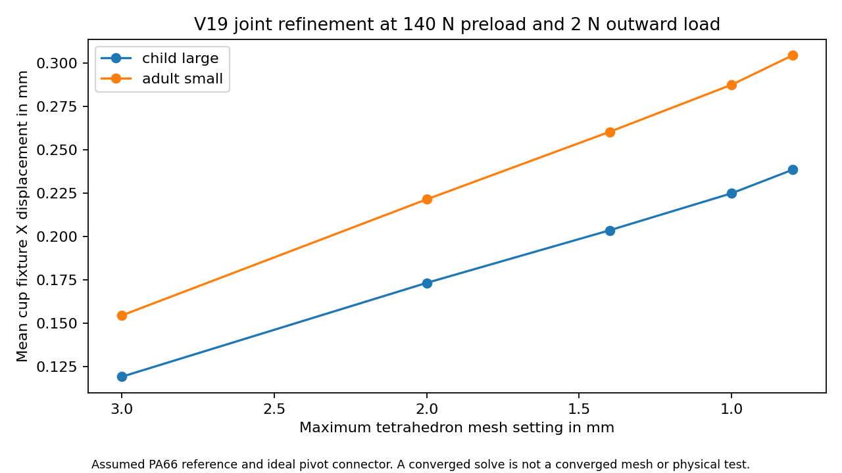
Solved displacement at the chosen outward 2 N fixture load. This model is a numerical development study; the final refinement result and gate are stated below.
We added a three dimensional calculation with flexible fork and tongue, one-way stop contact, washer contact and friction-limited tangential springs. There are 22 current cases: 22 converged and 0 did not converge. These counts describe numerical solves, not physical passes. Earlier low-preload low-friction runs reached the 80 iteration limit. Their failed records are retained alongside the later retry results. More iterations can fix an iteration-limit failure without proving physical holding or strength.
The model applies a prescribed preload and uses an ideal distributing pivot connector. It does not resolve real pin bearing clearance, bolt bending, thread load, disc spring deformation, guide contact or the full worn headset. The reference elastic modulus is 3500 MPa for TECAMID 66 natural and Poisson ratio 0.35 is assumed. This is a reference material calculation, not a qualified part grade or a prediction of long-term performance.

V19 Joint convergence and scope
Family and mesh change | Displacement change | Chosen 5 percent comparison
child large 3.0 to 2.0 mm | 45.5% | Fail
child large 2.0 to 1.4 mm | 17.5% | Fail
child large 1.4 to 1.0 mm | 10.5% | Fail
child large 1.0 to 0.8 mm | 6.0% | Fail
adult small 3.0 to 2.0 mm | 43.3% | Fail
adult small 2.0 to 1.4 mm | 17.6% | Fail
adult small 1.4 to 1.0 mm | 10.4% | Fail
adult small 1.0 to 0.8 mm | 5.9% | Fail

Reassembled equations, saved array comparisons, force balance, source hashes and a constant-strain control pass for 22 saved solves. These checks find algebra and file problems; they do not validate the physical model. Mesh results that miss the chosen limit are not hidden or promoted to a strength pass. There is no complete joint or whole-headset strength qualification.
The finest requested mesh in this run is 0.8 mm, with a chosen limit of 30000 nodes. A memory snapshot during the adult refinement showed about 1.3 GB free on the 16 GB laptop. This is a bounded study limit, not a proven hardware maximum. Further joint refinement or a different solver remains computer work if the numerical limit is not met; it is not being relabelled as completed physical testing.

V19 Material finding and prototype records
We checked additional published foam reference points rather than inventing a winning new material. PORON 4701-30 lists typical 25 percent compression pressures of 21, 35 and 62 kPa for its three density options. Under ideal uniform compression across our full annulus, those points imply the forces below. They do not provide a full loading and unloading curve for our pad.
Reference density | Child annulus force at 25 percent | Adult annulus force at 25 percent
240 kg per cubic metre | 64.6 N | 89.5 N
320 kg per cubic metre | 107.7 N | 149.1 N
400 kg per cubic metre | 190.9 N | 264.2 N

These ideal forces are much greater than the earlier 2 N per cup screening load. A material called very soft may still be unsuitable as a whole cushion at the required compression. This is a reason to request real samples and curves, not a comfort rejection based on one point. Supplier sheet thicknesses also do not automatically provide our full pad depth. We have not selected this foam or demonstrated its cost in India.
Rogers PORON 4701 30 data sheet
The handoff folder now contains CAD part envelopes, key dimensions, a nominal dimension-review PDF, assembly notes, blank material and test records, a Sony measurement form, a supplier quotation form and a measured-input readiness checker. No supplier was contacted and no quotation was obtained. The PDF is a prototype dimensional review, not a complete production drawing. Inputs remain blank because we have not measured a real sample.

V19 What we can conclude now
Workstream | Current decision
Six sizes adjustment folding and saved STEP poses | Recorded finite geometry checks completed
Component band tongue and fork fixtures | Earlier conditional numerical checks retained
Coupled 3D joint | Development model; see failed solves and refinement limits
Full worn foam cover and skin contact | Not calibrated or validated
Real acoustics heat durability and sensory acceptance | No product validation pass
Sony WH CH720N compatible carrier | Original pad and mount measurements still required
Native editable Fusion update | Current native archives V10; V19 is local STEP
Production tolerances final materials and cost | Supplier and sample evidence still required

The computer package is a traceable prototype handoff. It is not evidence that every possible computer analysis is finished. A full validated worn model, exact Sony fit and production release are still open. More arbitrary simulation inputs cannot prove comfort, sound reduction, zero leakage, sensory acceptance or that we outperform market headphones. Earlier reduced contact, acoustic and thermal models remain exploratory.
Next collect actual foam and cover curves, hinge torque and headband force, plus the original Sony mounting dimensions. Build a bench hinge and pad sample, compare measurements with the models, then revise the CAD and make a complete fixture prototype. Voluntary wearer feedback is needed before any claim about autistic users. Both living reports must continue to update together when real measurements or new revisions arrive.

V19 Higher order joint model
The first linear solid joint model still changed by about 6 percent at the finest mesh comparison. A separate model variant aligns the washer boundary and preload footprint with the mesh, then uses quadratic solid elements. Its contact faces are split into small linear triangles. This improves the bulk bending approximation; it is still the same ideal pivot and prescribed preload concept, not a real bolt or complete worn headset.
We kept the earlier 8 washer boundary pilot cases and all 22 original joint cases. The pilot made little difference to the linear solid result. The new quadratic variant has 4 nominal outward fixture cases, comparing 3 mm and 2.3 mm settings for child large and adult small. The later inward extension is recorded in the next chapter. Other friction settings were not repeated with quadratic solids, so these results do not replace every earlier load case.
The first adult mesh had a curved cell that folded inside out, so we rejected it. The retry adjusts the high order mesh and retains the failed log. Accepted meshes must keep positive local cell volumes, checked through their Jacobians. The reference fixture uses 140 N preload, assumed friction 0.2 and 2 N outward load. This is not a measured setting for the proposed 160 Nmm hinge target.
Family | Mesh displacement change | Chosen 5 percent comparison
child large | 0.39% | Pass
adult small | 0.41% | Pass

The element controls reproduce a constant strain and its analytic strain energy on a straight tetrahedron. The volume and matrix symmetry controls also pass. Each element uses 27 positive integration points. Saved displacement, contact force, friction, force balance and source hashes were rechecked for 4 solves. The mesh volumes differ from the reference CAD component volumes by less than the chosen 1 percent check.
A passing displacement comparison applies only to this selected outward fixture, these two meshes and the assumed material and contact laws. It does not prove convergence for every stress, load, friction value or hardware part. Stress is sampled at element centres. Actual friction, bolt and bearing behaviour, material conditioning, creep and a full worn model remain unvalidated. The earlier failed mesh comparisons and iteration-limit trials are preserved.
The digital record now separates numerical verification from physical validation. We can use the assembly as a bench prototype proposal, while collecting actual material curves and joint measurements for calibration. Exact Sony fit, real sound reduction, music leakage, heat, durability and sensory acceptance still need the measurements and sample tests listed in both reports.

V19 Inward joint load comparison
We extended the higher order joint calculation to a 2 N inward load. The four cases reuse exactly the saved child large and adult small meshes from the outward study. The assumed PA66 elastic reference, ideal pivot, 140 N prescribed preload and friction coefficient 0.2 are unchanged. The CAD geometry is unchanged. These are separate static equilibrium cases, not a load reversal sequence or a cycling test.
Family | Mesh mm | Mean X motion mm | Stop force N | Iterations
child large | 3.0 | -0.2798 | 0.000 | 31
child large | 2.3 | -0.2808 | 0.000 | 33
adult small | 3.0 | -0.3494 | 0.000 | 61
adult small | 2.3 | -0.3506 | 0.000 | 61

Child large displacement changed by 0.37 percent between these meshes. This passes the chosen 5 percent comparison.
Adult small displacement changed by 0.34 percent between these meshes. This passes the chosen 5 percent comparison.
4 cases converged and 0 did not. Saved-array reassembly, source hashes, CAD volume and force-balance checks passed for 4 accepted solves. Negative X motion describes direction; it is not evidence of a comfort benefit.
The new inward cases extend the numerical record. They do not establish convergence of local stress or qualify the bolt, bearing, friction across different materials, long-term retention or the full worn headset. The spring torque target remains uncalibrated. This does not prove the proposed hinge stays closed during a drop or bag transport.
The Sony WH CH720N replacement cushion is unchanged. No model-specific fit, pressure, sound isolation, playback leakage or ANC pass is added. Real pad and mounting measurements, material curves and fixture measurements remain the next inputs for both product routes.

V20 Internet dimensions and cushion candidates
Update on 21 October 2026. We can start buying small test samples, but both products remain unproven. SoftSpace keeps its V19 headphone design. SoftSpace Flex now has three V20 pad body candidates based on a published compatible-pad size. They are not yet fitted Sony replacement pads.
Brainwavz lists a WH CH720N compatible pad at 100 mm high, 80 mm wide and 30 mm thick. Sony confirms a groove attachment with top and bottom alignment features. Neither source gives us a complete mounting drawing. We did not measure the user headphone or infer exact dimensions from an unscaled picture.
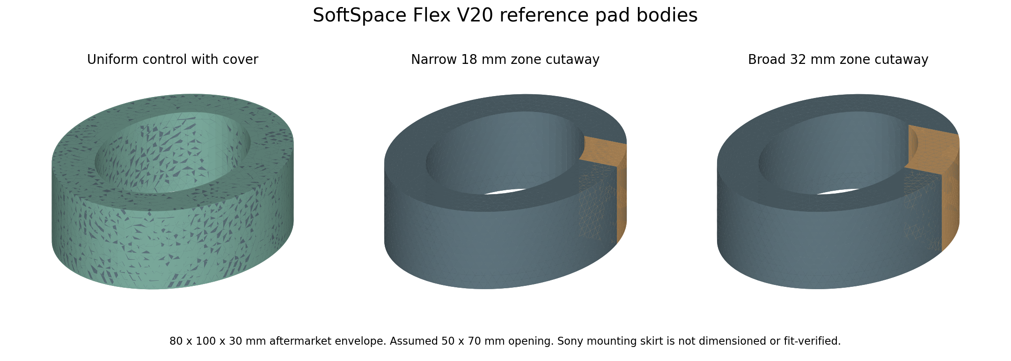
Actual saved V20 STEP surfaces. The two cutaways hide the cover to show different soft zones. The finished concept keeps a continuous cover. Colours identify parts, not selected material grades. Display triangles are not fabric texture.
Input | Value and evidence
Outside size | 100 by 80 by 30 mm from an aftermarket pad maker, not a Sony OEM drawing
Ear opening | 50 by 70 mm assumed for the first comparison
Cover thickness | 0.35 mm assumed; actual cover stiffness and seam need samples
Candidates | Uniform control, 18 mm soft zone and 32 mm soft zone
Attachment | Groove approach verified in Sony instructions; exact skirt and groove dimensions remain unknown

All three exported STEP bodies reimported with positive volumes and the expected part counts. This is a file and geometry check, not a mounting, sealing or comfort pass. The earlier generic V8 cushion remains in the history.

V20 What the cushion calculations show
We compared 11,664 paired cases with different assumed foam stiffness, cover stiffness, force, glasses thickness, position and zone size. This simple model treats areas of foam as separate compressible columns. It does not simulate a complete head, skin or real cover membrane.
Soft zone height | Paired cases | Cases with increased local pressure within the chosen compression screen
12 mm | 2916 | 624
18 mm | 2916 | 0
24 mm | 2916 | 0
32 mm | 2916 | 0

The 12 mm zone produced 624 cases with slightly increased pressure. The largest increase in the screened cases was 3.76 percent. A glasses arm that misses a soft patch can lose the intended benefit. The 18, 24 and 32 mm zones had no increases in this finite scenario set; this does not cover every face or glasses shape.
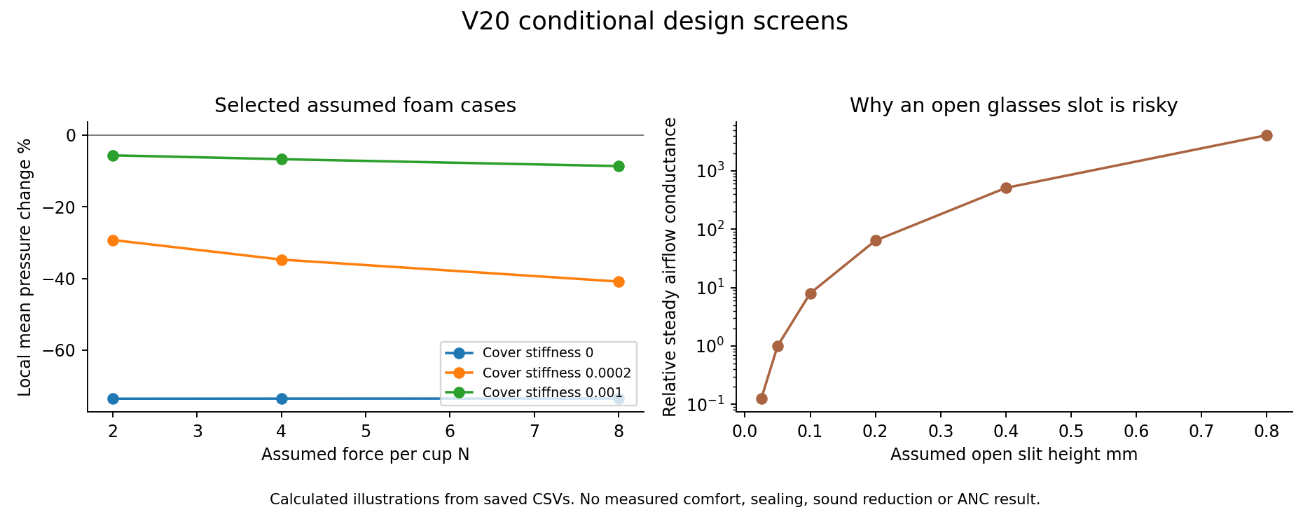
Left: selected pressure calculations show how an assumed stiffer cover can reduce the benefit of a soft insert. Right: a steady-airflow illustration shows sensitivity to an open gap. Neither plot is measured comfort, sound attenuation or ANC.
438 cases exceeded our chosen 40 percent compression screen and are flagged, not accepted as reliable high-compression predictions. The remaining 11,226 cases are still conditional calculations. No percentage here is a probability that a product will work.
Twelve selected rows were checked by a separately written scalar calculation with exact ellipse-strip areas. All stayed within the chosen 1 percent comparison. Force balance and a uniform-pressure reference also passed. These checks support the implementation, not the realism of its assumed material law.

V20 Headphone checks and remaining risks
All eight saved V19 higher-order joint solutions passed a fresh equation reassembly, file hash, force-balance and saved-array audit. This repeats the same model rather than using an independent physical experiment or a different joint solver. The original V19 assumptions, failed routes and limited stress sampling still apply.
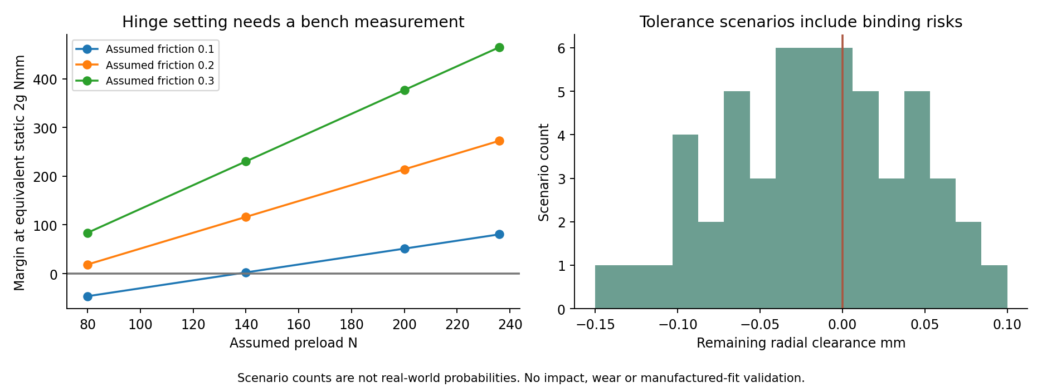
V19 geometry with new assumed friction, preload and tolerance combinations. Negative values identify scenarios that need a controlled setting or a better fit. Counts are not reliability statistics.
5 of 36 assumed hinge combinations had a negative holding margin. 33 of 54 assumed fit combinations used up the available clearance. We therefore recommend a bench hinge and a pin fit sample before ordering a complete headset.
The prior proposed clearance allocation still leaves 0.06 mm radial margin if its tight assumptions are achieved. That is a requested prototype condition, not evidence that a printer or supplier can achieve it. Measure the finished bore, pin and alignment before assembly. The proposed hinge torque needs direct measurement after locking the nuts.
Full worn contact, calibrated foam and cover behaviour, incoming sound reduction, outgoing music leakage, ANC, heat, fatigue and durability remain open. Replacing missing material curves or mounting dimensions with assumed numbers would not finish or validate those models. Native editable Fusion files remain V10; current headset geometry remains V19 STEP.

V20 What to buy for the first prototypes
Recommendation: proceed with inexpensive learning samples, not a batch of finished headphones or production tooling. Computer checks have narrowed some choices and found failures. We cannot put a credible success percentage on the first sample.
First purchase or sample | Purpose and condition
Material coupons | Small traceable foam and cover pieces with grade and lot details. Compare at least two foam stiffnesses and two covers. Measure compression and recovery before using a fitted material law.
Pad comparison set | Uniform and soft-zone bodies with the same outside size and cover. Start with the 18 mm and broader 32 mm options. Keep an original or correctly labelled compatible pad as the baseline.
Sony mounting reference | One model-specific replacement pad or a supplier-held WH CH720N reference. A supplier can measure its skirt and groove, so the user does not have to measure now. A claimed-compatible listing is not a verified fit.
One bench hinge | Use the V19 pin and joint proposal for supplier review. Check pin fit, tool access, spring setting, torque and nut locking before printing a full assembly.
Adult fixture prototype later | After the hinge, materials and pad attachment work, build one adult sample. Check contact, noise, heat and handling before voluntary wearer trials or child sizing trials.

Do not order custom Sony mounting tooling from these body STEP files. Do not order the rejected exact-thread experiment. No final material winner or cheapest-price result has been established; quotations and sample quality are still needed.
Grant wording we can support: We developed six adjustable headphone concepts, documented sampled folding checks and conditional joint calculations, and built three reference cushion designs using published aftermarket dimensions. We are seeking support to make samples, measure the missing inputs and test the proposed comfort and sealing benefits.
Claims we cannot support yet include proven benefit for autistic users, clinically tested comfort, a verified Sony fit, zero leakage, a quantified chance of success, a certified noise rating or superiority over other headphones. No funding application was submitted.

V20 Source evidence and audit trail
The screenshots below record the sources checked on 21 October 2026. They support dimensions and the mounting approach, not our product performance. Screenshots and attractive CAD pictures are supporting illustrations; raw files, assumptions and checks carry the numerical evidence.
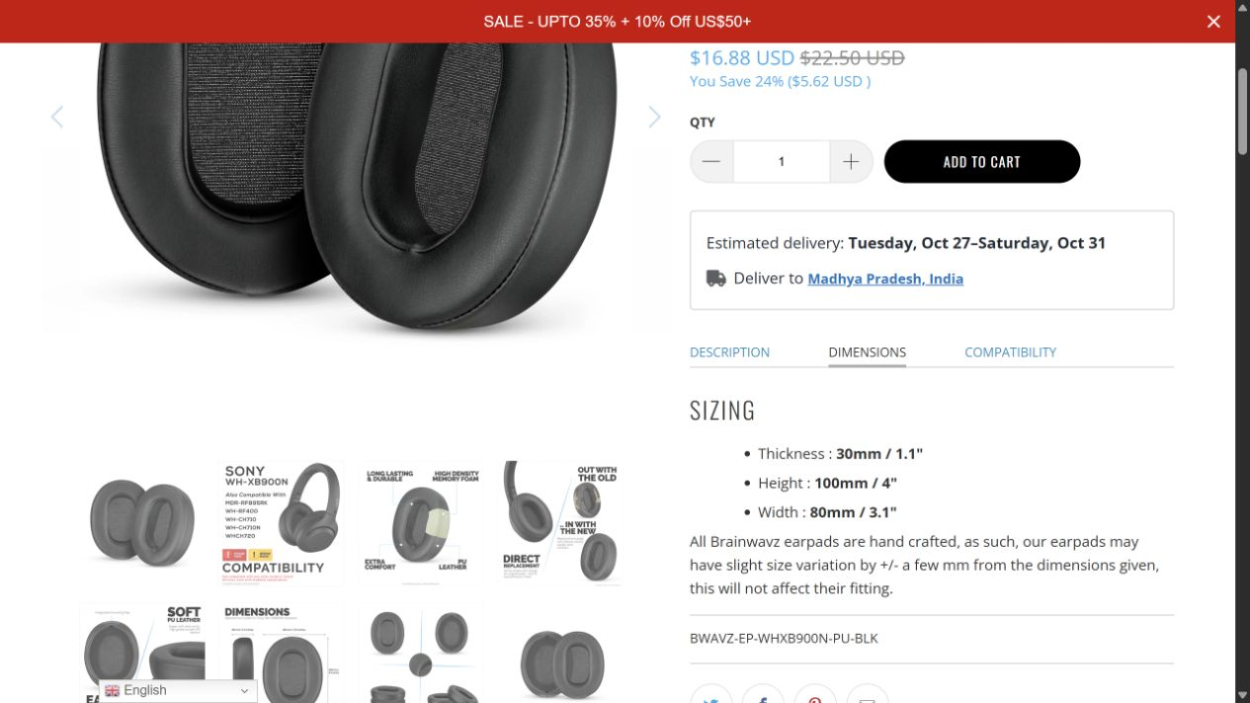
Brainwavz sizing panel for its compatible aftermarket pad. Not Sony OEM mounting metrology.
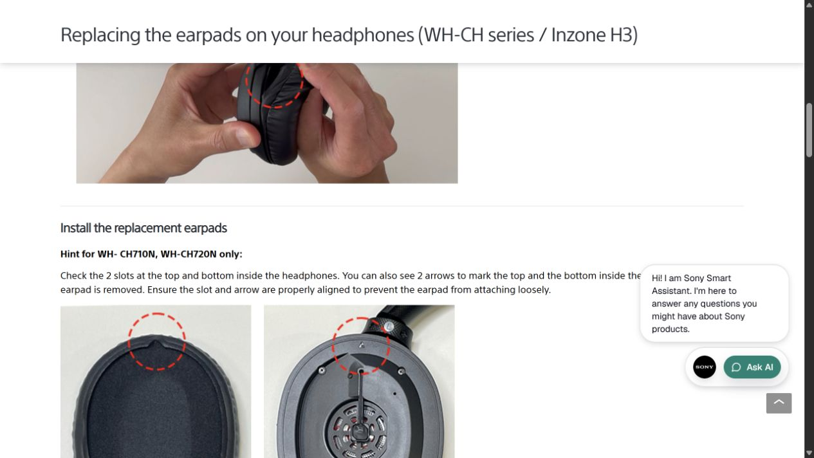
Sony instructions explicitly identify WH CH720N alignment features. No scale or groove dimensions are given.
Brainwavz compatible pad dimensions and model list
Sony replacement instructions for the WH CH series
Saved evidence: engineering-v20-results contains internet_sources.json, design_parameters.json, CAD_verification.json, contact_summary.json, contact_controls.json, verification.json, saved_audit_rerun.json, scenario CSVs and the source screenshots. Source scripts are v20_preprototype_screen.py, verify_v20_screen.py and build_v20_flex_reference.py. The first ellipse build error is preserved in CAD_build_trials.json.

V21 Additional software review
24 October 2026 review of calculations from 23 and 24 October. The added checks found useful passes and important failures. All possible software work is not finished. The first joint peak-stress comparisons failed; the following pages record the finer-mesh investigation and its exact scope. Material, mounting and whole-product performance remain unverified.
Part shapes remain SoftSpace V19 and SoftSpace Flex V20; V21 adds carrying pose STEP exports. We added 285 rigid motion samples across all six headset sizes. These include folding positions between the old 5 degree steps, unequal left and right slider positions, and selected simultaneous folding positions. The checks use the saved final STEP files and record their hashes.
Size | Folded box volume compared with wear box
adult large | 77.8 percent
adult medium | 77.5 percent
adult small | 88.7 percent
child large | 92.5 percent
child medium | 99.9 percent
child small | 97.7 percent

All the added recommended-path samples and simultaneous-fold diagnostics passed the existing interference gate. A smaller bounding box is useful for carrying, but this does not test a travel bag, fingers near a hinge, friction, loaded deformation or continuous motion between samples.
The test register now separates completed finite checks, failed numerical comparisons, missing measurements and tests that need people. A large number of calculations is not a probability that either product will work.

V21 Glasses positions change the result
The exact-area calculation checked all 11,664 old cushion rows. 334 differed by more than the chosen 1 percent comparison, with a maximum difference of 3.35 percent. The earlier 12 selected comparisons were correct, but they did not establish accuracy for every row. The old results remain saved; the new position screen uses exact elliptical areas.
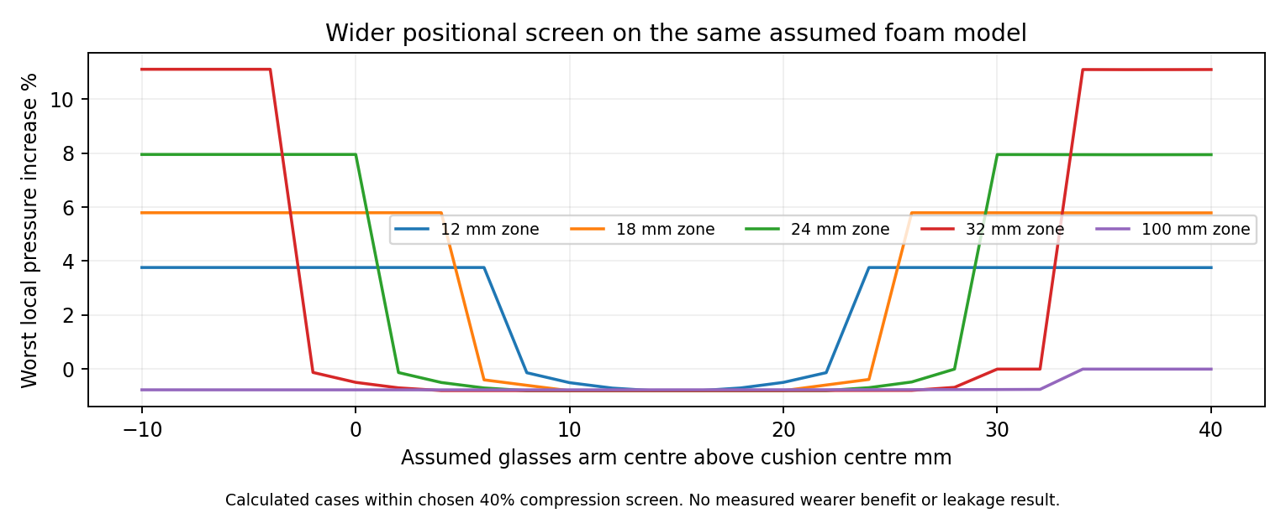
Calculated pressure changes across a wider assumed arm-height range. These are foam-column calculations, not measured pressure or comfort.
Zone height | Eligible cases with local pressure increase | Largest local increase
12 mm | 16158 | 3.76 percent
18 mm | 13666 | 5.79 percent
24 mm | 10560 | 7.95 percent
32 mm | 6884 | 11.10 percent
100 mm | 0 | 0.00 percent

The study has 126,360 cases. Glasses-arm centres range from 10 mm below to 40 mm above pad centre, at 2 mm steps. All values are assumptions, not a distribution of real users. Cases above the chosen 40 percent compression cutoff are flagged. A separately written integration and scalar root checked 127 selected rows successfully.
A 100 mm tall computational zone avoided the local increase in the eligible cases, but 780 cases increased peak pressure elsewhere and four showed model detachment. There is no final winner. This taller zone is a numerical alternative only; the three V20 STEP bodies are unchanged. Model detachment does not directly predict sound leakage.

V21 The first joint stress comparison failed
We recovered stresses at 27 interior points in each element of eight saved joint solutions. The old centre-point values were reproduced. Peak stress changed substantially between the two existing meshes. All eight comparisons exceeded our chosen 5 percent check. This is a failed numerical refinement check, not evidence that an actual part broke.
Load and size | Part | Peak change between meshes
Outward adult small | tongue | 49.7 percent
Outward adult small | fork | 26.8 percent
Outward child large | tongue | 49.6 percent
Outward child large | fork | 5.2 percent
Inward adult small | tongue | 57.3 percent
Inward adult small | fork | 8.3 percent
Inward child large | tongue | 52.5 percent
Inward child large | fork | 19.3 percent

The earlier stable displacement checks remain true. They cannot be used as evidence for stable peak stress. These failures triggered a finer-mesh investigation. Neither a material-strength margin nor fatigue life is established. Averaging stress would not make these original peak comparisons pass.
The hinge calculation also shows why settings matter. The old assumed worst moving-side mass needs about 206 N preload at friction 0.1 and equivalent static 3g. That is not an approved assembly setting. The catalogue reference point is not a full allowable spring-load curve; increasing preload also changes part stress.
For the 4 mm pin and 4.3 mm bore, the tight allocated errors leave 0.06 mm radial margin. The broad assumed raw errors leave minus 0.15 mm. A larger bore changes bearing behaviour, so we have not changed it blindly. Controlled finishing and real dimensional capability must be specified.
An extra 1.9 mm child large mesh trial has 33925 nodes. Trial status: equilibrium converged. The first unoptimized curved mesh had an invalid element and was rejected. The saved trial and failure log document the correction attempt; no result here is a full product-strength pass.

V21 Finer joint results
We added optimized 1.9 mm meshes for the child large and adult small representative joints, under outward and inward loads. The table compares the new interior-point peaks with the 2.3 mm results. The failed earlier comparisons remain in the history.
Size and load | Tongue peak change | Fork peak change
child large outward | 1.33 percent | 2.85 percent
child large inward | 3.19 percent | 2.89 percent
adult small outward | 4.65 percent | 27.52 percent
adult small inward | 0.18 percent | 28.31 percent

Six of eight finer peak checks pass. The adult fork changes by 27.52 percent outward and 28.31 percent inward, so those two checks still fail. The displacement comparisons and force balance are recorded separately. These checks concern selected computed quantities, not the strength of a real part.
Projected Anderson acceleration solved the original contact equations. Its child outward displacement field matched the saved unaccelerated direct reference. Its final force residual is checked independently of iteration progress. The model still uses an assumed PA66 stiffness of 3500 MPa, friction 0.2, 140 N prescribed preload and a 2 N side load in either direction.
These are isolated joint fixtures extracted from V19 ParallelDisc geometry. They do not model the full final AssemblyPrototype, resolved bolt and thread contact, actual bearing clearance, creep or fatigue. Peaks are sampled at 27 interior points per element; surface and contact-edge peaks are not globally bounded.
Hotspot locations and curved-element quality were also inspected. Their proximity to boundaries does not prove a singularity. Quantiles do not replace failed peak checks. The rejected mesh and stopped solver experiments are retained. A stopped experiment has no equilibrium pass. The final accepted route and raw solutions are identified in refinement/matrix_review.json and solver_experiments.json.

V21 What is still open
Topic | Current evidence and remaining work
Peak joint stress | Read the finer comparison page for the current status. Surface peaks, real material strength and full fastener contact remain unqualified.
Full worn contact | Reduced models only. Need actual foam, cover, seams, head geometry, friction and headband force.
Sound and ANC | Earlier acoustic proxies only. Need actual pad transfer properties and worn seal; no dB or ANC benefit is established.
Heat and moisture | Earlier assumed-property models only. Actual permeability and thermal inputs are missing.
Drop and life | No calibrated drop, fatigue, creep, cleaning or ageing result. Grade, process, joint details and criteria are missing.
Sony mounting | Published outer size and groove instructions do not define the exact skirt and groove.
Production details | Locking, tool access, tolerances, cover seam and bonding are not manufacturing released.
Comfort and sensory acceptance | Requires voluntary feedback from intended users. No software result proves acceptance.

This round is complete as a recorded set of checks. It does not close all software work, and it does not require us to pretend missing or failed tests passed. Small material coupons and reference-pad dimensions can improve later models, but no production batch or custom mounting tooling is released.
An analytic temperature calculation matched the old one-node heat proxy within 0.00013 degrees C across 216 saved rows. That checks the equation implementation. In 155 of those assumed rows the moisture calculation reached saturation. This is an older proxy, not the current headset or a measured comfort result; the heat and moisture problem is not solved.
Evidence: engineering-v21-results contains the motion logs, exact-area comparisons, wider position cases, separate scalar controls, stress recovery, mechanical limits and the complete test scope register. The two reports use the same evidence snapshot. No new market-price check or physical test was performed on this date.

V21 Carrying poses
The old fold reduced the child medium bounding volume by less than 0.1 percent. We therefore searched additional positions of the existing parts. This changes the assembly pose only; the headband, cups and cushions were not reshaped.
Size | Old folded volume relative to wear | New candidate volume relative to wear | Angles in degrees
adult large | 77.8 percent | 73.3 percent | [80, 65]
adult medium | 77.5 percent | 72.9 percent | [80, 65]
adult small | 88.7 percent | 68.0 percent | [85, 70]
child large | 92.5 percent | 75.3 percent | [85, 65]
child medium | 99.9 percent | 75.4 percent | [85, 70]
child small | 97.7 percent | 85.0 percent | [80, 60]

Each size search ranked 625 angle pairs at 5 degree increments up to 120 degrees. Candidates were tested in order until the first passing endpoint and sampled path. A selected candidate also passed left-first path samples every 2.5 degrees. Saved STEP poses were reimported and checked for 42 solids and matching volume.
This is a finite geometric carrying check. It does not prove a continuous path, finger safety, friction holding, loaded clearance or real bag fit. If a size has no selected candidate, its existing V19 pose remains the reference. The complete search trials and source hashes are saved.

V22 How reliable are the stress numbers
24 October 2026. We checked the saved joint results more deeply before relying on them. The material properties, loads and CAD are unchanged. A second method of calculating strain matched the original method. Increasing numerical integration from 64 to 125 points changed total elastic energy by less than 0.00004 percent in the saved fields. The 35 point mesh check found no turned inside out elements at the points tested. An additional adaptive Gmsh check was positive on all ten component meshes. These are mesh shape checks, not stress accuracy checks.
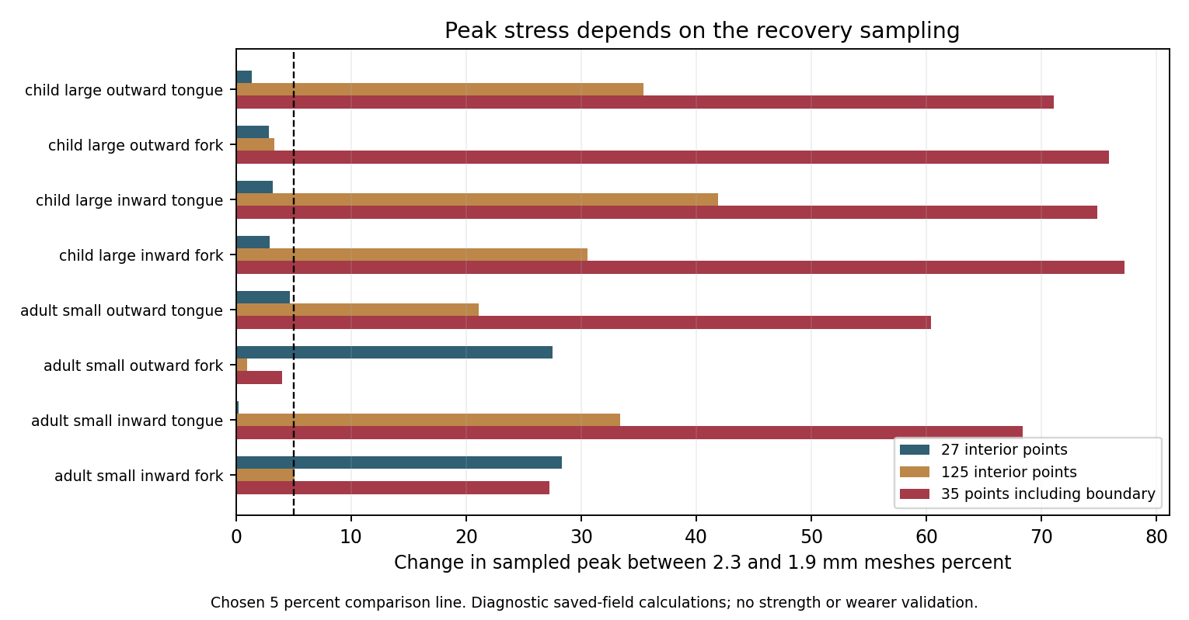
Changing where we sample stress changes the mesh comparison. This chart is a numerical diagnostic, not a material or product strength test.
The energy check passed, but peak stress depends strongly on the points being inspected. At 125 interior points, only two of the eight 2.3 to 1.9 mm comparisons meet the chosen 5 percent check. The earlier six passes used 27 interior points. Those were true for that limited test; they do not establish stable stress throughout a part.
The additional 35 point set includes element corners, edges and faces. Seven of its eight comparisons exceed 5 percent. These are sampled values, not a proof of the largest stress everywhere. No global stress, material strength, hinge life or break resistance pass is established. We have kept the earlier results and explained their limits.

V22 Targeted adult fork refinement
The adult fork had two recorded stress hotspots. We generated a mesh with a 0.9 mm local target around them, keeping the earlier tongue mesh and the same CAD. This mesh has 46,413 nodes. Both load directions use the same assumed stiffness, friction and preload as V21. Warm starting only speeds the calculation; each result must satisfy the final force residual check.
Load direction | Equilibrium | Displacement change | 125 point fork peak change
outward | Passed | 0.19 percent | 2.34 percent
inward | Passed | 0.27 percent | 5.44 percent

Some targeted sampling comparisons still exceed the chosen 5 percent check. This does not close the wider child and adult stress sampling problem. Stable force balance and displacement do not establish part strength. The actual edge and contact geometry, bolt detail and manufactured material remain unqualified.
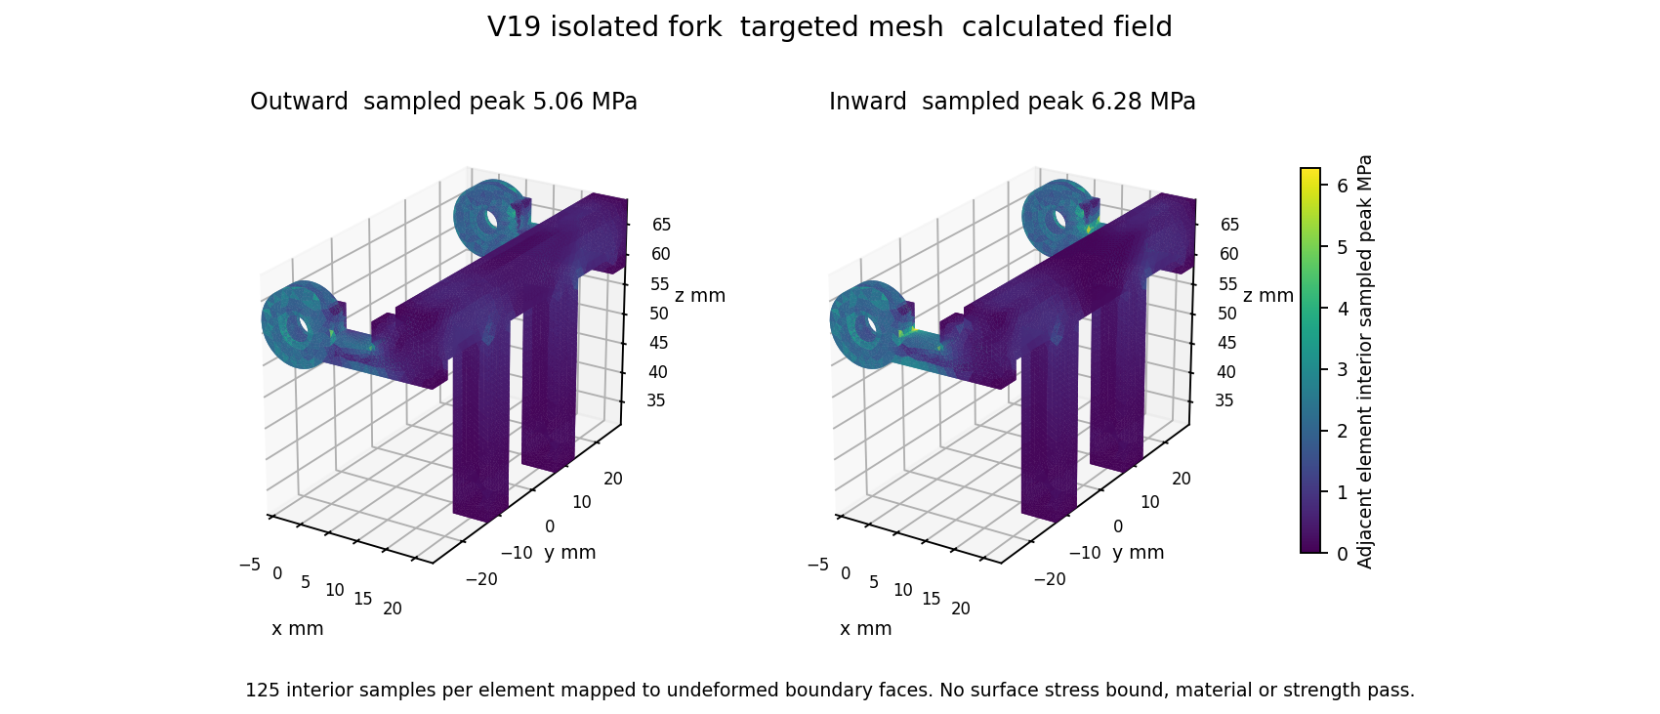
Original interface reference interior stress samples mapped to the unchanged fork mesh. These are not measured surface stresses or a strength pass.
The complete fields, mesh, force residuals, force balance and sampling comparisons are saved in engineering-v22-results. The local target is not a promise that every edge in the mesh has that size. A finite positive Jacobian check does not certify curved elements everywhere. This isolated fork and tongue fixture does not include a real bolt, thread, worn head or complete headset loading.
We did not change the CAD or raise the allowable stress to make a test pass. We also did not use average stress to replace a peak criterion. Further model or design changes need to state the actual contact and edge geometry, material and production process being represented.

V22 Contact consistency and correction
A rigid motion test moves the entire joint together. It should create no relative slip. The original friction interface passed common translations and rotation about the intended hinge axis, but failed rotations about the other two axes. The two representative sizes each showed 0.5 mm of false tangential motion per radian in those failed checks. This is a modelling issue, not a broken physical part.
Rigid motion checks across two sizes | Original interface | Proposed correction
Three common translations per size | 6 passed | 6 passed
Rotation about hinge axis per size | 2 passed | 2 passed
Other two common rotation axes per size | 4 failed | 4 passed

The correction accounts for a virtual 0.5 mm spacer rotating with the mean fitted bore rotation. It passes all twelve rigid motion checks. This is an explicit mathematical reference model. It does not replace a real washer, bolt, friction history or a physical contact measurement.
Corrected reference load | Equilibrium status | Final relative residual
outward | Passed | 2.69e-11
inward | Passed | 3.02e-11

The corrected reference uses new equilibrium calculations, starting from the saved refined fields. Contact derivative checks and linear solver residuals are recorded. The full pivot penalty is evaluated without building a large dense matrix. This changes storage, not its equation. A separate force, moment and equilibrium recheck also passed for both corrected fields. These solver checks do not resolve peak stress throughout the part or qualify an actual material.
The earlier stress fields remain saved with their original interface identified. The corrected reference remains conditional. Complete spacer contact, actual edge shape, material properties, preload and manufactured tolerances must be specified before treating it as the intended product.

V22 A simpler cushion control
We also checked a simpler option: make the entire foam pad softer, rather than adding a soft patch near the glasses arm. We ran 25,272 assumed cases using the same exact area foam model as V21. The glasses arm still acts on one side of the annulus; both sides of the foam are softened in this control.
Computer result | Whole pad softer foam
Assumed cases | 25272
Cases within chosen 40 percent compression range | 22012
Local pressure increases within that range | 0
Peak pressure increases within that range | 0
Model detachment cases within that range | 4
Cases outside the compression range | 3260

No eligible case increased the calculated local or peak pressure in this simplified model. This makes uniformly softer foam a useful control for future comparison with the patch designs. The model still has four detachment cases, and 3,260 cases fall outside the chosen compression range. It is not a final material choice or proof of less pain.
The added numerical control gives exactly the same active area pressures when we replace the whole pad modulus with its softer value directly. The force totals agree to numerical rounding. These check the arithmetic, not the behaviour of a real foam, cover or Sony headset.
The earlier 100 mm strip is not this whole pad control. That strip changes the arm facing half of the annulus. The new control changes both halves. Pad shape and mounting CAD are unchanged. No sound leakage, noise reduction, heat, durability or sensory acceptance result is added.

V22 Computer test status and next inputs
Area | What this means now
Six size CAD and folding | Finite geometry checks and smaller carrying poses are saved. Continuous motion, finger access and loaded clearances are not qualified.
Headband and hinge calculations | Idealized calculations are recorded. Reliable whole part peak stress and complete fastener behaviour are not established.
Glasses cushion | 126,360 assumed position cases and numerical controls are recorded. Soft zones can shift pressure elsewhere. No final foam or zone winner.
Materials and wear contact | Need named grades, measured or supplier compression curves, cover tension and friction, seam details and head geometry. Generic material names do not supply these.
Sound and heat | Need seal geometry, pad acoustic properties, permeability and assembled thermal inputs. Earlier proxy models are not current product performance.
Sony attachment | Need a dimensioned mounting skirt and groove. Published outer pad size and fitting instructions do not provide them.
Durability and manufacturing | Need final joint and material details, process tolerances and acceptance criteria before meaningful drop, fatigue, creep or cleaning models.
Comfort and sensory acceptance | Requires voluntary feedback from intended users. No computer model proves that a person will feel comfortable or safe.

This review finishes the listed V22 calculations and records the failures. It does not finish all possible software testing or release either product for production. Some remaining work is a model or design decision; other work needs real material and mounting inputs before the software can represent the intended product.
Both documents use the same update. SoftSpace keeps V19 part geometry with V21 carrying poses. SoftSpace Flex keeps its three V20 reference bodies. There is no new physical test, success probability, sound rating, market price check or proof of benefit for autistic users in this update.

V23 Corrected hinge checks across two size families
24 October 2026. The new campaign runs the corrected virtual spacer model on both the child large and adult small isolated joints. Each uses two mesh sizes and two load directions, giving eight new equilibrium calculations. The previous V22 local adult fields stay separate and unchanged. No CAD, material or actual fastener design is changed.
Joint family | Mesh mm | Direction | Relative force error
child large | 2.3 | outward | 8.31e-11
child large | 2.3 | inward | 5.05e-11
child large | 1.9 | outward | 2.65e-11
child large | 1.9 | inward | 3.89e-11
adult small | 2.3 | outward | 4.88e-11
adult small | 2.3 | inward | 6.84e-11
adult small | 1.9 | outward | 4.05e-11
adult small | 1.9 | inward | 4.81e-11

All eight new calculations passed the chosen equilibrium, independent residual, net force, net moment, friction bound and contact derivative checks. Twenty four distinct common rigid motions also passed across the four meshes. These checks tell us that the defined mathematical model behaves consistently. They do not establish that an actual hinge will have the same behaviour.
The fixed assumptions are stiffness 3500 MPa, Poisson ratio 0.35, preload 140 N, friction coefficient 0.2 and side force plus or minus 2 N. The virtual spacer is 0.5 mm. Actual washer contact, threads, production tolerances, material history and complete headset loads are still missing from this reference model.

V23 What the stronger stress check shows
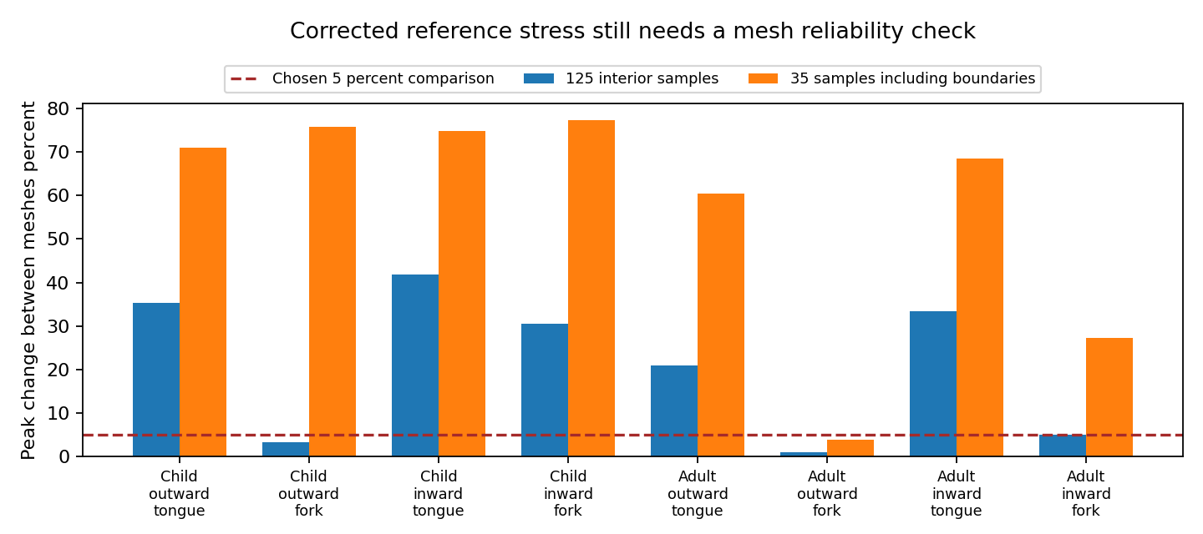
Same corrected reference equations and the same stress sampling methods on both meshes. The dashed line is our chosen comparison limit, not a safety standard.
10 of 24 stress comparisons meet the fixed 5 percent check. Sixteen compare 2.3 mm and 1.9 mm meshes across the two joint families. Eight compare the adult 1.9 mm fields with the previously solved local 0.9 mm fields. Both the 125 interior samples and the 35 samples including element boundaries are retained.
A stress comparison that exceeds the limit stays a failed comparison. We have not used average stress, a different allowable stress or a different sampling method to hide it. Even a passing pair does not prove that the largest stress anywhere in a part is known. Whole part strength and break resistance remain unproved. The next useful design work is to define the real edge, spacer and fastener details and repeat the relevant models.
The new raw fields, source hashes, solver histories, numerical controls and every comparison are saved in engineering v23 results. The older raw fields are preserved. This is a completed numerical campaign with unresolved design conclusions, not a finished headphone or a physical test.

V23 Software status and the remaining inputs
Area | Current conclusion | What is needed next
Corrected hinge equations | Eight new solves and numerical checks completed | Detailed physical joint and reliable stress model
Six size folding and adjustment | Earlier sampled CAD checks retained | Continuous path and pinch protection verification
Cushion and glasses pressure | Reduced assumed models compared | Foam curves cover friction and worn head geometry
Sony mounting | Envelope only exact fit unproved | Skirt groove carrier dimensions and tolerances
Sound leakage and noise reduction | No predictive product pass | Seal geometry and acoustic material data
Heat moisture and durability | No validated product pass | Traceable material and process properties
Comfort and sensory acceptance | No wearer result | Voluntary wearer testing

Both projects remain in development. The glasses cushion geometry is unchanged in this update; shared hinge results do not prove Sony fit or cushion benefit. Earlier local and whole pad softness screens remain useful comparisons, with their failed and out of range cases retained. There is no demonstrated improvement in comfort, sound leakage, ANC or heat.
We have finished the eight case corrected reference campaign and its numerical checks. We cannot call all product software testing complete. Missing material and interface inputs must be supplied before realistic full product simulations can be completed. Inventing those values would give misleading confidence. The remaining test register separates those input gaps from completed checks and from tests that require people.

V24 Finer child and adult joint calculations
24 October 2026. We added a finer 1.5 mm target mesh for both isolated joint families. There are four new equilibrium calculations, covering outward and inward loads on child large and adult small. The V19 part shapes and corrected virtual spacer equations are unchanged. These are new meshes of an existing mathematical reference, not new headphone designs.
Joint family | Load direction | Mesh nodes | Relative force error
child large | outward | 45406 | 6.70e-10
child large | inward | 45406 | 7.13e-11
adult small | outward | 59371 | 8.44e-11
adult small | inward | 59371 | 1.64e-10

All four new fields meet the chosen equilibrium, independent residual, net force, net moment, friction bound and contact derivative checks. Common rigid motion checks also pass. The old displacement fields were mapped only to help the solver start; the mapped values were not accepted as a solution. Each final field had to meet the force residual gate.
The assumptions remain stiffness 3500 MPa, Poisson ratio 0.35, preload 140 N, friction 0.2 and a side force of plus or minus 2 N. The virtual spacer is 0.5 mm. This model still omits a resolved real washer, bolt, material history, full headset loading and worn contact. The complete raw fields, histories and hashes are saved.

V24 Do the finer stress predictions agree
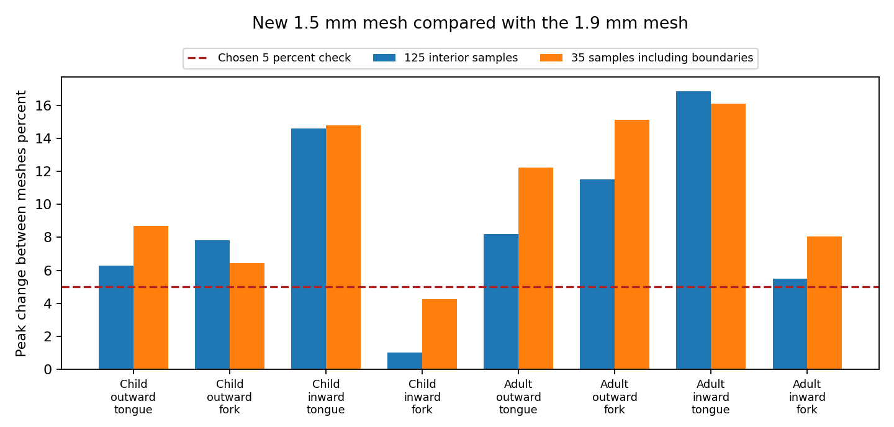
Same corrected reference equations and stress sampling sets on 1.9 mm and 1.5 mm target meshes. The dashed line is our chosen 5 percent comparison limit, not a product safety standard.
2 of 16 refined stress comparisons meet the chosen 5 percent limit. Eight comparisons use 125 interior samples per element and eight use a 35 point set including boundaries. All comparisons use the same method on the older and newer mesh. Earlier V23 comparisons remain unchanged in the history.
The finer child results still exceed the limit. This shows that the coarse mesh was not the only unresolved issue. It does not by itself identify the physical cause. A single passing pair would also not prove the maximum stress throughout a part. We have not changed the limit or replaced a failed peak criterion with average stress. Reliable whole part strength remains unproved.
Further useful work needs the intended physical edge, contact, spacer and fastener details to be defined and represented. More fine meshes of an incomplete contact idealization cannot prove the finished device is strong, comfortable or quiet. No CAD shape or final material is selected by these calculations.

V24 Restored records and the remaining software gates
Moving to D revealed that the main CAD readers still followed old C drive paths. They now resolve a source using its recorded hash. An audit matched all 623 recorded references, covering 304 distinct path and hash pairs. Four older V12 versions did not match the newer root files; exact copies were recovered from existing ZIP archives into a separate source archive. The newer files and historical recorded paths were preserved.
Recovered historical source | Recovery rule
V12 child small released | Exact recorded SHA256 required
V12 child small folded | Exact recorded SHA256 required
V12 child medium released | Exact recorded SHA256 required
V12 child medium folded | Exact recorded SHA256 required

Seven path loader controls passed, including rejection of a deliberately wrong hash. This fixes the two primary mesh and motion readers. It does not claim that every historical script has been migrated or that every CAD shape has passed every geometric test. The eight V23 raw solution files also remain unchanged.
Area | Remaining requirement
Joint strength | Define actual edge spacer fastener and loads then resolve stress reliability
Cushion contact | Traceable foam curves cover seams friction and worn head geometry
Sony compatibility | Exact skirt groove carrier dimensions and tolerances
Sound heat and durability | Material and assembly inputs for predictive full product models
Comfort and sensory acceptance | Voluntary wearer testing

Both products remain in development. The glasses cushion geometry is unchanged; these shared joint and source checks add no Sony fit, pain relief, sound leakage, ANC or cooling result. This finer numerical campaign is complete, but full product software sign off is not achieved. The test register records failed and missing requirements explicitly.

