QSAR Toolbox – Ethanol Toxicity Record

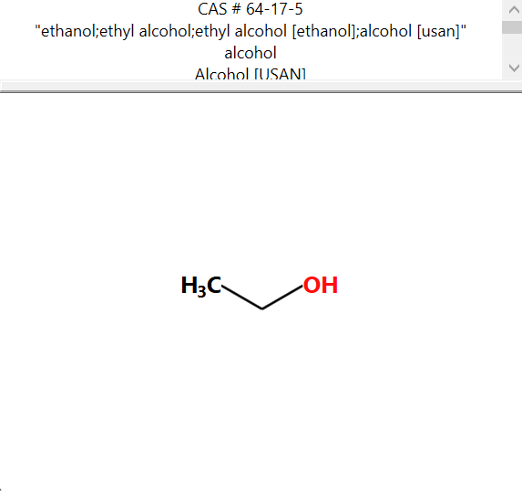
PHYSICOCHEMICAL PROPERTY REPORT – ETHANOL
1. CHEMICAL IDENTIFICATION
Chemical name | Ethanol (Ethyl alcohol)
CAS No. | 64-17-5
Molecular formula | C₂H₆O
Molecular weight | 46.07 g/mol
SMILES | CCO
2. PHYSICOCHEMICAL PROPERTIES
Property | Reference value
Physical state | Liquid
Melting/freezing point | −114.1 °C
Boiling point | 78.2 °C
Density | 0.789 g/cm³ at 20 °C
Water solubility | Miscible with water
Partition coefficient (log Kow) | ≈ −0.31
pKa | ≈ 15.9 (aqueous)
Vapour pressure | ≈ 5.95 kPa at 20 °C
Flammability | Highly flammable liquid and vapour
Stability | Stable under ordinary storage/handling conditions
pH | Not normally reported as a defining property of pure ethanol; depends on aqueous solution
3. RELEVANCE TO AQUATIC TOXICITY
Ethanol is a small, highly water-miscible organic liquid with a low boiling point and high volatility compared with the other chemicals in this experiment. Its very high water solubility and low log Kow indicate limited tendency for partitioning into non-polar phases. The high flammability is an important handling consideration. These physicochemical properties are relevant when interpreting aquatic toxicity because ethanol readily disperses in water and has comparatively low hydrophobicity.
4. SOURCE REFERENCES
- PubChem, Ethanol (CID 702).
- OECD QSAR Toolbox 4.9 – physical-chemical property profiling interface (for comparison with Toolbox fields).

AQUATIC TOXICITY REPORT – ETHANOL

1. Chemical Identity
Parameter | Value
Chemical | Ethanol (Ethyl alcohol)
CAS | 64-17-5
Molecular formula | C2H6O
SMILES | CCO

2. Zebrafish Aquatic Toxicity
Primary record selected from QSAR Toolbox: Danio rerio mortality LC50.
Parameter | Recorded value
Organism | Danio rerio (zebrafish)
Effect | Mortality
Endpoint | LC50
Exposure duration | 120 h (5 days)
LC50 | 1.56 × 10^4 mg/L
Molar value | 338 mM
Life stage / strain | AB strain embryos; 2.5–3.7 hpf
Temperature | 28 °C
pH | 6.8–7.2
Study | Ethanol- and Acetaldehyde-Mediated Developmental Toxicity in Zebrafish
Source | Reimers, Flockton & Tanguay

3. Selected Toxicity-Relevant Profiling
Profiler | Result
Acute aquatic toxicity classification | Class 5
Acute aquatic toxicity MOA by OASIS | Base-surface narcotics
Aquatic toxicity classification by ECOSAR | Neutral organics
Toxic hazard classification by Cramer | Low (Class I)
Carcinogenicity | No alert found
DNA / Ames / micronucleus alerts | No alert found

4. Working Interpretation
Ethanol has a recorded Danio rerio mortality LC50 of 1.56 × 10^4 mg/L after 120 h (5 days). The selected QSAR Toolbox profiling results classify ethanol as a neutral organic and assign a base-surface narcotic mode of action for acute aquatic toxicity. The Cramer profiler gives Low (Class I) hazard classification, while the selected genotoxicity/carcinogenicity alert profilers report no alert found.
Note: Exposure duration is retained exactly as reported in the database; the 120 h value is not treated as a 96 h value.

