QSAR Toolbox – Formaldehyde Record
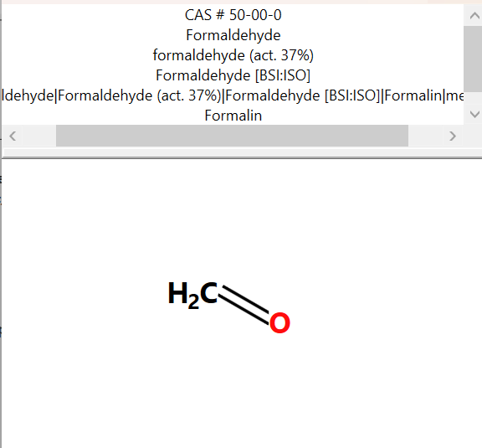

PHYSICOCHEMICAL PROPERTY REPORT – FORMALDEHYDE
1. CHEMICAL IDENTIFICATION
Chemical name | Formaldehyde
CAS No. | 50-00-0
Molecular formula | CH₂O (HCHO)
Molecular weight | 30.03 g/mol
SMILES | C=O
2. PHYSICOCHEMICAL PROPERTIES
Property | Reference value
Physical state | Gas at room temperature (pure formaldehyde)
Melting/freezing point | ≈ −92 °C
Boiling point | ≈ −19.5 °C
Density | ≈ 0.815 g/mL for liquid formaldehyde at about −20 °C
Water solubility | ≈ 400 g/L at 25 °C
Partition coefficient (log Kow) | ≈ 0.35; reported range includes approximately −0.75 to 0.35
pKa | ≈ 13.27 at 25 °C
Vapour pressure | ≈ 3883–3890 mm Hg at 25 °C
Flammability/reactivity | Highly reactive; flammable and readily polymerizes under suitable conditions
Stability | Reactive; incompatible with strong acids/bases and oxidizing conditions
pH | Depends on the aqueous solution/formulation; not a fixed property of pure gaseous formaldehyde
3. RELEVANCE TO AQUATIC TOXICITY
Formaldehyde is a very small, highly reactive and highly volatile compound. Its low boiling point means that pure formaldehyde exists as a gas at ordinary temperature. It is highly soluble in water and is commonly handled as aqueous formaldehyde solutions. Its chemical reactivity, volatility and high water solubility are important when considering environmental exposure and aquatic toxicity.
4. SOURCE REFERENCES
- U.S. National Toxicology Program, 15th Report on Carcinogens – Properties of Formaldehyde.
- U.S. EPA IRIS, Toxicological Review of Formaldehyde – Appendix A.

TOXICITY REPORT – FORMALDEHYDE

1. Chemical Identity
Parameter | Value
Chemical | Formaldehyde
CAS | 67-47-0

2. Zebrafish Aquatic Toxicity
Selected primary record: Danio rerio mortality LC50 at 96 h.
Parameter | Recorded value
Organism | Danio rerio (zebrafish)
Effect | Mortality
Endpoint | LC50
Exposure duration | 96 h
LC50 | 41 mg/L
Medium | Freshwater
Study type | Experimental study
Reliability | 2 (reliable with restrictions)
Test condition | Static
Source | Wellens, H. (1982), Z. Wasser-Abwasser-Forsch.

3. Selected Toxicity-Relevant Profiling
Profiler | Result
Acute aquatic toxicity classification | Class 3
Acute aquatic toxicity MOA by OASIS | Aldehydes
Aquatic toxicity classification by ECOSAR | Aldehydes (Mono)
Carcinogenicity | No alert found
DNA alerts for AMES, CA and MNT | No alert found
in vitro mutagenicity (Ames test) | No alert found
in vivo mutagenicity (Micronucleus) | No alert found
Oncologic Primary Classification | Aldehyde Type Compound
Respiratory sensitisation | Schiff base formation
Toxic hazard classification by Cramer | Low (Class I)
Ultimate biodeg | 0 to 1 day
DNA binding by OECD | Schiff base formers
Protein binding by OASIS | Schiff base formation
Skin irritation/corrosion inclusion rule | Aldehydes

4. Working Interpretation
Formaldehyde has a recorded Danio rerio mortality LC50 of 41 mg/L after 96 h. QSAR Toolbox profiling places it in Class 3 for acute aquatic toxicity and identifies aldehydes as the relevant aquatic toxicity mode of action. The ECOSAR classification is Aldehydes (Mono), while the Cramer profiler reports Low (Class I). The selected genotoxicity alert profilers report no alert found. Schiff base formation is identified by several mechanistic profilers.

