QSAR Toolbox – Monosodium glutamate (MSG) Report
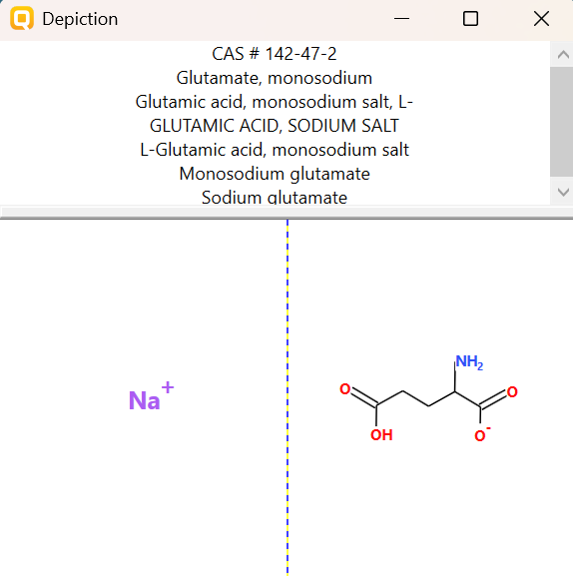
PHYSICOCHEMICAL PROPERTY REPORT – MONOSODIUM GLUTAMATE (MSG)
1. CHEMICAL IDENTIFICATION
Parameter | Value
Chemical name | Monosodium glutamate (MSG)
CAS No. | 142-47-2
Molecular formula | C₅H₁₀NNaO₅
Molecular weight | 187.13 g/mol
SMILES | C(CC(=O)[O-])[C@@H](C(=O)O)N.O.[Na+]
2. PHYSICOCHEMICAL PROPERTIES
Property | Reference value
Physical state | White/off-white crystalline powder
Melting point | ≈232 °C / decomposes
Boiling point | ≈225 °C (decomposes)
Water solubility | ≥100 mg/mL; freely soluble in water
pH | ≈7.0 for 0.2% solution
Partition coefficient | Low hydrophobicity; aquatic ionized form expected
Vapour pressure | Not expected to be environmentally important because it is ionic/nonvolatile in water
Stability | Water soluble; generally stable under ordinary handling
3. RELEVANCE TO AQUATIC TOXICITY
MSG is an ionic, highly water-soluble salt. In water it dissociates into sodium and glutamate ions, so volatilization is expected to be negligible. Its high water solubility and ionic character are important when interpreting aquatic exposure.
4. SOURCE REFERENCES
- PubChem, Monosodium Glutamate (CID 23689119).

AQUATIC TOXICITY REPORT – Monosodium glutamate (MSG)
1. Chemical Identity
Parameter | Value
Chemical | Monosodium glutamate (MSG)
CAS | 142-47-2
Molecular formula | C₅H₁₀NNaO₅
SMILES | C(CC(=O)[O-])[C@@H](C(=O)O)N.O.[Na+]
2. Zebrafish Aquatic Toxicity
Primary literature record selected for the practical; exposure duration and LC50 are retained exactly as reported.
Parameter | Recorded value
Organism | Danio rerio (zebrafish) embryos
Effect | Mortality
Endpoint | LC50
Exposure duration | 48 hpf
LC50 | 15,200 ppm
Life stage | Embryos
Second reported LC50 | 10,300 ppm at 96 hpf
Study | Effects of monosodium glutamate on heart beat and the embryonic development of zebrafish
Source | Suthamnatpong & Ponpornpisit (2017)
3. Selected Toxicity-Relevant Profiling
Profiler | Result
Acute aquatic toxicity literature | LC50 reported by Probit analysis
Developmental toxicity | Sublethal and malformation effects observed in the study
4. Working Interpretation
MSG produced a reported LC50 of 15,200 ppm at 48 hpf and 10,300 ppm at 96 hpf in zebrafish embryos. The study also reported developmental and cardiotoxic effects at lower concentrations. Because these are literature-derived values, they should be identified as literature data rather than QSAR Toolbox measurements.
5. Source References
- Suthamnatpong, N. & Ponpornpisit, A. (2017). Effects of monosodium glutamate on heart beat and the embryonic development of zebrafish. The Thai Journal of Veterinary Medicine, 47(4), 523–530.

