QSAR Toolbox – Sodium Benzoate Toxicity Record
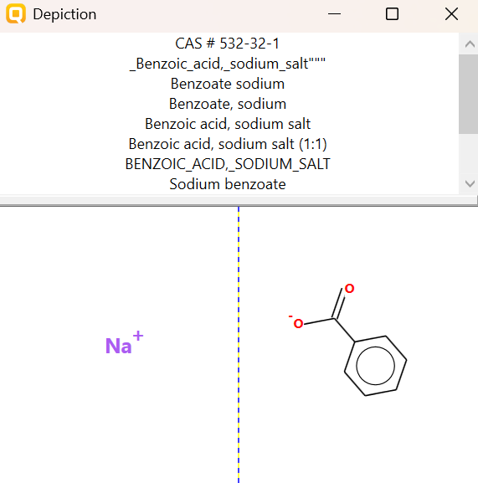
PHYSICOCHEMICAL PROPERTY REPORT – SODIUM BENZOATE
1. CHEMICAL IDENTIFICATION
Parameter | Value
Chemical name | Sodium benzoate
CAS No. | 532-32-1
Molecular formula | C₇H₅NaO₂
Molecular weight | 144.11 g/mol
SMILES | CC1=CC=CC=C1C(=O)[O-].[Na+]
2. PHYSICOCHEMICAL PROPERTIES
Property | Reference value
Physical state | Solid
Melting point | >300 °C
Boiling point | ≈249 °C*
Density | ≈1.49–1.50 g/cm³
Water solubility | ≈550–630 g/L at 20 °C
Partition coefficient (log Kow) | ≈−2.27 (estimated)
pKa | ≈4.2 for the benzoic acid/benzoate system
Vapour pressure | ≈2.9 × 10⁻¹² mm Hg at 25 °C (estimated)
Flammability | Not readily flammable under normal conditions
Stability | Stable under recommended storage conditions; hygroscopic
pH | ≈7.5 for a 10 g/L aqueous solution
3. RELEVANCE TO AQUATIC TOXICITY
Sodium benzoate is an ionic, highly water-soluble solid used widely as a preservative. Its high water solubility and very low estimated log Kow indicate a strong preference for the aqueous phase rather than hydrophobic phases. These physicochemical properties are relevant when interpreting its aquatic toxicity because the compound is readily present in the dissolved phase.
4. SOURCE REFERENCES
- WHO/IPCS, CICAD No. 26: Benzoic Acid and Sodium Benzoate.
- PubChem, Sodium Benzoate (CID 517055).
- U.S. EPA CompTox Chemicals Dashboard, Sodium benzoate.
- OECD QSAR Toolbox 4.9 – physical-chemical property profiling interface (for comparison with Toolbox fields).

AQUATIC TOXICITY REPORT – SODIUM BENZOATE
1. Chemical Identity
Parameter | Value
Chemical | Sodium benzoate
CAS | 532-32-1
Molecular formula | C7H5NaO2
SMILES | CC1=CC=CC=C1C(=O)[O-].[Na+]
2. Zebrafish Aquatic Toxicity
Primary record selected from QSAR Toolbox: Danio rerio mortality LC50.
Parameter | Recorded value
Organism | Danio rerio (zebrafish)
Effect | Mortality
Endpoint | LC50
Exposure duration | 48 h
LC50 | 461 mg/L
Life stage / strain | 48 hpf embryos; Wild-type
Temperature | 28 °C
Medium | E3 saline embryo medium
Study type | Laboratory
Study quality shown in Toolbox | A
Study | Set-up of an Infrared Fast Behavioral Assay Using Zebrafish (Danio rerio) Larvae, and Its Application in Compound Biotoxicity Screening
Source | Bichara, D., N.B. Calcaterra, S. Arranz, P. Armas, S.H. Simonetta
3. Selected Toxicity-Relevant Profiling
Profiler | Result
Acute aquatic toxicity MOA by OASIS | Basesurface narcotics
Biodegradation probability (BioWin) | Biodegrades fast
Biodegradation ultimate (BioWin 3) | Weeks
Bioaccumulation – metabolism half-life | Very fast
Toxic hazard classification by Cramer | Low (Class I)
4. Working Interpretation
Sodium benzoate has a recorded Danio rerio mortality LC50 of 461 mg/L after 48 h. The selected QSAR Toolbox profiling results assign a Basesurface narcotics mode of action for acute aquatic toxicity. BioWin predicts fast biodegradation, with ultimate biodegradation occurring over weeks, while the bioaccumulation metabolism half-life is classified as very fast. The Cramer profiler gives a Low (Class I) hazard classification.
Note: Exposure duration is retained exactly as reported in the database; the 48 h value is not treated as a 96 h value.

