QSAR Toolbox – Sunset Yellow FCF (E110) Report
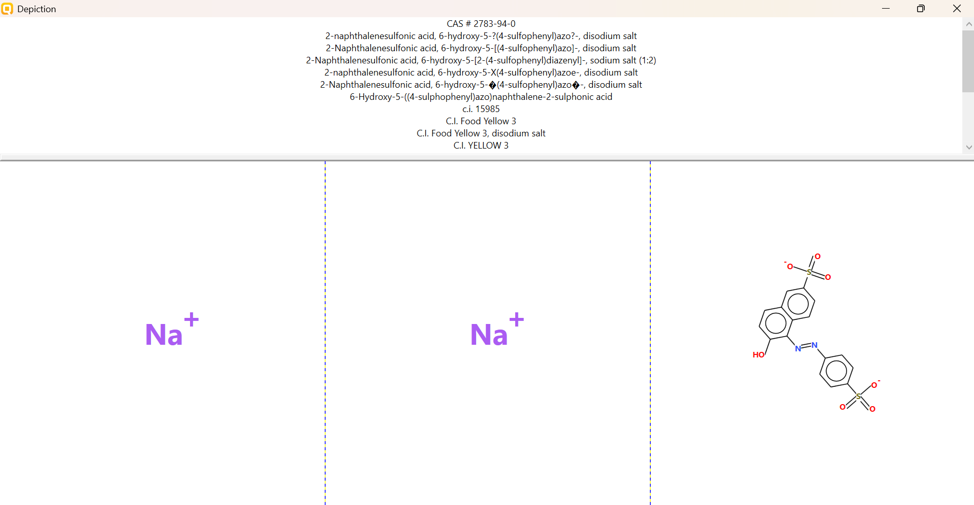
PHYSICOCHEMICAL PROPERTY REPORT – SUNSET YELLOW FCF (E110)
1. CHEMICAL IDENTIFICATION
Parameter | Value
Chemical name | Sunset Yellow FCF (E110)
CAS No. | 2783-94-0
Molecular formula | C₁₆H₁₀N₂Na₂O₇S₂
Molecular weight | 452.4 g/mol
SMILES | O=S([O-])(C1=CC=C(C=C1)N=NC2=C(C=CC3=CC(S(=O)([O-])=O)=CC=C32)O)=O.[Na+].[Na+]
2. PHYSICOCHEMICAL PROPERTIES
Property | Reference value
Physical state | Crystalline solid / orange-red crystals or red powder
Melting point | Not consistently reported in the sources reviewed
Water solubility | Highly water soluble; formulation-dependent values reported
Molecular weight | 452.4 g/mol
Partition coefficient | Expected low hydrophobic partitioning because of two sulfonate groups
pH | Commercial lake/formulation specifications can vary; aqueous behavior is pH dependent
Stability | Used as a synthetic food colorant; ionic sulfonate groups favor aqueous mobility
3. RELEVANCE TO AQUATIC TOXICITY
Sunset Yellow FCF is a disulfonated azo dye and therefore exists predominantly as an ionic species in aqueous media. Its sulfonate groups promote water solubility and reduce the tendency for neutral-phase partitioning. These properties are relevant to aquatic exposure and zebrafish embryo toxicity.
4. SOURCE REFERENCES
- PubChem, Sunset Yellow FCF (C.I. Food Yellow 3).
- Cayman Chemical, Sunset Yellow FCF technical information.
- European Union specification for E110 Sunset Yellow FCF.
AQUATIC TOXICITY REPORT – Sunset Yellow FCF (E110)
1. Chemical Identity
Parameter | Value
Chemical | Sunset Yellow FCF (E110)
CAS | 2783-94-0
Molecular formula | C₁₆H₁₀N₂Na₂O₇S₂
SMILES | O=S([O-])(C1=CC=C(C=C1)N=NC2=C(C=CC3=CC(S(=O)([O-])=O)=CC=C32)O)=O.[Na+].[Na+]
2. Zebrafish Aquatic Toxicity
Primary literature record selected for the practical; exposure duration and LC50 are retained exactly as reported.
Parameter | Recorded value
Organism | Danio rerio (zebrafish) embryos
Effect | Mortality
Endpoint | LC50
Exposure window | Embryos exposed from ~6 hpf; observations through 168 hpf
LC50 | 42.57 mM
Life stage | Developing embryos / larvae
Study | Food colorant Sunset Yellow (E110) intervenes developmental profile of zebrafish (Danio rerio)
Source | Published literature
3. Selected Toxicity-Relevant Profiling
Profiler | Result
Developmental toxicity | Teratogenic/embryotoxic effects reported
NOEC | 0.1 mM
EC50 | 19.41 mM for pericardial edema; 39.84 mM for yolk sac edema at 96 hpf
4. Working Interpretation
The selected literature study reported an LC50 of 42.57 mM for Sunset Yellow FCF in developing zebrafish. The study also reported developmental abnormalities and mortality at higher concentrations. A separate recent study reported 416.67 ppm, demonstrating that LC50 values can vary with experimental design and units; the selected report retains the 42.57 mM value exactly as reported by the primary paper.
5. Source References
- Sunset Yellow FCF PubMed record: Food colorant Sunset Yellow (E110) intervenes developmental profile of zebrafish (Danio rerio).
- Agustin & Sari, The effect of sunset yellow food coloring (E110) on zebrafish embryos development (reported LC50 416.67 ppm).

