CAPSTONE PROJECT

WHACK-A-MOLE

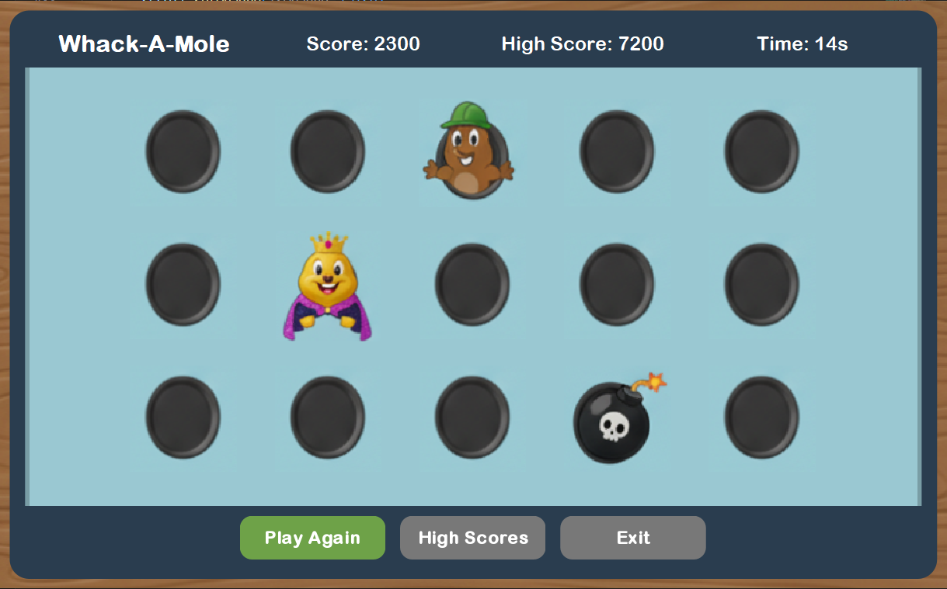

Name: Adil Muhammed
Roll no: 2410110018
Course: CSD213
Date: 21st November 2025

UML DIAGRAM

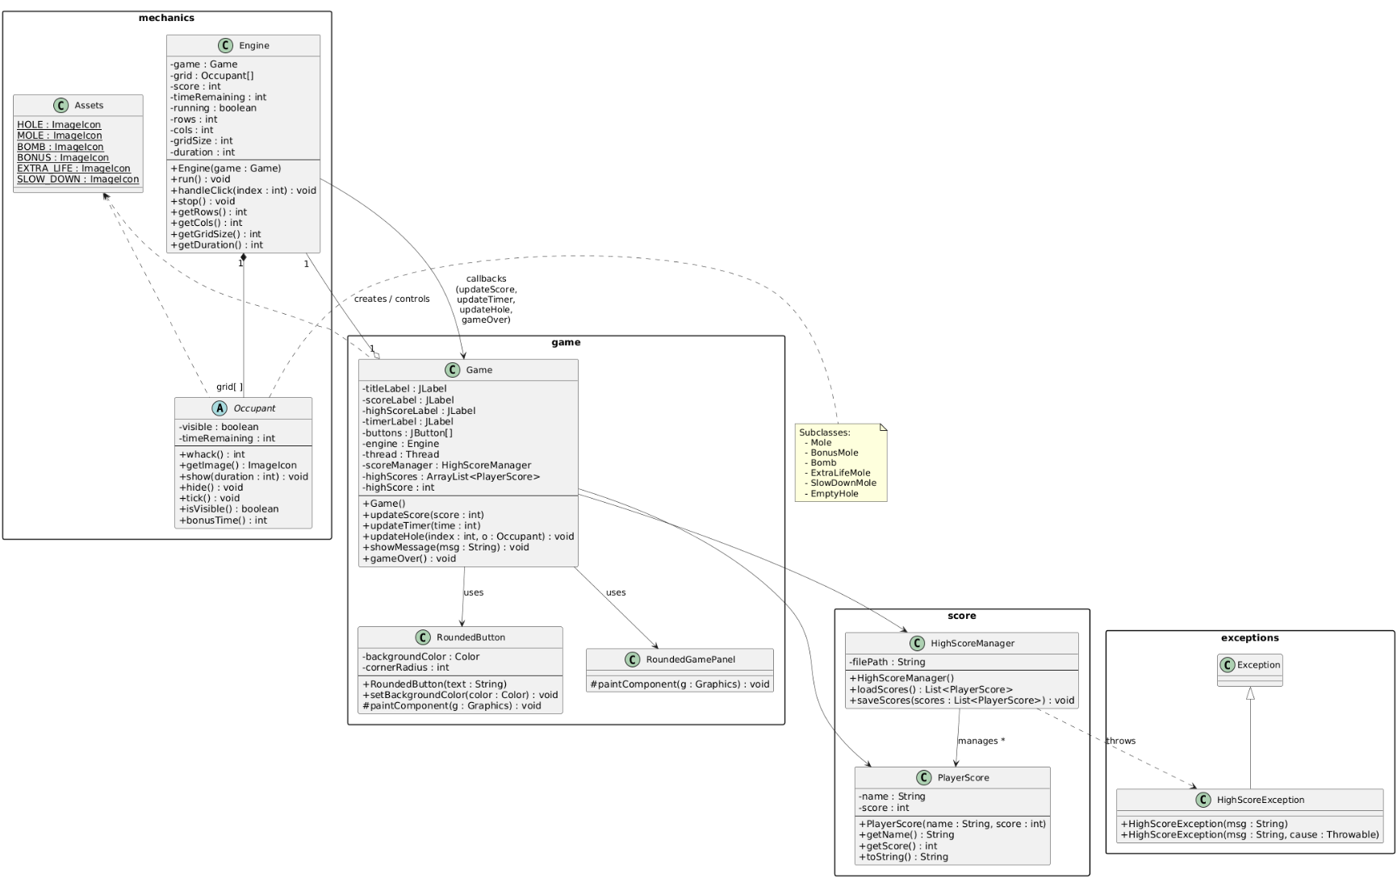

1. Object-Oriented Design Overview
The final design follows an object-oriented architecture that separates responsibility across clear, modular components. The system is structured around three main domains: Game UI, Game Logic (Engine), and Data Handling (Score System).
The Game class functions as the controller and entry point. It initializes the UI using Swing components and dispatches updates to the view based on state changes triggered by the Engine. Custom components such as RoundedButton and RoundedGamePanel were used to achieve the desired aesthetic.
The Engine class encapsulates game logic, timing, and interaction rules. It manages hole contents, mole durations, scoring, and random object generation. Encapsulating these rules separately supports maintainability and potential extension (for example, adding different game modes). Just from the Engine file private fields such as time duration, row, columns, icon duration can be changed and access of these is allowed by the getter functions. This is example of Encapsulation.
The Occupant hierarchy (Mole, BonusMole, Bomb, EmptyHole) was introduced following the Open–Closed Principle (OCP). New game entities can be introduced without modifying existing code, only extending the Occupant class. Such entities have been made such as ExtraLifeMole and SlowDownMole as proof of concept. This also supports polymorphism since each occupant defines its own scoring behavior and icon representation.
The HighScoreManager handles persistence and ensures the application remains functional across sessions. This allows storage implementation (JSON, text, or database) to be swapped without modifying gameplay logic.
This structure encourages reusability, minimizes coupling between UI and logic, and makes the project scalable for future enhancements and also makes the game editable for desired behaviour

2. Concurrency Strategy
The project uses a two-thread approach: the Swing Event Dispatch Thread (EDT) and the Game Engine thread.
- The EDT is responsible for rendering UI components, processing button clicks, and running all Swing-related code. Direct modification of Swing components from a background thread can cause race conditions and undefined behavior.
- The Engine thread runs the gameplay loop, including mole spawning logic, timers, and score updates. It executes continuously until the round ends or the user exits.
To safely coordinate both threads, the game uses the SwingUtilities.invokeLater() method whenever background logic needs to update the GUI. This ensures that all Swing component updates run safely inside the EDT.
Example interactions include:
- Updating countdown values in timerLabel
- Displaying new icons when moles or bombs appear
- Applying score changes after a click
This model avoids shared mutable UI state access from outside the EDT and ensures deterministic behavior between the UI and game loop. The concurrency approach is lightweight, avoids unnecessary synchronization complexity, and is scalable for real-time games of this size.

3. Custom Exceptions and Rationale
A dedicated custom exception, HighScoreException, is used within the storage layer. Its purpose is to provide meaningful context when reading or writing score data fails, rather than allowing generic IO exceptions to appear at game level.
This ensures:
- User-friendly error messaging instead of stack traces.
- Clear separation between system faults and expected user-level outcomes.
- Future extensibility if score validation or recovery strategies are added.
By isolating error handling inside the score system, other modules remain focused on gameplay logic, contributing to cleaner and safer code.

Conclusion
Overall, the project shows a working example of OOP design, threading, and exception handling, Graphics, Data persistence. This project dived into all the topic that were thought in the course. From the beginning of polymorphism to graphics were used extensively. The code is organized in a way that makes it easier to change or add new features later, and the separation between UI and logic keeps things manageable.
Extra Notes-
-ExtraLifeMole and SlowDownMole were created as proof of concept and as such odds of them appearing was kept to 0 and placeholder images were kept.
-If size of game has to be changed the existing wood frame would not suffice as it is tailored to be exact replica of the pdf example. So an extra wood frame(wood_frame2) is also included in images so that if size were to be changed using this frame instead will allow it.

