**Lab 09**

1. **Add a view called Managers in the Northwind database that shows only employees that supervise other employees.**

**Query:**

create view Managers as select a.Firstname+' '+a.Lastname as Employee ,b.Firstname+' '+b.Lastname as Manager from employees a,employees b where a.reportsto=b.employeeid

select * from Managers

**Output:**

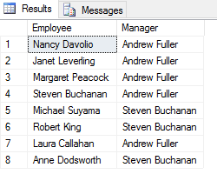

1. **Create Northwind view called “Products by Category” based on the columns CategoryName and ProductName.**

**Query:**

create view [Products by Category] as select CategoryName,ProductName from Categories,Products

select * from [Products by Category]

**Output:**

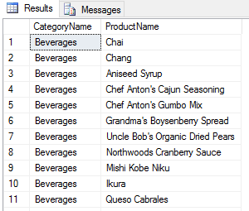

1. **Create a view that shows a table that list all the publishers and store names using pubs.**

**Query:**

create view [List of Publishers and Stores] as select pub_name,stor_name from Publishers,Stores

select * from [List of Publishers and Stores]

**Output:**

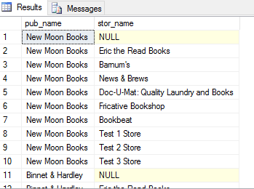

1. **Create a view that shows a table that list all the authors and store names using pubs.**

**Query:**

create view [List of Stores and Authors] as select stor_name ,au_fname+' '+au_lname as Author from Stores,Authors

select * from [List of Stores and Authors]

**Output:**

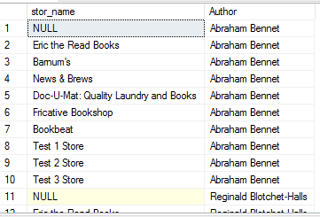

1. **Create a view the amount total amount spend by customers.**

**Query:**

create view CustomersTotalAmountSpend as select Customer,AmountSpend from (select ContactName as Customer,orderid from Customers inner join orders on customers.customerid=orders.customerid)table1 inner join (select orderid,sum(quantity*unitprice) as AmountSpend from orderdetails group by orderid)Table2 on table2.orderid=table1.orderid

**Output:**

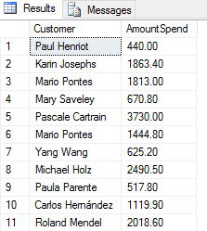

1. **Create a view for customers shippers information.**

**Query:**

create view CustomerShipperInfo as select contactname as customer ,shipperid,shipname,shippers.companyname,shippers.phone from customers left join orders on customers.customerid=orders.customerid left join shippers on orders.shipvia=shippers.shipperid

select * from CustomerShipperInfo

**Output:**

