Bahria University,

Karachi Campus



COURSE: CSL-220 Database Management System

TERM:

Spring-2021, CLASS: BSE- 4 (A)

Submitted By:

_____________ ADIL WAHEED__________

(Enrollment #02-131192-082) Reg #65190)

Submitted To:

Engr. BUSHRA FAZAL / Engr. AYESHA KHAN

Signed Remarks: Score:

INDEX

|  |  |  |  |  |
| --- | --- | --- | --- | --- |
| SNO | DATE | LAB NO | LAB OBJECTIVE | SIGN |
|  |  |  |  |  |
|  |  |  |  |  |
|  |  |  |  |  |
|  |  |  |  |  |
|  |  |  |  |  |
|  |  |  |  |  |
|  |  |  |  |  |
|  |  |  |  |  |
|  |  |  |  |  |
|  |  |  |  |  |
|  |  |  |  |  |
|  |  |  |  |  |
|  |  |  |  |  |
|  |  |  |  |  |

Bahria University,

Karachi Campus



LAB EXPERIMENT NO.

___01____

LIST OF TASKS

|  |  |
| --- | --- |
| TASK NO | OBJECTIVE |
| 1 | **Get Order id, Product id, Unit price from Order Details.** |
| 2 | **Find Title of employee Nancy** |
| 3 | **Display data of all employees those working as Sales Representative from London** |
| 4 | **Display product name whose unit price are greater than 90$** |
| 5 | **Write a query to get current Product list (Product ID and name).** |
| 6 | **Fetch data of customers where country is "Germany" AND city must be "Berlin" OR "München" (use parenthesis to form complex expressions)** |
| 7 | **Fetch data of customers from all countries except Germany and USA** |
| 8 | **Fetch Discontinued products who’s price is greater than 20** |

Submitted On:

____________

(Date: / /2021)

**Task No. 1: Get Order id, Product id, Unit price from Order Details.**

**Solution:** select OrderID,ProductID,UnitPrice from [Order Details]

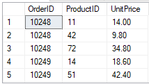**OUTPUT**:

**Task No. 2: Find Title of employee Nancy**

**Solution:** select Title from Employees where FirstName='nancy';

**OUTPUT**:

**Task No. 3: Display data of all employees those working as Sales Representative from London**

**Solution:** select * from Employees where Title='sales representative' and city='london';

**OUTPUT**: 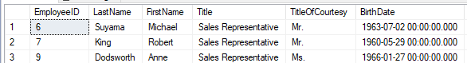

**Task No. 4: Display product name whose unit price are greater than 90$**

**Solution:** select ProductName from Products where UnitPrice >90

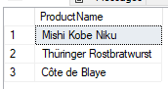 **OUTPUT**:

**Task No. 5: Write a query to get current Product list (Product ID and name).**

**Solution:** select ProductID,ProductName from Products

**OUTPUT**:

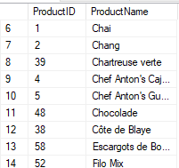

**Task No. 6: Fetch data of customers where country is "Germany" AND city must be "Berlin" OR "München" (use parenthesis to form complex expressions)**

**Solution:** select * from Customers where Country='germany' and ( city='berlin' or city='München');

**OUTPUT**: 

**Task No. 7: Fetch data of customers from all countries except Germany and USA**

**Solution:** select * from Customers where Country<>'germany'and Country<>'USA';

**OUTPUT**: 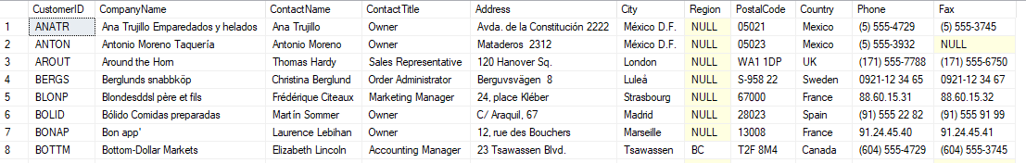

**Task No. 8: Fetch Discontinued products who’s price is greater than 20**

**Solution:** select * from products where Discontinued=1 and UnitPrice >20

**OUTPUT**: 