Bahria University,

Karachi Campus



LAB EXPERIMENT NO.

__02_____

LIST OF TASKS

|  |  |
| --- | --- |
| TASK NO | OBJECTIVE |
| 1 to 15 | 1. Get the price of an order (by multiplying unit price by quantity). 2. Display all cities that employees belong to but don’t allow repetition. 3. Find complete name of all employees. 4. List the name of all employees whose first name starts with the letter ‘A’. 5. In Customer table, display all cities that ends with the letter ‘a’. 6. Display names of all employees whose name contain ‘an’. 7. Display all the orders where unit price lies in the range of 10$ to 40$. 8. Display the company name where Region is NULL in Customer Table. 9. Write a query to list employees whose address does not contain Rd. 10. List all products where UnitPrice is not in 10,12,15,17 or 19 11. Display the highest, lowest, sum and average UnitPrice of each Category, where highest UnitPrice lies in the range of 50$ to 100$. Label column as CategoryId, Maximum, Minimum, Sum and Average, respectively. (Table: Products) 12. From customers table, Count all customers is each region where region is not null. (Table: Customers) 13. Write a query to display the number of ContactName with same ContactTitle. Sort contact title in descending order. (Table: Customers) 14. Write a query that count all orders against each product id. No of orders should be greater than 50. (Table: [Order Details])   15.List only those cities in which more than or equals to 2 employees are living |

Submitted On:

____________

(Date: / /2021)

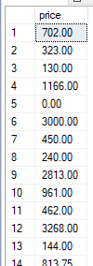**Task No. 1: OUTPUT**:

1. **Get the price of an order (by multiplying unit price by quantity).**

**Solution:** select unitprice*unitsinstock as price from products

**Task No. 2:**

1. 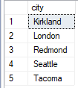**Display all cities that employees belong to but don’t allow repetition.**

**Solution:** SELECT DISTINCT (city) from employees

**OUTPUT**:

**Task No. 3:**

1. 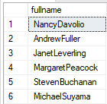**Find complete name of all employees.**

**Solution:** select firstname+lastname as fullname from employees

**OUTPUT**:

**Task No. 4:**

1. **List the name of all employees whose first name starts with the letter ‘A’.**

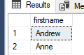**Solution:** select firstname from employees where firstname like 'A%'

**OUTPUT**:

**Task No. 5:**

1. 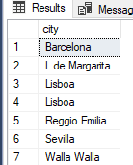**In Customer table, display all cities that ends with the letter ‘a’.**

**Solution:** select city from customers where city like '%a'

**OUTPUT**:

**Task No. 6:**

1. **Display names of all employees whose name contain ‘an’.**

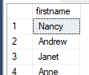**Solution:** select firstname from employees where firstname like '%an%'

**OUTPUT**:

**Task No. 7:**

1. **Display all the orders where unit price lies in the range of 10$ to 40$.**

**Solution:** select * from [order details] WHERE unitprice BETWEEN 10 AND 40

**OUTPUT**:

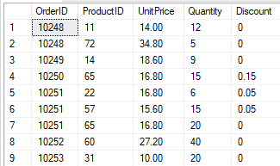

**Task No. 8:**

1. **Display the company name where Region is NULL in Customer Table.**

**Solution:** select companyname from customers where region is null

**OUTPUT**:

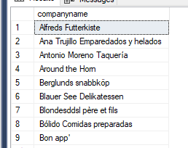

**Task No. 9:**

1. **Write a query to list employees whose address does not contain Rd.**

**Solution:** select * from employees where address not like '%Rd%'

**OUTPUT**:



**Task No. 10:**

1. **List all products where UnitPrice is not in 10,12,15,17 or 19**

**Solution:** select * from products WHERE unitprice not in(10,12,15,17,19);

**OUTPUT**:

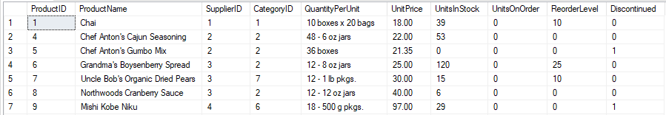

**Task No. 11:**

1. Display the highest, lowest, sum and average UnitPrice of each Category, where highest UnitPrice lies in the range of 50$ to 100$. Label column as CategoryId, Maximum, Minimum, Sum and Average, respectively. (Table: Products)

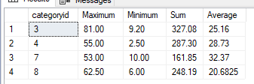**Solution:** SELECT categoryid, max(UnitPrice) as Maximum,min(UnitPrice) as Minimum,sum(UnitPrice) as Sum,avg(UnitPrice) as Average FROM Products group by CategoryID having max(UnitPrice) between '50' and '100'

**OUTPUT**:

**Task No. 12:**

1. 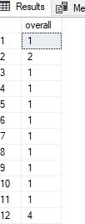From customers table, Count all customers is each region where region is not null. (Table: Customers)

**Solution:** SELECT count(customerid) as overall FROM Customers where not Region is null group by Region

**OUTPUT**:

**Task No. 13:**

1. Write a query to display the number of ContactName with same ContactTitle. Sort contact title in descending order. (Table: Customers)

**Solution:**

select Contactname,ContactTitle from Customers order by ContactTitle desc

**OUTPUT**:

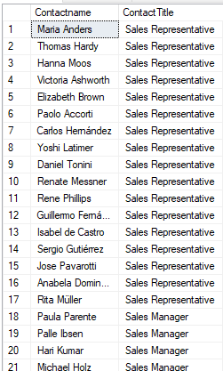

**Task No. 14:**

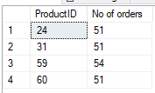Write a query that count all orders against each product id. No of orders should be greater than 50. (Table: [Order Details])  **OUTPUT**:

**Solution:** select ProductID, COUNT(orderid) as [No of orders] from [Order Details] group by ProductID HAVING COUNT(ProductID) > 50;

**Task No. 15:**

15.List only those cities in which more than or equals to 2 employees are living

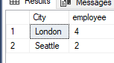**Solution:** select City, count(city) as employee from Employees group by City HAVING COUNT(City) >= 2;

**OUTPUT**: