Bahria University,

Karachi Campus



LAB EXPERIMENT NO.

___03____

LIST OF TASKS

|  |  |
| --- | --- |
| TASK NO | OBJECTIVE |
| 1 | Example 1: Viewing the Current Date and Time |
| 2 | Example 2: Returning Date and Time Parts |
| 3 | Example 4: Adding or Subtracting Date/Time Parts from Dates |
| 4 | Example 5: Calculating Differences between Dates or Times |
| 5 | How many orders were shipped within two days? |
| 6 | Which employees were hired more than 26 years ago as of the last day of the current month? |
| 7 | what are the months with the greatest and lowest number of orders? |

Submitted On:

____________

(Date: / /2021)

**Task No. 1:** Example 1: Viewing the Current Date and Time

**Solution:** select GETDATE() as [Current_Date];**OUTPUT**:

**Task No. 2:** Example 2: Returning Date and Time Parts

**Solution: OUTPUT**:

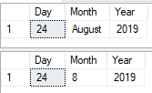 SELECT

DATENAME(DAY, '2019-08-24') AS [Day ],

DATENAME(MONTH, '2019-08-24') AS [Month],

DATENAME(YEAR, '2019-08-24') AS [Year ]

SELECT

Datepart(DAY, '2019-08-24') AS [Day ],

Datepart(MONTH, '2019-08-24') AS [Month],

Datepart(YEAR, '2019-08-24') AS [Year ]

**Task No. 3:** Example 4: Adding or Subtracting Date/Time Parts from Dates

**Solution:**

SELECT

DATEADD(MINUTE, -20, GETDATE()) AS Minute_Subtract,

GETDATE() AS [Current_Date],

DATEADD(MINUTE, 30, GETDATE()) AS Minute_Add

--For Date

SELECT

EOMONTH(GETDATE()) AS [Current_Day],

EOMONTH(GETDATE(), -1) AS Subtract_Day,

EOMONTH(GETDATE(), 1) AS Add_DaY

**OUTPUT**:

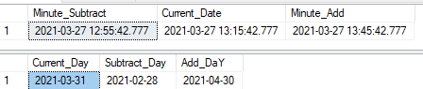

**Task No. 4:** Example 5: Calculating Differences between Dates or Times

**Solution:**

SELECT

DATEDIFF(DAY, GETDATE(), EOMONTH(GETDATE())) AS H,

DATEDIFF(DAY, GETDATE(), DATEADD(MINUTE, 3000, GETDATE())) AS I,

DATEDIFF(HOUR, '2019-01-01 00:00:00', GETDATE()) AS J,

DATEDIFF(SECOND, '2019-08-02 07:30:00', '2019-08-10 19:30:00') AS K

**OUTPUT**:



**Task No. 5:** How many orders were shipped within two days?

**Solution:** **OUTPUT**:

SELECT

COUNT(OrderId) AS ShippedOnTime

FROM Orders

WHERE DATEDIFF(DAY, OrderDate, ShippedDate) <= 2;

**Task No. 6:** Which employees were hired more than 26 years ago as of the last day of the current month?

**Solution:**

SELECT

CONCAT(FirstName, ' ', LastName) AS Employee,

HireDate

FROM Employees

WHERE HireDate < DATEADD(YEAR, -26, EOMONTH(GETDATE()))

**OUTPUT**:

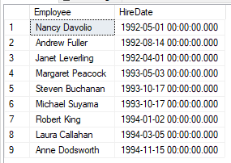

**Task No. 7:** what are the months with the greatest and lowest number of orders?

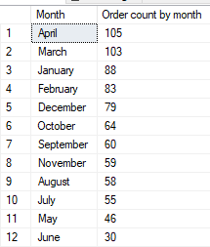**Solution: OUTPUT**:

SELECT

DATENAME(MONTH, OrderDate) AS [Month],

COUNT(OrderId) AS [Order count by month]

FROM Orders

GROUP BY DATENAME(MONTH, OrderDate)

ORDER BY Count(OrderId) DESC