Bahria University,

Karachi Campus



LAB EXPERIMENT NO.

___04____

LIST OF TASKS

|  |  |
| --- | --- |
| TASK NO | OBJECTIVE |
| 1 | Get shipper’s Company Name for an order using inner join. (Display only orderID from orders and comapnayName from Customers table) |
| 2 | Display Product’s name and their supplier’s name (ContactName), whose supplier’s name doesnot contain Dirk and there should be at most 7 characters in Product’s name. |
| 3 | Create a report showing order ID. OrderDate. EmployeeID, and the firstname and LastName of the associated Employee (Tables: Employees & Orders ) |
| 4 | Count no of Products’s against each suppliers name. list only those products whose count is greater than 3. |
| 5 | Display Region ID, Region Description, Territories Description and (inner join with table Territories and Region) |
| 6 | Display Company Name and Total orders placed by the company (Table: orders, customer, use inner join, group by) |
| 7 | List distinct cities from of customers and suppliers, country must be Germany. |
| 8 | List all cities (duplicate values allowed)from of customers and suppliers |
| 9 | lists all customers and suppliers (ContactName, City, Country) |

Submitted On:

____________

(Date: / /2021)

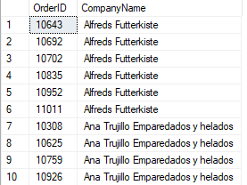**Task No. 1:** Get shipper’s Company Name for an order using inner join. (Display only orderID from orders and comapnayName from Customers table)

**Solution:** SELECT Orders.OrderID,Customers.CompanyName

FROM Orders INNER JOIN Customers ON Orders.CustomerID=Customers.CustomerID

**OUTPUT**:

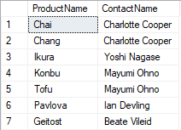**Task No. 2:** Display Product’s name and their supplier’s name (ContactName), whose supplier’s name doesnot contain Dirk and there should be at most 7 characters in Product’s name.

**Solution:** select Products.ProductName,Suppliers.ContactName from Products inner join Suppliers on Suppliers.SupplierID=Products.SupplierID

where ContactName not like '%Dirk%' and len(ProductName)<=7

**OUTPUT**:

**Task No. 3:** Create a report showing order ID. OrderDate. EmployeeID, and the firstname and LastName of the associated Employee (Tables: Employees & Orders )

**Solution:** select Orders.OrderID,Orders.OrderDate,Employees.EmployeeID,Employees.FirstName+Employees.LastName

as [Full Name] from Employees

inner join Orders on Employees.EmployeeID=Orders.EmployeeID

**OUTPUT**:

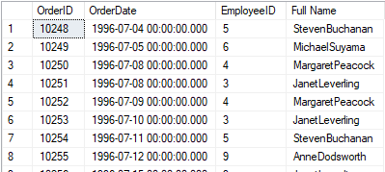

**Task No.4 :** Count no of Products’s against each suppliers name. list only those products whose count is greater than 3.

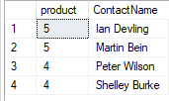**Solution:** select count(Products.ProductID) as product ,Suppliers.ContactName from Products inner join Suppliers

on Products.SupplierID=Suppliers.SupplierID group by Suppliers.ContactName

having count(Products.ProductID) > 3

**OUTPUT**:

**Task No. 5:** Display Region ID, Region Description, Territories Description and (inner join with table Territories and Region)

**Solution:** select Region.RegionID,Region.RegionDescription,Territories.TerritoryDescription from Region inner join

Territories on Region.RegionID=Territories.RegionID

**OUTPUT**:

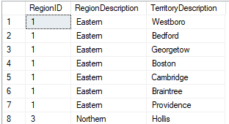

**Task No. 6:** Display Company Name and Total orders placed by the company (Table: orders, customer, use inner join, group by)

**Solution:** select Customers.CompanyName, count(orders.OrderID) as Order_placed from Customers inner join Orders on Customers.CustomerID=

orders.CustomerID group by Customers.CompanyName

**OUTPUT**:

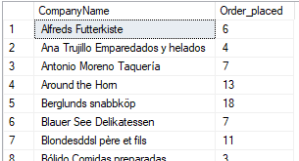

**Task No. 7:** List distinct cities from of customers and suppliers, country must be Germany.

**Solution:** select distinct city from Customers where Country='germany'

union select distinct city from Suppliers where Country='germany'

**OUTPUT**:

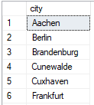

**Task No.8:** List all cities (duplicate values allowed)from of customers and suppliers

**Solution:** select city from Customers union all select city from Suppliers

**OUTPUT**:

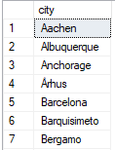

**Task No. 9:** lists all customers and suppliers (ContactName, City, Country)

**Solution:** select ContactName,City,Country from Customers union all

select ContactName,City,Country from Suppliers

**OUTPUT**:

