Bahria University,

Karachi Campus



LAB EXPERIMENT NO.

___04____

LIST OF TASKS

|  |  |
| --- | --- |
| TASK NO | OBJECTIVE |
| 1 | Display Product Name and its Category Name where Category Name starts with B (Hint: Left join category and product, use wild card) |
| 2 | Display Titles and their quantity (Hint Pubs database, table title and sales, left join) |
| 3 | Use Right join to display Book Title and publisher Names (Hint pubs Database,  Table Title and Publisher) Write down the reason for any null values if coming in title column. |
| 4 | User Right join to display those publishers where title is null. |
| 5 | Use self-join to display Publishers name where country is same (Publisher id should be different) Sample example |
| 6 | Use cross join (Cartesian join) to Display Book Title and Publisher Name. |
| 7 | Use two full joins to Display Product Name, Category Name and Supplier Name (Hint: Below Example) |
| 8 | Use full join to display the name of Supplier for the product starting with letter C (Hint: Northwind) |
|  |  |

Submitted On:

____________

(Date: 6 /04/2021)

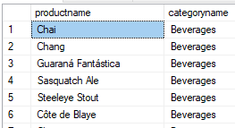**Task No. 1:** Display Product Name and its Category Name where Category Name starts with B (Hint: Left join category and product, use wild card)

**Solution:** select products.productname,categories.categoryname from products right join categories on products.categoryid=categories.categoryid where categoryname like 'B%'

**OUTPUT**:

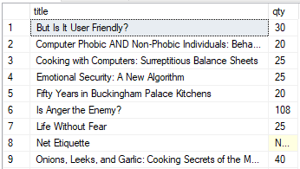**Task No. 2:** Display Titles and their quantity (Hint Pubs database, table title and sales, left join)

**Solution:** select titles.title,sum(sales.qty) as qty

from titles left join sales on titles.title_id=sales.title_id group by titles.title

**OUTPUT**:

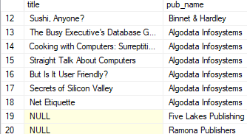**Task No. 3:** Use Right join to display Book Title and publisher Names (Hint pubs Database,

Table Title and Publisher) Write down the reason for any null values if coming in title column.

**Solution:** select titles.title,publishers.pub_name from titles right join publishers on titles.pub_id=publishers.pub_id

**OUTPUT**:

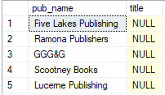**RESON**: [***The result is NULL from the left side, if there is no match***. ]

**Task No. 4:** User Right join to display those publishers where title is null.

**Solution:** select publishers.pub_name,titles.title from titles right join publishers on titles.pub_id=publishers.pub_id where titles.title is null

**OUTPUT**:

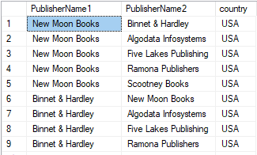**Task No. 5:** Use self-join to display Publishers name where country is same (Publisher id should be different) Sample example

**Solution:** SELECT A.pub_name AS PublisherName1, B.pub_name AS PublisherName2, A.country

FROM publishers A, publishers B

where A.country=B.country

and A.pub_id<>B.pub_id

**OUTPUT**:

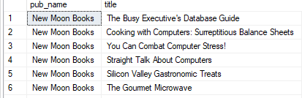**Task No. 6:** Use cross join (Cartesian join) to Display Book Title and Publisher Name.

**Solution:** select publishers.pub_name,titles.title from titles cross join publishers

**OUTPUT**:

**Task No. 7:** Use two full joins to Display Product Name, Category Name and Supplier Name (Hint: Below Example)

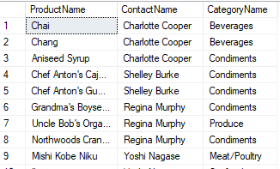**Solution:** select Products.ProductName,Suppliers.ContactName,Categories.CategoryName from products full join suppliers on Products.SupplierID=Suppliers.SupplierID full join Categories on Products.CategoryID =Categories.CategoryID;

**OUTPUT**:

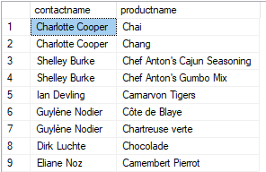**Task No. 8:** Use full join to display the name of Supplier for the product starting with letter C (Hint: Northwind)

**Solution:** select suppliers.contactname,products.productname from suppliers full outer join products on suppliers.supplierid=products.supplierid

where products.productname like 'C%'

**OUTPUT**: