Bahria University,

Karachi Campus



LAB EXPERIMENT NO.

___12____

LIST OF TASKS

|  |  |
| --- | --- |
| TASK NO | OBJECTIVE |
| 1 | Implement the FIFO and LRU policies described above in C language. |
| 2 | Execute both programs for the same set of reference strings. What difference did you  observe? Comment. |
|  |  |
|  |  |
|  |  |

Submitted On:

____________

(Date: / /2021)

**Task No. 1:** Implement the FIFO and LRU policies described above in C language.

**Solution:**

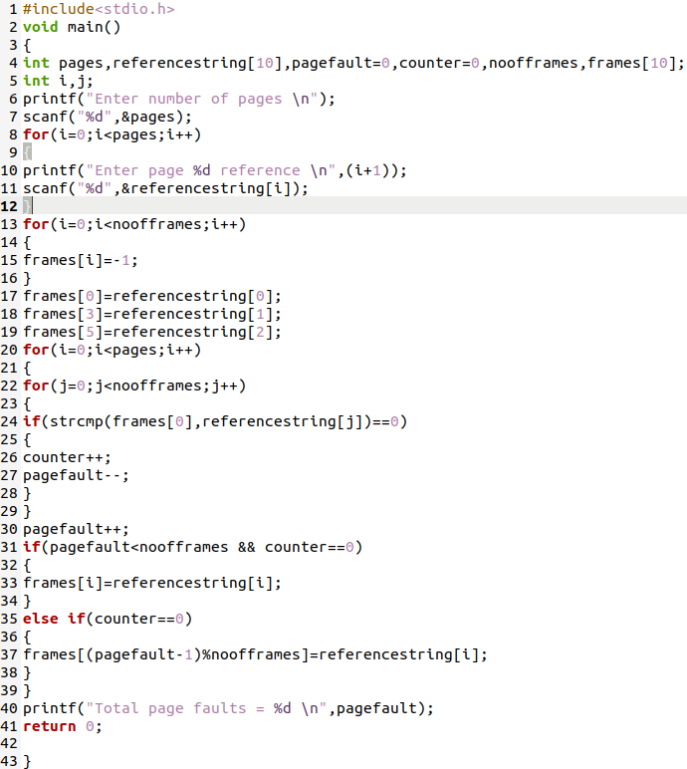

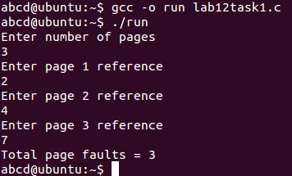

**RLU**

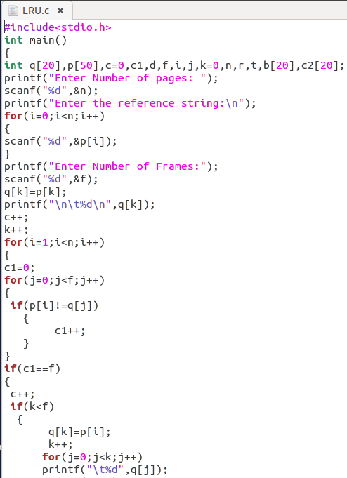

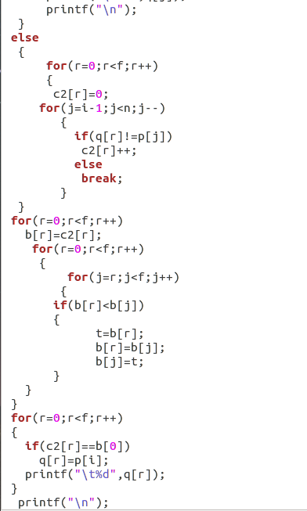

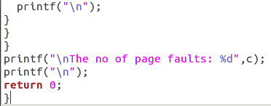

**Output:**

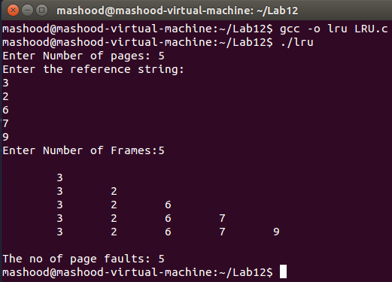

**Task No. 2:**. Execute both programs for the same set of reference strings. What difference did you

observe? Comment.

**Solution:**

**LRU** means Least Recently Used and the idea of this policy is to replace the blocks less used **in the** cache memory. ... The main **difference between LRU** and **FIFO** is after a hit. **FIFO** does not changes the order of the blocks **in the** cache, **LRU** instead puts the hit block into the newest position.