Bahria University,

Karachi Campus



COURSE: CSC-320 OPERATING SYSTEM

TERM:

Spring-2021, CLASS: BSE- 4 (A)

Submitted By:

_____________ ADIL WAHEED__________

(Enrollment #02-131192-082) Reg #65190)

Submitted To:

Engr. RIZWAN FAZAL / Engr. RAHEMEEN

Signed Remarks: Score:

INDEX

|  |  |  |  |  |
| --- | --- | --- | --- | --- |
| SNO | DATE | LAB NO | LAB OBJECTIVE | SIGN |
|  |  |  |  |  |
|  |  |  |  |  |
|  |  |  |  |  |
|  |  |  |  |  |
|  |  |  |  |  |
|  |  |  |  |  |
|  |  |  |  |  |
|  |  |  |  |  |
|  |  |  |  |  |
|  |  |  |  |  |
|  |  |  |  |  |
|  |  |  |  |  |
|  |  |  |  |  |
|  |  |  |  |  |

Bahria University,

Karachi Campus



LAB EXPERIMENT NO.

___01____

LIST OF TASKS

|  |  |
| --- | --- |
| TASK NO | OBJECTIVE |
| 1 | **By using the command line shell interface, practice the commands given in this lab. Write briefly about the usage of each command** |
| 2 | **By using gedit, open a text editor and write the C program That print your name. Save the written file as “name.c”. In order to compile and execute the output file, do the following:**   * **$ gcc - o name name.c** * **$ ./name** |
| 3 | **: Make changes within the above program to display a new output text as given below. Write down the developed program.**   * **Hello World! I am studying Operating Systems.** * **My name is “Enter your name”.** * **My registration number is “Enter your registration number”.** * **I belong to Bahria University Karachi Campus.** |
|  |  |
|  |  |

Submitted On:

____________

(Date: / /2021)

**Task No. 1: By using the command line shell interface, practice the commands given in this lab. Write briefly about the usage of each command**

**Solution:& OUTPUT**:

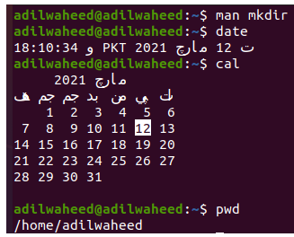

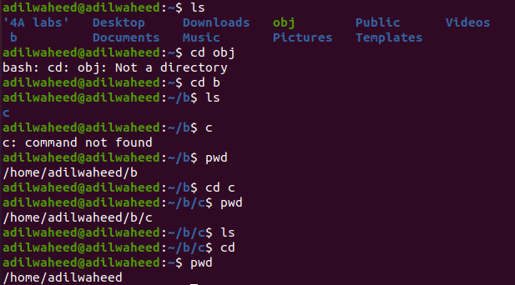

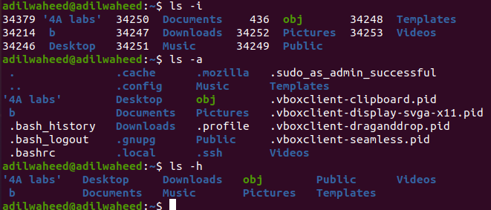

**Task No. 2: By using gedit, open a text editor and write the C program That print your name. Save the written file as “name.c”. In order to compile and execute the output file, do the following:**

* **$ gcc - o name name.c**
* **$ ./name**

**Solution:& OUTPUT**:

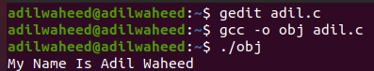

**Task No. 3: Make changes within the above program to display a new output text as given below. Write down the developed program.**

* **Hello World! I am studying Operating Systems.**
* **My name is “Enter your name”.**
* **My registration number is “Enter your registration number”.**
* **I belong to Bahria University Karachi Campus. Solution: & OUTPUT:** 