Bahria University,

Karachi Campus



LAB EXPERIMENT NO.

___03____

LIST OF TASKS

|  |  |
| --- | --- |
| TASK NO | OBJECTIVE |
| 1 | **Perform all the commands provided in the lab manual** |
| 2 | **Create an empty file with a .txt extension. Write a shell script that would write the current date, student’s name and registration number into that file, while using variables for all three entries.** |
| 3 | **Create a .txt file and input ten lines of entry while mixing it with both alphanumeric characters. Sort the contents of the created file in an ascending order and write the sorted output into another file.** |
| 4 | **Write C language programs that would generate the following for a given number $x$, e.g. $x=30$: Calculate the factorial of $x$.** |
| 5 | **write a Program to Sum of Natural Numbers Using for Loop** |

Submitted On:

____________

(Date: / /2021

**Task 1:**

**Perform all the commands provided in the lab manual**

**Solution: & OUTPUT**:

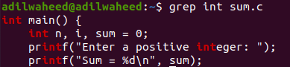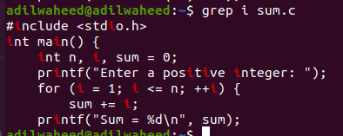**GREP:**

**FIND:**

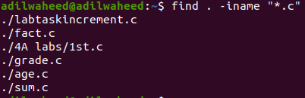



**VARIABLES AND SORT:**

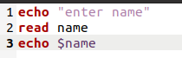

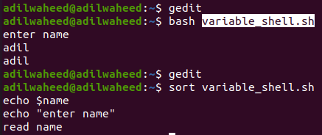

**Task 2:**

**Create an empty file with a .txt extension. Write a shell script that would write the current date, student’s name and registration number into that file, while using variables for all three entries.**

**Solution: & OUTPUT**:

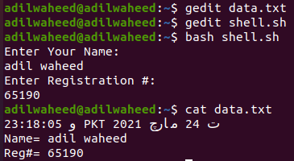

**Task 3:**

**Create a .txt file and input ten lines of entry while mixing it with both alphanumeric characters. Sort the contents of the created file in an ascending order and write the sorted output into another file.**

**Solution: & OUTPUT**:

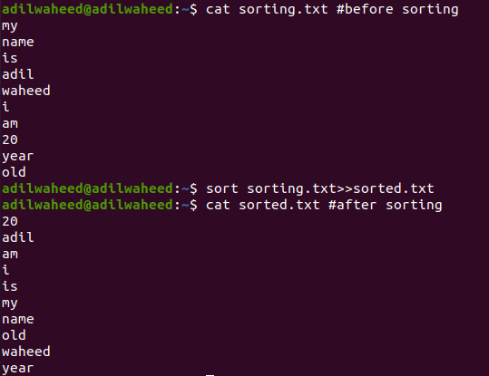

**Task 4: Write C language programs that would generate the following for a given number $x$, e.g. $x=30$: Calculate the factorial of $x$.**

**Solution:& OUTPUT**:

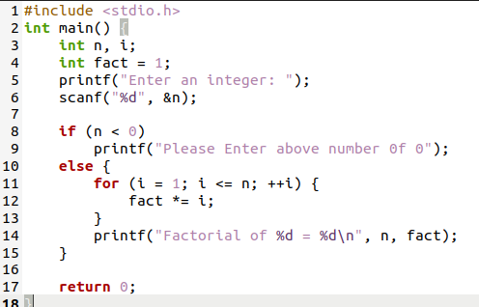

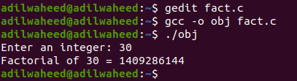

**Task 5:**

**write a Program to Sum of Natural Numbers Using for Loop**

**Solution: & OUTPUT**:

