Bahria University,

Karachi Campus



LAB EXPERIMENT NO.

___05____

LIST OF TASKS

|  |  |
| --- | --- |
| TASK NO | OBJECTIVE |
| 1 | **While utilizing the Linux commands studied so far, provide an example (other than the one shown in this Lab) of a combination of several Linux commands in which pipes are used more than once. Also provide a snapshot of the generated output.** |
| 2 | **Write C program to print all alphabets from a to z using while loop.(using ASCII)** |
| 3 | **Write a shell script that records the full path of all the files present within a directory into a record.txt file. Along with full path name, the script should also record the number of words, characters and lines within each file** |
| 4 | **Write a C program that asks the user to provide an integer input in the main() function. The program would call a function even_odd() from the main() function, where the function even_odd() accepts an integer as an argument, determine and display if the passed integer is either even or odd** |
|  |  |

Submitted On:

____________

(Date: / /2021)

**Task No. 1: While utilizing the Linux commands studied so far, provide an example *(other than the one shown in this Lab)* of a combination of several Linux commands in which pipes are used more than once. Also provide a snapshot of the generated output.**

**Solution: & OUTPUT**:

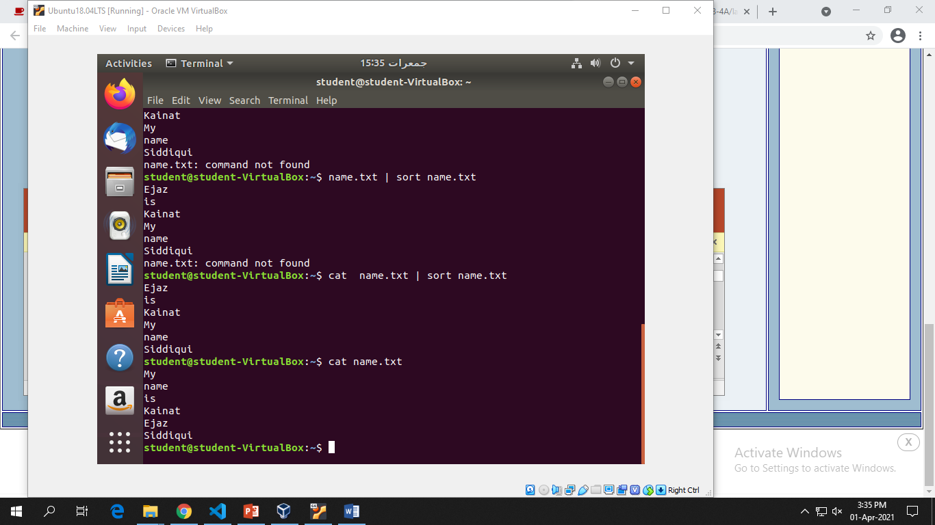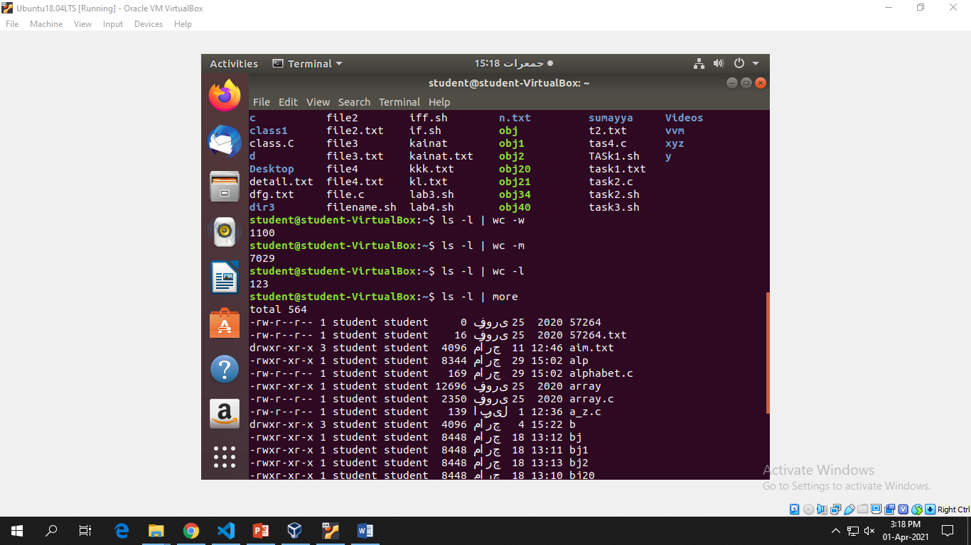

**Task No. 2: Write C program to print all alphabets from a to z using while loop.(using ASCII)**

**Solution: & OUTPUT**:

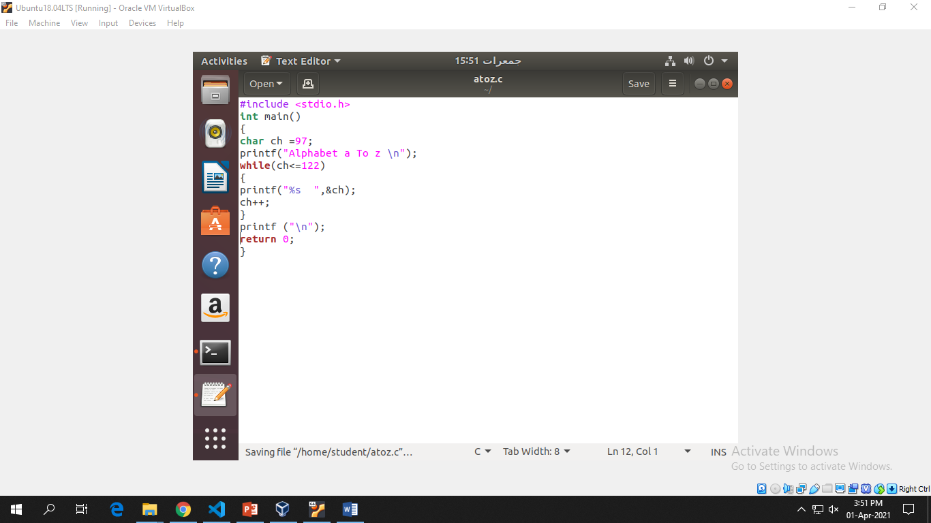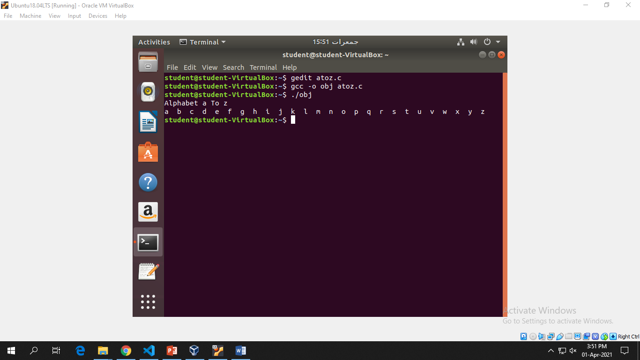

**Task No. 3: Write a shell script that records the full path of all the files present within a directory into a record.txt file. Along with full path name, the script should also record the number of words, characters and lines within each file**

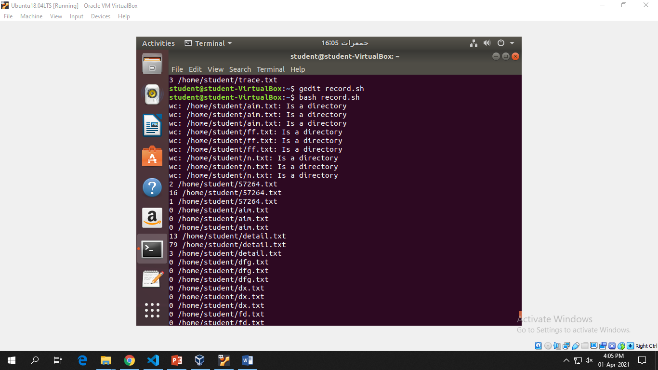**Solution: & OUTPUT**:

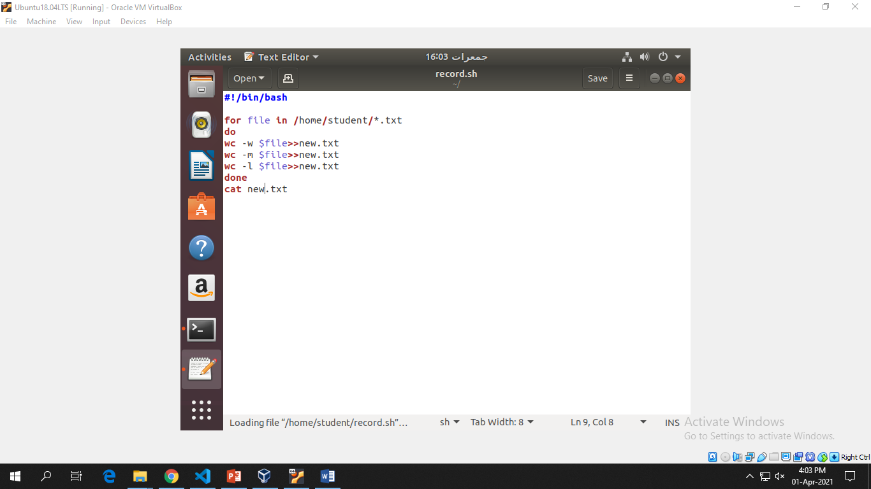

**Task No. 4: Write a C program that asks the user to provide an integer input in the main() function. The program would call a function even_odd() from the main() function, where the function even_odd() accepts an integer as an argument, determine and display if the passed integer is either even or odd**

**Solution: & OUTPUT**:

