Bahria University,

Karachi Campus



LAB EXPERIMENT NO.

___06____

LIST OF TASKS

|  |  |
| --- | --- |
| TASK NO | OBJECTIVE |
| 1 | **Write what you have learned in few lines on each of the three programs that were using the *fork()* system call** |
| 2 | **Write a C program that uses *fork()* system call to print a single line eight times without using *for* loop and repeated *printf* command** |
| 3 | **Code the C program given below and explain what it does along with providing a snapshot of the output. Investigate and write about the usage of *execlp()* system call.** |
| 4 | **Write a program to declare a counter variable initialized by zero. After fork() system call two processes will run in parallel both incrementing their own version of counter and print numbers 1 -5 . After printing numbers child process will sleep for three second, then print process id of its grandparent and terminates by invoking a gedit editor. Meanwhile, its parent waits for its termination.** |
|  |  |

Submitted On:

____________

(Date: / /2021)

**Task No. 1: Write what you have learned in few lines on each of the three programs that were using the *fork()* system call**

**Solution: & OUTPUT**:

Generate a copy that you were inserted.

**Task No. 2: Write a C program that uses *fork()* system call to print a single line eight times without using *for* loop and repeated *printf* command**

**Solution: & OUTPUT**:

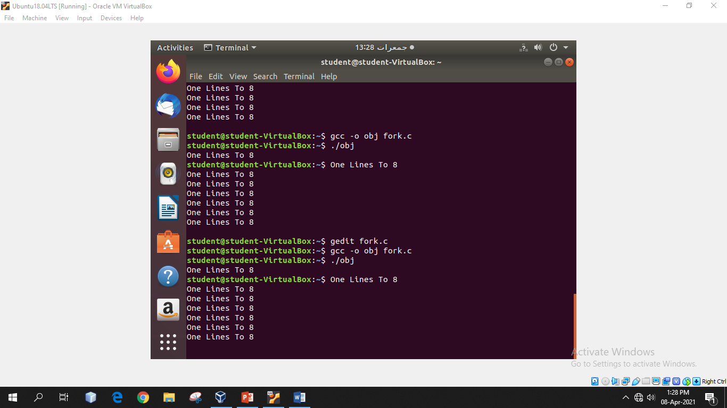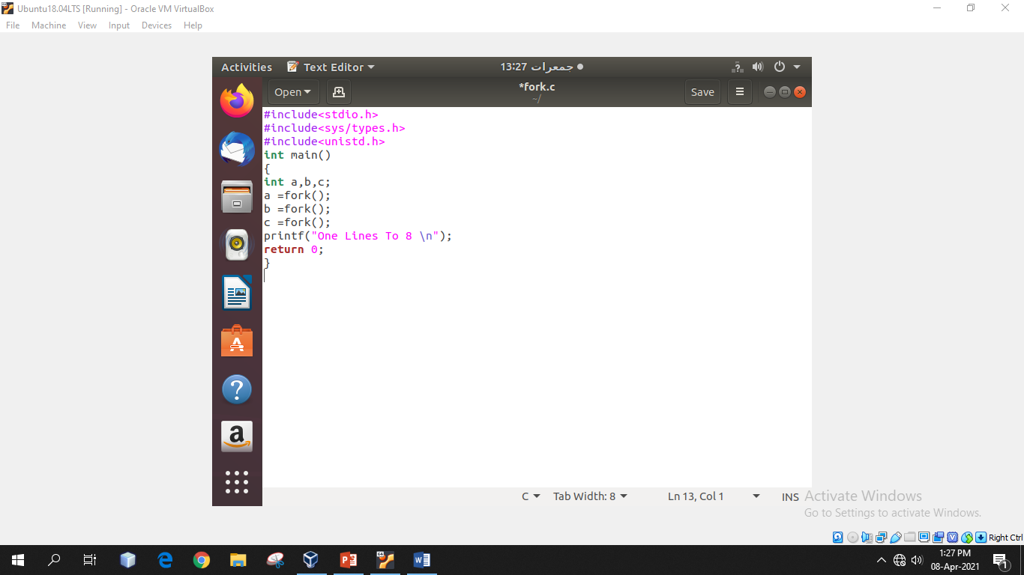

**Task No. 3: Code the C program given below and explain what it does along with providing a snapshot of the output. Investigate and write about the usage of *execlp()* system call.**

**Solution: & OUTPUT**:

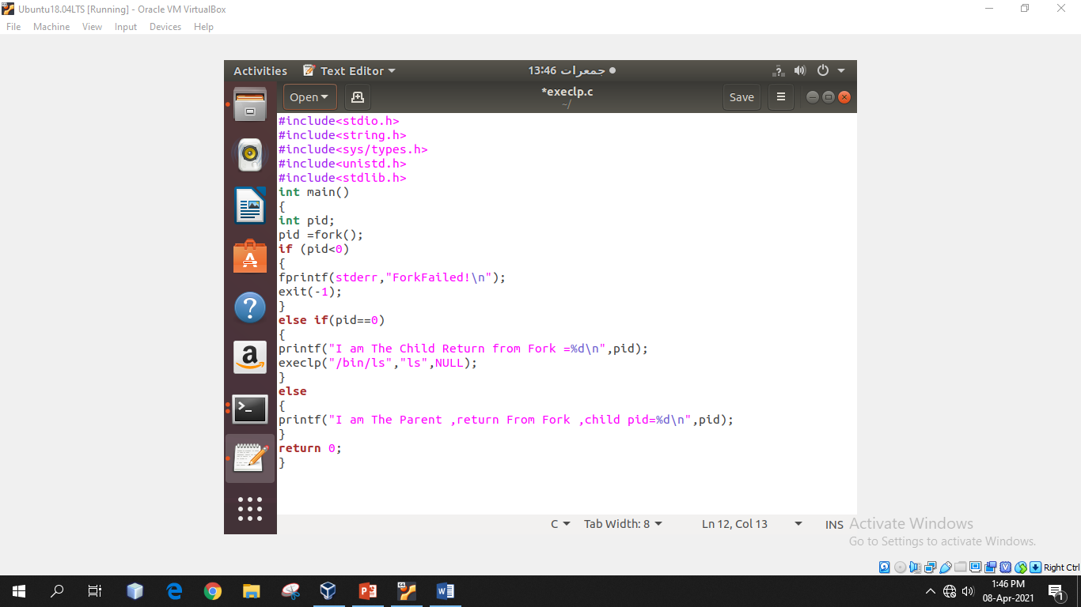

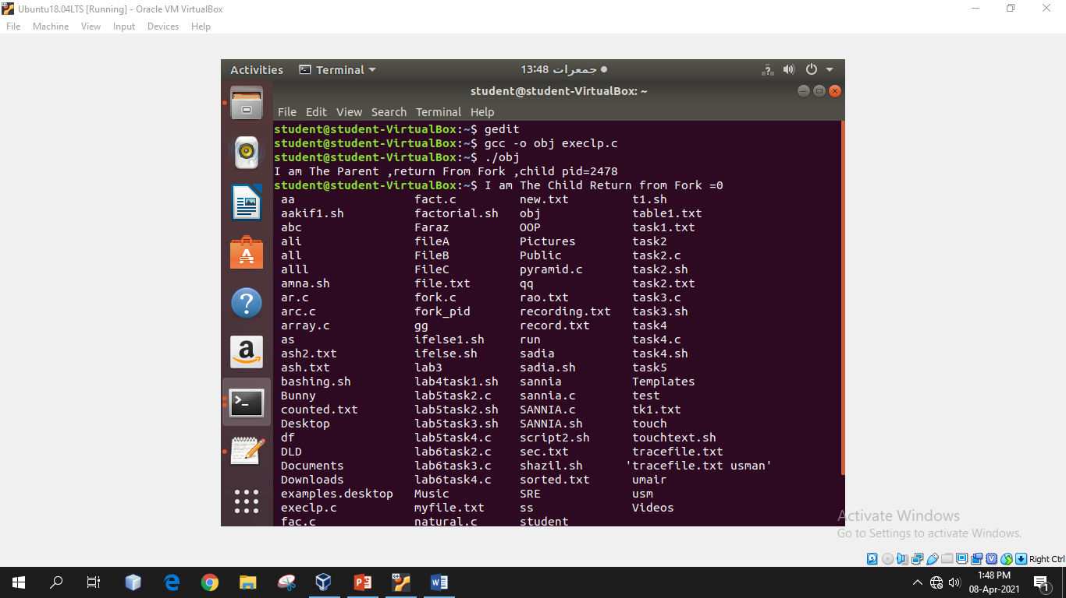

**Task No. 4:Write a program to declare a counter variable initialized by zero. After fork() system call two processes will run in parallel both incrementing their own version of counter and print numbers 1 -5 . After printing numbers child process will sleep for three second, then print process id of its grandparent and terminates by invoking a gedit editor. Meanwhile, its parent waits for its termination.**

**Solution: & OUTPUT**: