**Bahria University,**

**Karachi Campus**



**LAB EXPERIMENT NO.**

**07**

**LIST OF TASKS**

|  |  |
| --- | --- |
| TASK NO | OBJECTIVE |
| 1 | Implement the codes of Example#01 and Example#01. Discuss what you have learned after implementing and executing these two codes. Provide snapshots of the generated outputs. |
| 2 | The FCFS source code given above assumes that the arrival times for processes are provided in ascending order of time. Modify the code in C language for random process arrival times. |
| 3 | Modify the FCFS code of example#02 to be able to calculate the mean of Normalized Turnaround Time. Also the modified code should display the Normalized Turnaround Time of each process. |
|  |  |
|  |  |

**Submitted On:**

**/ /2020**

**(Date: DD/MM/YY)**

**TASK NO 1:**

Implement the codes of Example#01 and Example#01. Discuss what you have learned after implementing and executing these two codes. Provide snapshots of the generated outputs.

**OUTPUT:**

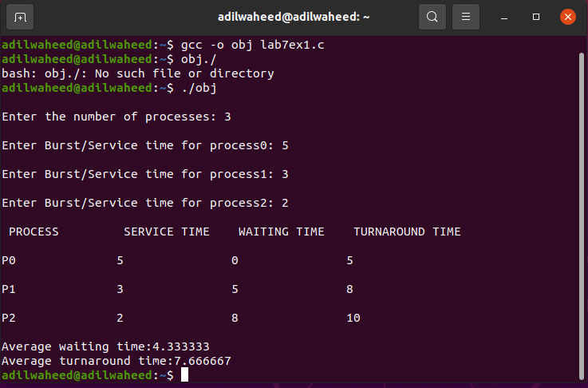

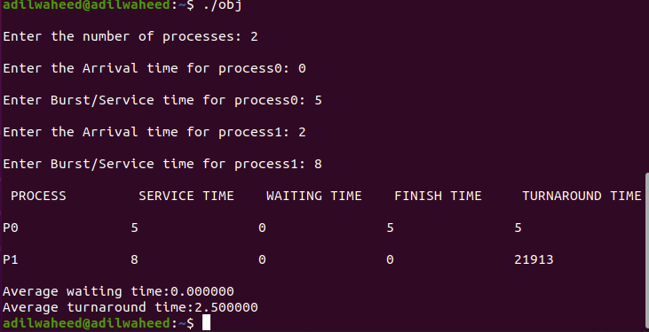

**TASK NO 2:** The FCFS source code given above assumes that the arrival times for processes are provided in ascending order of time. Modify the code in C language for random process arrival times.

**OUTPUT**

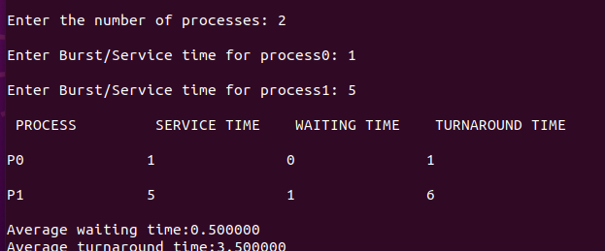

**TASK NO 3:**

Modify the FCFS code of example#02 to be able to calculate the mean of Normalized Turnaround Time. Also the modified code should display the Normalized Turnaround Time of each process.

**OUTPUT:**

