Bahria University,

Karachi Campus



COURSE: CSL-221 SOFTWARE DESIGN AND ARCHITECTURE

TERM:

Spring-2021, CLASS: BSE- 4 (A)

Submitted By:

_____________ ADIL WAHEED__________

(Enrollment #02-131192-082) Reg #65190)

Submitted To:

Engr:Mr.MAJEED KALEEM / Engr. MUHAMMAD REHAN BAIG

Signed Remarks: Score:

INDEX

|  |  |  |  |  |
| --- | --- | --- | --- | --- |
| SNO | DATE | LAB NO | LAB OBJECTIVE | SIGN |
|  |  |  |  |  |
|  |  |  |  |  |
|  |  |  |  |  |
|  |  |  |  |  |
|  |  |  |  |  |
|  |  |  |  |  |
|  |  |  |  |  |
|  |  |  |  |  |
|  |  |  |  |  |
|  |  |  |  |  |
|  |  |  |  |  |
|  |  |  |  |  |
|  |  |  |  |  |
|  |  |  |  |  |

Bahria University,

Karachi Campus



LAB EXPERIMENT NO.

___01_and 02___

LIST OF TASKS

|  |  |
| --- | --- |
| TASK NO | OBJECTIVE |
| 1 | Create class diagram with 5 classes and apply forward engineering approaches to generate code |
| 2 | From forward engineering update your Generated java code and add attributes and operations in your classes. |
| 3 | Reverse Engineer your edited code in task2 and display updated UML diagram |
| 4 | Create 4 Components Each Component contains at least 5 Classes |
|  |  |

Submitted On:

____________

(Date: 16/5/2021)

**Task No. 1:task 1 of lab1:**

1: Create class diagram with 5 classes and apply forward engineering approaches to generate code

2: From forward engineering update your Generated java code and add attributes and operations in your classes.

3: Reverse Engineer your edited code in task2 and display updated UML diagram

**Solution: & OUTPUT**:component 1:

Bank is the main module and further break into 4 components

Forward Engineering:

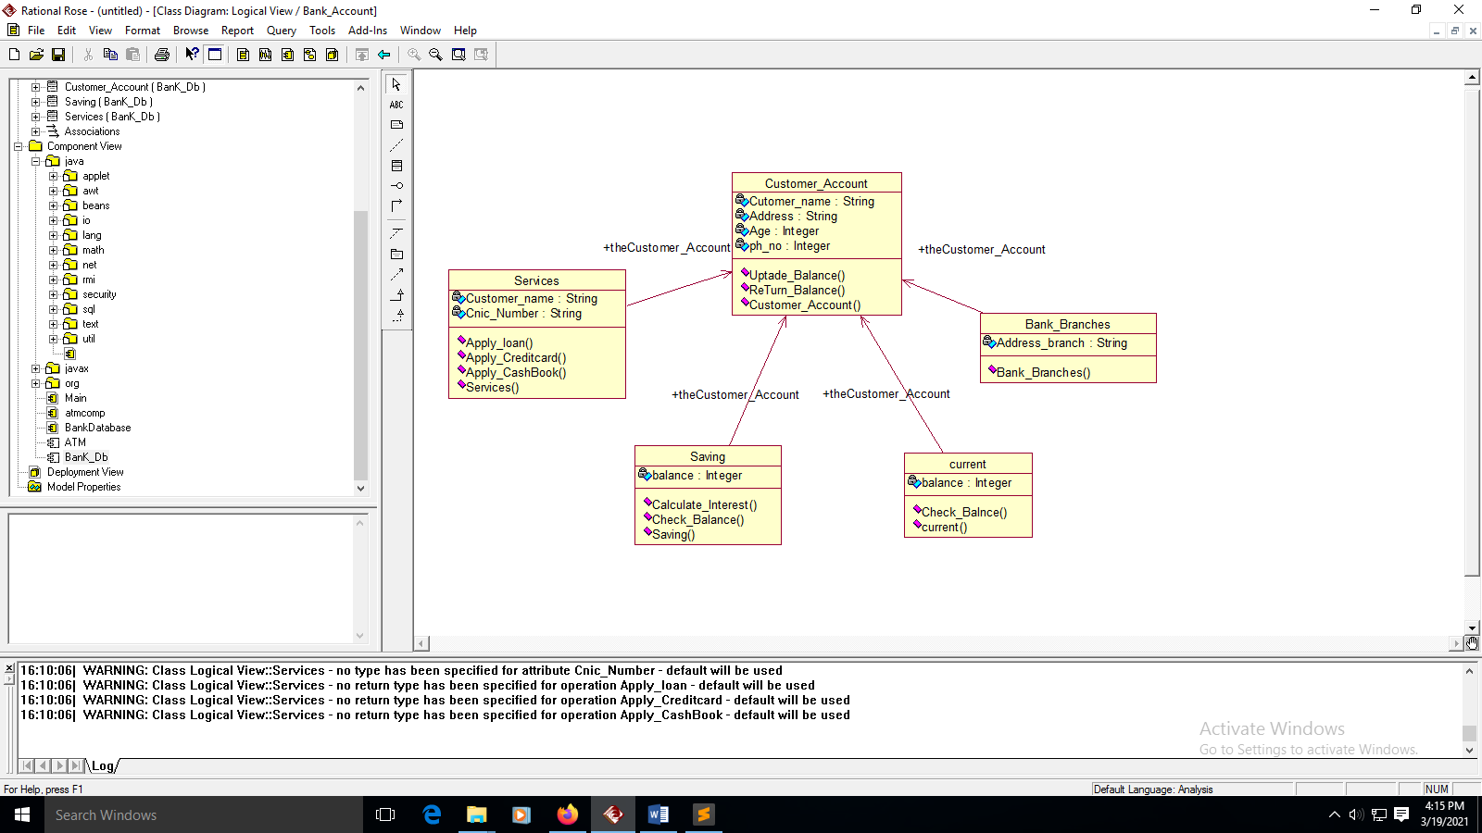

Reverse Engineering:

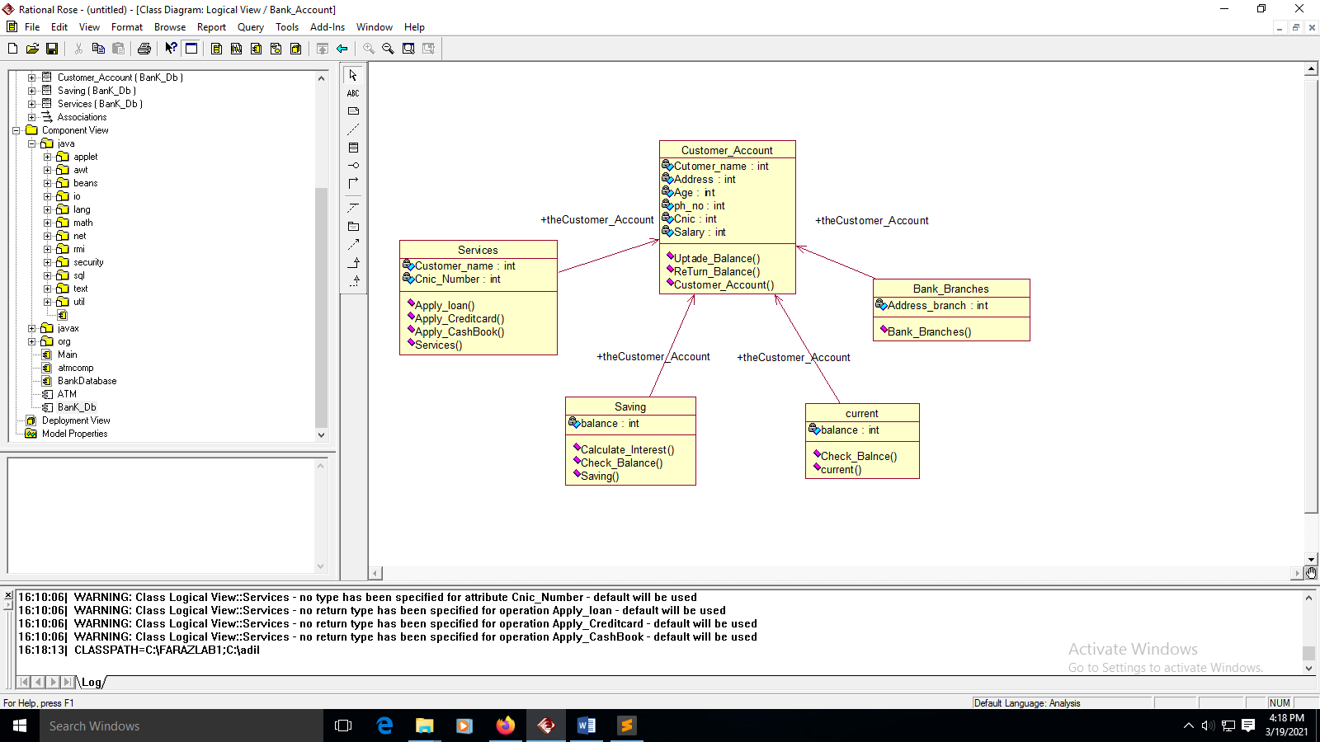

**Task No. 1:** Create 4 Components Each Component contains at least 5 Classes

**Solution: & OUTPUT**:

*component 2:*

Forward Engineering:

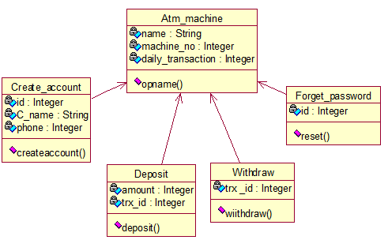

Reverse Engineering:

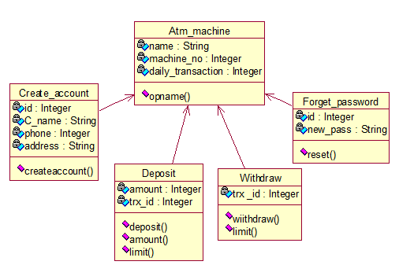

Forward Engineering: *component 3:*

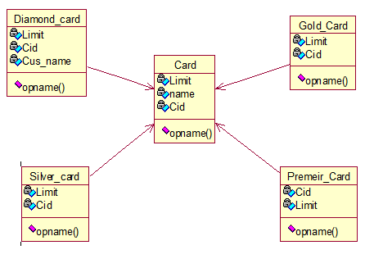

Reverse Engineering:

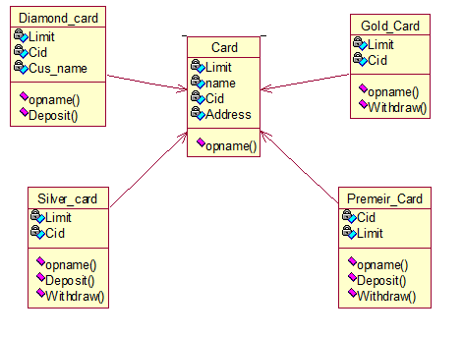

Forward Engineering: *component 4:*

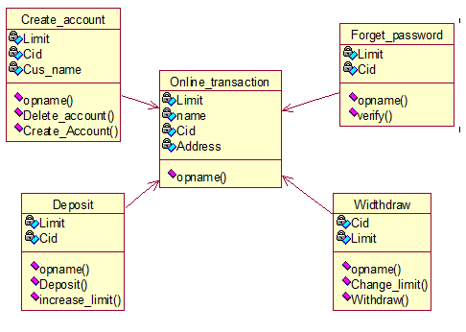

Reverse Engineering:

