Bahria University

Karachi Campus



LAB EXPERIMENT NO.

___3____

LIST OF TASKS

|  |  |
| --- | --- |
| TASK NO | OBJECTIVE |
| 1. | **Implement singleton pattern on printer functionality.** |
| 2. | **Implement singleton pattern on sessions** |
| 3. | **Implement singleton pattern for logger application.** |
|  |  |
|  |  |
|  |  |
|  |  |
|  |  |
|  |  |
|  |  |

Submitted On:

____________

(Date: DD/MM/YY)

**Task no 1:** Implement singleton pattern on printer functionality.

**Code:**

**Printer class:**

class Printer

{

public static Printer _obj;

private Printer()

{

}

public static Printer Getobject()

{

if (_obj == null)

{

_obj = new Printer();

}

return _obj;

}

public void Print(string e)

{

Console.WriteLine(e);

}

}

}

**Main class:**

static void Main(string[] args)

{

Printer PrinterObject = Printer.Getobject();

PrinterObject.Print("Leaser Printer");

Printer PrinterObject2 = Printer.Getobject();

PrinterObject2.Print("\nDot Matrix Printer");

Printer PrinterObject3 = Printer.Getobject();

PrinterObject3.Print("\nDark Printer");

Printer PrinterObject4 = Printer.Getobject();

PrinterObject4.Print("\nInjet Printer");

Console.ReadLine();

}

}

}

**Output:**

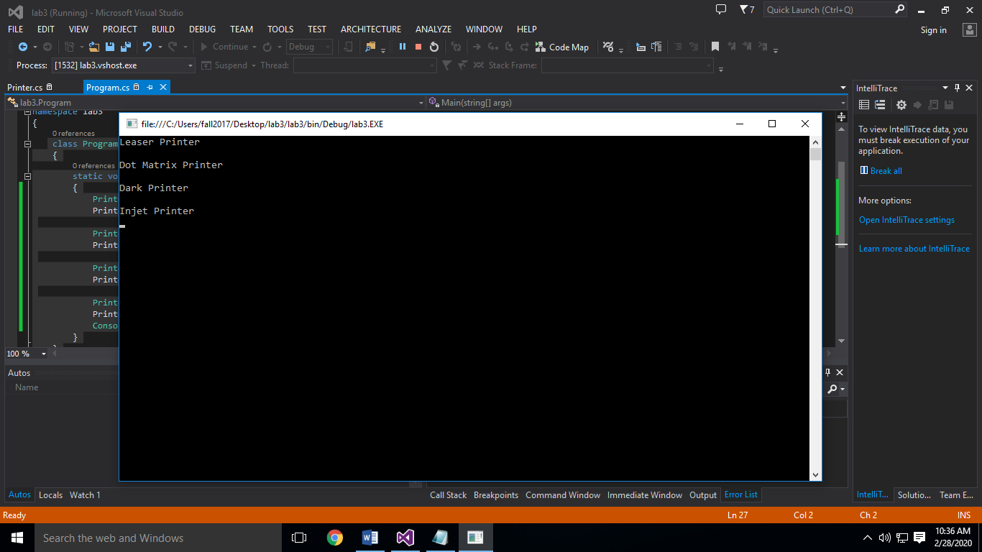

**Task no 2:** Implement singleton pattern on sessions

**Code**:

**Session Class:**

class Session

{

public static Session _obj;

private Session()

{

}

public static Session Getobject()

{

if (_obj == null)

{

_obj = new Session();

}

return _obj;

}

public void Print(string e)

{

Console.WriteLine(e);

}

}

**Main Class:**

static void Main(string[] args)

{

Session SingletonObject = Session.Getobject();

SingletonObject.Print("Session 1\n--------Welcome to Facebook---------\n\n");

Session SingletonObject2 = Session.Getobject();

SingletonObject2.Print("Session 2\n-------Please Login here----------\n\n");

Session SingletonObject3 = Session.Getobject();

SingletonObject3.Print("Session 3\n-----------Home---------------\n\n");

Session SingletonObject4 = Session.Getobject();

SingletonObject4.Print("Session 4\n----------Profile---------------\n\n");

Session SingletonObject5 = Session.Getobject();

SingletonObject5.Print("Session 5\n----------Setting---------------\n\n");

Console.ReadLine();

}

}

}

**Output:**

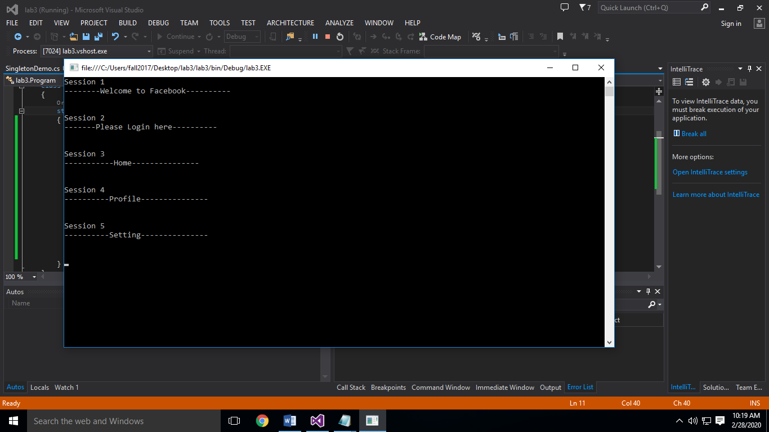

**Task no 3:** Implement singleton pattern for logger application.

**Code:**

**Logger Class:**

class Logger

{

public static Logger _obj;

private Logger()

{

}

public static Logger Getobject()

{

if (_obj == null)

{

_obj = new Logger();

}

return _obj;

}

public void Print(string e)

{

Console.WriteLine(e);

}

}

**Main Class:**

class Program

{

static void Main(string[] args)

{

Logger SingletonObject = Logger.Getobject();

SingletonObject.Print("Application 1\n========Runs efficiently========\n\n");

Logger SingletonObject2 = Logger.Getobject();

SingletonObject2.Print("Application 2\n======Found error during the login======\n\n");

Logger SingletonObject3 = Logger.Getobject();

SingletonObject3.Print("Application 3\n==========Intializing==========\n\n");

Logger SingletonObject4 = Logger.Getobject();

SingletonObject4.Print("Application 4\n=========Giving Warnings=========\n\n");

Logger SingletonObject5 = Logger.Getobject();

SingletonObject5.Print("Application 5\n=========Processing Completed=========\n\n");

Console.ReadLine();

}

**Output:**

