Bahria University,

Karachi Campus



LAB EXPERIMENT NO.

04

LIST OF TASKS

|  |  |
| --- | --- |
| TASK NO | OBJECTIVE |
| 01 | **Implement Factory pattern for creating pages and popups(Modals, Alerts, etc.) in website for pages separate interface defined and for popups separate interface defined.** |
| 02 | **Implement factory pattern for creating Ranks/Positions of employees.** |

Submitted On:

16/04/2021

(Date: DD/MM/YY)

**Task No. 1:** Implement Factory pattern for creating pages and popups (Modals, Alerts, etc.) in website for pages separate interface defined and for popups separate interface defined.

**Solution:**

**Main:**

Console.WriteLine("What do you want to look:\n1)Page \n2)Pop-up ");

int x = int.Parse(Console.ReadLine());

Console.Write("Enter that Page or Pop-up Name: ");

string type = Console.ReadLine();

switch (x)

{

case 1:

Page_interface pgobj = CreateObj.get_pageObj(type);

Console.WriteLine(pgobj.get_welcome());

break;

case 2:

popup_Interface popobj = CreateObj.get_popObject(type);

Console.WriteLine(popobj.Be_carefull());

break;

}

**Page:**

interface Page_interface

{

string get_welcome();

}

class Home : Page_interface

{

public string get_welcome()

{

return "Welcome to Home Page";

}

}

class About : Page_interface

{

public string get_welcome()

{

return "Welcome to About Page";

}

}

class Contact : Page_interface

{

public string get_welcome()

{

return "Welcome to Contact Page";

}

}

**Pop-up**

interface popup_Interface

{

string Be_carefull();

}

class Information : popup_Interface

{

public string Be_carefull()

{

return "Welcome to Information Page";

}

}

class Warning : popup_Interface

{

public string Be_carefull()

{

return "Welcome to Warning Page \n Be Alert!";

}

}

**CreateObj**

public static Page_interface get_pageObj(string type)

{

Page_interface pageObj = null;

if (type.ToLower() == "home")

{

pageObj = new Home();

}

else if (type.ToLower() == "about")

{

pageObj = new About();

}

else if (type.ToLower() == "contact")

{

pageObj = new Contact();

}

else

return null;

return pageObj;

}

public static popup_Interface get_popObject(string type)

{

popup_Interface popObj = null;

if (type.ToLower() == "information")

{

popObj = new Information();

}

else if (type.ToLower() == "warning")

{

popObj = new Warning();

}

else

return null;

return popObj;

**Output:**

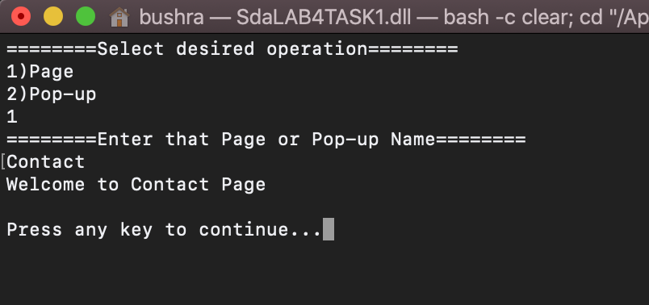

**Task No. 2:** Implement factory pattern for creating Ranks/Positions of employees.

**Solution:**

**Main**

static void Main(string[] args)

{

IEmployee m = new DepartmentManager();

IEmployee t = new Teacher();

m.EmployeeTitle();

m.EmployeeInfo();

m.EmployeeSalary();

t.EmployeeTitle();

t.EmployeeInfo();

t.EmployeeSalary();

Console.ReadLine();

}

}

**Interface:**

interface IEmployee

{

void EmployeeTitle();

void EmployeeSalary();

void EmployeeInfo();

}

**IMPLEMENTATION:**

class Teacher : IEmployee

{

public void EmployeeTitle()

{

Console.WriteLine("Title: Teacher");

}

public void EmployeeSalary()

{

Console.WriteLine("Employee Salary is : 30000");

}

public void EmployeeInfo()

{

Console.WriteLine("Employee Info\nName: Adnan\nPhone No: 0212121121\naddress: abc");

}

}

class DepartmentManager : IEmployee

{

public void EmployeeTitle()

{

Console.WriteLine("Department Manager\nTitle: Manager");

}

public void EmployeeSalary()

{

Console.WriteLine("Employee Salary is : 200000");

}

public void EmployeeInfo()

{

Console.WriteLine("Employee Info\nName: abcd\nPhone No: 0212121121\naddress: xyz");

}

**Output:**

