**Lab No. 10 :Advanced UI**

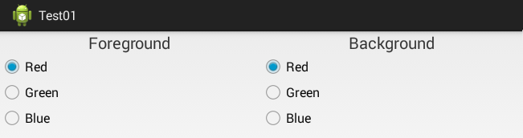**Tasks:**

1. ColorChanger using RadioButton

SOLUTION:

public class MainActivity extends AppCompatActivity {  
  
 RadioGroup radioGroupback,radioGroupFore;  
 RadioButton selectedRadioButton;  
 @Override  
 protected void onCreate(Bundle savedInstanceState) {  
 super.onCreate(savedInstanceState);  
 setContentView(R.layout.*activity_main*);  
 radioGroupback=(RadioGroup)findViewById(R.id.*rdgback*);  
 radioGroupFore=(RadioGroup)findViewById(R.id.*rdgfore*);  
 }  
 public void onClick(View v)  
 {  
 View root=v.getRootView();  
 switch(radioGroupback.getCheckedRadioButtonId())  
 {  
 case R.id.*redbg*:  
 root.setBackgroundColor(Color.*RED*);  
 break;  
 case R.id.*greenbg*:  
 root.setBackgroundColor(Color.*GREEN*);  
 break;  
 case R.id.*bluebg*:  
 root.setBackgroundColor(Color.*BLUE*);  
 break;  
 }  
 }  
 public void onClick1(View view) {  
 selectedRadioButton = (RadioButton)findViewById(radioGroupFore.getCheckedRadioButtonId());  
 switch(radioGroupFore.getCheckedRadioButtonId())  
 {  
 case R.id.*red*:  
 selectedRadioButton.setTextColor(Color.*RED*);  
 break;  
 case R.id.*green*:  
 selectedRadioButton.setTextColor(Color.*GREEN*);  
 break;  
 case R.id.*blue*:  
 selectedRadioButton.setTextColor(Color.*BLUE*);  
 break;  
 }}}

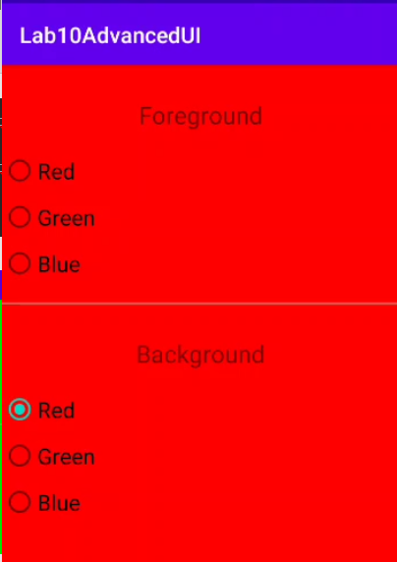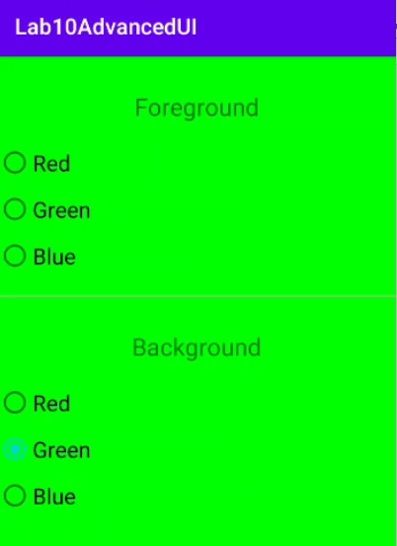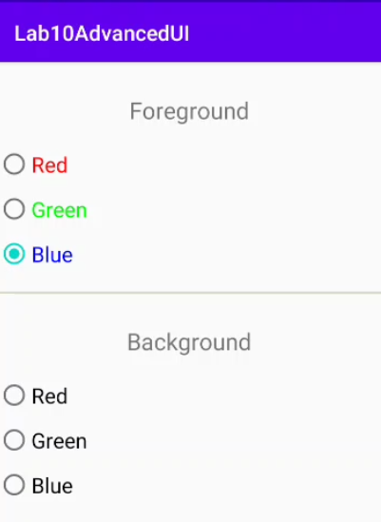OUTPUT:

1. Managing sign up application in which you have list view which allow user to either sign in, cancel or sign up. In sign up activity you have to use radio Button and spinner as per your requirements.

public class MainActivity extends AppCompatActivity {  
  
 RadioGroup radioGroupback,radioGroupFore;  
 RadioButton selectedRadioButton;  
 ListView listView;  
 String[] listItem;  
 @Override  
 protected void onCreate(Bundle savedInstanceState) {  
 super.onCreate(savedInstanceState);  
 setContentView(R.layout.*activity_main*);  
 listView=(ListView)findViewById(R.id.*listView*);  
 listItem = getResources().getStringArray(R.array.*array_Sign*);  
 final ArrayAdapter<String> adapter = new ArrayAdapter<String>(this,  
 android.R.layout.*simple_list_item_1*, android.R.id.*text1*, listItem);  
 listView.setAdapter(adapter);  
 listView.setOnItemClickListener(new AdapterView.OnItemClickListener() {  
 @Override  
 public void onItemClick(AdapterView<?> adapterView, View view, int i, long l) {  
 String value=adapter.getItem(i);  
 if (value.equals("SignUp"))  
 {  
 Intent intent=new Intent(MainActivity.this,Signup.class);  
 startActivity(intent);  
 }  
 Toast.*makeText*(getApplicationContext(),value,Toast.*LENGTH_SHORT*).show();  
 }});}

SIGN UP JAVA CLASS:

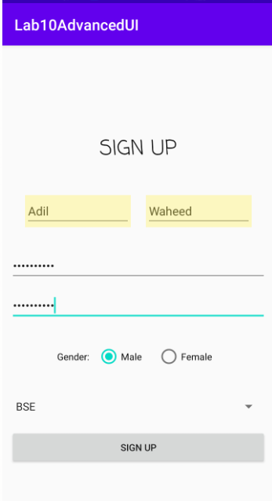public class Signup extends AppCompatActivity implements AdapterView.OnItemSelectedListener {  
 String[] Feild = { "BSE", "BEE", "BBA-2[Year]", "BBA-4[Year]", "Other"};  
 @Override  
 protected void onCreate(Bundle savedInstanceState) {  
 super.onCreate(savedInstanceState);  
 setContentView(R.layout.*activity_signup*);  
 Spinner spin = (Spinner) findViewById(R.id.*spinner*);  
 spin.setOnItemSelectedListener(this);  
 ArrayAdapter aa = new ArrayAdapter(this,android.R.layout.*simple_spinner_item*,Feild);  
 aa.setDropDownViewResource(android.R.layout.*simple_spinner_dropdown_item*);  
 //Setting the ArrayAdapter data on the Spinner  
 spin.setAdapter(aa);  
 }  
 @Override  
 public void onItemSelected(AdapterView<?> adapterView, View view, int i, long l) {  
 Toast.*makeText*(getApplicationContext(),Feild[i] , Toast.*LENGTH_SHORT*).show();  
 }  
 @Override  
 public void onNothingSelected(AdapterView<?> adapterView) {  
 }  
}

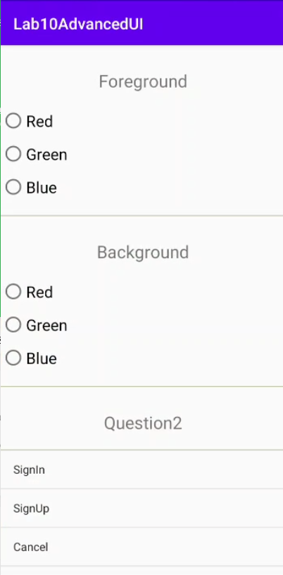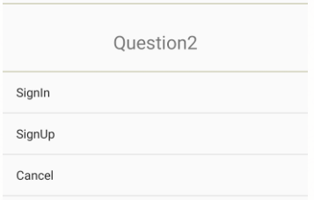OUTPUT: