**Lab No. 8:Services – Started Services**

**Tasks:**

1. Using Toast class, create an application which can demonstrate all callbacks of a ***started*** service.

**Code:**

public class AndriodServices extends Service {  
 private MediaPlayer player;  
 @Override  
 public int onStartCommand(Intent intent, int flags, int startId) {  
 player=MediaPlayer.*create*(this, Settings.System.*DEFAULT_ALARM_ALERT_URI*);  
 player.setLooping(true);  
 player.start();  
 Toast.*makeText*(this, "Service Started", Toast.*LENGTH_SHORT*).show();  
 return *START_STICKY*;  
 }  
 @Override  
 public void onDestroy() {  
 super.onDestroy();  
 player.stop();  
 Toast.*makeText*(this, "Service Destroyed", Toast.*LENGTH_SHORT*).show();  
 }  
 @Nullable  
 @Override  
 public IBinder onBind(Intent intent) {  
 return null;  
 }  
}

public class MainActivity extends AppCompatActivity implements View.OnClickListener {  
private Button start,stop,start1,stop1;  
 @Override  
 protected void onCreate(Bundle savedInstanceState) {  
 super.onCreate(savedInstanceState);  
 setContentView(R.layout.*activity_main*);  
 start=findViewById(R.id.*buttonstart*);  
 stop=findViewById(R.id.*buttonstop*);  
 start1=findViewById(R.id.*buttonstart1*);  
 stop1=findViewById(R.id.*buttonstop1*);  
 start.setOnClickListener(this);  
 stop.setOnClickListener(this);  
 start1.setOnClickListener(this);  
 stop1.setOnClickListener(this);  
 }  
 @Override  
 public void onClick(View view) {  
 if (view ==start)  
 {  
 startService(new Intent(this,AndriodServices.class));  
 }  
 else if (view ==stop)  
 {  
 stopService(new Intent(this,AndriodServices.class));  
 }  
 else if (view ==start1)  
 {  
 startService(new Intent(this,CounterServices.class));  
 }  
 else if (view ==stop1)  
 {  
 stopService(new Intent(this,CounterServices.class));  
 }  
 }  
}   
 <service android:name=".AndriodServices"/>

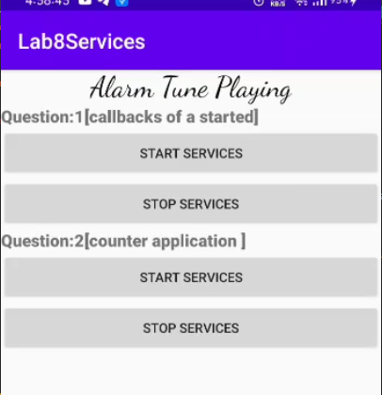OUTPUT:



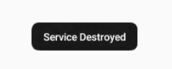



1. Using Toast class, create counter application which can demonstrate all callbacks of a ***started*** service.

CODE:

public class CounterServices extends Service {  
 private MediaPlayer player;  
 private static int *count*=0;  
 @Override  
 public int onStartCommand(Intent intent, int flags, int startId) {  
 player=MediaPlayer.*create*(this, Settings.System.*DEFAULT_ALARM_ALERT_URI*);  
 player.setLooping(true);  
 player.start();  
 *count*++;  
 Toast.*makeText*(this, "Service Started:"+*count*, Toast.*LENGTH_SHORT*).show();  
 return *START_STICKY*;  
 }  
 @Override  
 public void onDestroy() {  
 super.onDestroy();  
 player.stop();  
 Toast.*makeText*(this, "Service Destroyed:"+*count*, Toast.*LENGTH_SHORT*).show();  
 *count*--;  
 }  
 @Nullable  
 @Override  
 public IBinder onBind(Intent intent) {  
 return null;  
 }  
}

<service android:name=".CounterServices"/>

**OUTPUT:**

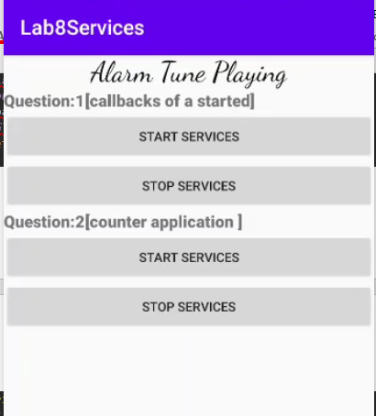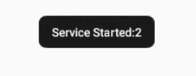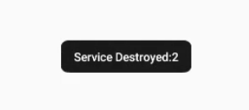

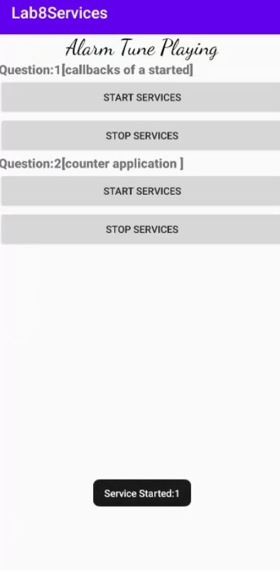**LAYOUT:**

