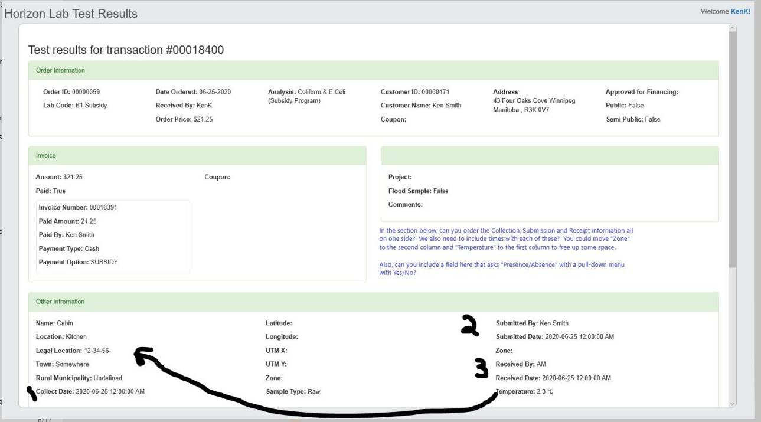

What if we went with our current package titles

Drinking Water

Environmental Water

Livestock

Agriculture Irrigation Water

Recreational Water