Assignment 2
Factory Method and Abstract Factory
Astana IT University | School of Software Engineering
Course: ShP-2216 Software Design Patterns
Programme: 6B06102 Software Engineering
Full name: Adilzhan Kuandykov
Group: SE-2526
Instructor: Yerassyl Bekenov
GitHub repository: github.com/adilzhandev/design-pattern-factory

1. Introduction
This project is a small Java console application for a logistics company. The application can deliver cargo by road or by sea, and it can also show user interface components for two platforms: Windows and macOS.
When the program starts, the user makes two independent choices. The first choice is the delivery mode (ROAD or SEA). The second choice is the UI platform (WINDOWS or MACOS). All four combinations work without changing any code.
Two creational design patterns are used in the application:
- Factory Method is used to create the transport. The abstract class Logistics declares the factory method createTransport(). Each subclass decides which transport object to build. This pattern fits here because there is one product type (Transport) with several variants, and the delivery workflow must stay the same for all of them.
- Abstract Factory is used to create the UI components. The interface GUIFactory declares createButton() and createCheckbox(). Each concrete factory builds a complete family of components for one platform. This pattern fits here because a button and a checkbox must always belong to the same platform, and Abstract Factory guarantees this consistency.
The two patterns solve different problems, so they work together well. Factory Method answers the question "which single object should I create?", while Abstract Factory answers the question "which family of related objects should I create?".

1.1 Package structure
src/
logistics/ Transport, Truck, Ship,
Logistics, RoadLogistics, SeaLogistics
gui/ Button, Checkbox,
WindowsButton, MacOSButton,
WindowsCheckbox, MacOSCheckbox,
GUIFactory, WindowsFactory, MacOSFactory
app/ DeliveryApplication, Main
The two patterns are kept in separate packages. The package app contains only the client code and the startup code, so it depends on both other packages but neither of them depends on app.

2. UML class diagrams

2.1 Factory Method
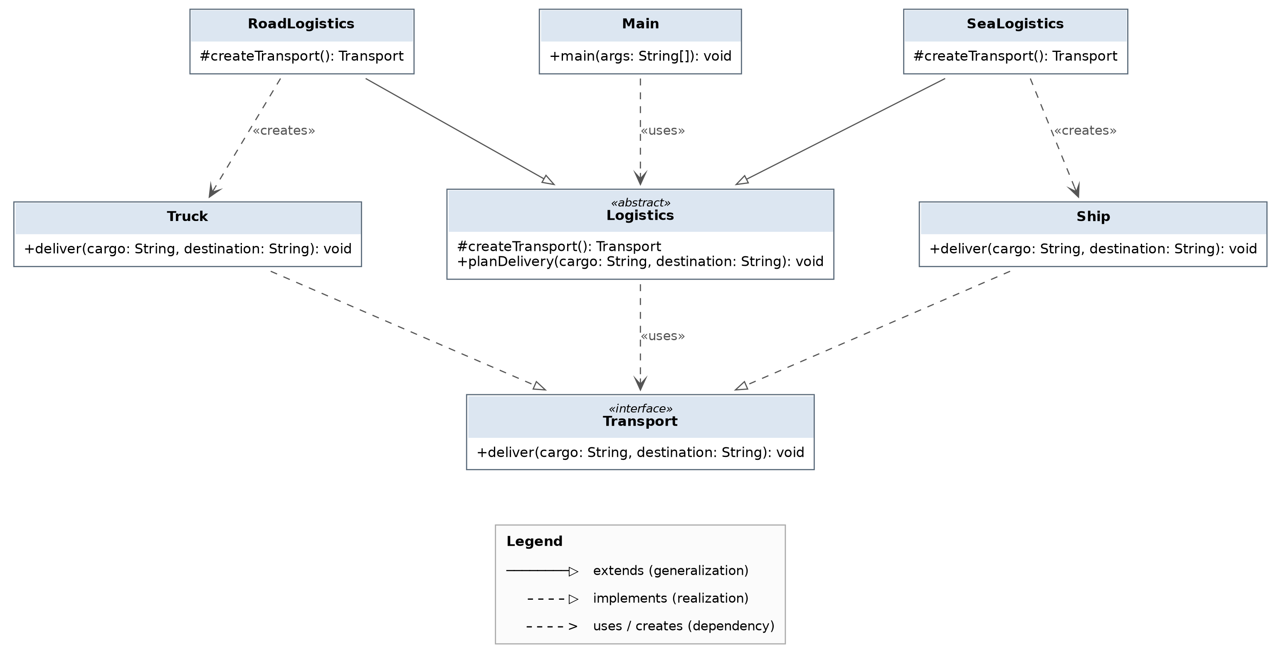
Figure 1. Factory Method: Transport is the product, Logistics is the creator.
Pattern roles in this diagram:
- Product: the interface Transport, which declares deliver(cargo, destination).
- Concrete Products: Truck and Ship. Each one implements Transport and prints its own delivery behaviour.
- Creator: the abstract class Logistics. It declares the factory method createTransport() and contains the shared workflow planDelivery(cargo, destination).
- Concrete Creators: RoadLogistics and SeaLogistics. Each one overrides createTransport() and returns its own transport.
- Client: Main depends only on the abstract type Logistics.

2.2 Abstract Factory
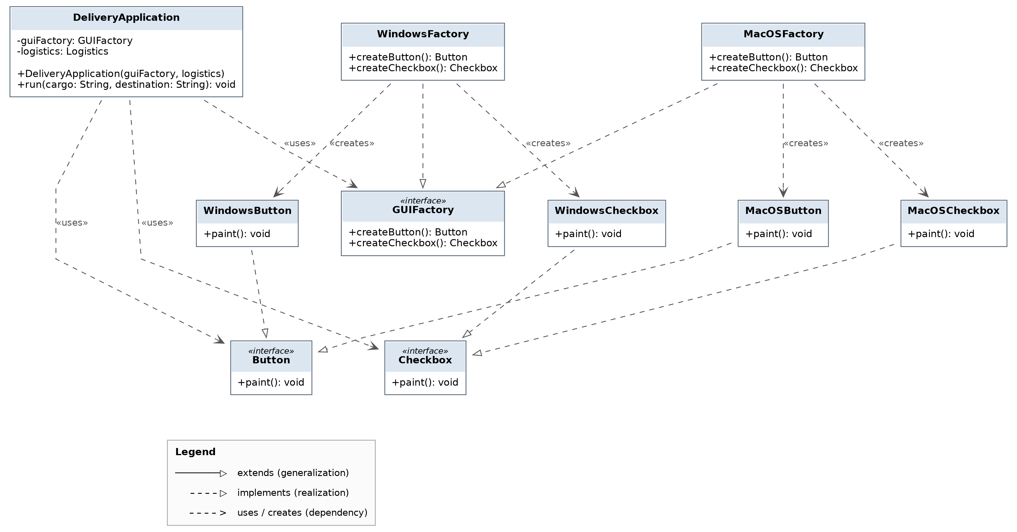
Figure 2. Abstract Factory: two product types and two platform families.
Pattern roles in this diagram:
- Abstract Products: the interfaces Button and Checkbox, each with the method paint().
- Concrete Products grouped into families: WindowsButton and WindowsCheckbox form the Windows family; MacOSButton and MacOSCheckbox form the macOS family.
- Abstract Factory: the interface GUIFactory with createButton() and createCheckbox().
- Concrete Factories: WindowsFactory and MacOSFactory. Each one returns only products from its own family.
- Client: DeliveryApplication receives a GUIFactory through its constructor and uses the products only through the interfaces Button and Checkbox.

3. Clean Code evidence
Five Clean Code practices are demonstrated below. Each one uses a real excerpt from the submitted code. Practices 4 and 5 are connected to Clean Code, Chapter 6 (Objects and Data Structures).

Practice 1 — Meaningful names
public abstract class Logistics {
protected abstract Transport createTransport();
public void planDelivery(String cargo, String destination) { ... }
}

public class RoadLogistics extends Logistics { ... }
public class SeaLogistics extends Logistics { ... }
Benefit: the names describe both the business domain and the pattern role. A reader sees immediately that Logistics is a creator and that RoadLogistics and SeaLogistics are its concrete creators. The method names planDelivery and createTransport say what happens, so no comment is needed to explain them. The parameters are called cargo and destination instead of short names like a and b, so the delivery workflow can be read like a sentence.

Practice 2 — Small methods with one responsibility
private static Logistics createLogistics(String mode) {
return switch (mode) {
case "ROAD" -> new RoadLogistics();
case "SEA" -> new SeaLogistics();
default -> null;
};
}

private static GUIFactory createGUIFactory(String platform) {
return switch (platform) {
case "WINDOWS" -> new WindowsFactory();
case "MACOS" -> new MacOSFactory();
default -> null;
};
}
Benefit: the startup selection is split into two small methods, and each one does exactly one job. The method main() only reads the input, checks the result, and starts the application; it does not contain the selection logic. Because each method is short, it can be understood without scrolling, and a new delivery mode or a new platform is added in only one place.

Practice 3 — Avoid duplicated logic
public void planDelivery(String cargo, String destination) {
Transport transport = createTransport();
transport.deliver(cargo, destination);
}
Benefit: the delivery workflow is written only once, in the parent class Logistics. RoadLogistics and SeaLogistics do not repeat it; they only answer the question which transport to build. If the workflow later needs a new step, for example writing a log line, the change is made in one method and both subclasses get it automatically.

Practice 4 — Data abstraction (Clean Code, Chapter 6)
public void run(String cargo, String destination) {
Button button = guiFactory.createButton();
Checkbox checkbox = guiFactory.createCheckbox();

button.paint();
checkbox.paint();

logistics.planDelivery(cargo, destination);
}
Benefit: Chapter 6 explains that a class should expose abstract behaviour and hide its implementation. Here the client works only with the abstractions Button, Checkbox, GUIFactory and Logistics. It never writes new WindowsButton() and it never uses a cast or instanceof to find out which class it received. The variables are typed with the interfaces, not with the concrete classes, so the client cannot depend on any detail of the implementation. Because of this, the same method run() works for every platform and every delivery mode without a single change.

Practice 5 — Objects and encapsulation (Clean Code, Chapter 6)
public class DeliveryApplication {

private final GUIFactory guiFactory;
private final Logistics logistics;

public DeliveryApplication(GUIFactory guiFactory, Logistics logistics) {
this.guiFactory = guiFactory;
this.logistics = logistics;
}

public void run(String cargo, String destination) { ... }
}
Benefit: Chapter 6 says that objects should expose behaviour and hide data, while data structures do the opposite. DeliveryApplication is a real object: both fields are private and final, and there are no getters such as getGuiFactory(). The only public member is the behaviour run(). Outside code cannot read or replace the factory after construction, so the object can never be left in a broken state. The dependencies arrive through the constructor, which makes the class easy to test and easy to reuse with a different factory.

Additional practice — meaningful class naming fix
During the work the concrete factory for macOS was first written as macOSFactory, with a small first letter. This broke the Java naming convention and made the class look different from WindowsFactory. It was renamed to MacOSFactory, so now all pattern roles follow the same naming style. A temporary test class in the package logistics was also removed, because dead code makes a project harder to read.

4. Verification evidence
All six required checks were run on one Linux machine with JDK 17. The macOS components were produced without any macOS computer, because the components only print their platform name.
# | Input | Actual result | Status
1 | ROAD + WINDOWS | Producing windows button... / Producing windows checkbox... / Truck delivers building materials to BI Group Astana | Pass
2 | SEA + WINDOWS | Producing windows button... / Producing windows checkbox... / Ship delivers building materials to BI Group Astana | Pass
3 | ROAD + MACOS | Producing macOS button... / Producing macOS checkbox... / Truck delivers building materials to BI Group Astana | Pass
4 | SEA + MACOS | Producing macOS button... / Producing macOS checkbox... / Ship delivers building materials to BI Group Astana | Pass
5 | AIR + WINDOWS (unsupported mode) | Error: unsupported delivery mode 'AIR'. Expected ROAD or SEA. The program stopped before asking for the platform, so no delivery and no UI were created. | Pass
6 | ROAD + LINUX (unsupported platform) | Error: unsupported platform 'LINUX'. Expected WINDOWS or MACOS. No UI components were created and no delivery was started. | Pass
7 | Empty input (missing value) | Error: unsupported delivery mode ''. Expected ROAD or SEA. An empty line matches no supported value, so the program stops cleanly. | Pass
Missing-input behaviour: the program does not use a default value and does not continue with a null factory. Any value that is not supported ends the program with a clear message. Input is not case sensitive and extra spaces are removed, because the input is processed with trim() and toUpperCase().
The four valid runs also confirm the required independence of the two choices. Comparing run 1 with run 3 shows that changing only the platform replaced both UI components and kept the same transport. Comparing run 1 with run 2 shows that changing only the delivery mode replaced the transport and kept the same UI family.

4.1 Console screenshots
The screenshots below were taken from the real console output of the submitted program.
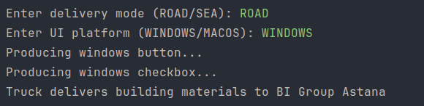
Figure 3. Check 1 - ROAD + WINDOWS: Truck delivery with a complete Windows UI pair.
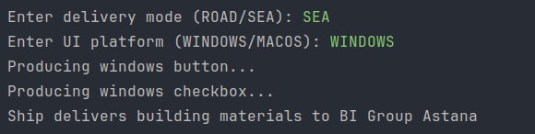
Figure 4. Check 2 - SEA + WINDOWS: the transport changed to Ship, the UI family stayed the same.
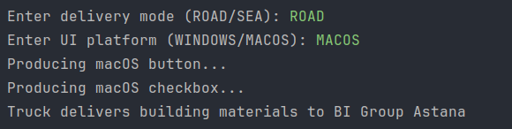
Figure 5. Check 3 - ROAD + MACOS: the UI family changed to macOS, the transport stayed the same.
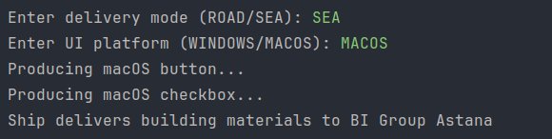
Figure 6. Check 4 - SEA + MACOS: Ship delivery with a complete macOS UI pair.
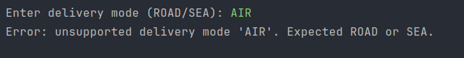
Figure 7. Check 5 - unsupported delivery mode: the program stopped before asking for the platform.
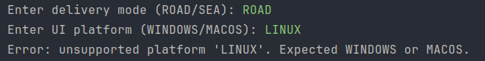
Figure 8. Check 6 - unsupported platform: no UI components were created.
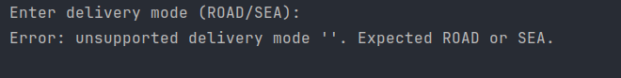
Figure 9. Check 7 - missing input: an empty line is treated as an unsupported value.

5. Conclusion

5.1 Comparison of the patterns
A Simple Factory puts all creation logic into one method with an if or a switch. When a new product is added, that method must be edited, so the class is not closed for modification.
Factory Method moves the decision into subclasses. The parent class declares an abstract creation method and writes the shared workflow, and each subclass overrides the method and returns its own product. In this project planDelivery() is the shared workflow and createTransport() is the factory method. A small switch is still used at startup in Main, but this is allowed, because it only selects which creator object to use; it does not decide how a transport is built.
Abstract Factory works one level higher. Instead of one product it creates a whole family of related products, and it guarantees that the products belong to the same family. In this project a Windows button can never appear next to a macOS checkbox, because both components come from the same factory object.
In short: Factory Method works with one product hierarchy (Transport), while Abstract Factory works with several related hierarchies (Button and Checkbox) and keeps the family consistent.

5.2 Design reflection: three possible extensions
a) Adding one more transport, for example an airplane
- New classes: Plane implements Transport, and AirLogistics extends Logistics with an overridden createTransport().
- Changed code: only the method createLogistics() in Main, to accept the new value AIR.
- Unchanged code: Transport, Logistics, planDelivery(), DeliveryApplication and the whole gui package. The client keeps working, because it depends on the abstract type Logistics.
b) Adding one more UI family, for example Linux
- New classes: LinuxButton implements Button, LinuxCheckbox implements Checkbox, and LinuxFactory implements GUIFactory.
- Changed code: only the method createGUIFactory() in Main, to accept the new value LINUX.
- Unchanged code: the interfaces Button, Checkbox and GUIFactory, the existing factories, DeliveryApplication and the whole logistics package. This is the main strength of Abstract Factory: a new family costs no change in the client.
c) Adding one more UI product type, for example a text field
- New interface: TextField with the method paint().
- New classes: WindowsTextField and MacOSTextField.
- Changed code: the interface GUIFactory needs a new method createTextField(), so every existing factory must implement it. The client DeliveryApplication must also be updated if it should render the new component.
- This extension is the most expensive one, because it changes an existing interface instead of only adding new classes. This is a known trade-off of Abstract Factory: adding a family is cheap, but adding a product type is not.

5.3 References
- Lecture 2: Factory Method and Abstract Factory, ShP-2216 Software Design Patterns, Astana IT University, 2026.
- E. Freeman, E. Robson. Head First Design Patterns, Chapter 4: The Factory Pattern. O'Reilly Media.
- R. C. Martin. Clean Code: A Handbook of Agile Software Craftsmanship, Chapter 6: Objects and Data Structures. Prentice Hall.
- E. Gamma, R. Helm, R. Johnson, J. Vlissides. Design Patterns: Elements of Reusable Object-Oriented Software. Addison-Wesley.
- Oracle. Java SE 17 Documentation. https://docs.oracle.com/en/java/javase/17/

