Name: Adil Zhapar
ID: 20B030340

Web lab 10

CSS of first three tasks are in “styles.css”

Task – 1

Make Website Load Indicator which updates every few milliseconds

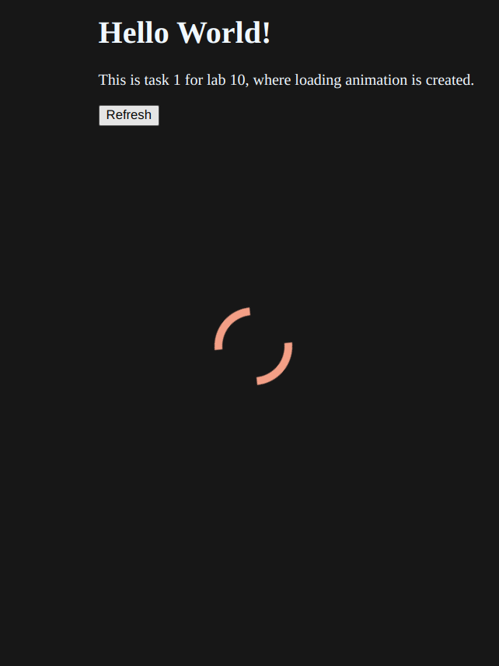
On loading & refresh button loading animation appears for one second:

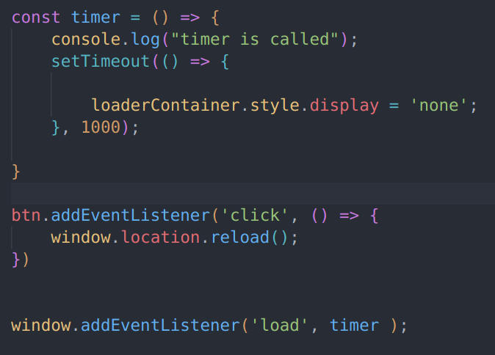

Animation was made via CSS:

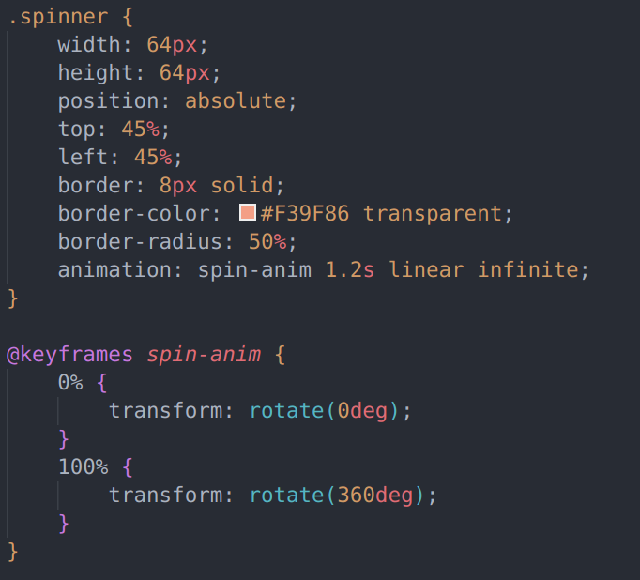
Task – 2

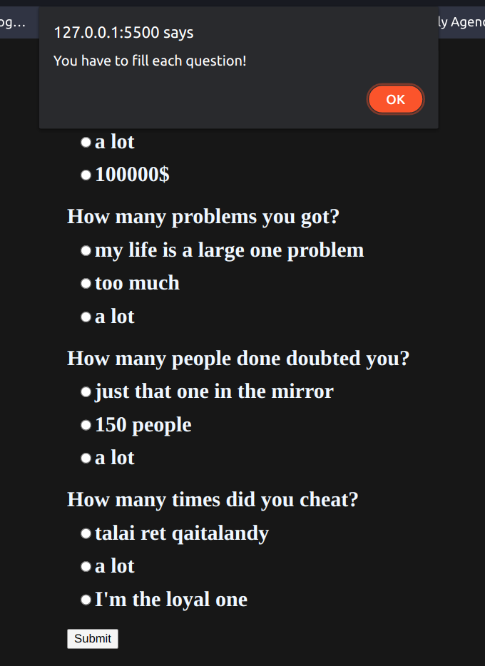
Dynamic quiz with 4 questions. There are alert if you didn’t fill each form, and shuffle of variants of questions each time.
There are more than 100 lines in js, so I just put link to github instead of screenshot:

https://github.com/adilzhapar/WebDevMKM/blob/main/lab-10/t_2.js

Quiz questions are made as array of objects.

In some lines I’ve used ternary operators, because it looks more proffesional))

Task – 3

