Remember the quadrants:

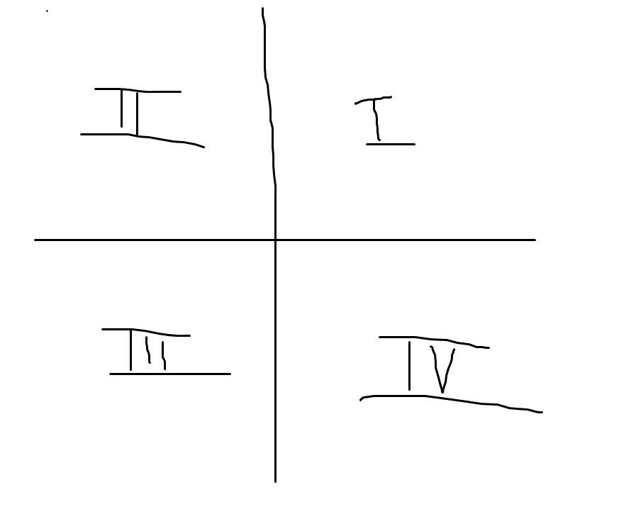

Also remember: When you are given an angle, that determines what direction the hypotenuse of the triangle branches out in. When you are drawing your right triangle, **always** draw the leg of your triangle from the end of your hypotenuse toward the **x axis**. The **reference angle** is the angle at the origin inside the triangle you just made. Sample problem:

Given the angle 210 degrees, what is its reference angle?

Step 1:

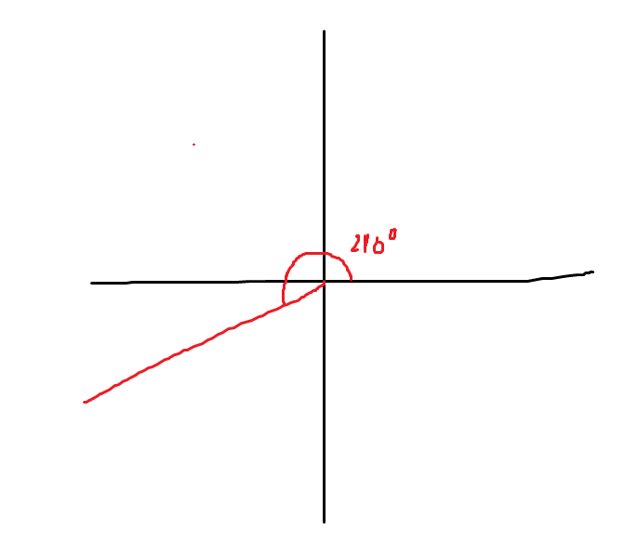

Step 2:

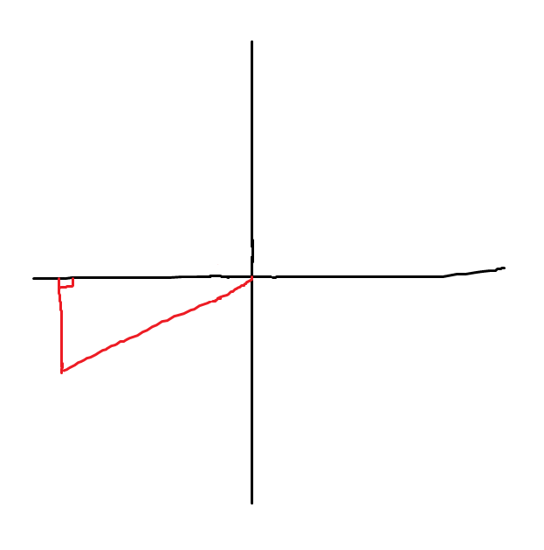

Step 3:

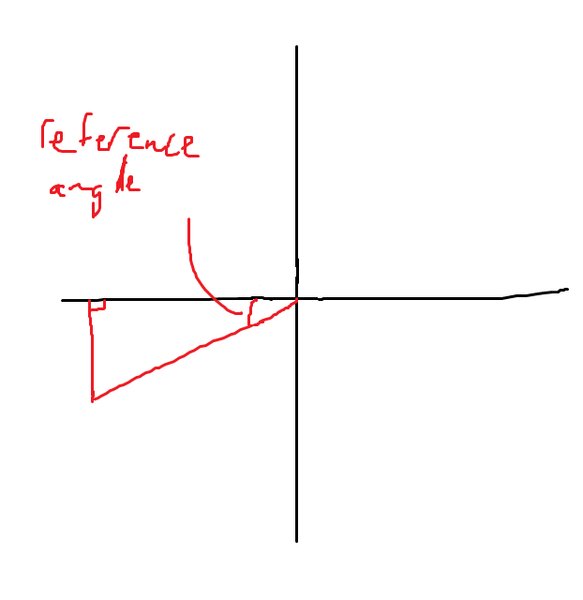

Step 4:

Simple Calculations:

Looking back at Step 1, I know that 180 degrees + my reference angle = 210 degrees (angle over a straight line – the x axis in this scenario - is 180 degrees). Thus, my reference angle = 30 degrees.

Practice problems:

Find the reference angle for the following full angles:

1. 45 degrees
2. 150 degrees
3. 240 degrees
4. 315 degrees
5. 30 degrees
6. 150 degrees
7. 210 degrees
8. 330 degrees

Answer Key:

1. 45 degrees
2. 30 degrees
3. 60 degrees
4. 45 degrees
5. 30 degrees
6. 30 degrees
7. 30 degrees
8. 30 degrees

Notice that a reference angle is always an angle between 0 degrees and 90 degrees – always in quadrant 1. Thus, you could say the reference angle is just the angle of the original triangle moved into quadrant 1.

Notice anything interesting about the last 4 angles? They all had the same **reference angle**. That’s because when you draw out the triangles for the last 4 full angles, they’re the same triangle but in different quadrants (see next page):

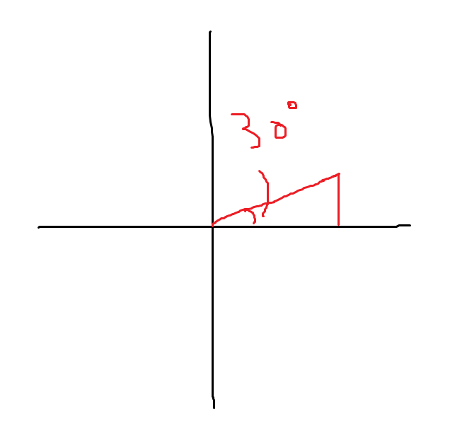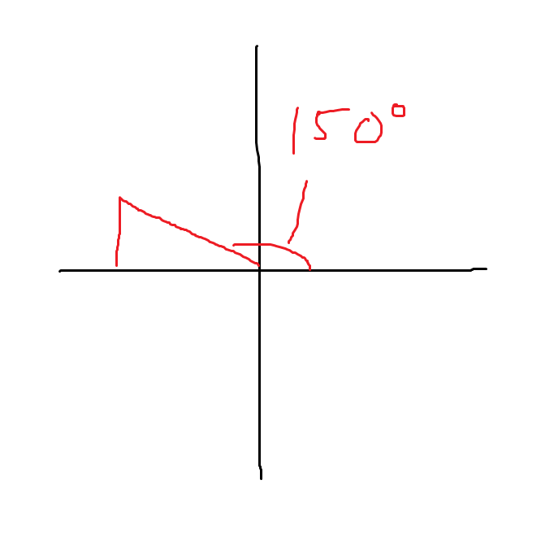

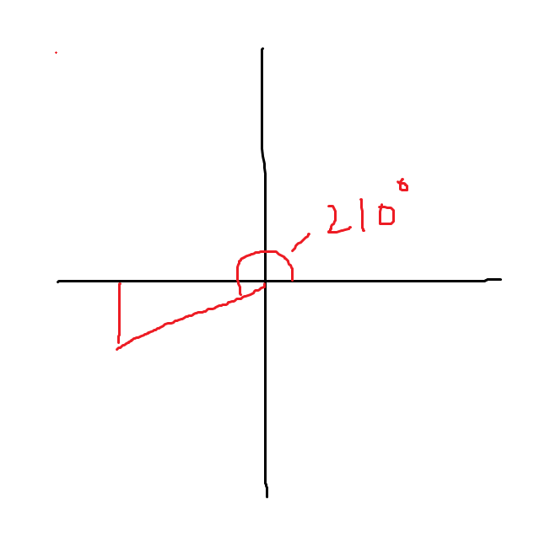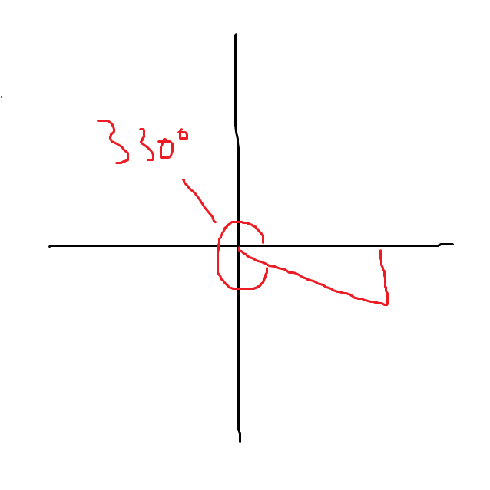

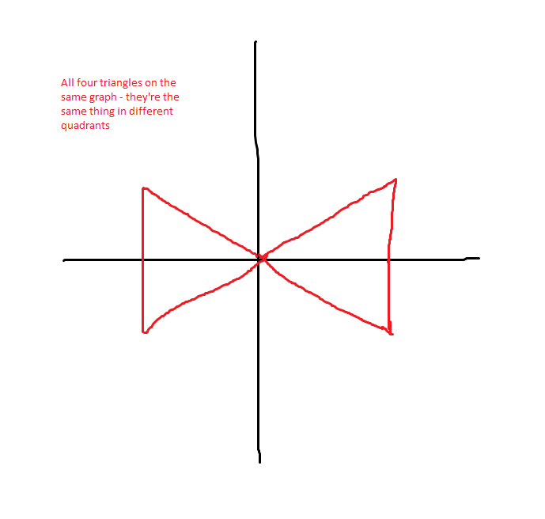

This is why reference angles are so important – all triangles with the same shape have the same reference angle, regardless of what quadrant they’re in. A triangle with a 30 degree reference angle will always be short and fat, no matter what quadrant it’s in. A triangle with a 60 degree reference angle will always be tall and skinny, no matter what quadrant it’s in.

The inverse tangent value gives you either an angle in quadrant 1 or 4.

The reference angle for an angle in quadrant 1 is itself – for a full angle 30 degrees, its reference angle is 30 degrees. Thus, an angle in quadrant 1 is easy to work with.

An angle in quadrant 4 is just the negative version of its reference angle. This is because if you take a triangle in quadrant 1 and flip it over the x axis into quadrant 4, the triangle remains the same but the angle goes down instead of up (negative instead of position). This can be seen relatively easily by just drawing it out, but here’s an example:

The reference angle for the angle -30 degrees.

-30 degrees -> 330 degrees (just going counterclockwise around the graph instead of clockwise)

330 degrees has reference angle of 30 degrees (draw it out)

-30 degrees -> reference angle of 30 degrees

So with that being said, if you take the absolute value of the angle returned by the atan, you’ll always get your reference angle. Then, it’s pretty simple to translate the reference angle into different quadrants. Try the calculations yourself first, but here are the formulas to check with:

Quadrant 1 angle = reference angle

Quadrant 2 angle = 180 degrees – reference angle

Quadrant 3 angle = 180 degrees + reference angle

Quadrant 4 angle = 360 degrees – reference angle