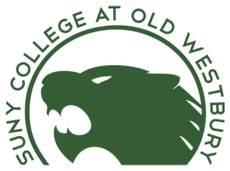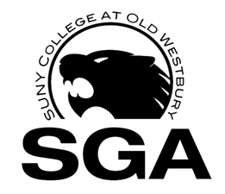

**Application for Candidacy for 2015-16**

**Student Government Association**

January 25th- Applications Available at OWSGA.COM

February 22th- Applications Deadline

February 23rd-26th- Judicial/ GPA Check

February 29th- Candidate Approval Notices

March 3rd – Mandatory Candidate Meeting 8pm Student Union

(Review of Bylaws to Candidates)

March 4th – 21st Candidate Campaigning

March 7th – 10th Tabling in Campus Center F-Wing - Common Hour

**SGA**

March 15th – Meet the Candidates in Student Union MPR A - Common Hour

March 16th– Executive Board Debates

March 22nd -24th - Elections Online in Campus Center F-Wing- 11am – 9pm

March 25th- Announced Results

April 1st – Results Online via www.CampusVine.com