TECHNICAL DESIGN & DEVELOPMENT PLAN
Santha
System design, technology stack, mobile architecture, development plan and wireframes for a Zepto-grade hyperlocal app fulfilled by local stores — Android and iOS from one codebase
Version 0.9 (draft for review)
Date 19 October 2026
Status Draft — pending founder and tech-lead review
Companion documents Santha PRD v0.9 · Santha BRD v0.9 · Santha brand kit v1.0
Scope MVP build (Months 1–6) and Nellore pilot (Months 6–9); Phase 2 noted where it shapes architecture

Contents

1. Document control and how to read this
Purpose | Give the founding team and engineers one place that answers: what exactly are we building, with which technologies, how is it structured, how will it scale, and in what order will we build it. The PRD says what and why; this document says how.
Audience | Founders, tech lead, engineers, designer, DevOps/security advisors, and investors doing technical diligence.
Design stance | Zepto-grade consumer experience (location-first, fast, reliable, app-native) applied to a no-store model. Where Zepto optimises for dark-store picking, Santha optimises for merchant acceptance, catalogue truth and hybrid last-mile.
Decisions marked | Decisions are stated with the alternatives considered and when to revisit them. Anything marked 'Phase 2' is excluded from the MVP build but accounted for in the architecture.
Assumptions | Team of ~6 engineers; 6-month build; Nellore pilot of 3–4 micro-markets scaling to 20,000 orders/month; later replication across Andhra Pradesh and Telangana cities. India data residency.

Version | Date | Author | Change
0.9 | 19 Oct 2026 | Product / Tech | Full draft for review

2. What we are building

2.1 Product in one paragraph
Santha is a three-app marketplace (consumer, merchant, rider) plus a web operations console. Consumers see the live catalogue of every participating local shop, home kitchen and home business within their micro-market, order in one flow with a committed 30–45 minute ETA (or a slot), pay by UPI/card/COD, and track the order live. Merchants accept orders in seconds and choose per order whether to deliver with their own staff or request a Santha rider. The platform owns no inventory and no stores.

2.2 Zepto parity map
The consumer-facing bar is set by Zepto, Blinkit and Instamart. The table maps each expected capability to how Santha delivers it without dark stores.
Zepto / quick-commerce capability | Santha equivalent | What changes because supply is local stores
Location-first home with ETA promise | Same: GPS/address → micro-market → ETA chips per store | ETA = store prep median + travel + buffer, computed per store, not per dark store
Category grid, banners, offers | Same, plus supply-type tabs: Stores · Fashion · Home Kitchens · Home Biz | Categories are a platform taxonomy that merchants map into
Fast typo-tolerant search | Typesense search across all stores in radius; Telugu transliteration and synonyms | Results grouped by store; price can differ by store
Product pages with variants, MRP, discounts | Same, backed by master catalogue for packaged goods | Store-created SKUs for fresh, loose and handmade items
Cart, coupons, bill breakdown, tips | Same; single-store cart at MVP (multi-store Phase 2) | Substitution preference per item; merchant MOV
ASAP + scheduled delivery | ASAP for stores; slots for home kitchens | Slot capacity and cut-offs are merchant-defined
UPI / cards / wallets / COD, instant refunds | Razorpay or Cashfree with split settlement; wallet for refunds | Split payouts to hundreds of small merchants T+1
Live tracking with rider on map | Same for Santha riders; status-only or staff-link tracking for merchant self-delivery | Hybrid fulfilment is the core difference
Order accuracy, substitutions, item issues | Merchant confirms items at acceptance/pack; rules-based refunds | Catalogue truth is the hardest problem; see 7.6
Ratings, reorder, saved items, referrals | Same, plus store-level loyalty and 'your stores' | Store identity is first-class
Membership / pass, ads, brand promotions | Phase 2–3 | Merchant-funded promotions rather than brand media
Dark-store picker app, inventory, replenishment | Not needed — replaced by merchant app and ops catalogue QA | Zero inventory systems; merchant tooling instead

2.3 Architecture principles
- One codebase per surface type: Flutter for the three mobile apps (shared packages), Next.js for web. Android first, iOS from the same code.
- Modular monolith first, services later: one deployable NestJS backend with strict module boundaries and domain events. Split only when a module needs independent scale (dispatch, search) — likely after city 3.
- Event-driven order lifecycle: every state change is an event; tracking, notifications, analytics and settlements consume the same stream.
- Configuration over code: micro-market polygons, fees, SLAs, rider pay, promo budgets and feature flags live in data with effective dating, so ops can launch a city without a release.
- Designed for ₹10k Android phones and patchy networks: performance budgets, offline queues in merchant and rider apps, cached catalogue in the consumer app.
- Compliance built in: India data residency, DPDP consent model, PCI scope kept at the payment aggregator, audit log on every ops action.

3. Requirements that drive the design

3.1 Functional scope by surface (MVP)
Surface | Must-have capabilities | Reference
Consumer app | Location & serviceability, discovery, search, store and product pages, single-store cart, substitution preferences, ASAP/slots, pricing & promos, UPI/card/COD, tracking, issues & refunds, ratings, Telugu/English | PRD 8.1–8.5, 8.8
Merchant app | Onboarding & KYC, catalogue (barcode, custom SKU, assisted), availability, order alerts and acceptance, item unavailability, hybrid fulfilment choice, staff management, earnings & statements, performance | PRD 8.3, 8.6, 8.7
Rider app | Onboarding, online/offline, offers with pay, navigation hand-off, pickup code, OTP/photo proof, COD handling, earnings | PRD 8.7
Ops console | Onboarding queue, catalogue QA, micro-market config, live map, manual dispatch, refunds & disputes, finance reconciliation, dashboards, moderation | PRD 8.11
Store link page | Public mobile-web storefront per merchant with deep link to app | PRD 7.1

3.2 Non-functional targets
Area | Target
Latency | Home feed ≤1.2 s p95; search ≤400 ms p95; order placement ≤3 s p95; merchant alert delivery ≤5 s p95; dispatch assignment ≤3 min p90
Availability | 99.9% monthly for ordering and merchant alerts; graceful degradation (cached catalogue, read-only search)
Scale (pilot) | 20,000 orders/month ≈ 700/day; lunch and dinner peaks ≈ 120 orders/hour; 250 merchants; ~30 riders online at peak; 10,000 MAU
Scale (design headroom) | 10× without architecture change (3 cities); 100× with the documented split into services (Section 4.4)
Devices | Android 8+ on 2 GB RAM; iOS 14+; app size ≤40 MB; cold start ≤2.5 s on mid-range
Security | OWASP ASVS L2; no card data on platform; OTP + device binding; RBAC in ops; encryption in transit and at rest
Privacy | DPDP Act 2023: consent, purpose limitation, rights fulfilment ≤30 days, breach runbook; data in India
Localisation | Telugu and English at pilot; strings externalised; transliterated search

3.3 Load estimate and why a monolith is right
At pilot steady state the system handles roughly 700 orders a day with peaks near 2 orders a minute, a few hundred merchant and rider sessions, and perhaps 300 location pings a minute from riders. This is small. A single well-structured NestJS service on two to three containers, PostgreSQL with read replica, Redis and Typesense will run this with wide margins. The design effort therefore goes into correctness (state machine, money, catalogue truth) and operability (configuration, observability), not into premature distribution. Section 4.4 describes the seams along which the monolith splits when city count and order volume grow.

4. System architecture
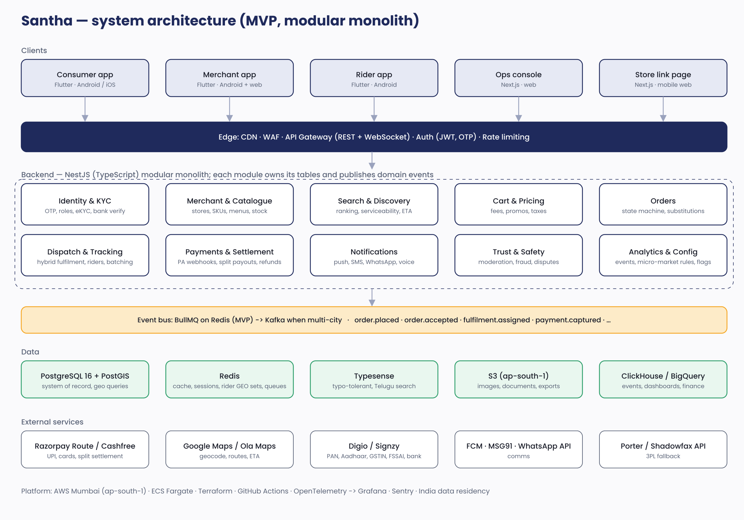
Figure 1 — System architecture at MVP

4.1 Backend modules and responsibilities
Module | Owns | Key interactions
Identity & KYC | Users, roles (consumer/merchant/staff/rider/ops), OTP login, sessions, device binding, eKYC records, bank verification | KYC provider, Notifications
Merchant & Catalogue | Merchants, staff, hours, radius, catalogue items, variants, master-catalogue matches, menus/slots, stock state, images | Search (index updates), Orders (availability)
Search & Discovery | Serviceability (PostGIS polygons), ranking, ETA estimation, Typesense indexing and queries, taxonomy | Catalogue, Dispatch (rider supply for ETA)
Cart & Pricing | Carts, fee engine, promos, taxes, MOV, invoices | Micro-market config, Payments
Orders | Order state machine, items, substitutions, cancellations, issue windows | Payments, Dispatch, Notifications, Settlement
Dispatch & Tracking | Fulfilment assignments (self/rider/3PL), rider presence and GEO, offer engine, batching, fallback ladder, live tracking channel, proof of delivery | Orders, Maps, 3PL APIs, WebSocket gateway
Payments & Settlement | Payment intents, PA webhooks, refunds, wallet, split settlement runs, statements, TCS/TDS records, reconciliation | Payment aggregator, Orders, Finance exports
Notifications | Templates, channels (push, SMS, WhatsApp, voice), escalation (ringing alerts), preferences, delivery receipts | FCM/APNs, MSG91, WhatsApp API
Trust & Safety | Image/text moderation queue, prohibited items, trust scores, fraud signals, disputes, grievance workflow | Catalogue, Orders, Ops
Analytics & Config | Event ingestion, micro-market configuration with effective dates, feature flags, experiments, audit log | All modules

4.2 Request, event and real-time flows
- Synchronous REST (JSON over HTTPS, versioned /v1) for all client reads and commands. Idempotency keys on order placement, payment confirmation and refunds.
- Domain events published to BullMQ (Redis) with a transactional outbox table so an event is never lost if the publish fails: order.placed, order.accepted, order.item_substituted, fulfilment.requested, fulfilment.assigned, fulfilment.picked_up, order.delivered, payment.captured, refund.issued, merchant.auto_paused, and so on.
- Real-time via a WebSocket gateway (Socket.IO) with per-order rooms: consumers subscribe to their order; merchants to their store; riders to their offers. Rider location pings (every 5 s while on a job) go to Redis GEO sets and are fanned out to the order room at 1 Hz.
- Webhooks in from the payment aggregator, KYC provider, WhatsApp and 3PL; each verified by signature, stored raw, then processed idempotently.
- Scheduled jobs (BullMQ repeatable): ETA model refresh, settlement runs, slot pre-booking for kitchens, catalogue staleness nudges, auto-pause checks, reconciliation.

4.3 Offline and degraded modes
- Merchant app queues stock toggles and order actions locally (Drift/SQLite) and syncs with conflict rules (server wins on state, client wins on stock toggles within 2 minutes).
- Rider app caches order details and the route once accepted; proof of delivery captured offline and uploaded on reconnect.
- Consumer app caches the last catalogue per store for 15 minutes with a 'may be out of date' indicator; checkout always validates against the server.
- If Typesense is down, search falls back to PostgreSQL trigram search within the micro-market with reduced ranking. If the payment aggregator is down, COD-eligible orders proceed; others see a retry screen.

4.4 How it scales (the seams)
Trigger | Change | Why it is cheap later
City 2–3, Kafka-level volumes of events | Swap BullMQ for Kafka/Redpanda behind the same event-publisher interface | Modules publish through one interface; outbox pattern already in place
Dispatch CPU or latency pressure | Extract Dispatch & Tracking as its own service with its own Redis | It already owns its tables and talks to others only via events and two APIs
Search index size or query volume | Dedicated Typesense cluster; later OpenSearch if faceting needs grow | Indexing is event-driven; clients only call the Search module
Read load on PostgreSQL | Read replicas for feed/search/reporting; partition orders by month | Queries are already routed through repository layer
Multi-city ops | Per-city config and dashboards already keyed on micro_market_id/city_id | Tenancy key present from day one

5. Technology stack

5.1 Stack at a glance
Layer | Choice | Why | Alternative considered / revisit when
Mobile apps (consumer, merchant, rider) | Flutter 3.x (Dart), Riverpod, go_router, Dio, Drift (SQLite), freezed/json_serializable, flutter_localizations, Firebase (FCM, Crashlytics) | One codebase for Android and iOS with native-grade rendering on low-end Android; consistent Telugu text rendering; three apps share a design-system package in a melos monorepo | React Native + Expo (TypeScript everywhere, OTA updates). Revisit if hiring skews heavily RN or web-sharing becomes critical
Code push | Shorebird (optional, Phase 2) | Hot-fix Dart code without store review | Not needed at MVP; weekly store releases
Web (ops console, store link page) | Next.js 15 (React, TypeScript), Tailwind, shadcn/ui, TanStack Query, MapLibre/Google Maps JS | Fast to build, SSR for store pages, shared types with backend | Flutter Web — rejected for SEO and desktop ergonomics
Backend | Node.js 22, NestJS (TypeScript), Prisma or Drizzle ORM, Zod validation, Socket.IO, BullMQ | Strong modular structure, one language with web, excellent ecosystem for webhooks and real-time | Go (performance) or Spring Boot (enterprise). Revisit for dispatch service if CPU-bound
Primary database | PostgreSQL 16 + PostGIS (AWS RDS Multi-AZ) | Transactions for money and orders; polygons, distance and nearest-store queries natively | MongoDB — rejected for financial consistency; DynamoDB — rejected for geo and reporting
Cache, queues, geo | Redis 7 (ElastiCache) | Sessions, hot catalogue, rider GEO sets, BullMQ queues, rate limits | Managed Kafka later for events
Search | Typesense (self-hosted on ECS or Typesense Cloud) | Typo tolerance, synonyms, geo-filter, sub-50 ms, cheap, simple ops | Elasticsearch/OpenSearch — heavier; Algolia — cost at scale
Object storage & CDN | S3 (ap-south-1) + CloudFront; on-upload image pipeline (Sharp) for resize/WebP | Catalogue images dominate bandwidth | Cloudinary — faster to start, pricier
Analytics warehouse | ClickHouse (ClickHouse Cloud or self-hosted) fed by event stream; Metabase dashboards | Fast event analytics and finance cubes at low cost | BigQuery — fine, but data leaves AWS region
Product analytics & flags | PostHog (self-hosted, EU/India region) for events, funnels, feature flags, experiments | One tool for analytics and flags; self-hostable for data residency | Amplitude + Unleash
Payments | Razorpay (Payments + Route for split settlement) — Cashfree Easy Split as alternate | UPI intent/collect, card tokenisation, nodal split payouts to many small merchants, penny-drop | Decide by commercials and Route onboarding speed in Phase 0
Maps & routing | Google Maps Platform (Places, Geocoding, Routes, SDKs); evaluate Ola Maps / Mappls for cost | Best Nellore coverage and SDK maturity | Switch tiles/routing to Ola Maps if Google cost >₹40k/month
KYC & verification | Digio or Signzy (PAN, Aadhaar offline/eKYC, GSTIN, FSSAI, bank penny-drop) | Single API vendor for all verifications | Cashfree Verification Suite
Communications | FCM/APNs push; MSG91 SMS (DLT) and voice OTP; WhatsApp Business API via Gupshup/Interakt; Exotel for click-to-call masking | Reliable Indian delivery, number masking | Twilio — pricier for India
3PL fallback | Porter / Shadowfax hyperlocal APIs where available in Nellore | Fallback only; cost-capped | Own standby pool if 3PL absent
Infrastructure | AWS Mumbai: ECS Fargate, ALB, RDS, ElastiCache, S3, CloudFront, WAF, Secrets Manager; Terraform | Managed, India-resident, small-team friendly | EKS when >15 services; GCP if team prefers
CI/CD | GitHub Actions (backend/web) → ECR → ECS blue/green; Codemagic or GitHub Actions + fastlane for Flutter builds, TestFlight and Play internal tracks | Automated, reproducible store releases | Bitrise
Observability | OpenTelemetry → Grafana Cloud (metrics, logs, traces); Sentry for apps and backend; UptimeRobot/Checkly synthetics | End-to-end order tracing; SLO alerts | Datadog — cost

5.2 Flutter vs React Native — the decision
Criterion | Flutter | React Native (Expo) | Weight for Santha
Low-end Android performance and jank | Own renderer; consistent 60 fps lists with images | Good with Hermes and FlashList, more tuning | High — ₹10k phones are the norm in Nellore
Telugu rendering and text layout | Consistent across OS versions | Depends on OS text engine | High
Three apps sharing code | Melos monorepo, shared packages, flavors | Monorepo with workspaces; also good | Medium
OTA hot-fixes | Shorebird (paid, newer) | EAS Update (mature) | Medium
Hiring in Hyderabad/Chennai/Bengaluru | Large pool | Large pool | Neutral
Sharing with web ops console | No | Types and some logic with Next.js | Low — ops console is a different product
Maps, camera, barcode, background location | Mature plugins | Mature plugins | Neutral
Decision | Chosen | Documented alternative | Switch only before Sprint 1

6. Mobile application architecture (Flutter)

6.1 Monorepo layout
Package / app | Contents
apps/consumer | Consumer app; features: location, home, search, store, product, cart, checkout, orders, tracking, account, support
apps/merchant | Merchant app; features: onboarding, catalogue, availability, orders, fulfilment, staff, earnings, performance
apps/rider | Rider app; features: onboarding, shift, offers, job, navigation hand-off, proof, earnings
packages/santha_ui | Design system: tokens from the brand kit (Santha Indigo, Market Marigold, Poppins, Noto Sans Telugu), components (buttons, cards, chips, sheets), icons (SVG set), theming, accessibility defaults
packages/santha_api | Generated API client (OpenAPI → Dart), Dio interceptors (auth, retry, idempotency), WebSocket client, DTOs
packages/santha_core | Auth/session, secure storage, analytics (PostHog), feature flags, logging, error handling, connectivity, localisation helpers
packages/santha_offline | Drift database, sync queue, conflict rules used by merchant and rider apps
packages/santha_maps | Map widget abstraction (Google Maps SDK now, swappable), geocoding, polyline rendering, ETA display
tooling | melos scripts, lint rules (very_good_analysis), golden tests, CI workflows, flavors (dev/stg/prod), fastlane lanes

6.2 Patterns and conventions
- Feature-first structure (feature/{data,domain,presentation}) with Riverpod providers; immutable models via freezed; repository interfaces in domain, implementations in data.
- Navigation with go_router and typed routes; deep links for store link pages (santha.app/s/{slug}) and order tracking; universal links and App Links configured.
- State and caching: TanStack-style async notifiers with stale-while-revalidate for feed and store pages; optimistic cart updates with server validation at checkout.
- Performance budgets: image thumbnails ≤40 KB WebP via CDN variants; list virtualisation; precaching above-the-fold; cold start measured on a Redmi-class device in CI (Firebase Test Lab).
- Localisation: ARB files for English and Telugu; numerals and currency formatting for INR; fallback fonts; RTL not required.
- Accessibility: semantic labels on all actionable widgets; minimum 44 px touch targets; text scaling to 130% tested; colour contrast per brand kit.
- Background work: rider location via foreground service (Android) and background location (iOS) only while on an active job; FCM data messages for merchant ringing alerts with a full-screen intent on Android and critical-alert entitlement request on iOS.
- Security: tokens in secure storage; certificate pinning for API host; root/jailbreak detection advisory for rider COD; no secrets in the app — all third-party keys scoped per platform and restricted.
- Quality gates: unit tests for domain logic, widget tests for key flows, golden tests for design system, integration tests (Patrol) for order placement and merchant acceptance, crash-free sessions ≥99.5%.

7. Backend design deep-dive

7.1 API surface (REST, /v1)
Area | Representative endpoints | Notes
Auth | POST /auth/otp/request · POST /auth/otp/verify · POST /auth/refresh · POST /auth/logout | Role claims; device binding; rate-limited
Serviceability & feed | GET /serviceability?lat&lng · GET /feed?micro_market&tab · GET /merchants/{id} · GET /merchants/{id}/items | ETA chips computed server-side; cached 30–60 s per micro-market
Search | GET /search?q&micro_market&filters | Proxies Typesense with ranking params and grouping by merchant
Cart & pricing | PUT /cart · POST /cart/price · POST /cart/promo | Price quote returns fee breakdown, ETA and payment options
Orders | POST /orders (Idempotency-Key) · GET /orders/{id} · POST /orders/{id}/cancel · POST /orders/{id}/issues | State machine enforced server-side
Merchant | POST /merchants · PUT /merchants/{id}/availability · POST /items · POST /items/scan · PUT /items/{id}/stock · POST /orders/{id}/accept|reject · POST /orders/{id}/items/{iid}/unavailable · POST /orders/{id}/fulfilment · POST /orders/{id}/ready | Accept carries fulfilment choice and staff assignment
Rider | PUT /riders/me/status · POST /offers/{id}/accept|decline · POST /jobs/{id}/picked-up · POST /jobs/{id}/delivered (otp|photo) · POST /riders/me/location | Location also over WebSocket
Payments | POST /payments/intent · POST /webhooks/razorpay · GET /wallet · POST /refunds (ops) | Webhook signature verification; idempotent processing
Ops | /ops/merchants/queue · /ops/micro-markets · /ops/orders/{id}/reassign · /ops/refunds · /ops/settlements/run · /ops/moderation | RBAC: ops, finance, support, admin; every call audited

7.2 Data model
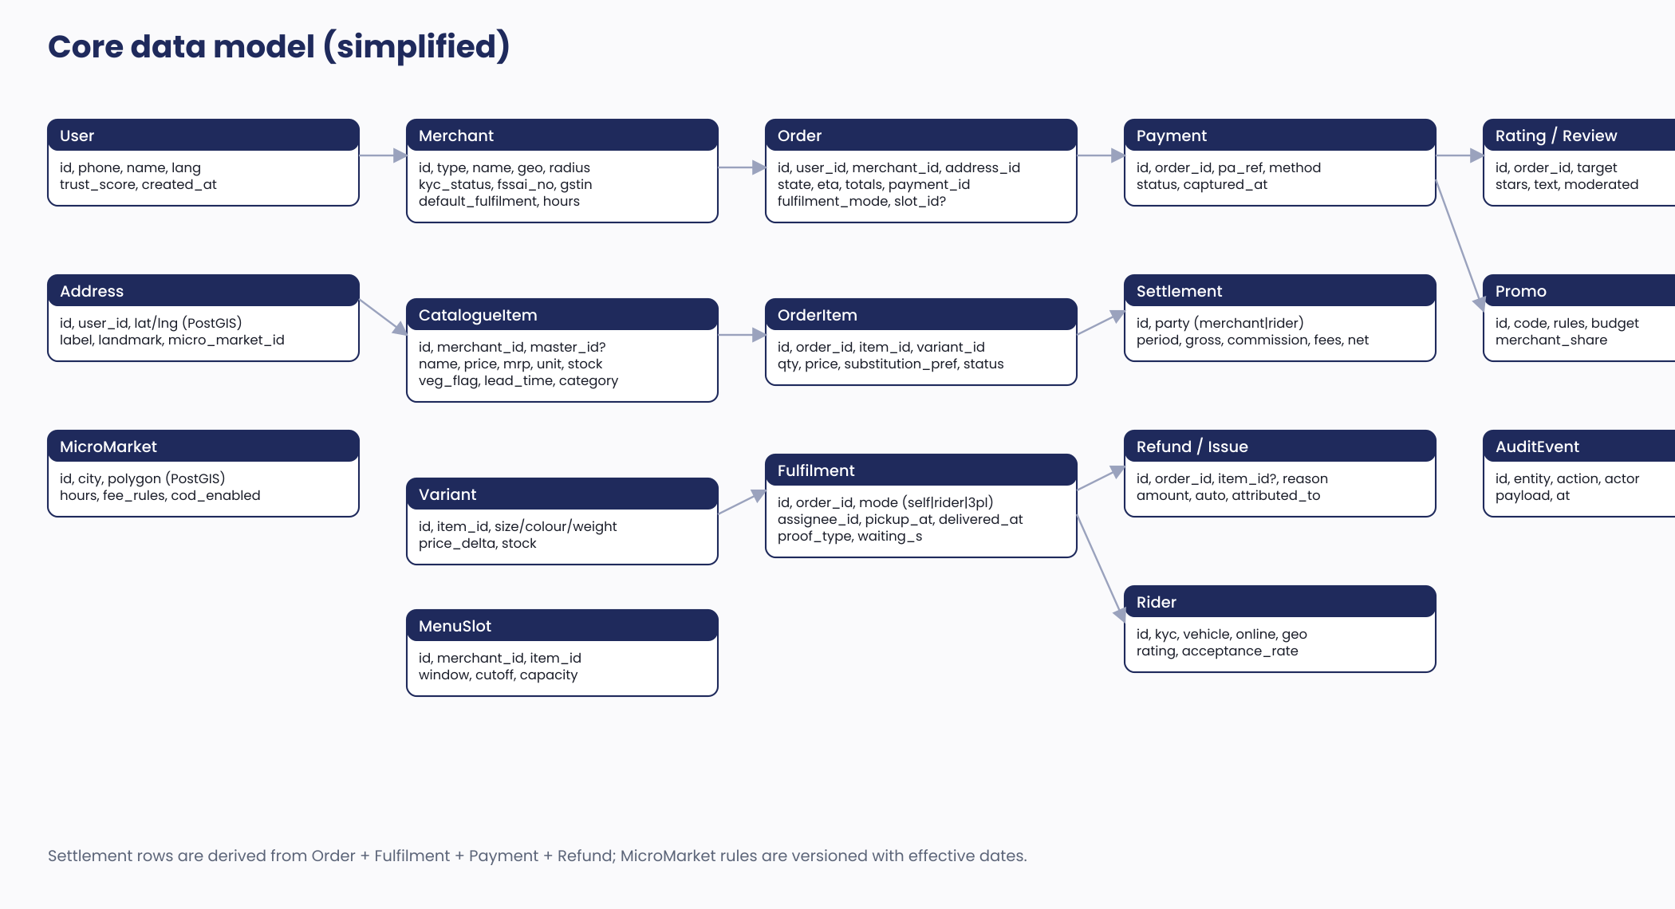
Figure 2 — Core data model (simplified)
- Money is stored in integer paise; totals are recomputed from line items and fee rows, never stored alone.
- Geo columns use PostGIS geography; serviceability is ST_Within(address, micro_market.polygon); nearest-store queries use GiST indexes.
- Micro-market configuration rows are versioned with effective_from/effective_to so pricing can be reconstructed for any past order.
- Every mutating action writes an AuditEvent (entity, action, actor, before/after payload) — required for disputes, finance and DPDP.
- Orders partitioned monthly from day one (declarative partitioning) to keep operational tables small.

7.3 Order lifecycle
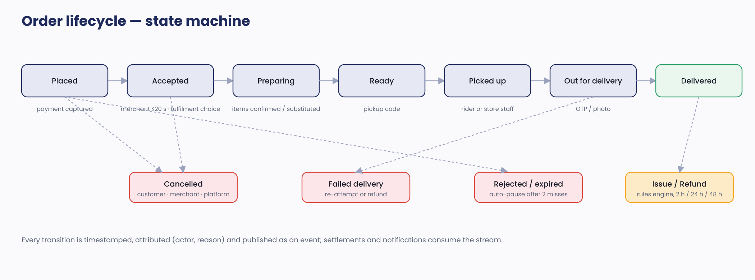
Figure 3 — Order state machine
Transitions are implemented as a single guarded function (from, to, actor, reason) inside a database transaction; illegal transitions throw and are logged. Timers (acceptance window, pack SLA, issue windows) are BullMQ delayed jobs keyed by order id and cancelled on transition. Customer cancellation rules, merchant auto-pause and ETA recomputation hang off the same transitions.

7.4 Hybrid fulfilment and dispatch
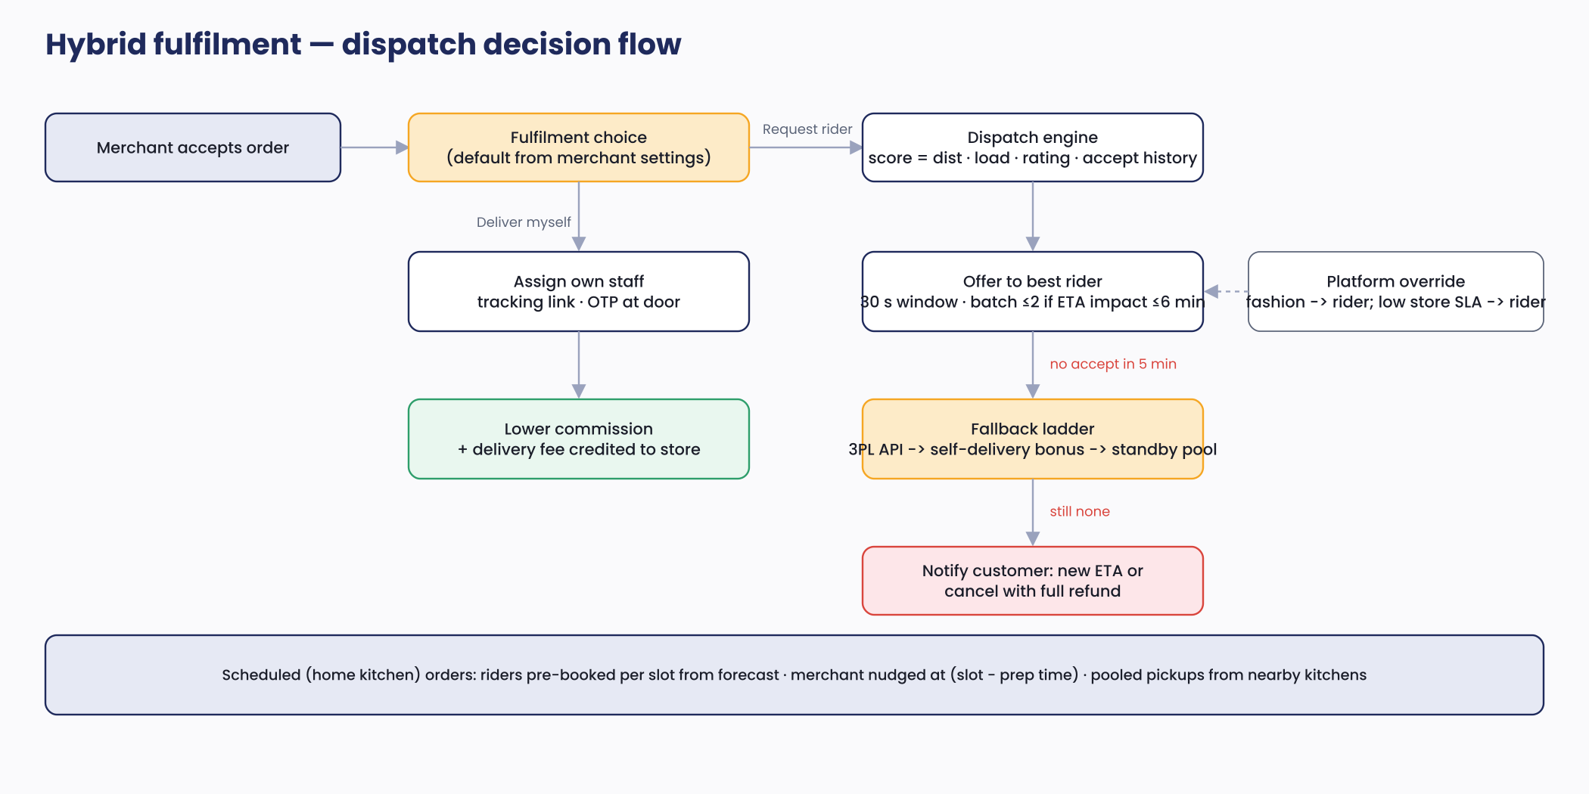
Figure 4 — Dispatch decision flow
- Scoring: candidates = online riders within 3 km of the store (Redis GEORADIUS) not exceeding load; score = w1·distance_to_store + w2·current_load + w3·(1 − acceptance_rate) + w4·(5 − rating); weights per micro-market config.
- Offer protocol: best rider gets a 30-second exclusive offer (push + socket); on decline/timeout the next candidate is offered; after 5 minutes the fallback ladder runs (3PL quote if available → merchant self-delivery bonus offer → standby pool → customer notification).
- Batching: a second order may be attached if pickup stores are within 500 m and drops within 800 m and the projected ETA impact on either order ≤6 minutes; never for cooked food beyond one extra stop.
- Self-delivery: merchant assigns a registered staff member; the staff receives an SMS/WhatsApp link to a lightweight web flow (or the merchant app in 'staff mode') to mark picked-up/delivered with OTP; the platform still tracks SLA.
- Scheduled slots: a nightly job forecasts slot demand per micro-market from history and pre-books rider capacity (incentives); a 'start preparing' nudge is sent at slot start − merchant prep median.
- Pay computation: deterministic formula (base + distance bands + waiting beyond 5 min attributed to merchant + peak/rain multipliers + incentives) evaluated at offer time and stored with the assignment.

7.5 Serviceability, ETA and ranking
- ETA = merchant prep p50 (rolling 30-day, per hour-of-day) + travel estimate (Routes API, cached per store–hex pair using H3 cells) + buffer (micro-market config, e.g. 8 min). Shown as a range (ETA−5, ETA+5).
- Ranking blends distance, rating, ETA, acceptance rate, fill rate, catalogue freshness and a small diversity term across supply types; weights configurable; closed merchants shown last with next-open time.
- Merchant radius is enforced server-side; store ETA chips are cached 60 s per (store, H3 cell).

7.6 Catalogue truth (the hard problem)
- Master catalogue (GS1/commercial source) seeds packaged goods; merchant scans resolve to master ids with store-specific price and stock.
- Stock is tri-state (in, low, out) and ages: items untouched for 72 hours get a staleness flag that lowers ranking and prompts the merchant; acceptance requires item-level confirmation for flagged items.
- Order-time truth: on acceptance the merchant confirms each item; unavailable items trigger the customer's substitution preference; refunds auto-issue for removed items.
- Feedback loops: 'item not available' events update stock automatically; repeated unavailability pauses the item; merchant fill rate feeds ranking and the commission ladder.

7.7 Payments, refunds and settlement
- Payment intent created at checkout; client completes UPI/card via aggregator SDK; order moves to Placed only on captured webhook (or COD authorisation). Idempotency keys prevent double orders.
- Refund rules engine runs on issue events: auto-approve by (issue type × order value × trust score); wallet credit is instant; source refunds via aggregator API with status tracking.
- Settlement run (daily 02:00 IST): for each merchant, sum delivered orders closed past issue window → item value + packaging + delivery fee (self-delivered) − commission − adjustments → Route transfer; rider payouts weekly (daily optional) via payouts API. Statements and GST documents generated as PDFs to S3.
- Reconciliation job matches aggregator settlement files to internal ledgers to the paise; exceptions land in the ops queue.

7.8 Caching, idempotency and resilience
- Cache tiers: CDN for images and store pages; Redis for feed/ETA chips (60 s), merchant profiles (5 min), micro-market config (until changed), rate-limit counters.
- Idempotency-Key header on all money-moving and order-creating POSTs; keys stored 24 h with the first response.
- Retries with jitter on outbound calls; circuit breakers for maps, KYC and 3PL; dead-letter queues for failed jobs with ops visibility.
- Backpressure: ringing alerts and offers are time-boxed; WebSocket fan-out throttled to 1 Hz per room.

8. Data, analytics and experimentation
- Event taxonomy (snake_case, versioned) defined in Sprint 0 and enforced via a shared schema package; apps send to PostHog; backend emits domain events to the warehouse.
- Pipeline: domain events and PostHog exports → ClickHouse (hourly) → Metabase dashboards: funnel, on-time and fill rate by micro-market and merchant, unit economics per order, merchant health score, rider utilisation, support drivers.
- Feature flags and experiments via PostHog: fee presentation, ETA buffer, self-delivery commission ladder, slot granularity. Flags are per micro-market where relevant.
- Finance marts: daily GMV, revenue by stream, contribution per order, payouts, refunds — reconciled to settlement runs.

9. Infrastructure, environments and DevOps

9.1 Environments
Environment | Purpose | Notes
dev | Per-developer local via Docker Compose (Postgres, Redis, Typesense, LocalStack) + shared dev cloud stack | Seed data for Nellore micro-markets and demo merchants
staging | Full AWS replica at small size; aggregator and KYC in test mode; TestFlight/Play internal | Beta merchants and riders use staging builds before launch
production | Multi-AZ RDS, 2–3 Fargate tasks per service, WAF, CloudFront | Blue/green deploys; DB migrations gated

9.2 Pipelines and operations
- Backend/web: PR → lint, unit, integration (Testcontainers) → build image → deploy to staging → smoke tests → manual approve → blue/green to production. Database migrations run as a pre-deploy job with backward-compatible changes only.
- Mobile: PR → analyse, unit, widget, golden tests → build flavors → Firebase Test Lab on low-end devices → TestFlight / Play internal; weekly release train to production tracks with staged rollout (10% → 50% → 100%).
- Infrastructure as code with Terraform; secrets in AWS Secrets Manager; least-privilege IAM; all resources tagged by environment and cost centre.
- Observability: OpenTelemetry traces across order placement → payment → dispatch; SLO dashboards (acceptance time, dispatch time, ETA breach, payment success) with alerts to on-call; Sentry for crashes; structured logs with PII redaction.
- Backups: RDS automated daily + PITR; S3 versioning; quarterly restore drill. RTO 2 h, RPO 15 min for the pilot.
- On-call: founders/tech lead rotation at pilot; runbooks for payment webhooks lag, dispatch stall, notification failures, Typesense outage.

9.3 Indicative monthly infrastructure cost (pilot)
Item | ₹ / month | Notes
AWS (Fargate, RDS Multi-AZ, ElastiCache, S3/CloudFront, WAF) | 60,000–90,000 | Small instance sizes; scales with cities
Typesense, PostHog, ClickHouse (self-hosted on the same account) | 15,000–25,000 | Or managed tiers at ~2× cost
Google Maps Platform | 20,000–40,000 | Routes and Places dominate; cache aggressively
Communications (SMS, WhatsApp, voice, push) | 10,000–20,000 | Volume-based
KYC verifications | ~₹25–60 per merchant/rider verified | One-time per onboarding
Payment aggregator | ~1.8% of GMV + Route fees | Variable; in unit economics
Sentry, Grafana Cloud, Codemagic, GitHub, Apple/Google developer | 15,000–25,000 | Mostly fixed
Total fixed-ish | ≈ 1.2–2.0 lakh | Within the ₹3 L infra line in the BRD

10. Security, privacy and compliance engineering
- Threat model covers account takeover (OTP abuse), merchant impersonation, refund fraud, COD theft, data scraping and payment webhook spoofing; controls mapped to OWASP ASVS L2 and verified by an external pen-test before launch.
- PCI scope stays with the aggregator: card data never touches Santha servers or apps (hosted SDK, tokenisation).
- DPDP implementation: consent records per purpose (ordering, marketing, location), privacy notice in Telugu and English, data-principal request workflow (access/correct/erase) with 30-day SLA, retention schedule, breach runbook and notification templates, grievance officer contact in app.
- Phone-number masking via click-to-call; precise addresses revealed to merchants only after acceptance and to riders only after assignment; location sharing stops at delivery.
- RBAC in ops with per-action audit; four-eyes approval for refunds above a threshold and for manual payout adjustments.
- Secrets rotation, dependency scanning (Dependabot, Trivy), signed container images, WAF rules, rate limiting per phone/device/IP on OTP endpoints.
- Regulatory hooks: FSSAI number validation and display, GST invoice/credit-note generation and TCS records, Legal Metrology fields on packaged items, prohibited-item classifier, Consumer Protection e-commerce disclosures on store pages.

11. Quality strategy
Level | What | Tooling
Unit | Pricing engine, state machine, dispatch scoring, settlement maths, refund rules — 90%+ coverage on these modules | Jest/Vitest; Dart test
Integration | API contracts, DB migrations, webhooks, outbox/event flows | Testcontainers, Supertest, Pact for app↔API contracts
Mobile | Widget and golden tests for design system; end-to-end flows (place order, accept, fulfil, deliver) on device farm | flutter_test, Patrol, Firebase Test Lab (Redmi/Realme class devices)
Performance | Load test peak × 5 (600 orders/hour) and dispatch stress; app cold start and scroll jank budgets | k6; Flutter DevTools; CI perf checks
Security | SAST/DAST, dependency scanning, external pen-test pre-launch | Semgrep, ZAP, vendor
UAT | Closed beta with 30 merchants, 300 users, 10 riders in Month 5; scripted scenarios plus real orders | Staging + production flags
Release gates | No open P1 defects; crash-free ≥99.5%; SLOs met in beta for 2 weeks; store listing and policy compliance (Play Families? no; location, background location declarations) | Checklist in repo

12. Development plan

12.1 Team and roles
Role | Count | Responsibilities
Tech lead / architect (backend) | 1 | Architecture, backend core, code review, DevOps ownership at pilot
Backend engineers | 1–2 | Modules per sprint plan; integrations (payments, KYC, maps, comms)
Flutter engineers | 2 | Consumer app; merchant and rider apps; design-system package
Full-stack (web + QA automation) | 1 | Ops console, store link page, test automation, release engineering
Product designer | 1 | Design system from brand kit, hi-fi screens, usability tests in Telugu
Product/founder | 1 | Backlog, acceptance, merchant/rider research, analytics
Advisors (part-time) | — | Security pen-test, tax/legal, DevOps review

12.2 Ways of working
- Two-week sprints; trunk-based development with short-lived branches; PR review required; definition of done includes tests, analytics events, Telugu strings, accessibility check and docs.
- Weekly demo to founders; fortnightly merchant council feedback on merchant-app increments; monthly architecture review of the 'seams' list.
- Vendor onboarding runs in parallel from Sprint 0: aggregator KYB and Route approval, DLT template registration, WhatsApp API approval, maps billing, KYC contracts, Apple Developer and Play Console accounts.

12.3 Sprint plan (Months 1–6)
Sprint | Weeks | Goals and deliverables | Exit criteria
0 — Foundations | 1–2 | Monorepos, CI/CD, Terraform dev/staging, design tokens from brand kit, API skeleton, auth/OTP, event taxonomy, seed Nellore micro-markets | Hello-world apps on TestFlight/Play internal; OTP login end to end
1 — Identity & merchant onboarding | 3–4 | Merchant app onboarding flow, eKYC/bank/FSSAI/GSTIN integration, ops onboarding queue, micro-market config UI | Merchant can be onboarded and approved on staging
2 — Catalogue | 5–6 | Master catalogue import, barcode scan, custom SKU with image pipeline, variants, stock toggles, assisted-catalogue ops tool, Typesense indexing | 500 SKUs scanned from 5 test stores; search returns in <400 ms
3 — Consumer discovery | 7–8 | Serviceability, home feed, tabs, categories, store page, product page, search with Telugu synonyms, ETA v1 | Consumer can browse Nellore test stores with ETA chips
4 — Cart, pricing, payments | 9–10 | Cart, fee engine, promos, taxes, checkout, Razorpay intent + webhooks, COD rules, order creation with idempotency | Paid order created on staging with correct bill
5 — Order lifecycle & merchant flow | 11–12 | State machine, timers, ringing alerts, accept/reject, item unavailability and substitutions, notifications (push/SMS/WhatsApp) | Order flows Placed → Ready with merchant app; alerts ≤5 s
6 — Hybrid fulfilment | 13–14 | Fulfilment choice, staff link flow, rider app core, dispatch v1 (scoring, offers), live tracking, OTP/photo proof | End-to-end delivery by rider and by staff on staging
7 — Money | 15–16 | Settlement runs, Route transfers, statements/GST docs, refund rules engine, wallet, issue reporting, reconciliation | Settlement reconciles to the paise on test data
8 — Kitchens, fashion, trust | 17–18 | Menus/slots/capacity, scheduled dispatch pre-booking, fashion returns pickup, ratings & reviews, moderation queue, trust score, prohibited-item checks | Scheduled kitchen order fulfilled on time; returns flow works
9 — Ops & analytics & hardening | 19–20 | Ops console completion (live map, reassign, refunds, finance), ClickHouse pipeline, dashboards, load test, pen-test fixes, performance on low-end devices | SLOs met under 5× load; pen-test criticals closed
10 — Beta & launch readiness | 21–22 | Closed beta (30 merchants, 300 users, 10 riders), bug fixing, store submissions, support macros, runbooks, DPDP artefacts, launch checklist | Beta: on-time ≥85%, fill ≥95%, crash-free ≥99.5%
11–12 — Buffer & launch | 23–26 | Contingency for slips; production launch in 3–4 micro-markets; hyper-care | Launch gate signed off

12.4 Pilot sprints (Months 6–9) — P1 and learning
- Order-again and personalised modules; merchant daily digest; rider tipping; bulk CSV catalogue; wallet at checkout; promo experiments; ETA model v2 from real data; dispatch weight tuning; Telugu copy polish from support transcripts.
- Monthly architecture checkpoint against Section 4.4; begin city-2 configuration dry run in Month 8.

12.5 Milestones
Milestone | Target | Evidence
M1 — Foundations live | End Week 2 | CI/CD green; staging up; apps installable
M2 — Merchant can go live | End Week 6 | Onboarding + catalogue on staging with real test stores
M3 — First paid order | End Week 10 | Order placed and paid on staging
M4 — First delivered order (both modes) | End Week 14 | Rider and staff deliveries completed on staging
M5 — Money closes | End Week 16 | Settlement and refunds reconcile
M6 — Beta start | Week 21 | 30 merchants, 300 users
M7 — Public launch (Nellore) | Week 26 | Launch checklist signed; stores live
M8 — Pilot review | Month 9 | PRD 7.4 criteria assessed

12.6 Dependencies and lead times
Dependency | Lead time | Owner / mitigation
Razorpay Route (or Cashfree Easy Split) KYB and activation | 3–6 weeks | Start Week 1; keep both in evaluation
DLT SMS template registration; WhatsApp Business API approval | 2–4 weeks | Start Week 1; use push + voice fallback in staging
Apple Developer / Play Console (company accounts, D-U-N-S) | 2–4 weeks | Start Week 1
Master catalogue data licence | 2–6 weeks | Begin with open barcode data + ops enrichment
Google Maps billing and quota; Ola Maps evaluation | 1 week | Week 1
KYC vendor contract and sandbox | 2–3 weeks | Week 1
External pen-test slot | Book by Week 12 for Week 19 | Tech lead
Legal memo on FSSAI, GST ECO, DPDP, gig-worker rules | Phase 0 | Founders; gates launch

12.7 Delivery risks and mitigations
Risk | Impact | Mitigation
Scope creep toward Zepto's full feature set | Slips launch | P0 list frozen after Sprint 1; Phase 2 parking lot; weekly scope review
Payment aggregator split-settlement onboarding delays | Blocks money flows | Dual-vendor evaluation; manual payouts via bank API as interim
Flutter background location / ringing alert behaviour on vendor Android skins | Missed merchant alerts | Device matrix early (Sprint 5); voice-call fallback; battery-optimisation guidance in onboarding
Catalogue data quality | Low fill rate at beta | Assisted catalogue ops from Sprint 2; staleness rules; beta with 30 curated merchants
Small team, single points of knowledge | Delays on absence | Pairing on money and dispatch modules; docs in repo; architecture reviews
Low-end device performance | Poor conversion | Perf budgets in CI from Sprint 3; test on target devices weekly

13. Launch and operations readiness
- Launch checklist: store listings (Telugu + English), privacy policy and DPDP consent flows, grievance officer, FSSAI licence as e-commerce FBO, GST registration and TCS process, support hours and macros, rider insurance, incident runbooks, on-call rota, dashboards and alerts live, rollback plan.
- Ops tooling at day one: onboarding queue, catalogue QA, live map with reassign, refunds with approval limits, payouts with reconciliation, merchant/rider actions (pause, warn, offboard), audit log.
- SLOs for pilot: payment success ≥92% UPI; merchant alert delivery ≤5 s p95; dispatch ≤3 min p90; API availability 99.9%; crash-free sessions ≥99.5%.
- Hyper-care for the first 4 weeks: engineering shadowing support, daily defect triage, weekly release.

14. Wireframes
Low-fidelity wireframes for the primary flows. They fix information hierarchy and interactions, not visual design; the designer will produce hi-fi screens using the Santha design system (brand kit v1.0). Individual screens are supplied as SVG and PNG in the wireframes folder.

14.1 Consumer app
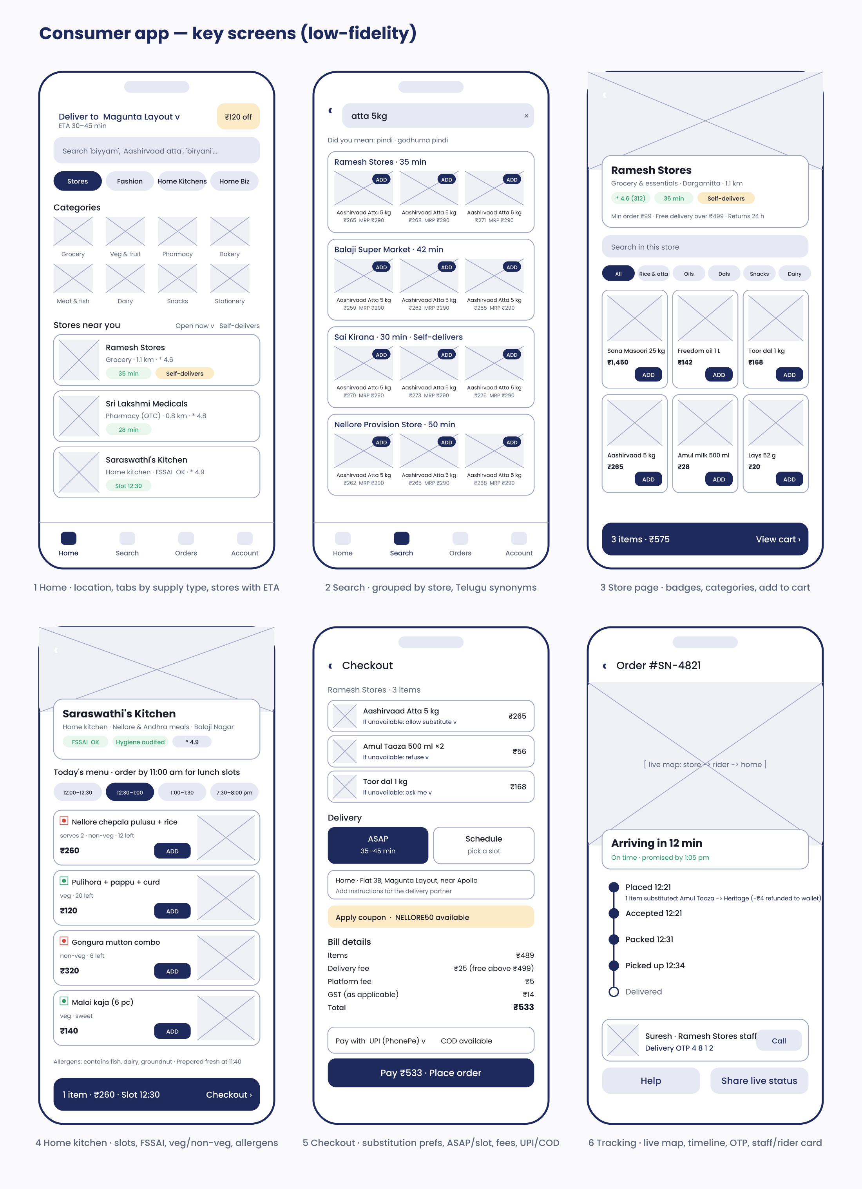
Figure 5 — Consumer app: home, search, store, home kitchen, checkout, tracking
Screen | Key decisions
Home | Location and ETA at top (Zepto pattern); supply-type tabs; category grid; store cards show distance, rating, ETA chip and a 'Self-delivers' badge; offers chip is subtle
Search | Results grouped by store so price differences are visible; Telugu synonym hints; one-tap ADD inside results
Store page | Trust row (rating, ETA, self-delivers, FSSAI where food); MOV and free-delivery threshold stated; in-store search; sticky cart bar
Home kitchen | Slots as chips with cut-off messaging; FSSAI and hygiene badges; veg/non-veg marks; remaining portions; allergens and 'prepared at' time
Checkout | Per-item substitution preference (the key accuracy control); ASAP vs slot; address with landmark; transparent bill; UPI default with COD where allowed
Tracking | Live map; big ETA with 'on time' status; timeline with substitution note; staff/rider card with masked call and delivery OTP; help and share actions

14.2 Merchant and rider apps
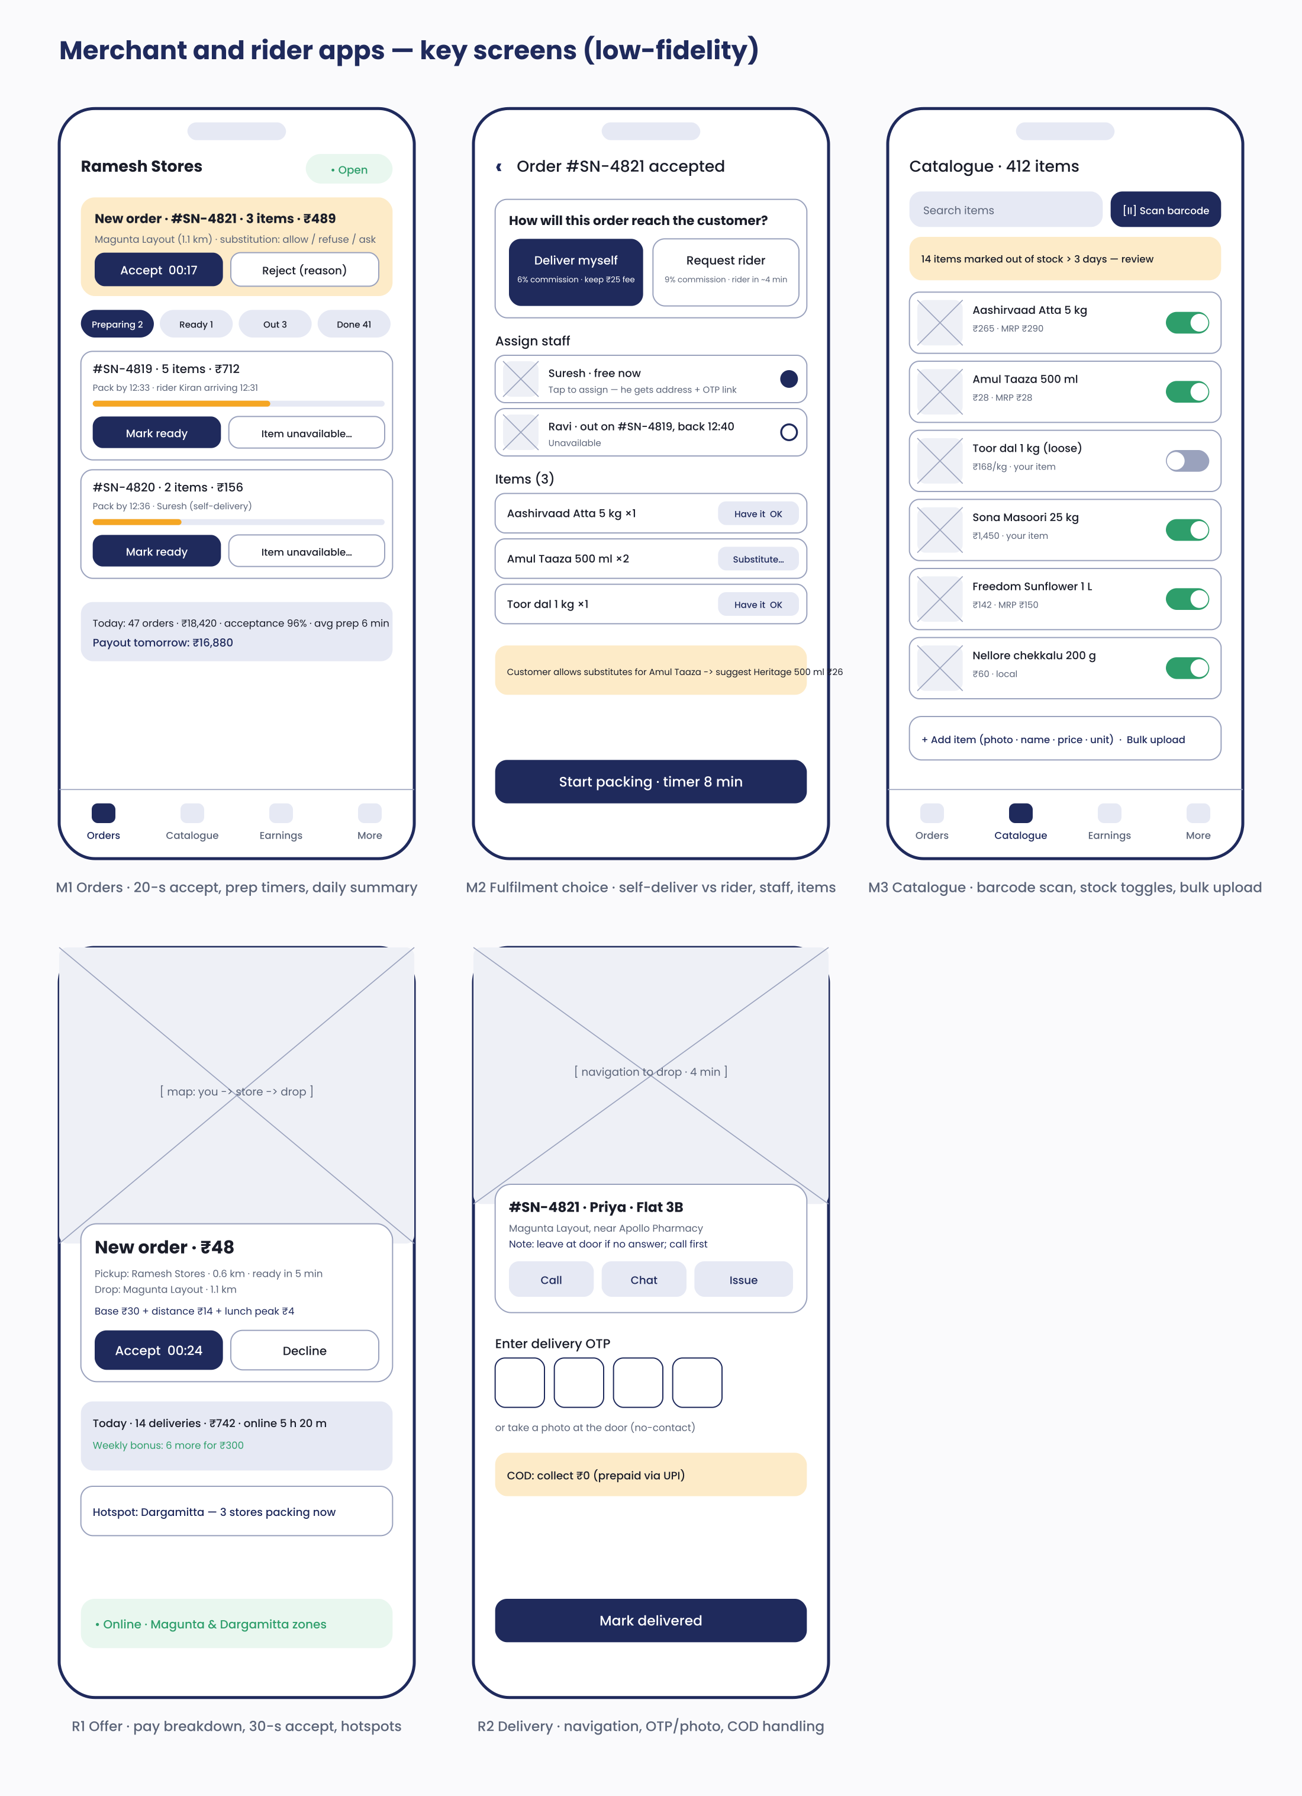
Figure 6 — Merchant: orders, fulfilment choice, catalogue · Rider: offer, delivery
Screen | Key decisions
Merchant · Orders | New-order card dominates with a 20-second countdown accept button and customer substitution preferences; progress bars for pack SLA; daily earnings and tomorrow's payout visible
Merchant · Fulfilment choice | Two large options with the economics spelled out (commission and delivery fee); staff assignment with availability; item-level 'Have it / Substitute'; packing timer
Merchant · Catalogue | Barcode scan as the primary add method; large stock toggles; staleness banner; add item and bulk upload
Rider · Offer | Pay breakdown shown before accepting; pickup readiness and distances; 30-second accept; hotspot hint; earnings and bonus progress
Rider · Delivery | Navigation hand-off; customer note; masked call/chat; OTP entry or photo proof; COD amount explicit

14.3 Operations console
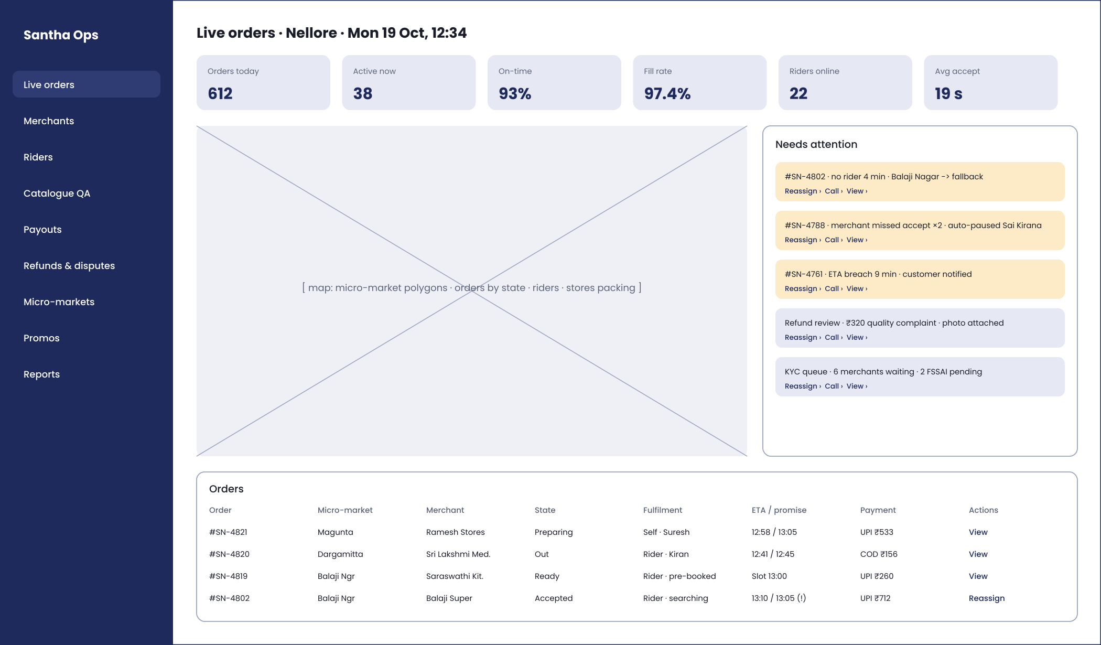
Figure 7 — Ops console: live orders with alerts and actions
The ops console is desktop web. The live view combines KPIs, a map of micro-markets with orders and riders, a 'needs attention' queue driven by SLA events (no rider, missed acceptance, ETA breach, refund review, KYC queue) and an orders table with one-click reassign, call and view actions. Further screens (merchant onboarding queue, catalogue QA, payouts, micro-market editor) follow the same layout.

15. Appendices

A. Domain events (initial list)
user.registered · merchant.created · merchant.kyc_updated · merchant.went_live · merchant.availability_changed · merchant.auto_paused · item.created · item.stock_changed · item.flagged · order.placed · order.accepted · order.rejected · order.item_substituted · order.item_removed · order.preparing · order.ready · fulfilment.requested · fulfilment.offered · fulfilment.assigned · fulfilment.fallback_triggered · fulfilment.picked_up · order.out_for_delivery · order.delivered · order.cancelled · delivery.failed · payment.intent_created · payment.captured · payment.failed · refund.requested · refund.issued · issue.reported · issue.resolved · rating.submitted · settlement.run_completed · payout.transferred · rider.online · rider.offline · rider.location_updated · config.micro_market_changed · audit.action

B. Definition of done
- Acceptance criteria met and demonstrated on staging; unit/integration tests added; analytics events emitted and documented; Telugu and English strings present; accessibility labels; error states handled; logs and metrics in place; feature flag where risky; docs updated.

C. Glossary
Term | Meaning
Micro-market | Configurable polygon that is the unit of launch, pricing and dispatch
Hybrid fulfilment | Per-order choice between merchant self-delivery and Santha rider
Outbox | Pattern that writes events to a table in the same transaction as the state change, then publishes them reliably
H3 | Hexagonal geo-index used to cache travel estimates
Route / Easy Split | Payment-aggregator products for splitting a payment to multiple payees
DLT | Telecom registration required for transactional SMS in India
PA | RBI-licensed payment aggregator

D. References
- Santha PRD v0.9; Santha BRD v0.9; Santha brand kit v1.0.
- Flutter, NestJS, PostgreSQL/PostGIS, Typesense, Razorpay Route, Google Maps Platform and PostHog documentation (verify current versions and pricing at Sprint 0).

