**Team project members**

Yonhi: Programmer, 3d artist, level designer

Helei: Programmer, 2d artist, 2d animator, level designer

**Title: Restaurant Full Moon**

Tagline: "Serving the juiciest burgers in town, made with love, care, and whatever’s available after dark. No waste, no questions, just great taste!"

**Genre**: Tycoon, cooking, action

**Target Audience:**

age: All

For people who enjoy mange restaurant and cooking, people who enjoy seeing some black humorous and conflict, reverse inside the game

Goal: during day time, selling burgers to pay rent, and during night time, clean up the mess while hiding from the passengers. Just do everything you can to keep the restaurant running.

**Mechanics:**

[Kitchen - Daytime] Different types of ingredient(resumable/unlimited, cuttable, cookable), Generating random recipes, Ingredients quantity restoring, Cooking (Interaction for picking up, cutting, timer for patty), Checking if the hamburger is cooked and built in correct way (event), Saving System, SFX, VFX, UI Animation, UI

Cleaning mini games in 2d during the night time (player movement, interaction, drag and throw); Patrol AI for Npcs, actions that Npcs will do after they caught the player. Garbage generation (object pools)

**Level Design References:**

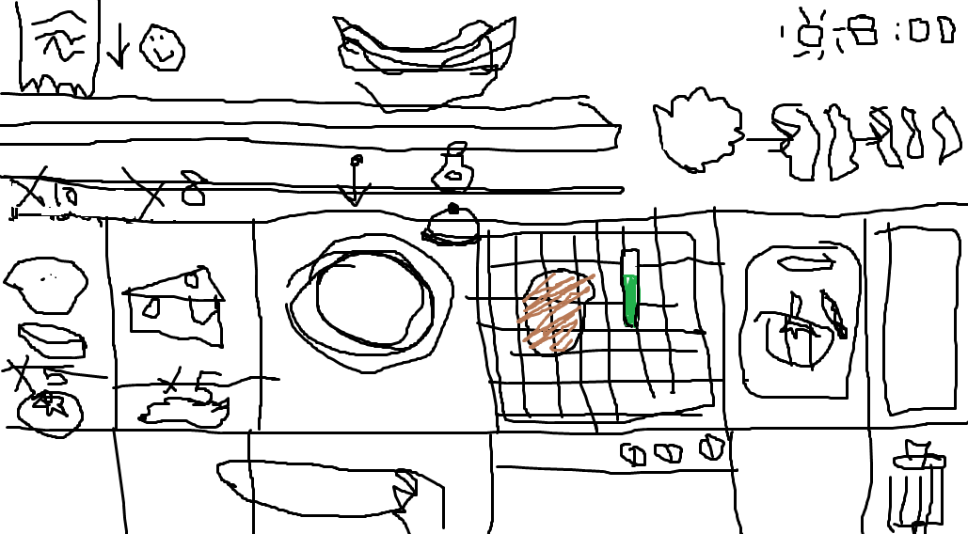

(Kitchen)

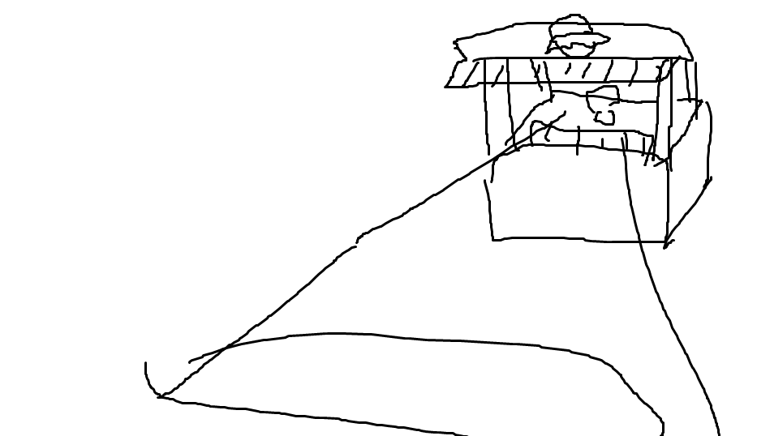

(Outside - Nightview)

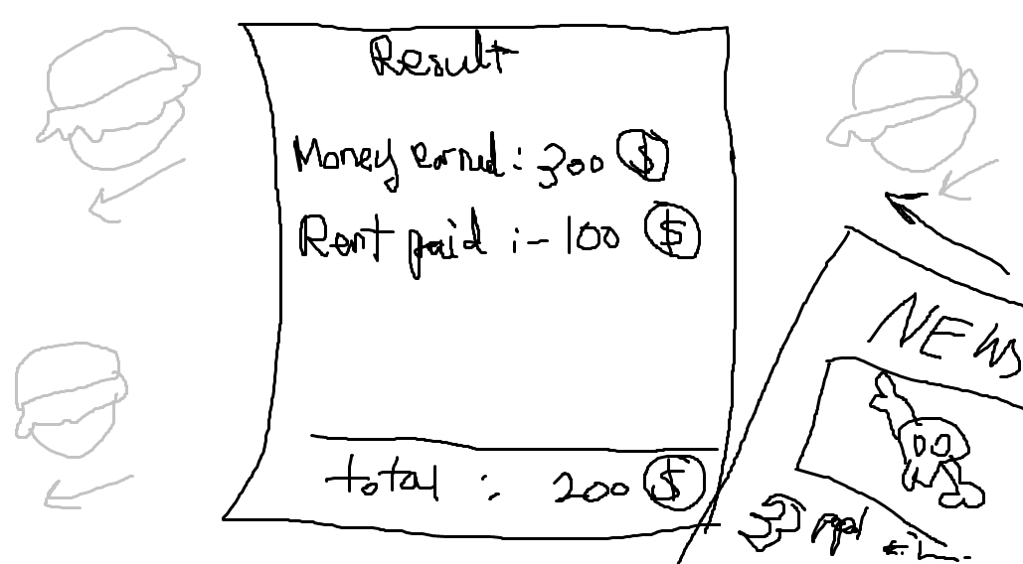

(Summary of the day)

**Task Breakdown for Next Deliverables:**

https://dgdoyh.atlassian.net/jira/software/projects/MFLP/boards/1?atlOrigin=eyJpIjoiZDYxOTE3ZGZiODdiNDkyYzgwMmM2NjhmOGNhMzdhZDciLCJwIjoiaiJ9