**Team Members**: Hanson Yang Oliver D’Avino Yaniv Lazar

**Title** Legends of the Fallen: Boss Conquest

**Tag line** “Become the Greatest Knight! Defeat Evil!”

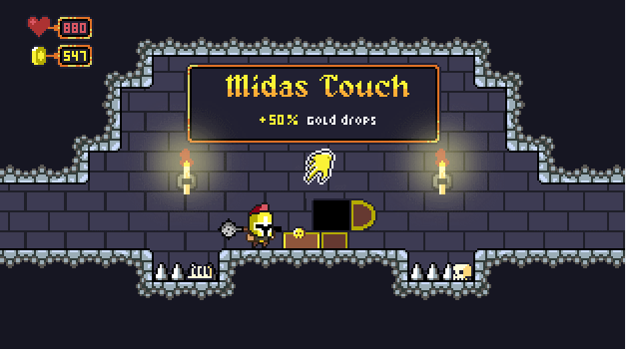

*Draft of Box Art*

**Genre** RPG

**Target**  15+ Rated Teen

**Goal Beat the boss**

**Plays like** Blasphemous meets The Binding of Isaac

**Core Mechanics**

1. The Fighting Mechanics: attack, jump, parry, dash
2. Precision Timing Mechanic: Parry
3. Looting Chest: luck based, RNG
4. Title: Blasphemous Publisher: Team17 Genre: Rogue RPG Year: 2019
5. Title: Hollow Knight Publisher: Cherry Team Genre: Metroidvania Year: 2017
6. Title: The Binging of Isaac Publisher: Edmund McMillen Genre: Rogue Like Year: 2011

**Game Project Summary**

*Supporting Screenshot / Drawings / Collage for Worlds / Levels / Characters / Game Items*

Setting: In a Castle, dark, medieval, grim

Reference

1. Game: Blasphemous
2. Game: Hollow Knight
3. Movie: Lord of The Ring
4. Game: Elden Ring
5. Game: The Binding of Isaac
6. Game: Fear & Hunger

Key Experiences

1. Trying to defeat the boss using everything that you have learned and upgraded.
2. Learning to parry attacks for the first time against some of the dungeon enemies. Timing a parry for the first time lets you learn the main mechanic to defend yourself.
3. Looting chest to gets upgrades to your character. The first time getting an item that significantly makes the game easier.

Selling Point:

1. Short and engaging
2. Challenging fighting mechanics
3. Fun Learning the mechanics
4. Thrill of getting a good equipment
5. Satisfying boss fight
6. Good music

________________________________________________________________________________________

*Supporting Screenshot / Drawings / Collage for Worlds / Levels / Characters / Game Items*