**Team Members**: Lucas Coveyduck Ehsan Hussain Tegran Tamrazayan Ravneet Singh

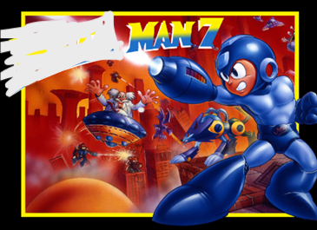

**Title** Bullet Chess



**Tag line** “Small Pawn, big bullets”

**Genre** Shoot ‘em up/Boss Rush/Puzzle

**Target**  Everybody 10+

**Goal** Defeat the bosses & become the Queen

*Draft of Box Art*

**Plays like** *Cuphead’s Boss Rush* meets *Chess with Upgrades*

WITH  *Sprinkles of Mega Man*

**Core Mechanics**

1. Bullet hell shooting (Like TBOI)
2. Constant upgrades + optional upgrades

**Related Games (Optional, remove section if you don’t use it)** ________________________________________________________________________________________

*Title Publisher or Developer Genre/Platform Year*

1. The Binding Of Issac Edmund McMillen Roguelike, Shooter game 2011

2. Hades Supergiant Games Roguelike, Fighter 2020

3. Cuphead Studio MDHR Run and Gun, Shooter 2017

4. Mega Man Capcom Action, Boss Rush 1987

________________________________________________________________________________________

**Game Project Summary**

*Supporting Screenshot / Drawings / Collage for Worlds / Levels / Characters / Game Items*

You are a pawn that wants to reign supreme over the chess kingdom! Yet there are many other royal figures trying to impede your path to power. Thus you must slay all your foes to become top of the kingdom! Along the way you will gain more and more power with options to take on side activities. These side activities will cause thou to embark on many different puzzles to gain ultimate power!!!



Sample Layout

Challenge

Hubs in between

Puzzle

Boss

Boss

Boss

*Supporting Screenshot / Drawings / Collage for Worlds / Levels / Characters / Game Items*

Pieces for game,

From <https://opengameart.org/content/pixel-chess-pieces>





[Side Blaster GFX (M484 Games) | OpenGameArt.org](https://opengameart.org/content/side-blaster-gfx-m484-games)

Sample Power Ups

Death animation [Pixel Explosion (12 Frames) | OpenGameArt.org](https://opengameart.org/content/pixel-explosion-12-frames)

[Pixel Bullet | OpenGameArt.org](https://opengameart.org/content/pixel-bullet)