**Team Members**: Nathaly Kim Barinotto, Ryan Ciot, Waleed Muhammmad, Jacob Almeida

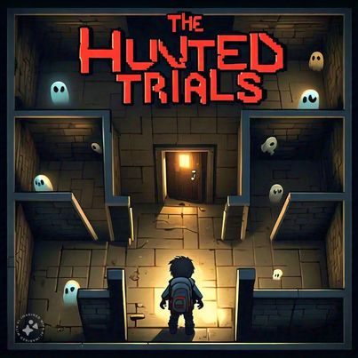**Title** The Haunted Trials

**Tag line** “Face Your Fears, Solve the Secrets.”

**Genre** Puzzle Adventure

**Target**  Teenagers/Adults

**Goal** Solve each puzzle/get though each level to be able to

find out who the murder is.

*Draft of Box Art*

**Plays like** Clue meets Luigi’s Mansion

**Core Mechanics**

1. **Clue Collection**: As players explore, they gather clues that help them piece together the murder mystery. Clues may be physical items, notes, or environmental details.
2. Survival: As the players navigate the game and try to solve the puzzle, ghosts will be roaming around and trying to kill the player, which will lead to game over. A crucial part of winning the game is avoiding these ghosts.

**Game Project Summary**

*Supporting Screenshot / Drawings / Collage for Worlds / Levels / Characters / Game Items*

Players will be spawned into a haunted house where they will have to solve puzzles to reach the next level which will be the next puzzle. Throughout the game the player, after every level a clue will be revealed that will individually help find out who the murder is at the end, which will lead to the game being won. But all of this wil have to be while avoiding ghosts that have the power to kill the player (game over).

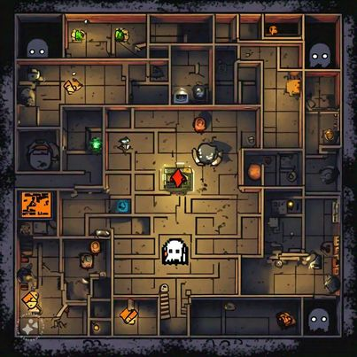

*Supporting Screenshot / Drawings / Collage for Worlds / Levels / Characters / Game Items*