**Team Members**: Mikhayla De-Las-Alas, Sofia De Palma, Kaci Luu, David Shlaifer

**Title** *Monkey Goes Bananas: Lab Escape*

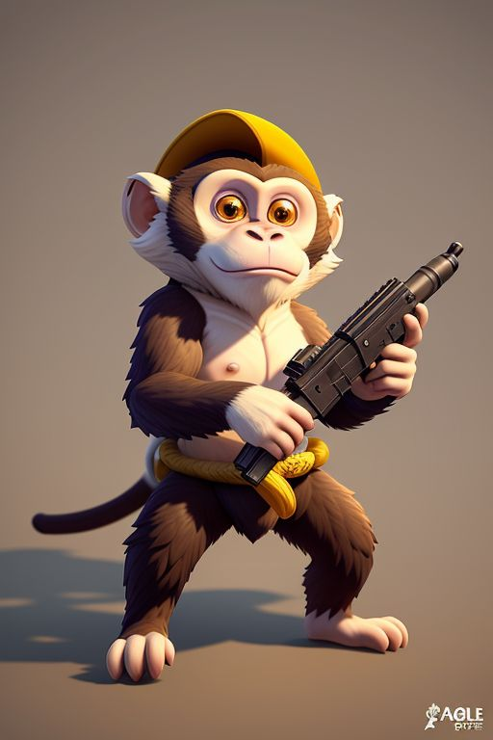

Figure 1: Concept art for main character (not final)

**Tag line** “Eat bananas, go *pew pew*, gain your freedom!”

**Genre** Action (arcade-style single-player shooter)

**Target** Teens

**Goal** Shoot and kill enemies to escape.

**Plays like** *Asteroids* meets *Super Mario*

**Core Mechanics**

1. Shoot and eliminate enemies as you play through the map in order to complete the game.
2. Gain “power-ups” by shooting boxes to reveal 1 of 2 possible the power-ups

**Game Project Summary**

Drawing inspiration from games such as *Asteroids (1979)* and *Super Mario Bros. (1985),* this arcade-style single-player shooter game has players take on the role of a monkey who was being experimented on by humans in a lab.

We decided to use the film *Rise of the Planet of the Apes (2011)* as inspiration for the story of our video game.

The goal of the game is to fight through the map by shooting and eliminating evil lab employees in order to reach the end of the map where the player will face the final boss: the despicable head scientist.

Additionally, as the game progresses, players will encounter boxes which may be destroyed in order to reveal one of two possible power-ups. The first and more common type of power-up is a banana. This power up will temporarily increase the players strength by decreasing their damage intake; this power up will be visualized by increasing the player’s size. The second power-up will be a bit more rare to encounter. This power-up will be represented as a lab vial filled with a vibrant green fluid. If the player uses it, they will temporarily have an increased firing rate.

*Supporting Screenshot / Drawings / Collage for Worlds / Levels / Characters / Game Items*

Lastly, if the player manages to eliminate the final boss, they have won game and have gained their freedom as a free monkey in the wild! Players will then see a winning screen with an image of a jungle background. However, if at any point during the playthrough they get caught, a losing screen with an image of a monkey (the player) behind bars will be displayed.

*Supporting Screenshot / Drawings / Collage for Worlds / Levels / Characters / Game Items*