Cookie
A cookie is a small piece of data that a website stores on a user's device (like a computer or smartphone) through the web browser. Cookies help websites remember information about the user, such as login status, preferences, or items in a shopping cart.
Real-Time Example:
Example: Online Shopping (Amazon)
Imagine you are shopping on Amazon:
- 🛒 You add items to your cart.
- 🧭 Then you leave the website without checking out.
- 🕒 Later, you return to Amazon—and your cart still has the items.
How does Amazon remember?
👉 It’s because cookies were used to store your cart information on your browser or track it via a session ID.
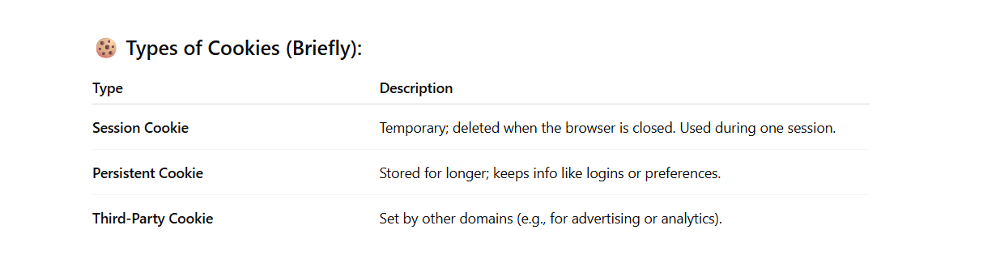

How to use cookie in express JS
_______________________________________________________________________
Using cookies in Express.js is simple with the help of the cookie-parser middleware. This allows your Express server to set, read, and clear cookies in HTTP requests and responses.
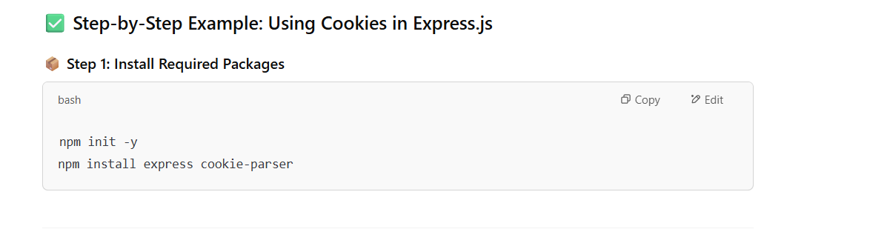

Step 2: Create server.js
const express = require('express');
const cookieParser = require('cookie-parser');

const app = express();
const PORT = 3000;

// Use cookie-parser middleware
app.use(cookieParser());

// Route to set a cookie
app.get('/set-cookie', (req, res) => {
res.cookie('username', 'JohnDoe', {
maxAge: 24 * 60 * 60 * 1000, // 1 day
httpOnly: true // Cookie only accessible by the web server
});
res.send('Cookie has been set!');
});

// Route to read the cookie
app.get('/get-cookie', (req, res) => {
const username = req.cookies.username;
res.send(`Cookie retrieved! Username: ${username}`);
});

// Route to clear the cookie
app.get('/clear-cookie', (req, res) => {
res.clearCookie('username');
res.send('Cookie has been cleared!');
});

app.listen(PORT, () => {
console.log(`Server is running on http://localhost:${PORT}`);
});



