DBMS & SQL+PLSQL
__________________________________________________________________________
Q. What is Database?
_________________________________________________________________________
Database means it is collection organized data and typically store and manage for future use or may be past use or may be for analysis purpose or may be some other purpose called as database

Q. What is DBMS?
_______________________________________________________________________
DBMS stands for Database Management System Basically it is standard format for manage the database or data collected by users and typically stored in computer system.

How many ways to manage the DBMS or Types of Databases
_________________________________________________________________________________
1. Relational database: Relational database means when we store data in the form of table & provide internal relationship between multiple tables using integrity constraints called as relational database management system
Note: Relational word use for table structure
Example
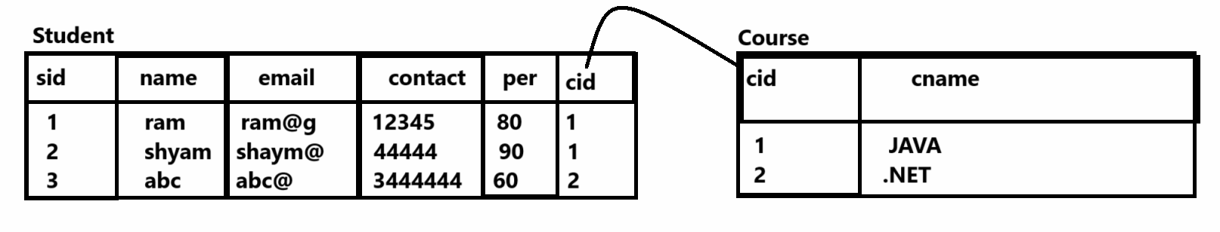
Example of Relational Database management system is : MYSQL/Oracle/DB2/Postgres SQL
2. Object oriented database: If we think about object oriented database we store data in the form of objects and collections
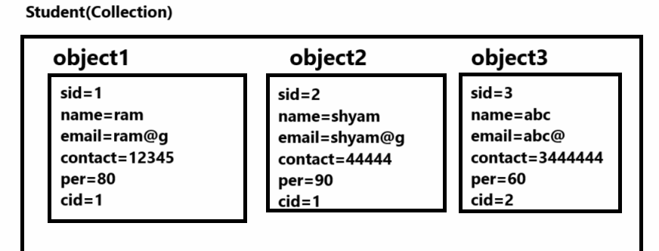
3. Hierarchical database: when we manage data or database in the form tree format called as Hierarchical database.
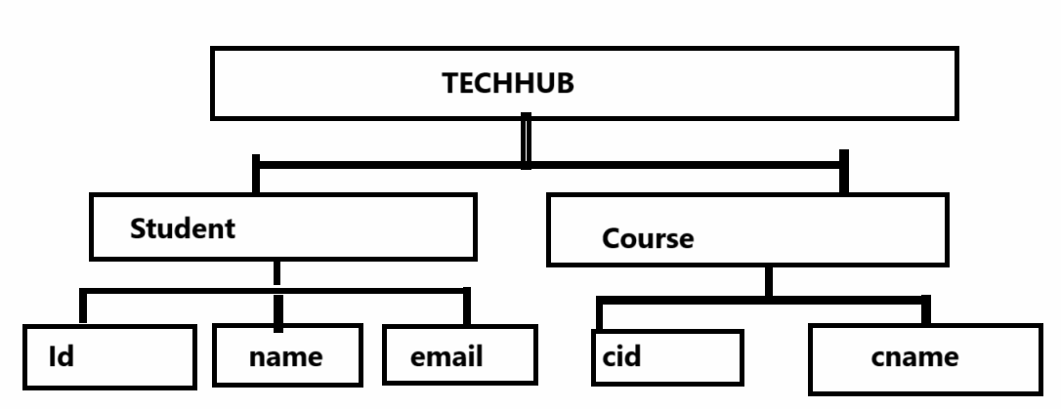
Example: Windows File management system and folder management system is an example of
Hierarchical database management system
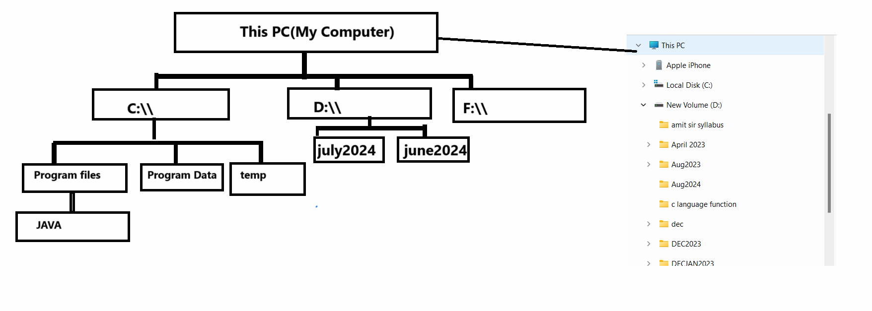
4. Distributed database: Distributed database consist of two or more files or database located on multiple computers or scattered in different networks and connected with centralized database or data center called as distributed database management system
5. Document/JSON: we can store data in the form of JSON file using key and value pair as well as json format work as object but when we save this database then we save as file with extension of .json so it is documentary or file base database.
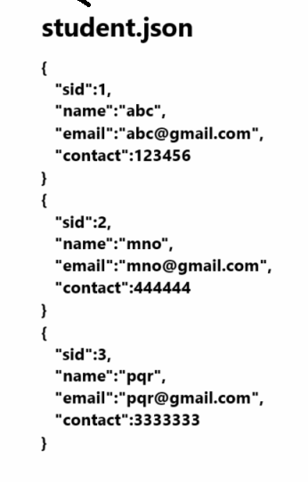
6. Cloud database: cloud database means when we have database on remote server or on cloud and we can use it centralized by multiple users and data not stored on user machine but user can access it from remote servers or cloud called as cloud database
Example: Google drive, Microsoft one drive
etc

Now we want to work with Relational Database Management System
___________________________________________________________________
If we want to work with relational database management system we have some important steps.
1. Download the any tool which support to RDBMS
Note: if we want to work with RDBMS we have n number of vendors like as oracle,IBM etc
Oracle provide two tools to us for work with RDBMS oracle, MYSQL

Important point
MySQL was owned and sponsored by the Swedish company MySQL AB, which was bought by Sun Microsystems (now Oracle Corporation). In 2010, when Oracle acquired Sun, Widenius forked the open-source MySQL project to create MariaDB.
Now we want to work with MYSQL
Q. What is MYSQL?
___________________________________________________________________
MYSQL is tool which provide environment to us for work with relational database management system means we can say MYSQL implement all methodology/Concept of RDBMS
You can download the MYSQL using Following Link
https://www.mysql.com/downloads/
2. Create Database using SQL
_____________________________________________________________________________
Q. What is SQL?
___________________________________________________________________________
SQL stands for Structure Query Language basically programming language use for work with relational database management system.
Q. What is Database definition according to RDBMS?
_________________________________________________________________
According to RDBMS database is a collection of tables and integrated with each other internally.
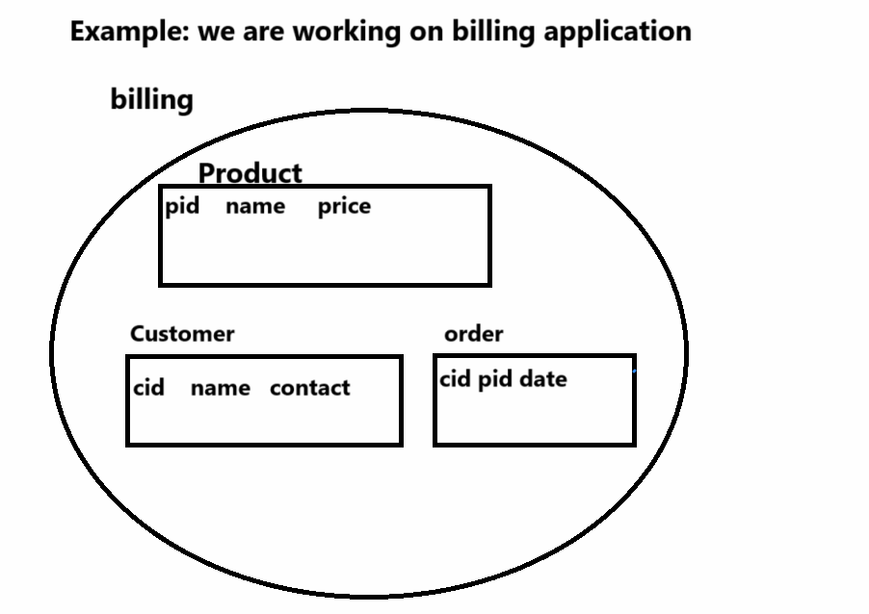

Note: if we think about above diagram we consider we have billing database it contain three table
like as Product,Customer,Order etc

Steps to create database using MYSQL
_______________________________________________________________________
a) Open MYSQL –
start menu -- search – type mysql and press enter
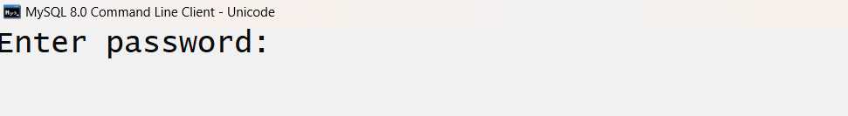
b) Enter password which we provide at the time of installation
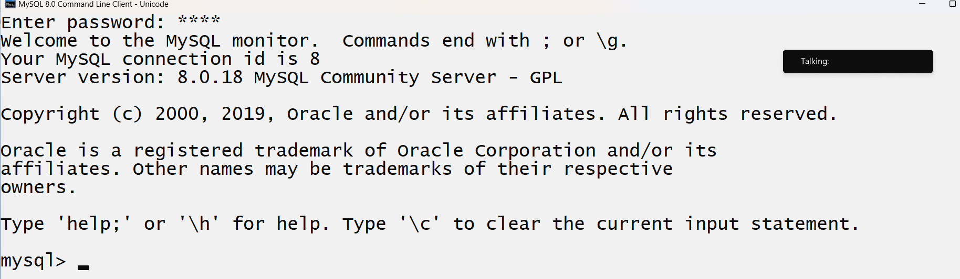
c) Enter in default database provided by MYSQL Tool name as mysql
if we want to use mysql database or default database provided by MYSQL to us or use any other database we have to use following command
Syntax: use databasename;
Example: use mysql
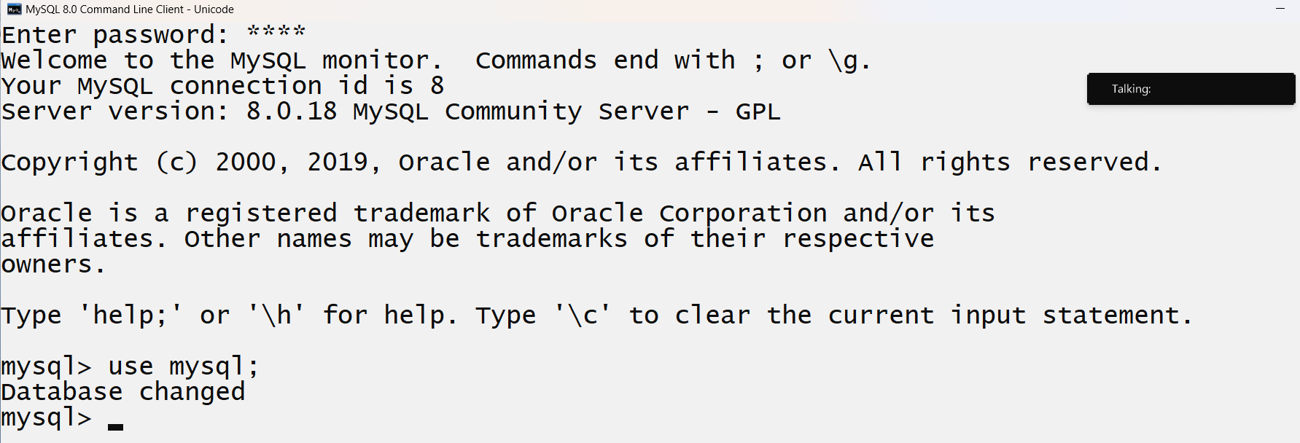
if we think about above screen short we enter in mysql database provided by MYSQL tool to us
d) Create your own database
If we want to create your own database we have command name as

Syntax: create database databasename;
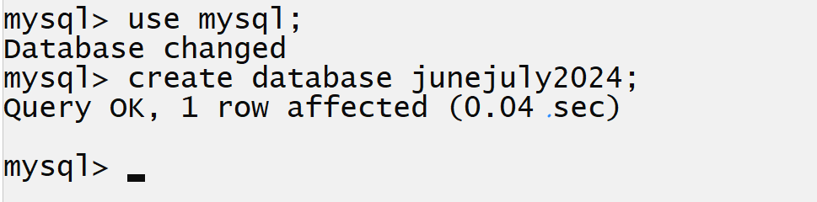
After this command we have two database in MYSQL one is default database name as Mysql and one is user created database name as junejuly2024
Now we want to enter in user database name as junejuly2024 and for that we can use following command
Example: use junejuly2024
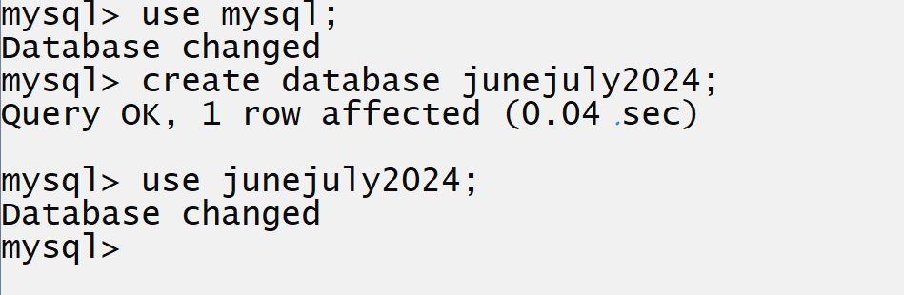
Once we create your database after that we can work with database

3. Work with Database
________________________________________________________________________
If we want to work with database we have some command provided by SQL to us
1. DDL
2. DML
3. DCL
4. TCL

