Take-Home Project
Design & Develop an Agentic Multimodal RAG System

📌 Project Overview

You are tasked with building an agentic multimodal Retrieval-Augmented Generation (RAG) chatbot with real-time web search capabilities. The chatbot should answer user questions by drawing from both internal source documents — such as PDFs, Word, Excel, or text files — and external web content. It should leverage a vector database for context retrieval and a large language model (LLM) for response generation.
This project mirrors real-world AI assistants such as ChatGPT and Claude by integrating agents, LLMs, and diverse knowledge sources to deliver accurate, context-aware, and explainable answers. Your implementation should reflect your own design decisions, understanding, and any enhancements you choose to make.

✅ Core Requirements

1. Document Ingestion & Vectorization
- Load and parse source documents (PDF, Word, Excel, TXT, etc.) from a root directory. You may use any publicly available, synthetic, or dummy files for illustration and testing.
- Chunk & embed text using a transformer-based embedding model.
- Store embeddings in a vector database (e.g., Weaviate or equivalent).

2. Agentic RAG Pipeline
- Implement a conversational retrieval chain powered by an LLM.
- Retrieve top-k relevant chunks and generate grounded answers.
- Display source references — the most relevant sources and retrieved content should be shown alongside the generated response.

3. Web Interface
- Build a chat UI (ChatGPT/Claude-style) using FastAPI, Gradio, Streamlit, or any web framework of your choice.
- Support text and voice input with answers displayed alongside references.
- Include chat session history so users can review prior interactions within a session.
- Implement a basic login/registration flow.

4. Memory
- Session / Short-term memory: maintain context within an active conversation.
- Long-term memory: persist relevant information across sessions where applicable.

5. Code Quality
- Organize code into logical modules or functions.
- Include inline comments and a README with clear setup instructions.

🌟 Bonus Points & Nice-to-Have

- Orchestration Frameworks: LangChain, LangSmith, LangGraph, or similar.
- Safety Guardrails: e.g., NeMo Guardrails, hallucination detection/mitigation, or fallback logic.
- Web Search Fallback for queries not answered by internal documents.
- Dockerize your application for portable, reproducible deployment.
- Logging, Monitoring, or Performance Metrics such as latency and token usage.
- Test Suite, Video Demo, or Notebook demonstrating the end-to-end system or key components.
- With proper attribution/references in your final report.

📤 Submission Instructions

Deliverables — Submit as a single zipped folder:
- Complete source code for your implementation.
- README.md with setup instructions and a brief explanation of your approach and design decisions.
- Short video demo with a code walkthrough — max 5 minutes — demonstrating your solution end-to-end.

Required File Structure
Please organize your submission according to the directory structure shown below:
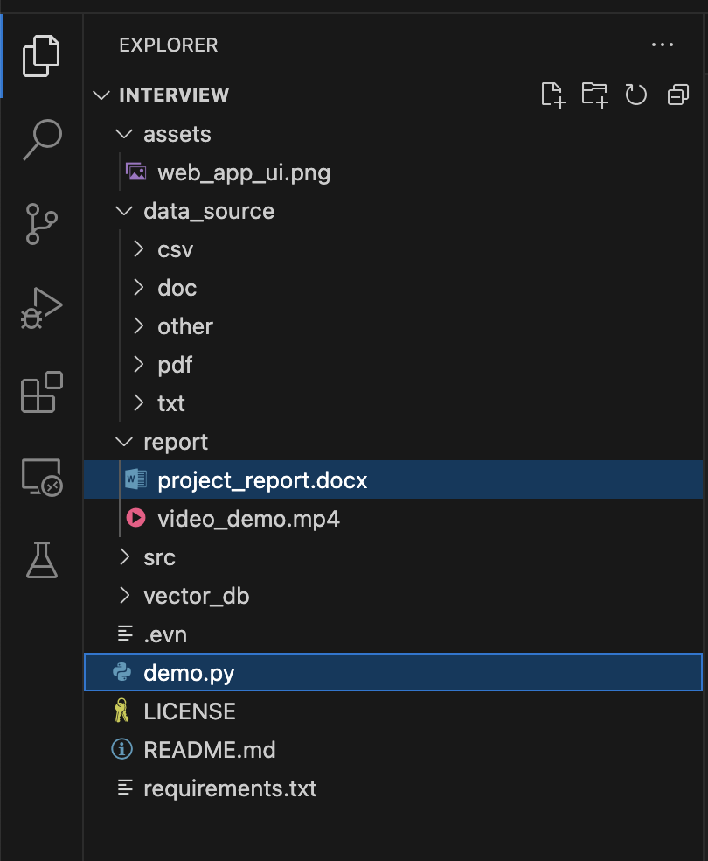
Figure: Required project submission file structure

