Use case

Build gcc-4.9.2

Number of files:84895

Total storage space:728M

Top 10 files:

6.6M gcc-4.9.2/MD5SUMS

6.1M gcc-4.9.2/libgcc/config/libbid/bid_binarydecimal.c

3.0M gcc-4.9.2/libstdc++-v3/doc/html/ext/lwg-defects.html

2.9M gcc-4.9.2/gcc/testsuite/go.test/test/fixedbugs/bug257.go

2.4M gcc-4.9.2/gcc/doc/gcc.info

2.3M gcc-4.9.2/gcc/doc/gccint.info

2.3M gcc-4.9.2/gcc/po/es.po

2.2M gcc-4.9.2/gcc/po/sr.po

2.1M gcc-4.9.2/libstdc++-v3/configure

2.1M gcc-4.9.2/gcc/po/fr.po

Retry once when there is failure.

m5.large x 4, with gp2 storage

clients connect to NFS server through a single load balancer

|  |  |  |  |  |  |
| --- | --- | --- | --- | --- | --- |
| Number of Clients | Max Average CPU (5 minutes period with 5 samples) on all NFS Servers | Combined Max IOPS on all disks | Average copy time | Average compile time | Average delete time |
| 1 (no load balancer) | 23% | 659 | 3m30s | 25m25.043s | 1m50.360s |
| 1 | 29% | 698 | 6m1s  6m30s  5m50s | 27m8.283s  26m3s  26m2s | 2m3.735s  1m59s  2m1s |
| 5 | 61% | 2113 | 8m10s  6m23s  7m32.095s  7m29.979s  7m39.286s | 27m25.524s  27m39.753s  27m38.227s  27m42.410s  28m0.267s | 2m3.735s  2m47.589s  2m48.101s  2m26.183s  2m43.556s |
| 10  (Note: two failures, had to do make clean, and rebuild) | 78% | 4000 | 9m10s  10m12.961s  10m10.643s  9m36.959s  10m26.442s  10m11.439s  10m53.213s  10m43.591s  9m52.422s | 28m49.475s  28m34.340s  28m47.339s  28m16.571s | 3m32.510s |
|  |  |  |  |  |  |
| 20 (4 failures) | 99% | 6240 | 16m55.472s  17m13.176s  16m30.668s  15m35.422s  17m2.556s  16m40.682s  15m39.523s  16m10.524s  16m7.266s  16m31.743s | 32m58.020s  34m0.307s  33m33.275s  33m48.061s  33m48.304s  33m3.367s  32m31.298s |  |

Single Client

Server metrics

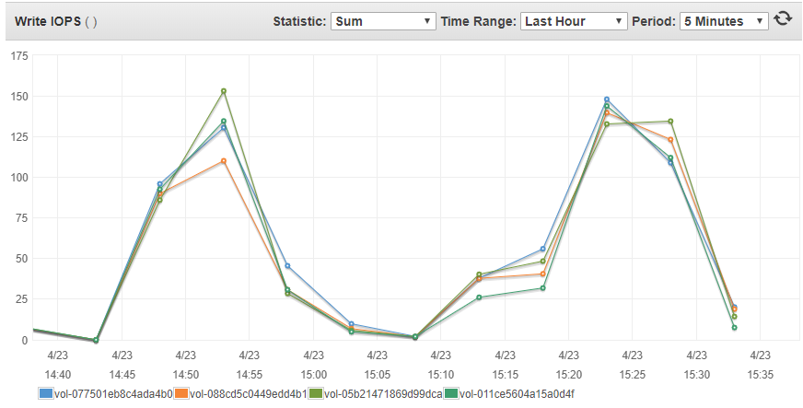

Two consecutive runs: Gluster volumes bursts to 698 IOPS in total

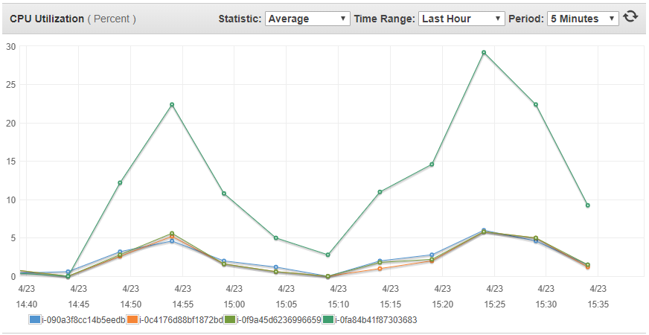

Gluster/NFS servers CPU reaches 29% max

10 Clients

Server

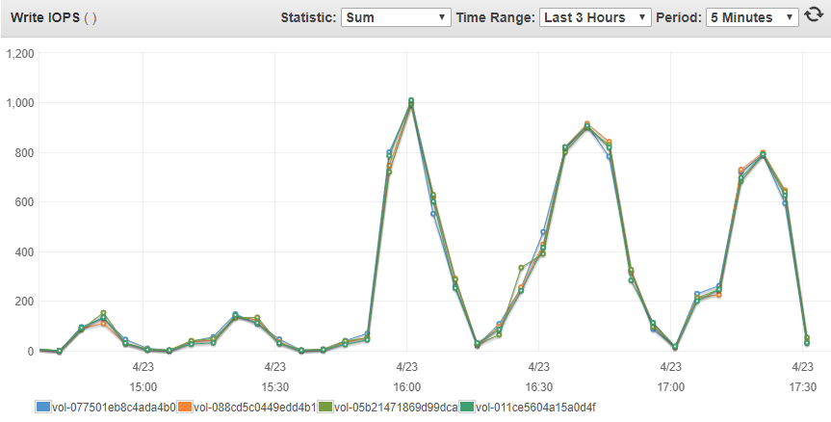

Gluster volumes bursts to 4000 IOPS in total

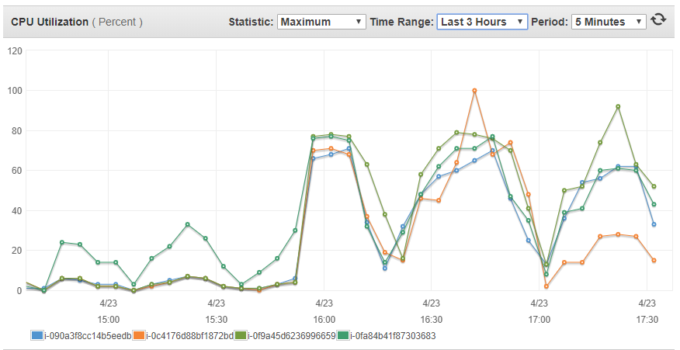

Gluster/NFS servers CPU reaches 80% max

Client

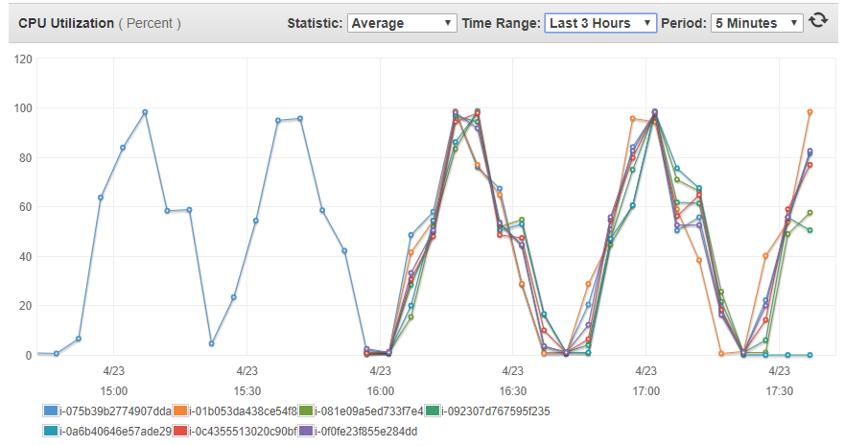

Client hosts CPU can reach 100%

20 clients

Server

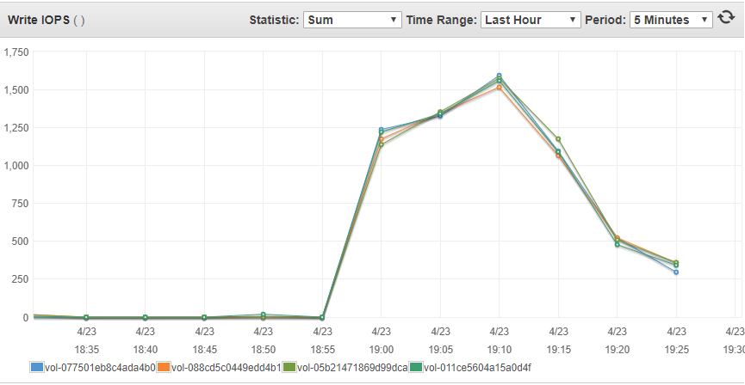

Gluster volumes bursts to 6240 IOPS in total

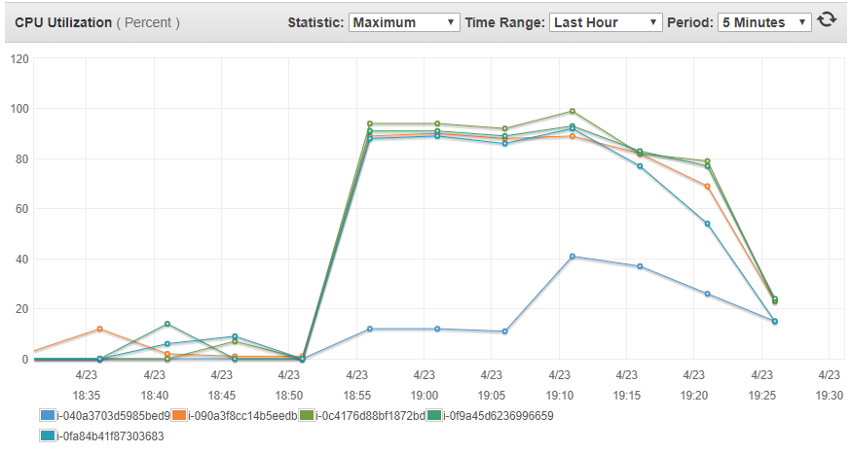

CPUs on Gluster/NFS servers close to 100% during file copies from 20 clients

CPU on load balancer reaches 40%

Load balancer

Clients

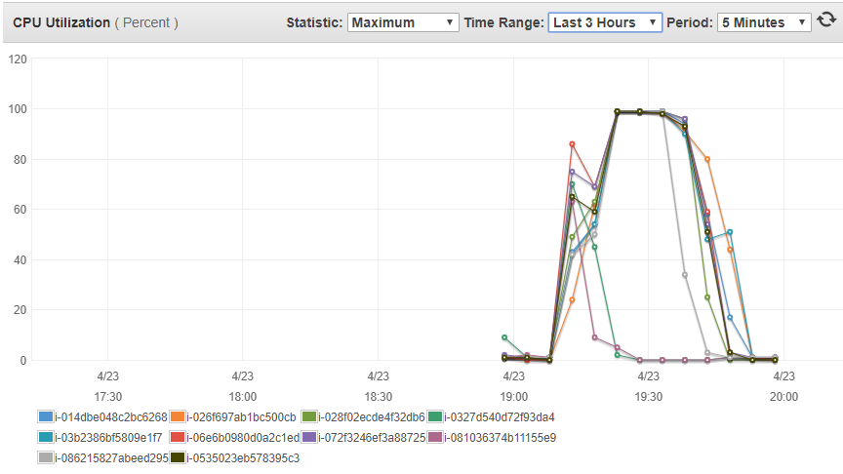

Client hosts CPU can reach 100% with some client builds failsprematurely

m5.xlarge x 4, with gp2 storage with enough IOP balance

|  |  |  |  |  |  |
| --- | --- | --- | --- | --- | --- |
| Number of Clients | Max Average CPU (5 minutes period with 5 samples) on all NFS Servers | Combined Max IOPS on all disks | Average copy time | Average compile time | Average delete time |
| 20 | 77%  Glusterfsd 162%  Ganesha 127% | 7,615 | 11m57.451s  11m53.814s  11m35.771s  11m39.983s  11m40.378s  11m37.720s  11m22.869s  12m1.546s  11m49.090s  11m48.383s  11m46.497s  11m44.307s  12m1.204s  11m45.771s  11m52.732s  11m22.753s  11m42.584s  11m57.197s  11m46.675s  11m40.908s |  |  |
| 30 | 86%  Glusterfsd 193%  Ganesha 148% | 11,158 | 15m15.815s  14m43.461s  14m57.731s  15m6.105s  14m56.538s  14m26.196s  15m37.722s  14m59.951s  15m56.660s  15m27.477s  15m11.105s  15m10.896s  15m14.065s  15m8.592s  15m11.347s  15m8.775s  14m10.435s  15m39.211s  15m35.761s  14m46.563s  15m2.491s  14m20.439s  14m50.252s  14m0.493s  14m15.893s  14m9.685s  14m56.579s  15m33.331s  15m11.281s  15m17.868s |  |  |

20 clients connect to NFS server via load balancer

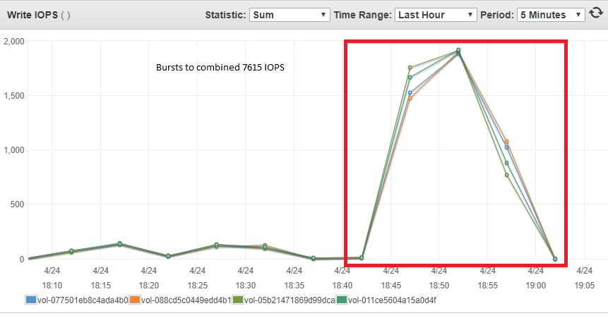

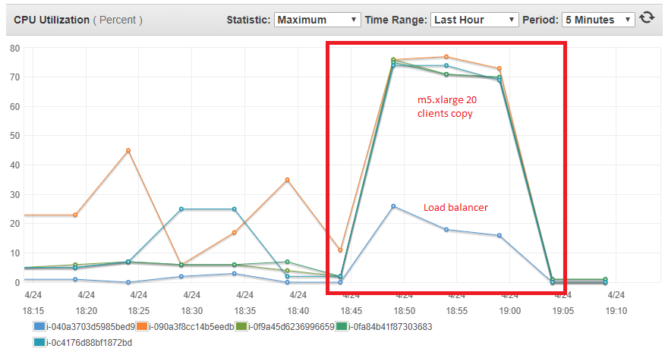

30 clients connect to NFS server via load balancer

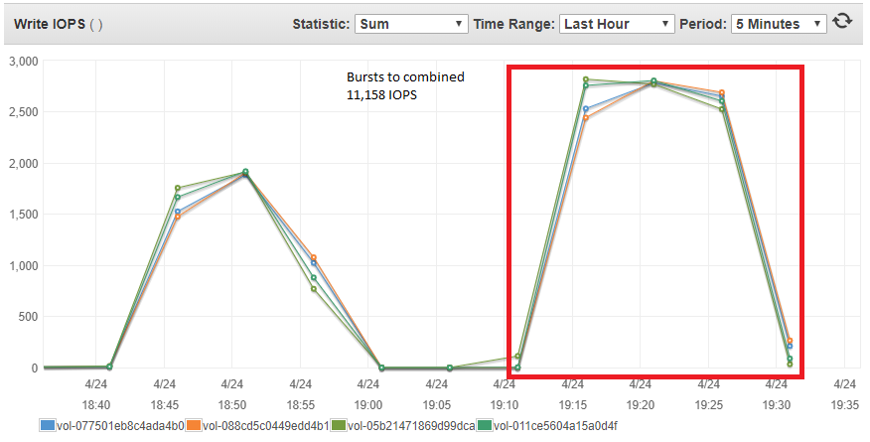

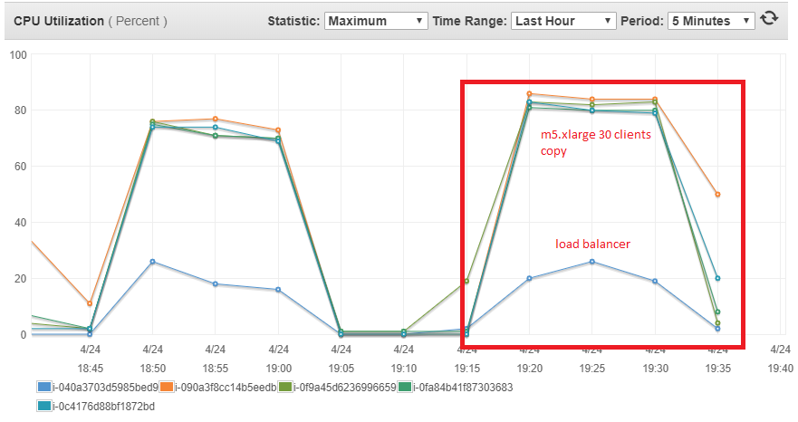

m5.2xlarge x4, with gp2 storage with enough IOP balance

|  |  |  |  |  |  |
| --- | --- | --- | --- | --- | --- |
| Number of Clients | Max Average CPU (5 minutes period with 5 samples) on all NFS Servers | Combined Max IOPS on all disks | Average copy time | Average compile time | Average delete time |
| 40 | 61%  Glusterfsd 264%  Ganesha 208% | 12,827 | 15m58.533s  16m34.021s  16m10.479s  16m34.630s  16m19.228s  16m1.727s  16m12.475s  16m16.293s  15m56.625s  16m5.728s  16m39.974s  16m13.262s  16m20.171s  16m8.201s  16m18.291s  16m18.496s  16m59.955s  16m12.235s  16m6.208s  16m19.202s  16m12.430s  16m16.808s  16m35.110s  16m16.881s  18m6.819s  16m38.117s  16m14.097s  16m37.195s  16m34.356s  16m37.134s  16m9.995s  16m40.183s  16m17.018s  16m30.093s  16m8.307s  16m26.406s  16m20.906s  17m10.188s |  |  |

