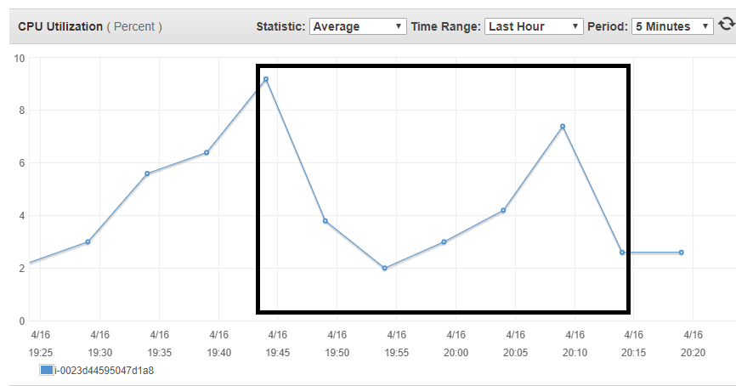

NFS server

Instance: m5.large (2 vCPU, 8GiB Mem)

NFS version: v3

Exported volume size: 100G

Provisioned IOPS: 5000

NFS Client

GCC build with make -j8

|  |  |  |  |  |  |
| --- | --- | --- | --- | --- | --- |
| Number of Clients | Max CPU on NFS Server | Max IOPS on disk | Average copy time | Average compile time | Average delete time |
| 1 | 9% | 683 | 3m30s | 22m50s | 1m14s |
| 15 | 34% | 4674 | 10m22s | 24m3s | 4m40s |
| 20 | 50% | 5000 | 12m50s | 26m38s | 6m14s |
| 25 | 71% | 5000 | 18m11s | 30m11s | 8m20s |
| 30 | 100% |  |  | - | - |

15:40 – 16:23 (20 client)

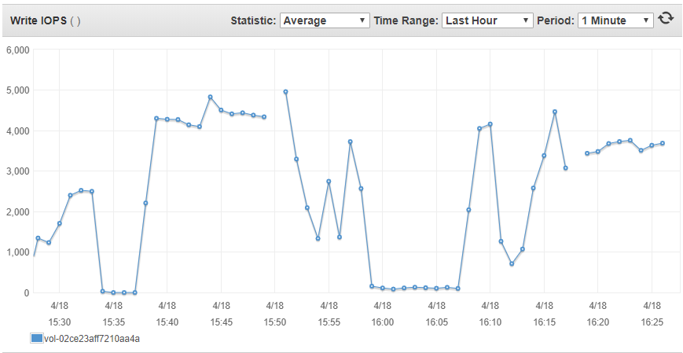

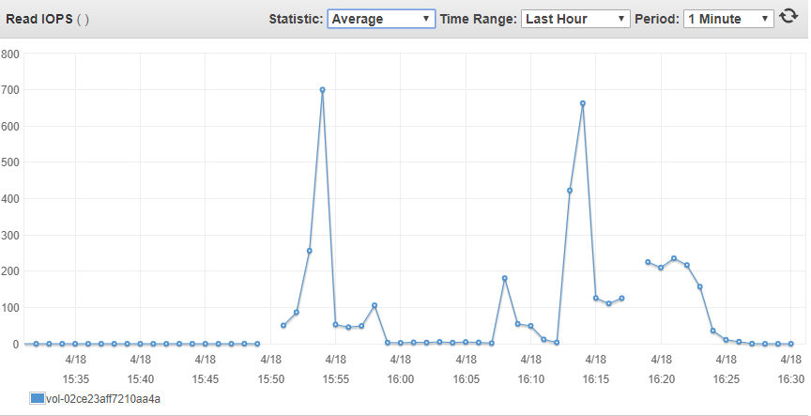

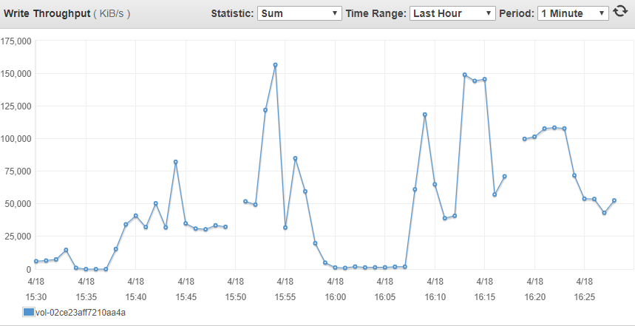

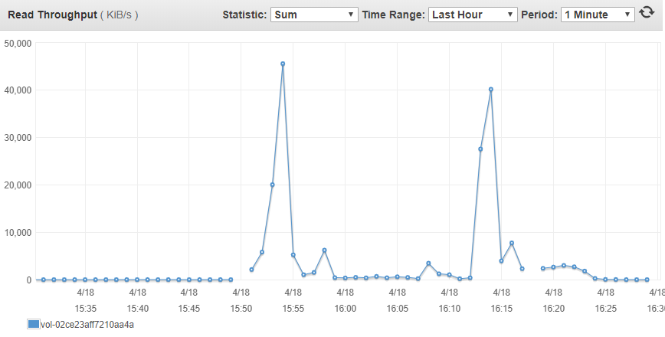

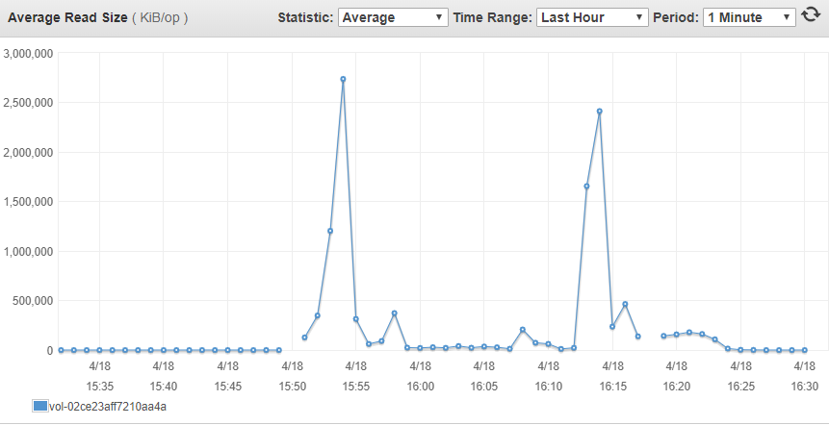

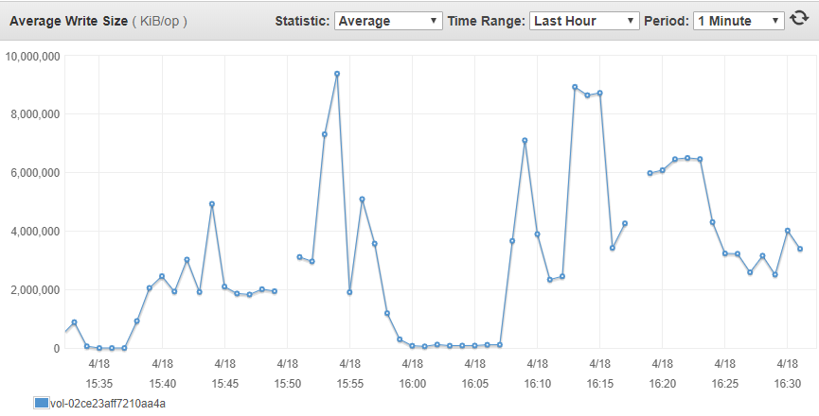

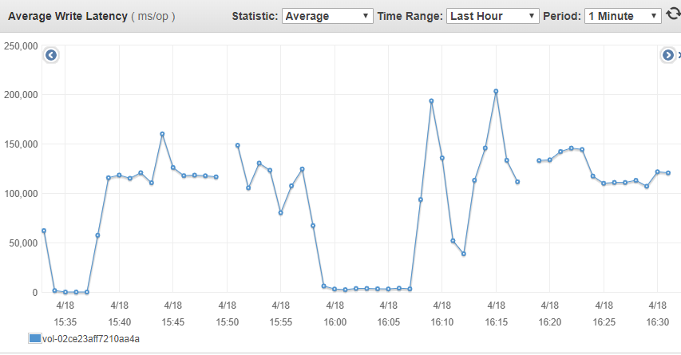

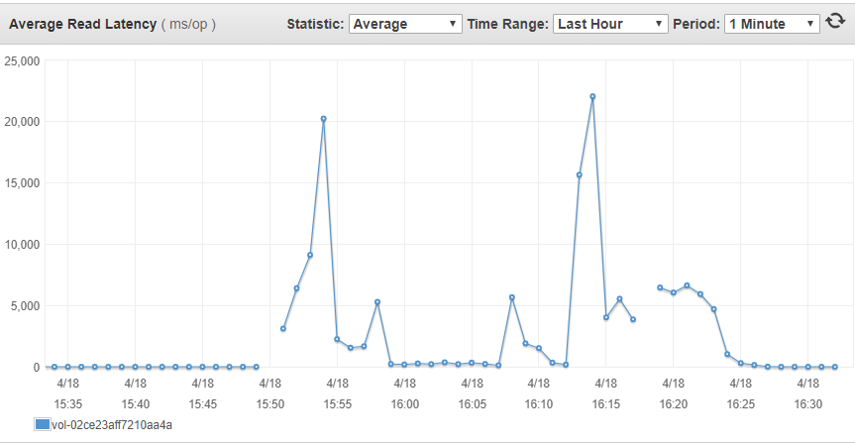

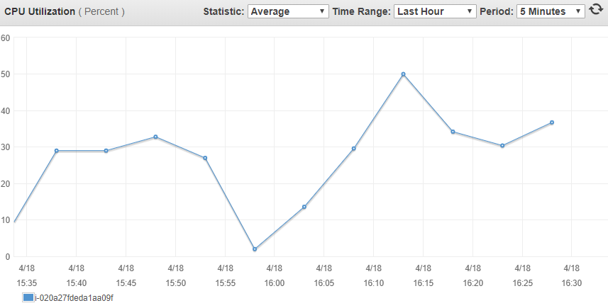

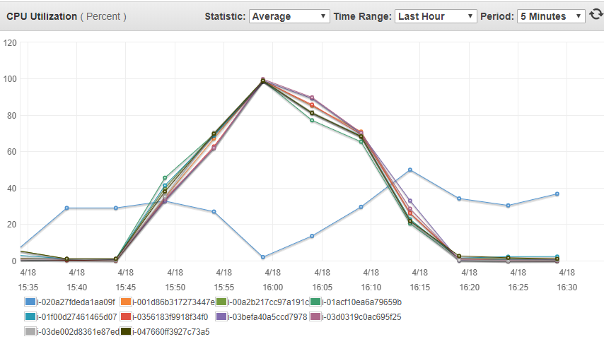

15:40 – 17:15 20 clients two rounds of build, each client is doing GCC build with make -j8

17:15 – 18:00 adding 10 more clients (30 clients total), NFS server fails eventually

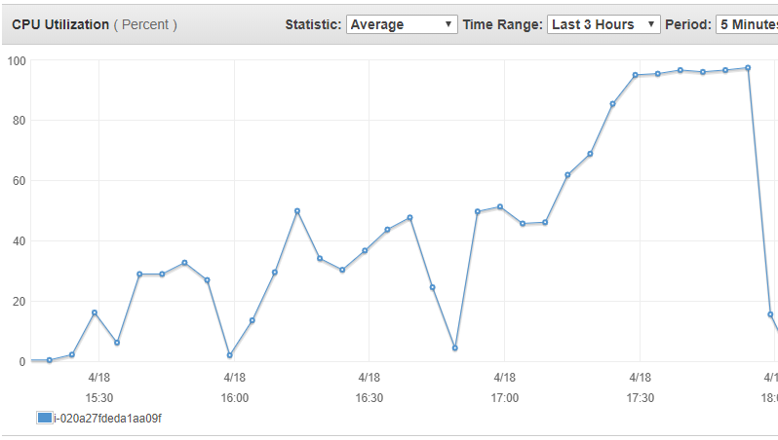

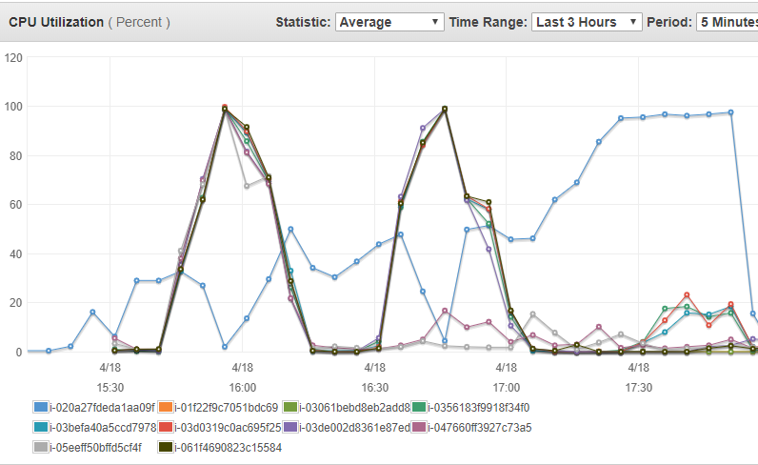

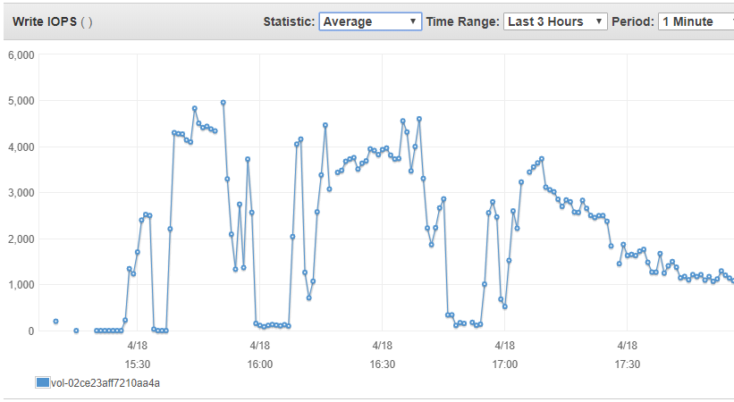

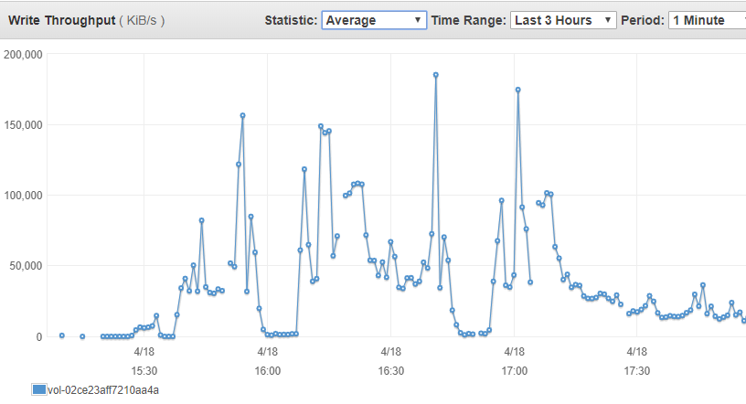

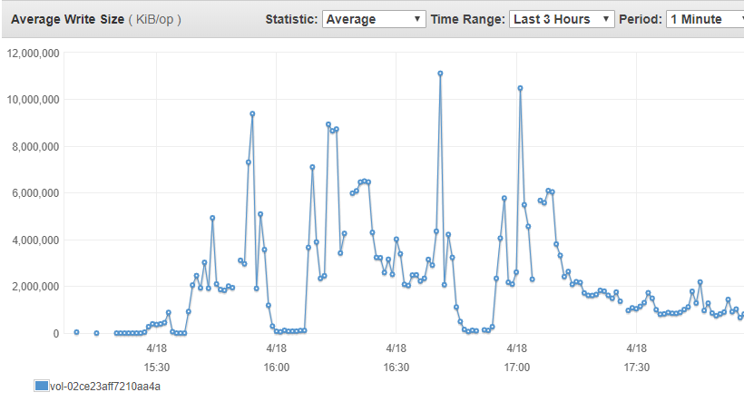

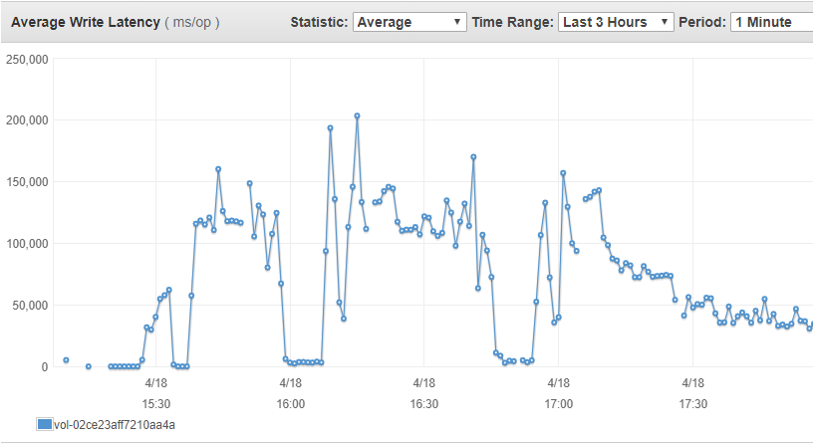

NFS server

Instance: m5.large (16 vCPU, 64GiB Mem)

NFS version: v3

Exported volume size: 100G

Provisioned IOPS: 5000 (translate to 80MiB/s for 16KB data size – 320 MiB/s for 64KB data size)

Modified when concurrent clients increase to 40:

Exported volume size: 150G

Provisioned IOPS: 7500 (translate to 120MiB/s for 16KB data size – 480 MiB/s for 64KB data size)

NFS Client

GCC build with make -j8

Network

64 bytes from 172.31.18.0: icmp_seq=2 ttl=64 time=0.093 ms

64 bytes from 172.31.18.0: icmp_seq=3 ttl=64 time=0.095 ms

64 bytes from 172.31.18.0: icmp_seq=4 ttl=64 time=0.095 ms

64 bytes from 172.31.18.0: icmp_seq=5 ttl=64 time=0.098 ms

64 bytes from 172.31.18.0: icmp_seq=6 ttl=64 time=0.092 ms

64 bytes from 172.31.18.0: icmp_seq=7 ttl=64 time=0.096 ms

Each processor:

vendor_id : GenuineIntel

cpu family : 6

model : 85

model name : Intel(R) Xeon(R) Platinum 8175M CPU @ 2.50GHz

stepping : 4

microcode : 0x200003a

cpu MHz : 2499.998

cache size : 33792 KB

30 clients write at the same time, total size 900MBx30 = 22.3GB, Average time 18 min = 1080 second. Average throughput is 25 MB/s

|  |  |  |  |  |  |
| --- | --- | --- | --- | --- | --- |
| Clients | Max Average CPU (5 minutes period with 5 samples) on NFS Server | Max IOPS on disk | Average copy time | Average compile time | Average delete time |
| 1 | 0.6% | 1682 | 3m30s | 22m59s | 1m5s |
| 5 | 2.6% | 3637 | 5m4s | 23m30s | 1m9s |
| 10 | 4.6% | 3928 | 5m28s | 24m46s | 2m47s |
| 20 | 5.2% | 4170 | 11m20 | 26m47s | 6m14s |
| 30 | 10% | 5098 (max provisioned 5000) | 19m33s | 30m30s | 10m35s |
| 40  (Resize disk from 100G to 150G) | 8.4% | 5579 (max provisioned 7500) | 25m54s | 36m40s | 13m16s |

Spot instance interruption in the middle of 30 clients testing

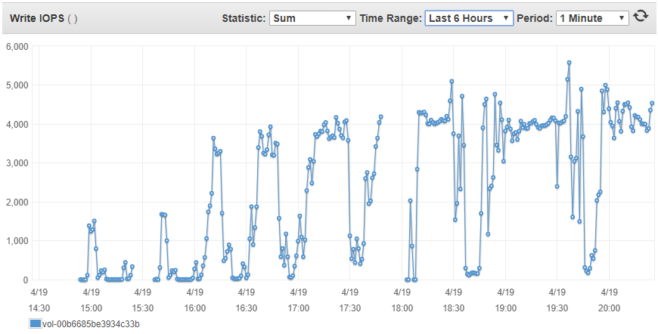

30

40

20

1

30

10

5

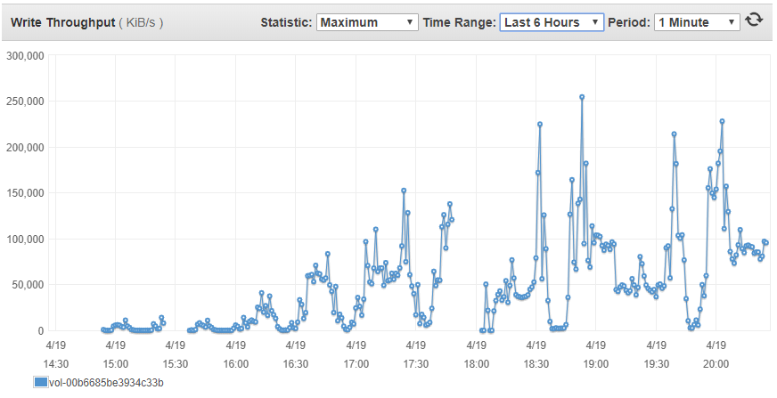

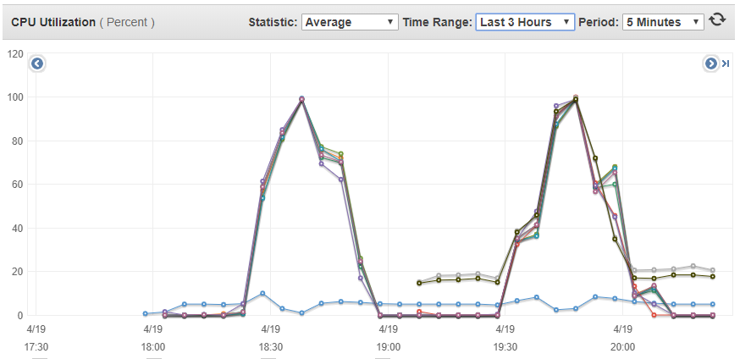

NFS Server CPU ut

Sampled every 1 minute, average over 5 minutes period

40 clients

30 clients