## ****Title:****

### Salesforce-Based CRM and Inventory Automation for HandsMen Threads

## ****1. Introduction****

HandsMen Threads, a growing enterprise in the fashion domain, has embarked on a digital transformation journey through Salesforce to streamline its operations. This project involved implementing a customized CRM and inventory management system with automation at its core. By leveraging Salesforce tools such as Lightning App Builder, Apex, Flows, and Process Automation, the system is designed to improve operational efficiency, enhance customer relations, and ensure real-time inventory tracking.

## ****2. Objective****

* Establish a robust CRM and inventory solution using Salesforce.
* Design scalable and secure data models for customer, product, order, and inventory records.
* Implement business logic automation using Flows, Apex, Triggers, and Email Alerts.
* Enable loyalty tracking and automated customer engagement.
* Train users and deploy a fully functional application.

## ****3. Tools and Technologies Used****

* **Salesforce CRM Platform**
* **Lightning App Builder**
* **Apex Programming Language**
* **Flows & Process Automation**
* **Validation Rules**
* **Email Templates and Alerts**
* **Profiles, Roles & Permission Sets**
* **Batch Apex for Scheduled Jobs**

## ****4. Step-by-Step Implementation****

### ****Step 1: Creating a Salesforce Developer Account****

To begin the implementation, a Salesforce Developer Account is required.

**Procedure:**

* Visit <https://developer.salesforce.com/signup>
* Fill in the signup form:
  + First Name, Last Name
  + Email
  + Role: Developer
  + Company: (e.g., College Name)
  + Country: India
  + Postal Code
  + Username: any format like name@org.com
* Click **Sign Me Up**
* Activate the account via the verification email.

### ****Step 2: Initial Setup and Navigation****

* After activation, log in and go to **Setup**.
* Navigate using the gear icon → **Setup**
* Familiarize yourself with Object Manager, Flows, Users, and App Builder.

### ****Step 3: Creating Custom Objects****

Created the following custom objects for data modeling:

1. **HandsMen Customer**
2. **HandsMen Product**
3. **HandsMen Order**
4. **Inventory**
5. **Marketing Campaign**

Each object includes specific fields, such as Name, Email, Phone, SKU, Price, Quantity, Loyalty Status, etc.

### ****Step 4: Creating Custom Fields****

For each object, created relevant fields such as:

* Email, Phone, Loyalty Status (Picklist)
* SKU, Price, Stock Quantity
* Order Number (Auto-Number), Status, Total Amount
* Warehouse, Campaign Dates

Also created **formula fields** and **validation rules** for data consistency.

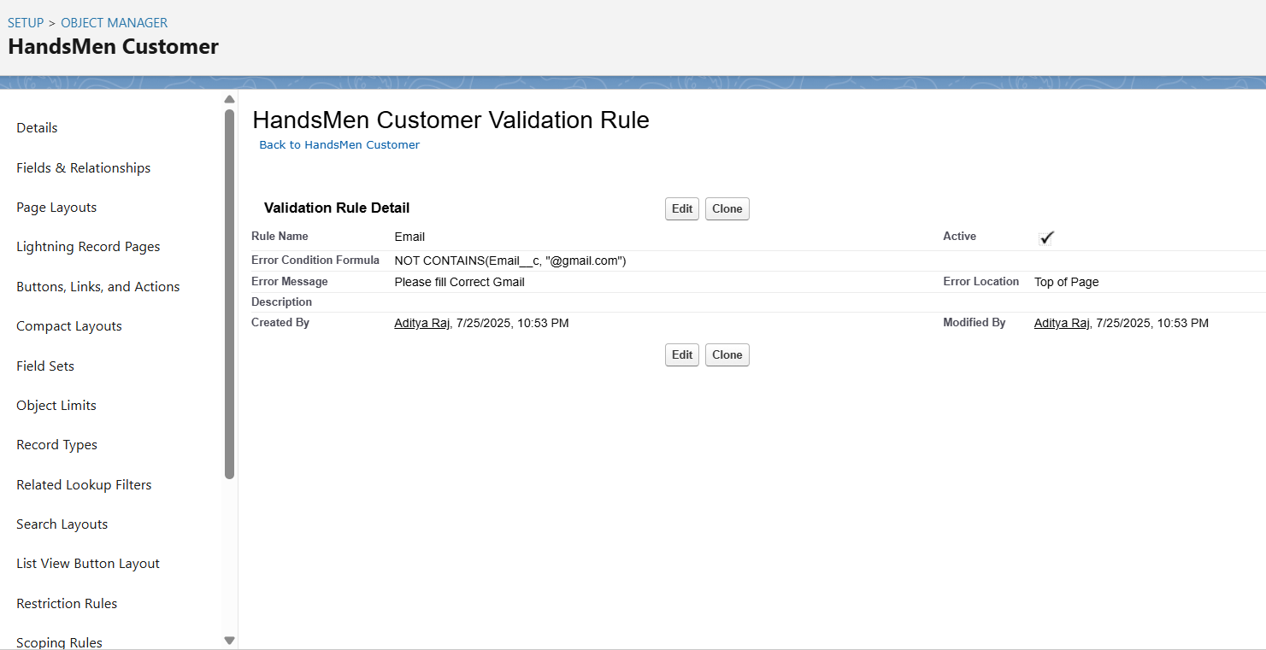\

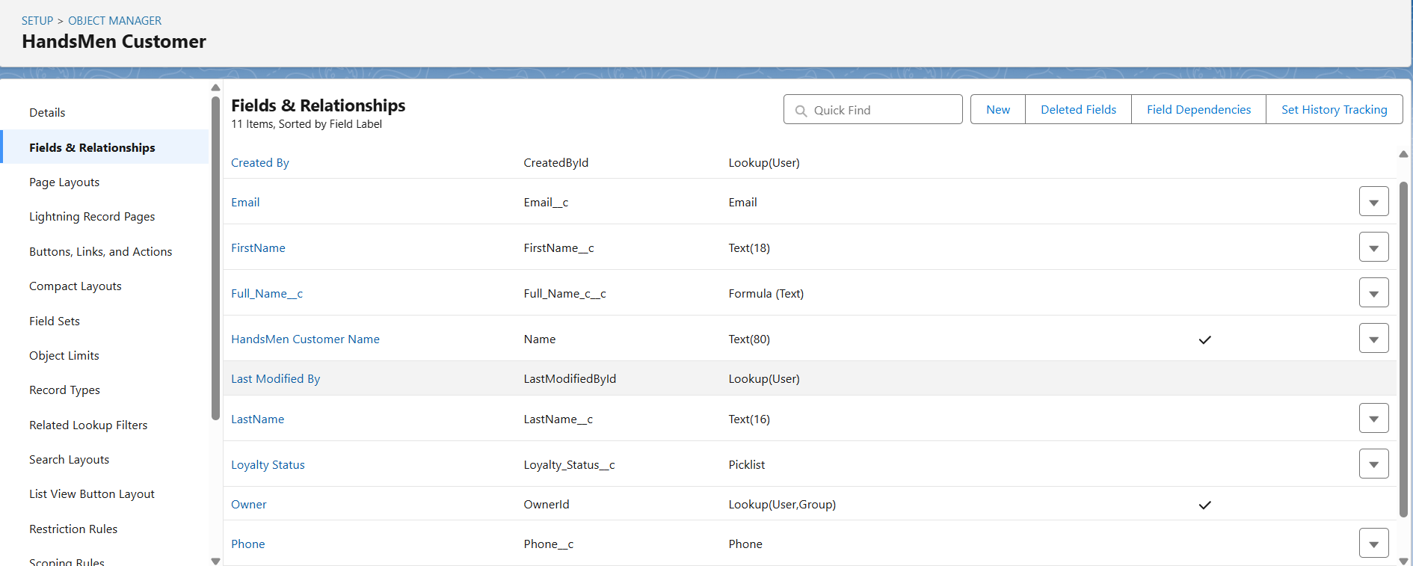

### ****Step 5: Creating Relationships Between Objects****

* **Lookup Relationships:**
  + Marketing Campaign → HandsMen Customer
  + HandsMen Product → HandsMen Order
  + HandsMen Order → HandsMen Customer
* **Master-Detail:**
  + Inventory → HandsMen Product

### ****Step 6: Creating Tabs for Custom Objects****

Created tabs for:

* HandsMen Customer
* HandsMen Product
* HandsMen Order
* Inventory

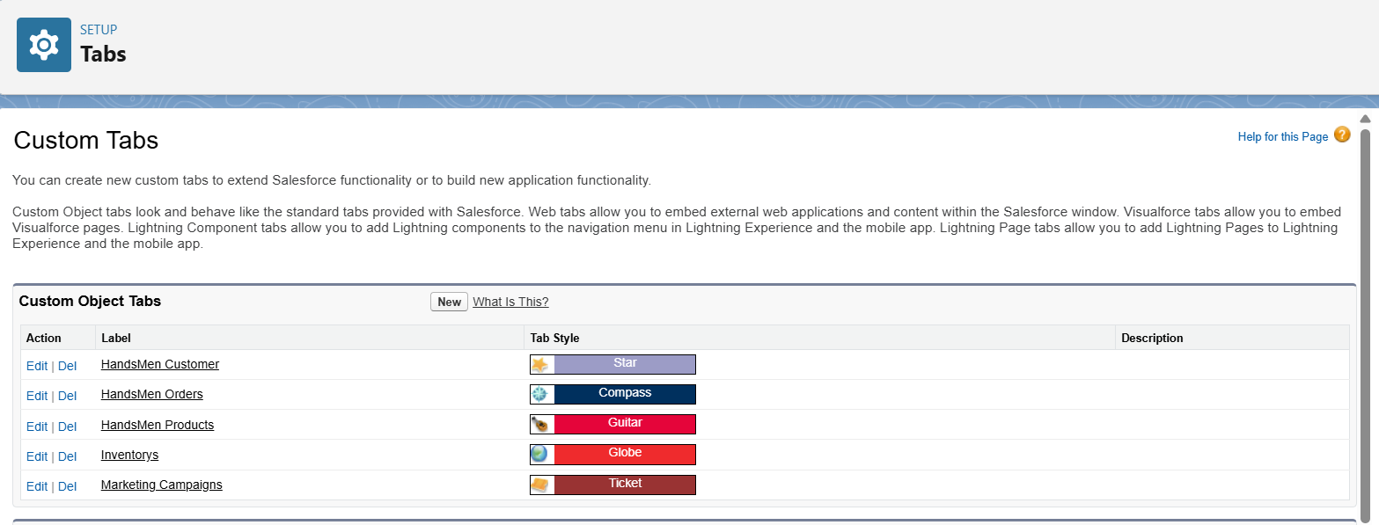

### ****Step 7: Creating Lightning App: “HandsMen Threads”****

* Used App Manager to create a new app
* Added custom objects and navigation items
* Assigned to System Administrator profile

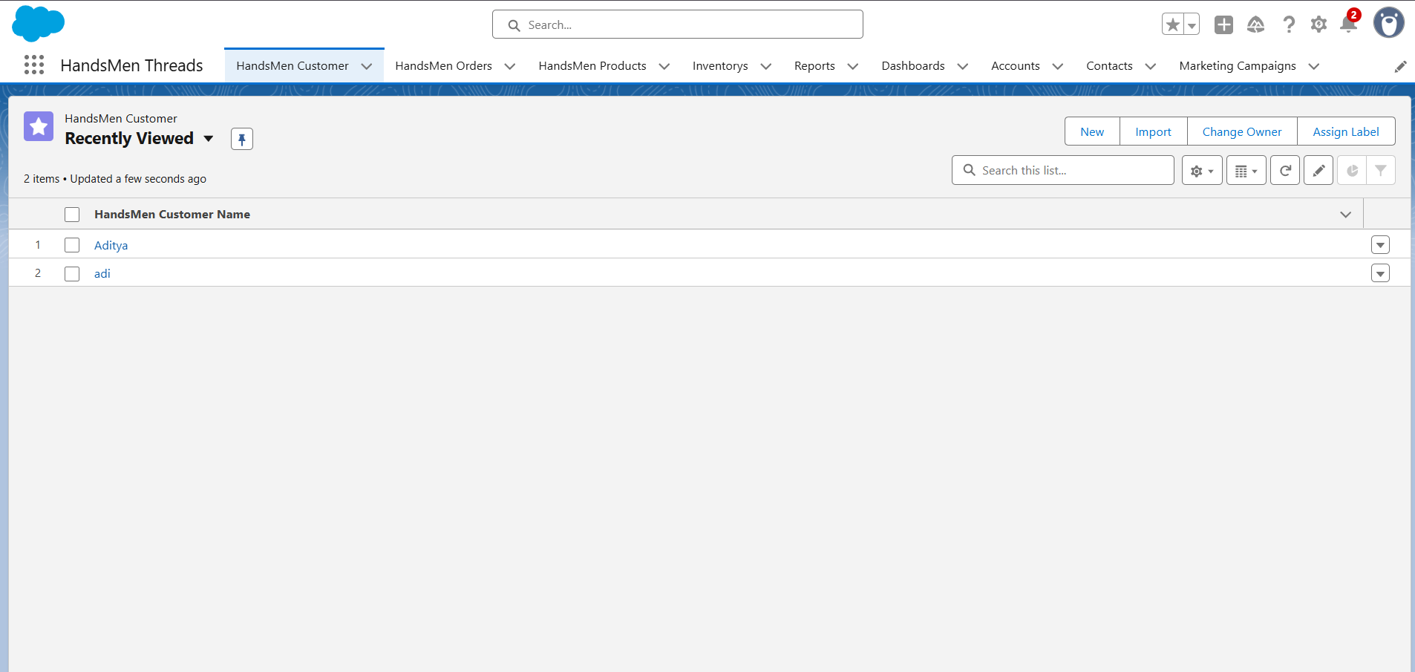

### ****Step 8: Implementing Business Logic & Validations****

* Added **Validation Rules**:
  + Total_Amount ≤ 0 (Order)
  + Stock_Quantity ≤ 0 (Inventory)
  + Email must contain "@gmail.com" (Customer)

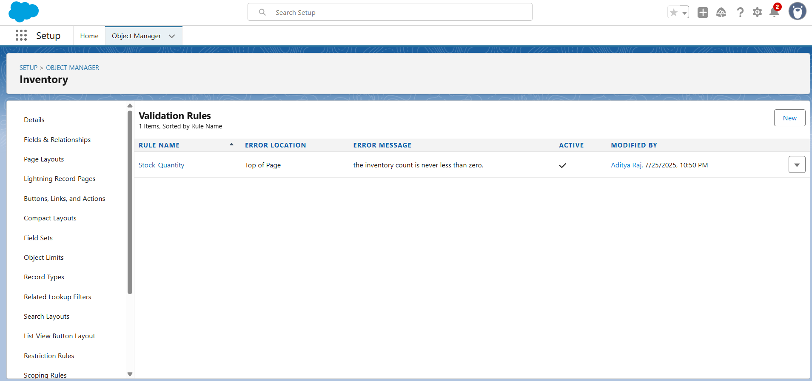

### ****Step 9: Creating Users, Roles, and Profiles****

* Cloned “Standard User” profile → “Platform 1”
* Created Roles:
  + Sales
  + Inventory
  + Marketing
* Created Users: Niklaus, Kol, etc.
* Assigned Roles and Profiles accordingly

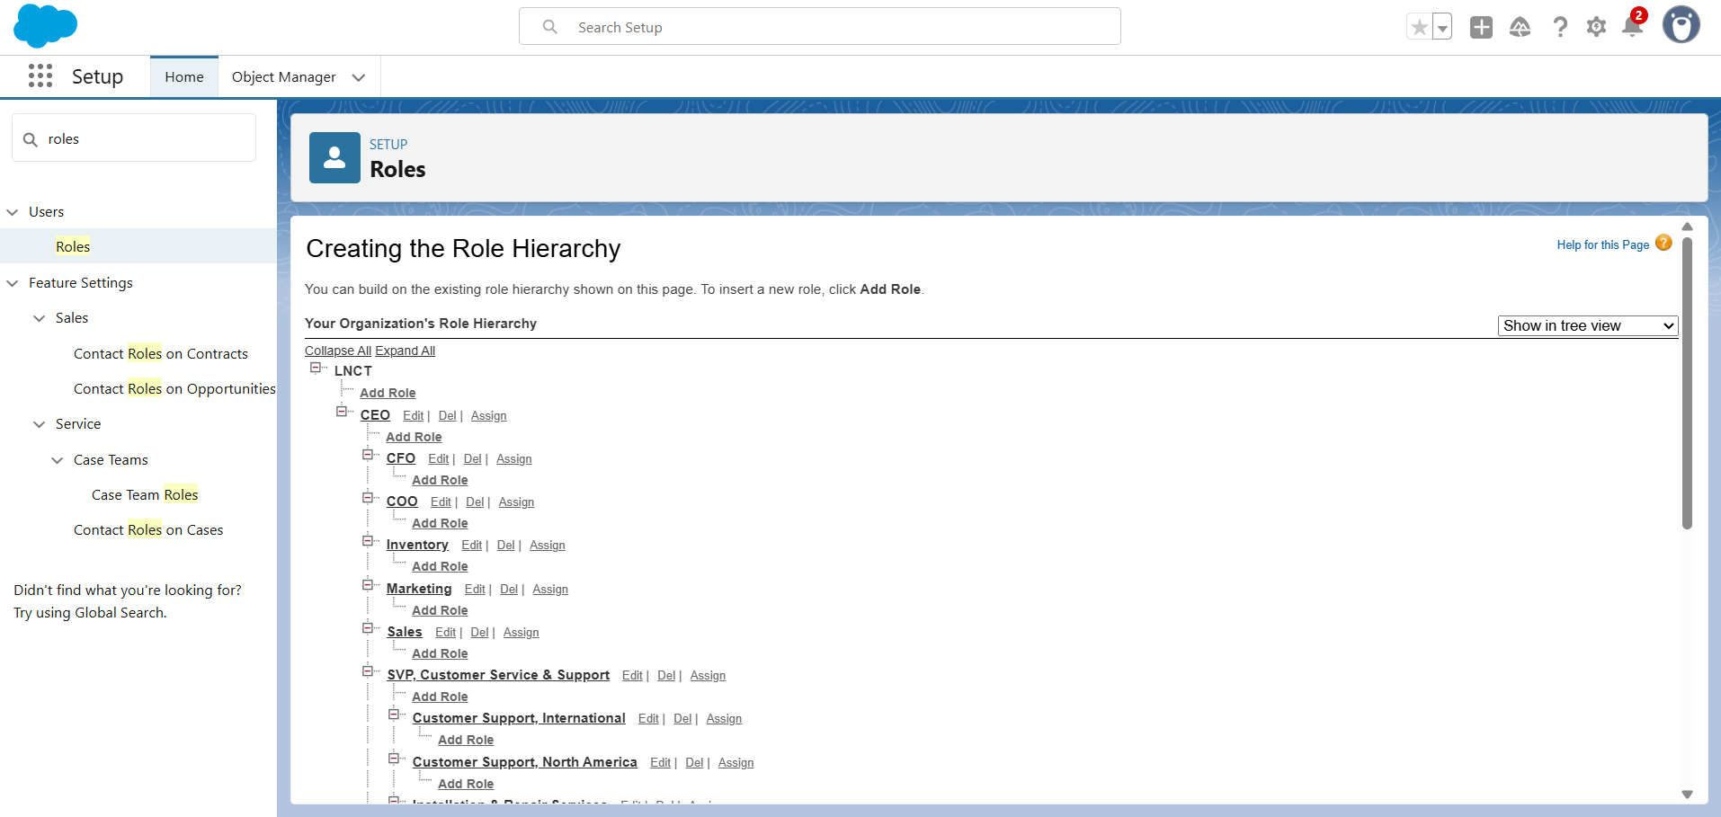

### ****Step 10: Setting Up Permission Sets****

* Created permission set “Permission_Platform_1”
* Granted CRUD access on custom objects
* Assigned to Platform 1 users

### ****Step 11: Creating Email Templates****

Created the following email templates:

1. **Order Confirmation**
2. **Low Stock Alert**
3. **Loyalty Program Update**

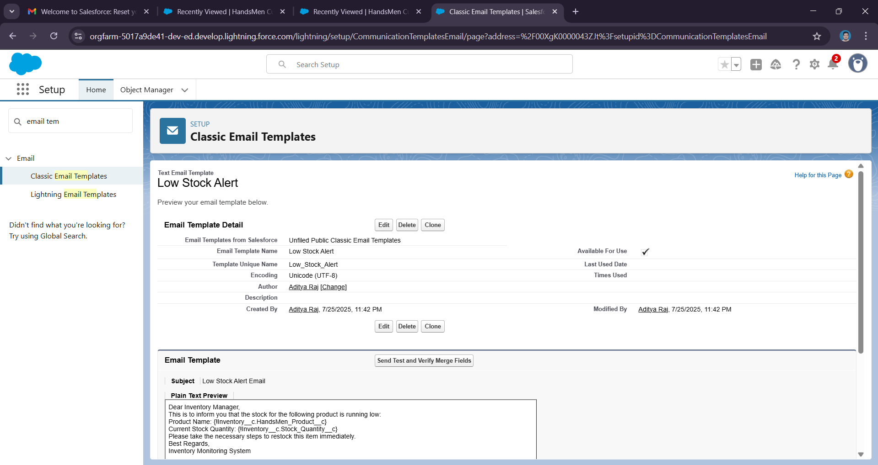

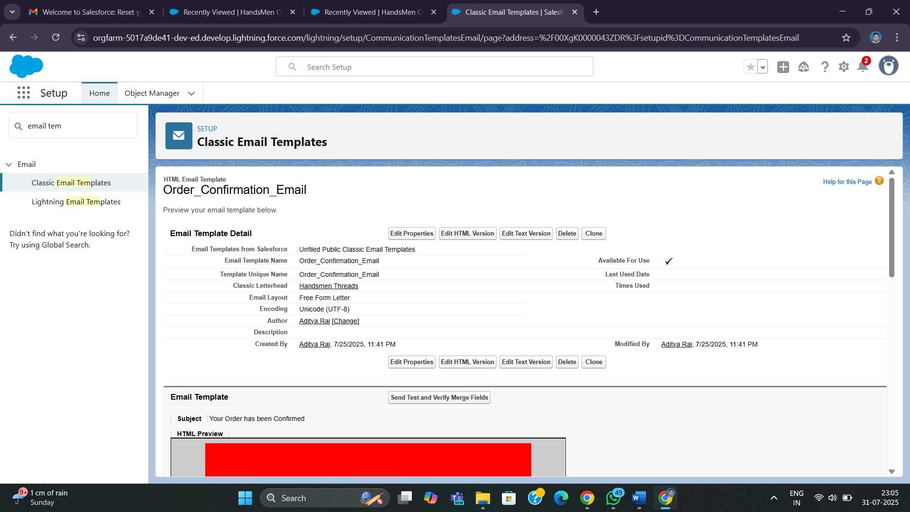

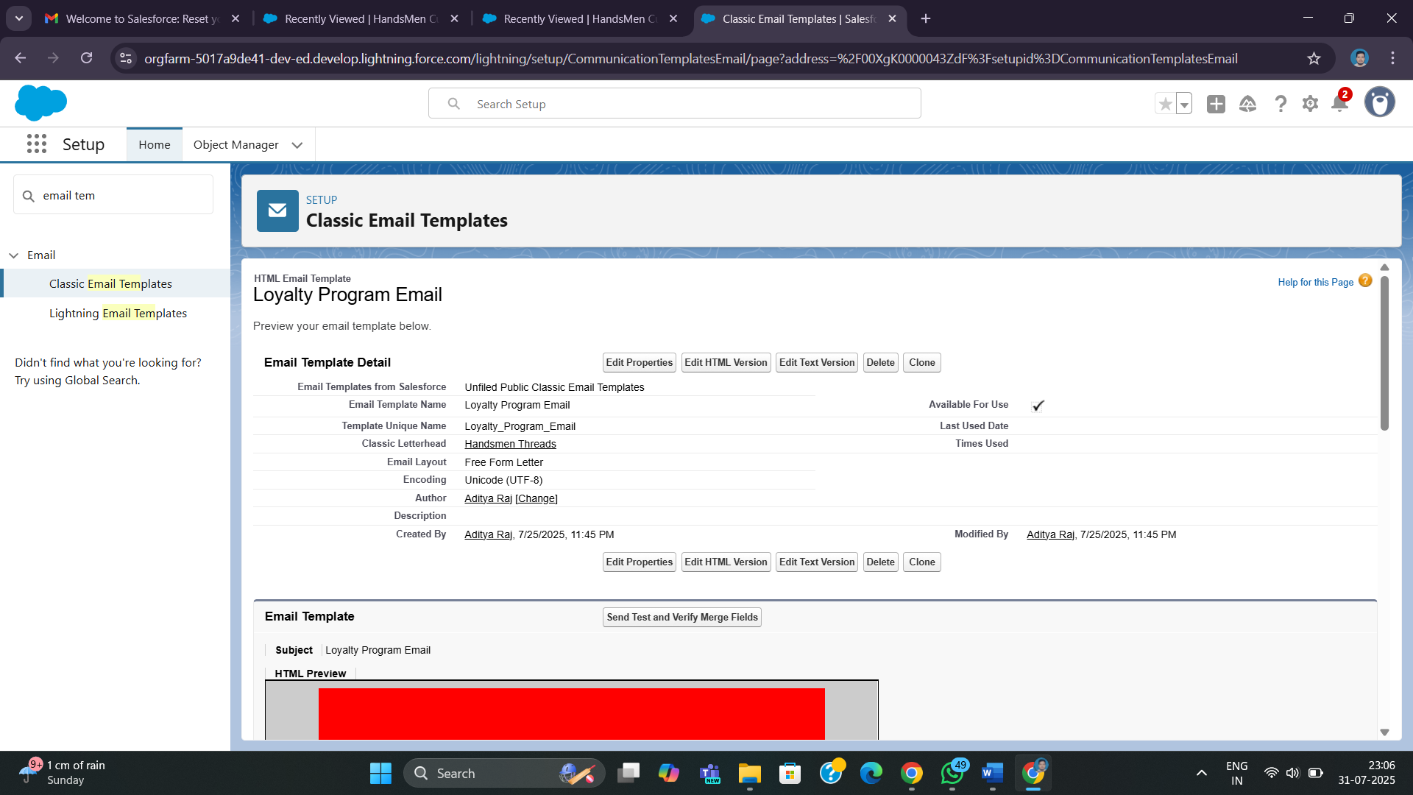

### ****Step 12: Building Flows for Automation****

* **Order Confirmation Flow**: Sends email when order status is "Confirmed"
* **Low Stock Flow**: Alerts warehouse when inventory < 5
* **Loyalty Status Update Flow**: Updates loyalty based on total purchases daily

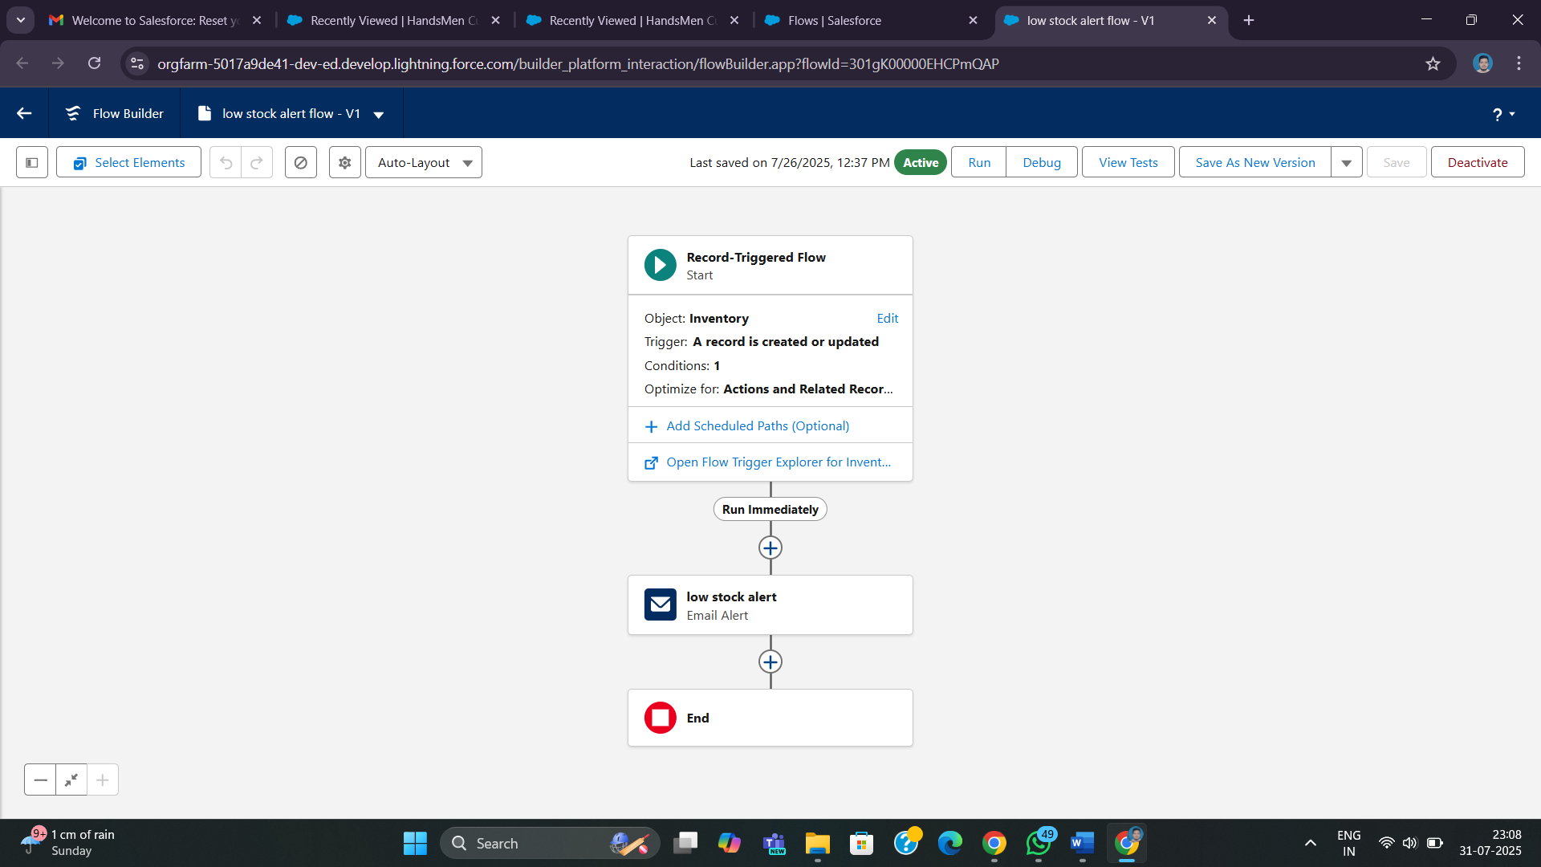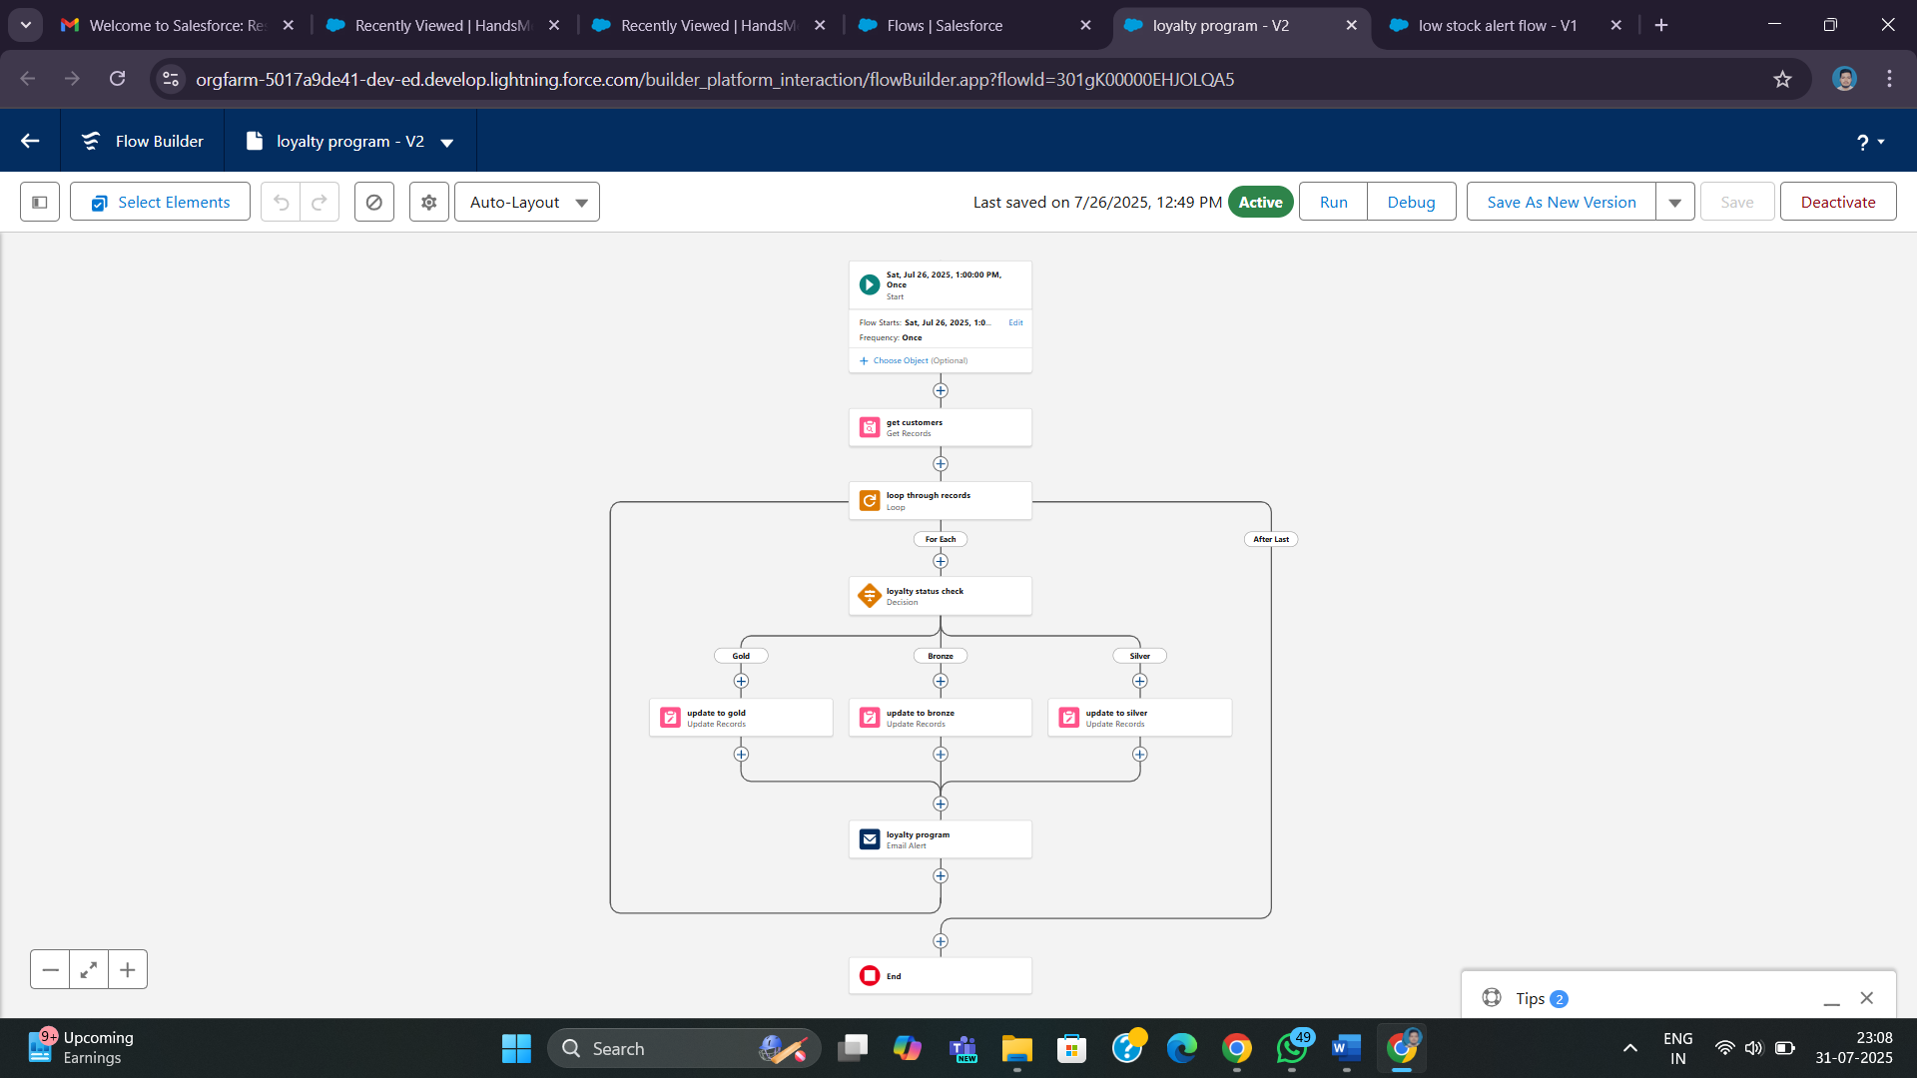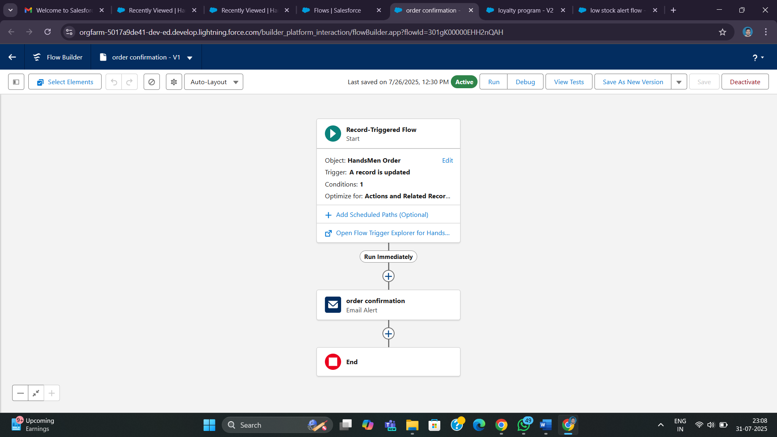

### ****Step 13: Writing Apex Code****

**Apex Trigger & Handler**:

* Validates order quantity based on order status.

**Batch Apex (InventoryBatchJob):**

* Restocks items with low quantity.
* Scheduled to srun at midnight daily.

**Execute Anonymous Code:**

* Used to schedule the batch job.

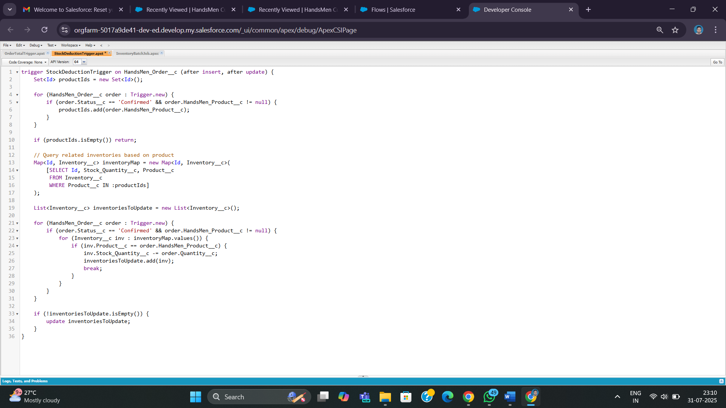

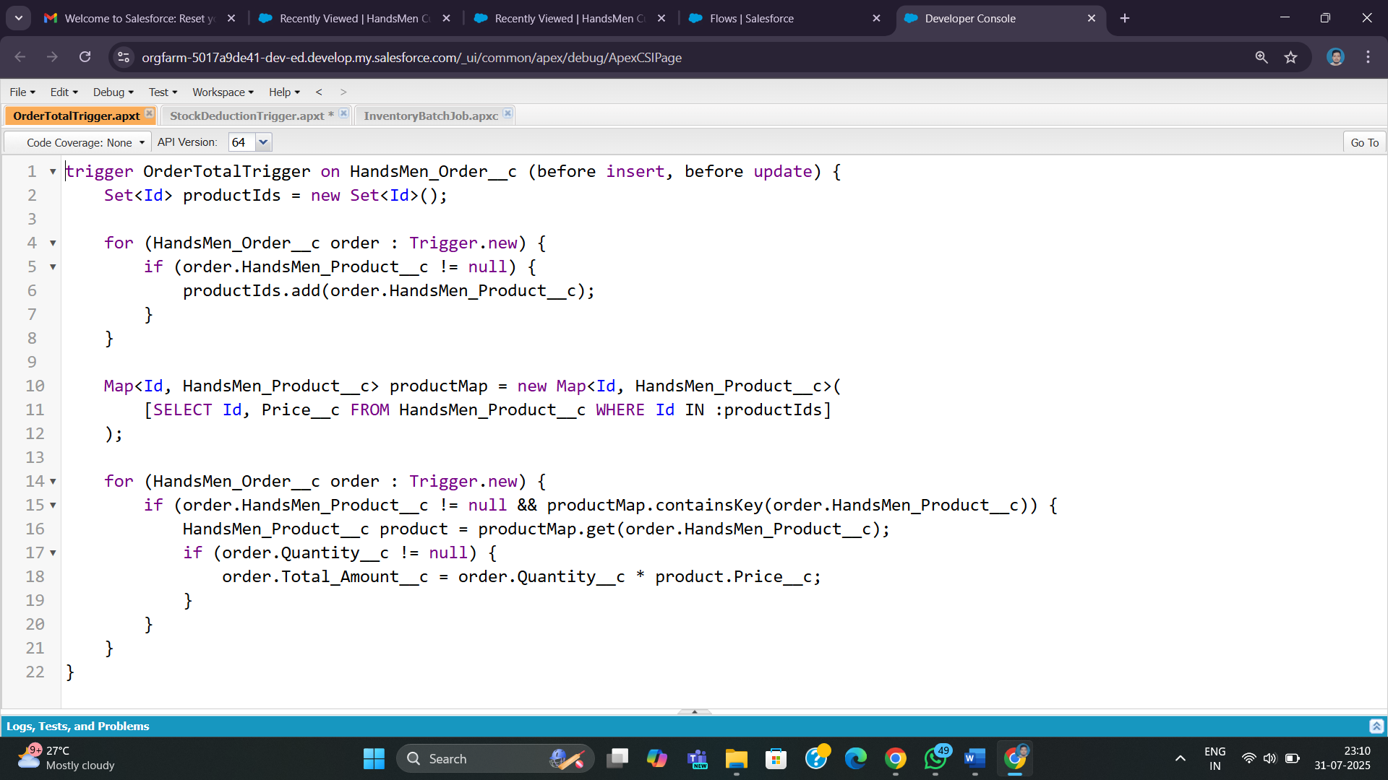

### ****Step 14: Scheduling Batch Job****

Scheduled the InventoryBatchJob using System.schedule:

System.schedule('Daily Inventory Sync', '0 0 0 * * ?', new InventoryBatchJob());

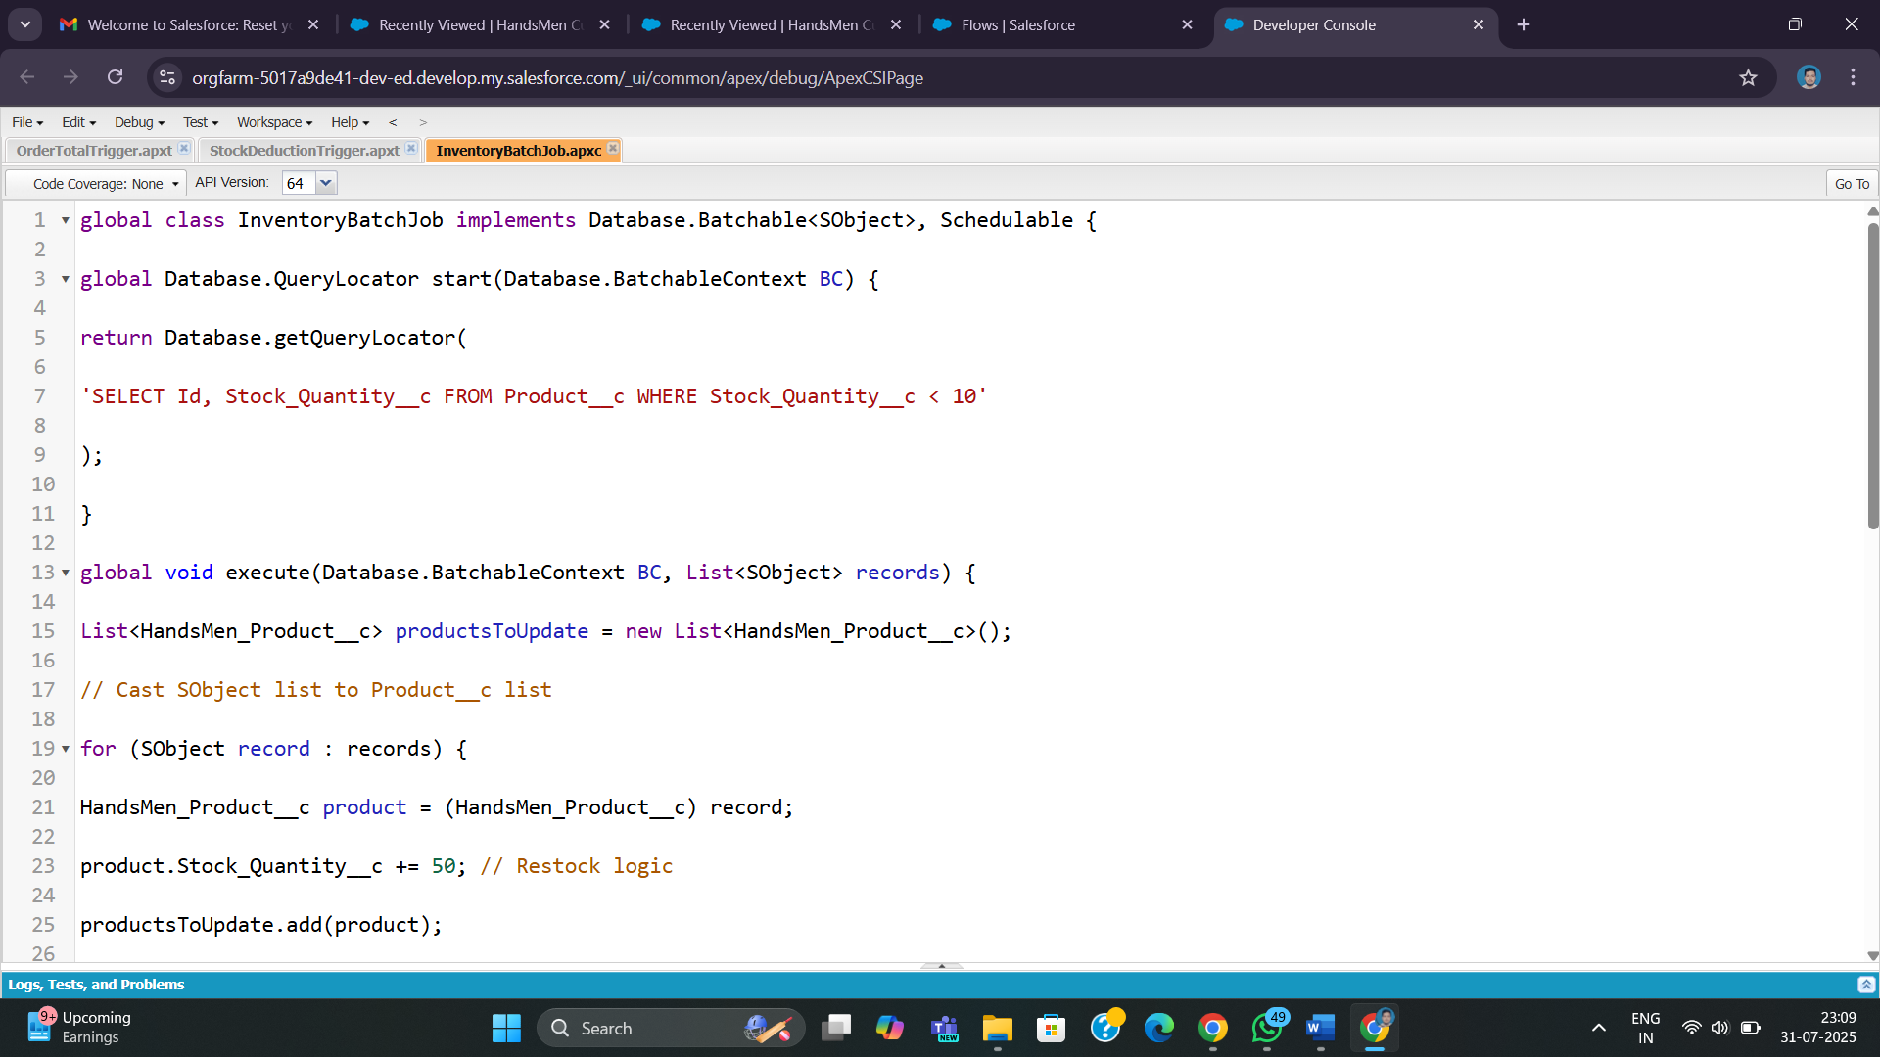

### ****Step 15: Testing & Debugging****

* Tested validation rules with negative scenarios.
* Used sample data for Orders, Products, and Customers.
* Performed Flow Debugging and Log Tracing.

### ****Step 16: Deployment & User Training****

* Deployed the solution in developer org.
* Walked users through:
  + App navigation
  + Flow triggers
  + Email responses
* Conducted post-deployment monitoring.

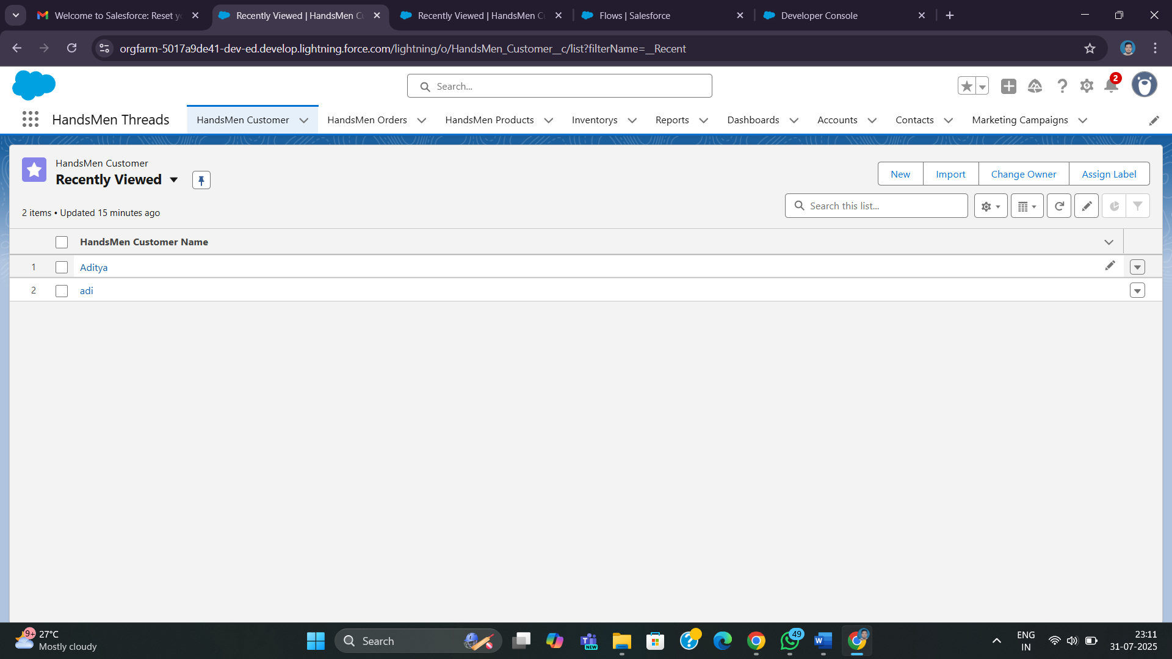

## ****5. Deliverables****

* Custom Salesforce App with all objects
* Apex Classes, Triggers, Flows, and Scheduled Jobs
* Email Templates and Alerts
* Fully Documented Solution Design
* User Roles, Profiles, and Training Guide

## ****6. Learning Outcomes****

* Real-world Salesforce app development lifecycle
* Data modeling and entity relationships
* Business automation using Flow and Apex
* Apex triggers and asynchronous logic
* User access management
* Email automation and customer engagement
* Deployment and troubleshooting

## ****7. Future Scope****

The current solution serves as a foundation for scaling business operations at HandsMen Threads. Future developments may include:

* **Customer Portal Integration:** Creating a self-service portal for order tracking, loyalty point redemption, and personalized offers.
* **Advanced Analytics & Reporting:** Implement dashboards with AI-powered insights using Salesforce Einstein.
* **Mobile App Extension:** Build a mobile-first interface using Salesforce Mobile SDK for on-the-go access by sales and warehouse teams.
* **Payment Gateway Integration:** Automate online transactions and payment confirmations within the platform.
* **Third-Party Integration:** Link with ERP systems or e-commerce platforms like Shopify or WooCommerce for end-to-end automation.
* **Multi-location Inventory Tracking:** Track stock movement across various warehouse locations and apply geolocation intelligence.
* **WhatsApp/SMS Notifications:** Add multi-channel communication for order updates and low-stock alerts.

## ****8. Conclusion****

This project has effectively transformed the manual order and inventory operations of HandsMen Threads into a modern, automated Salesforce system. By integrating customer management, order processing, inventory control, and scheduled automation, this solution not only improves operational efficiency but also elevates customer satisfaction through timely communication and personalized rewards.

**Prepared By:**  
Aditya Raj  
MCA 2nd SemesterLakshmi Narain College of Technology