PROJECT REPORT
PARALLEL SORTING
USING OPENMP
Implementation and Performance Comparison of Sequential and Parallel Merge Sort

Submitted by | ADITYARAJ PAULBUDHE
Institute | MIT Art, Design and Technology University, Pune
Course / Laboratory | High Performance Computing (HPC) Laboratory
Submitted to | Prof. Sharon Christa (Computer Science Engineering)
Academic details | Class / Division: LY-21 CORE Roll No.: D2233003 Enrollment: MITU23BTCSD003
Academic Project • 2026

Abstract
This project implements and evaluates two versions of Merge Sort: a sequential implementation and a parallel implementation using OpenMP tasks. The objective is to study how task-based parallelism can reduce execution time for sorting large arrays on a High Performance Computing (HPC) system. The program was compiled with GCC 12.3 and executed on the PARAM Rudra cluster using a SLURM batch job configured with four CPUs. Three input sizes—100,000, 500,000 and 1,000,000 elements—were tested. The parallel implementation produced correct sorted output in all three tests and achieved observed speedups between approximately 2.22x and 2.60x compared with the sequential implementation.

1. Introduction
High Performance Computing uses multiple processing resources to solve computational problems more efficiently. Parallel programming divides a problem into smaller tasks that can execute concurrently. Sorting is a useful example because Merge Sort naturally divides an array into smaller subarrays, sorts them, and merges the sorted portions.
OpenMP is an API for shared-memory parallel programming in C, C++ and Fortran. In this project, OpenMP tasks are used to process the two halves of the Merge Sort recursion in parallel, while a task-wait operation ensures that both halves are complete before they are merged.

2. Problem Statement
To implement sequential Merge Sort and parallel Merge Sort using OpenMP tasks, execute both implementations for multiple input sizes on PARAM Rudra, verify the correctness of the results, and compare their execution times and speedup.

3. Objectives
- Implement the standard recursive Merge Sort algorithm.
- Develop a parallel Merge Sort implementation using OpenMP tasks.
- Compile the program with GCC and OpenMP support.
- Submit and execute the program on PARAM Rudra using SLURM.
- Measure sequential and parallel execution times for different input sizes.
- Verify that the parallel output is correctly sorted and matches the sequential output.

4. Software and Execution Environment
Parameter | Configuration
Programming language | C++
Parallel programming API | OpenMP
Compiler | GCC 12.3
HPC system | PARAM Rudra
Scheduler | SLURM
Partition | standard
Compute node | rdcn20
Allocated CPUs / OpenMP threads | 4
SLURM job ID | 72632

5. Algorithm and Implementation

5.1 Sequential Merge Sort
The sequential implementation recursively divides the array into two halves until each subarray contains one element. It then merges adjacent sorted subarrays in ascending order. A temporary array is used during merging.

5.2 Parallel Merge Sort using OpenMP Tasks
The parallel implementation follows the same divide-and-conquer structure. For sufficiently large subarrays, two OpenMP tasks are created: one for the left half and one for the right half. The taskwait directive synchronizes the tasks before the parent call merges the two sorted halves. A task cutoff of 16,384 elements is used; smaller subarrays are processed sequentially to avoid excessive task-creation overhead.

5.3 Correctness Verification
For each input size, the program creates identical input copies for the sequential and parallel versions. It checks that both resulting arrays are equal and that the parallel result is sorted in ascending order. The program reports PASSED only when both conditions are satisfied.

6. Compilation and Job Execution
The C++ program was compiled on PARAM Rudra using the GCC compiler with OpenMP enabled:
g++ -O2 -fopenmp merge_sort.cpp -o merge_sort
The SLURM batch script requested one node, one task, four CPUs per task and a ten-minute time limit on the standard partition. It loaded GCC 12.3, set OMP_NUM_THREADS to the allocated CPU count, and executed the compiled program. The submitted job completed successfully with exit code 0:0.

7. Experimental Results
The following timings were recorded during the PARAM Rudra execution. These values represent the observed timings from the recorded run; they are not averages across repeated trials.
Input size | Sequential (ms) | Parallel (ms) | Speedup | Correctness
100,000 | 9.91737 | 4.47692 | 2.21522x | PASSED
500,000 | 53.3184 | 20.9737 | 2.54216x | PASSED
1,000,000 | 114.348 | 44.0103 | 2.5982x | PASSED

Speedup is calculated as sequential execution time divided by parallel execution time. For all tested input sizes, the parallel version completed faster than the sequential version. The highest observed speedup was approximately 2.60x for one million elements.

8. PARAM Rudra Execution Evidence
Insert one screenshot of the PARAM Rudra terminal output below. The screenshot should show the SLURM job information, allocated CPU count, input sizes, sequential and parallel timings, speedups, correctness results and successful job completion.
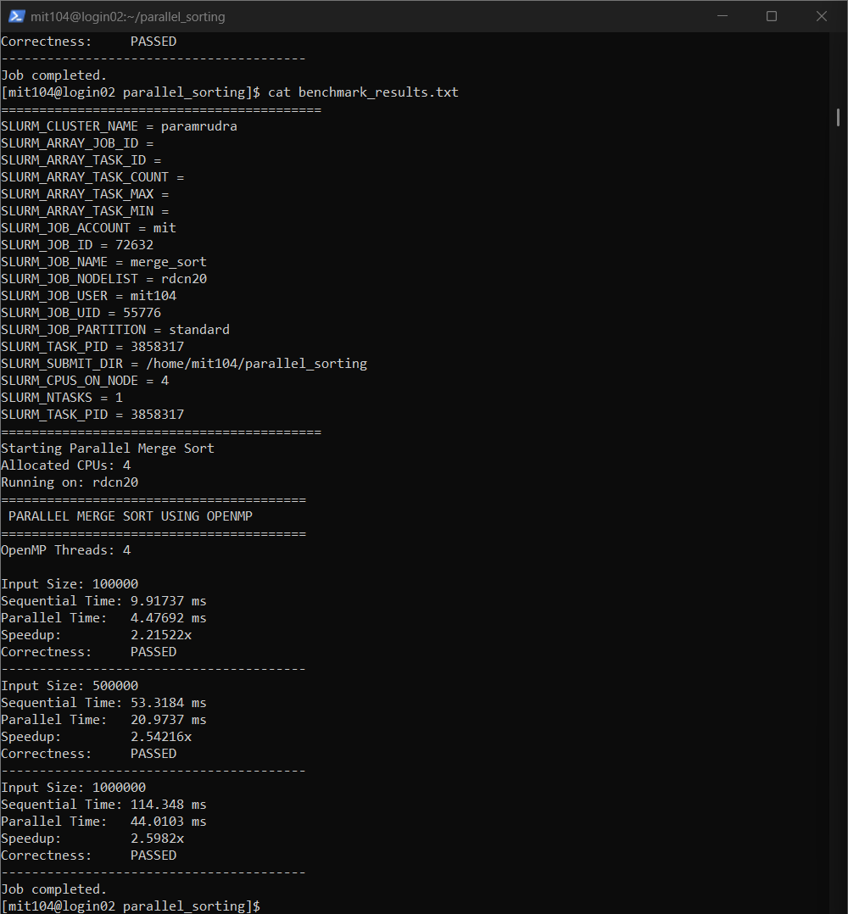
Figure 1. PARAM Rudra SLURM execution output for Parallel Merge Sort (Job ID: 72632).

9. Discussion
The experiment shows that the OpenMP task-based implementation reduced execution time for each tested input size on the allocated four-CPU configuration. The measured speedup increased from approximately 2.22x at 100,000 elements to approximately 2.60x at 1,000,000 elements. This trend is consistent with parallel work becoming more substantial relative to fixed overhead as the input size increases. However, performance depends on the compute node, system load, task granularity, compiler settings and runtime conditions. Since the reported values are from one recorded run, repeated trials and averaging would provide a more robust performance estimate.

10. Conclusion
The project successfully implemented sequential Merge Sort and parallel Merge Sort using OpenMP tasks in C++. The program was compiled with GCC 12.3 and executed on the PARAM Rudra HPC cluster through SLURM. All three test cases passed correctness verification. The parallel implementation achieved observed speedups of 2.21522x, 2.54216x and 2.5982x for input sizes of 100,000, 500,000 and 1,000,000 elements respectively. The experiment demonstrates how OpenMP task parallelism can improve the execution time of a divide-and-conquer sorting algorithm.

11. Project Files
File | Description
merge_sort.cpp | C++ source code containing sequential and parallel Merge Sort implementations.
merge_sort.sh | SLURM batch script used to submit the program on PARAM Rudra.
benchmark_results.txt | Saved benchmark output from the recorded run.
merge_sort_72632.out | SLURM standard output log for job 72632.
merge_sort_72632.err | SLURM standard error log; empty for the successful run.
README.md | Project overview, environment details and benchmark summary.

References
- OpenMP Architecture Review Board, OpenMP Application Programming Interface Specification.
- GNU Compiler Collection (GCC) documentation, OpenMP support.
- SLURM Workload Manager documentation.

— End of Report —

