---

title: "Reproducible Research project 1"

author: "Me"

date: "13/03/2020"

output:

word_document: default

html_document:

df_print: paged

---

```{r setup, include=FALSE}

knitr::opts_chunk$set(echo = TRUE)

```

## Completing the Assignment

### Question 1: Loading and preprocessing the data

Reads into R

```{r}

setwd("D:/RStudio/projects/First/")

initialData <- read.csv("activity.csv")

```

An initial look at the data confirms its dimensions and contents

```{r}

head(initialData)

str(initialData)

```

### Question 2: What is mean total number of steps taken per day?

Removing the missing values

```{r}

data <- initialData[!(is.na(initialData$steps)), ]

```

calculating the total number of steps taken per day

```{r}

totalStepsDay <- aggregate(steps ~ date, data, sum)

```

histogram is created to indicate the frequency of total steps taken each day

```{r}

hist(totalStepsDay$steps, breaks=20, xlab="Number of Steps Taken",

main="Histogram of the Total Number of Steps Taken per Day",

col=blues9)

```

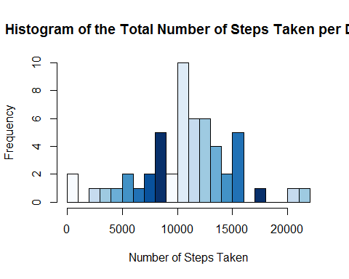

summarary function can calculate the mean and median values of the total number of steps taken per day

```{r}

summary(totalStepsDay$steps)

```

Therefore the mean value calculated is **10766.19**, and the median value **10765**

### Question 3: What is the average daily activity pattern?

Time plot should look at the average number of steps taken for each interval, the aggregate function is used.

```{r}

meanStepsInterval <- aggregate(steps ~ interval, data, mean)

plot(x=meanStepsInterval$interval, y=meanStepsInterval$steps, type="l",

main="Time Series Plot of Average Steps Taken per Interval",

ylab="Number of Steps", xlab="Intervals (in 5 mins)",

col="darkblue")

```

maximum number of steps

```{r}

meanStepsInterval[grep(max(meanStepsInterval$steps), meanStepsInterval$steps), ]

```

So the interval with the maximum number of steps is interval **835**.

### Question 4: Imputing missing values

replace each missing value with the mean value for the same interval, averaged across all days.

```{r}

imputedData <- initialData

for(x in 1:17568) {

if(is.na(imputedData[x, 1])==TRUE) {

imputedData[x, 1] <- meanStepsInterval[meanStepsInterval$interval %in% imputedData[x, 3], 2]

}

}

imputedTotalStepsDay <- aggregate(steps ~ date, imputedData, sum)

head(imputedTotalStepsDay)

```

```{r}

hist(imputedTotalStepsDay$steps, breaks=20, xlab="Number of Steps Taken",

main="Histogram of Total Number of Steps Taken per Day (With Imputed Values)",col="red")

```

mean and median total number of steps taken per day

```{r}

imputedStepsSummary <- summary(imputedTotalStepsDay,

meanOfTotalSteps=mean(imputedTotalStepsDay$steps),

medianOfTotalSteps=median(imputedTotalStepsDay$steps))

mean <- mean(imputedTotalStepsDay$steps)

median <- median(imputedTotalStepsDay$steps)

mean

median

```

histograms of the two data sets (imputed and non-imputed) are compared:

```{r}

par(mfrow = c(1, 2))

hist(totalStepsDay$steps, breaks=20, xlab="Number of Steps Taken",

col="Blue", family="serif", ylim=c(0, 20), main=NULL)

hist(imputedTotalStepsDay$steps, breaks=20, xlab="Number of Steps Taken",

col="Red", family="serif", ylim=c(0, 20), main=NULL)

mtext("Histograms of Total Number of Steps Taken per Day, Without/With Imputed Values",

adj=0.95, family="serif", font=2)

```

```{r}

length(unique(data$interval))

```

missing observations are due to entirely missed days, (8 of the days) where no measurements were made whatsoever

### Question 5: Are there differences in activity patterns between weekdays and weekends?

used the weekdays function to automatically calculate the day of the week

```{r}

library(lubridate)

daysData <- imputedData

daysData$days <- weekdays(as.Date(daysData$date))

daysData$weekday <- as.character(rep(0, times=17568))

for(x in 1:17568) {

if(daysData[x, 4] %in% c("Saturday", "Sunday")) {

daysData[x, 5] <- "weekend"

} else {

daysData[x, 5] <- "weekday"

}

}

daysData$weekday <- factor(daysData$weekday)

head(daysData)

```

```{r}

weekdayData <- daysData[daysData$weekday=="weekday", ]

weekendData <- daysData[daysData$weekday=="weekend", ]

```

average number of steps per interval is calculated

```{r}

weekdayMean <- aggregate(weekdayData$steps, list(weekdayData$interval), mean)

weekendMean <- aggregate(weekendData$steps, list(weekendData$interval), mean)

```

panel plot is created

```{r}

par(mfrow=c(2, 1), mar=c(4, 4.1, 3, 2.1))

plot(weekdayMean$Group.1,weekdayMean$x, type="l",

main="Time Series Plot of Average Steps Taken per Interval, for Weekdays",

xlab="Intervals (in 5 mins)", ylab="Number of Steps",

col="darkred", lwd=1.5, ylim=c(0, 230))

plot(weekendMean$Group.1, weekendMean$x, type="l",

main="Time Series Plot of Average Steps Taken per Interval, for Weekends",

xlab="Intervals (in 5 mins)", ylab="Number of Steps", family="serif",

col="darkblue", lwd=1.5, ylim=c(0, 230))

```