My Electronic R Lab Notebook

Miles Benton

This is an [R Markdown](http://rmarkdown.rstudio.com) Notebook. When you execute code within the notebook, the results appear beneath the code.

# Friday 18th November 2016

What follows is a template for the basic structure laid out in the WILS Lab Book pdf manual.

### Title

**Using R Notebooks for electronic lab book documentation in Bioinformatics** (and generally any other field you want!)

### Aims

Explore

### Introduction

### Materials

### Methods

### Results

#### Inline code

#### Evaluate statistics/models and display in text

#### Can even include plots

Try executing this chunk by clicking the *Run* button within the chunk or by placing your cursor inside it and pressing *Ctrl+Shift+Enter*.

plot(cars)

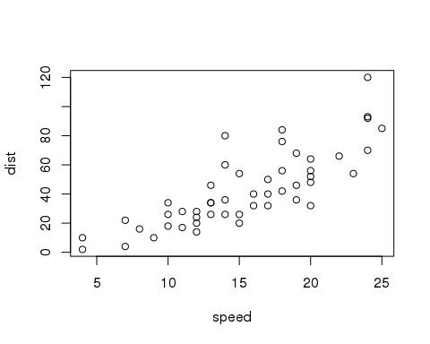

Add a new chunk by clicking the *Insert Chunk* button on the toolbar or by pressing *Ctrl+Alt+I*.

### Tables are also straight forward

### Output to many popular formats

RStudio uses the power of the knitr package and pandoc to allow the exporting of your document to several flexible and popular formats.

#### HTML

By selecting *knit to HTML* an HTML file containing the code and output will be saved alongside it (click the *Preview* button or press *Ctrl+Shift+K* to preview the HTML file).

#### Word (.docx)

By selecting *knit to Word* your notebook will be exported to *.docx* format, which will be able to be read by Microsoft Word and other office packages (i.e. Libre Office).

#### pdf

By selecting *knit to Word* your notebook will be exported to *.pdf*, the universal format.

### Discussion

### Conclusion

The framework provided by R, RStudio and RMarkdown come together in the form of R Notebooks and make for an excellent form of electronic recording for daily activities/experiments, providing an ideal solution for Bioinformatics lab books.

# Monday 21st November 2016

Can easily create bullet lists:

Also numbered lists:

# Tuesday 22nd November 2016