

American International University-Bangladesh (AIUB)  
**Department of Computer Science and Engineering   
Faculty of Science &Technology (FST)  
Fall 23-24  
CSC 01488 SOFTWARE ENGINEERING**

**Section: A**

**Group NO: 11**

**Project Title: Missing Vowels**

**Submitted by:**

|  |  |
| --- | --- |
| **Name** | **ID** |
| 1. **MD SARAFAT ALI ADIR** | **20-41926-1** |
| 1. **HASIN AABRAR KHAN** | **21-45297-2** |
| 1. **MD TANVIR BIN ZOHA** | **21-45307-2** |

**Submitted to:**

**DR. ABDUS SALAM**

**Assistant Professor, Computer Science**

**Project Description:**

The Missing Vowels Game is a console-based word game that challenges users to guess words with missing vowels within a limited time of 2 minutes. The game includes features such as user registration and login, a timer-controlled gameplay mechanism, a scoring system, an admin panel with user management capabilities, and a leaderboard to track user performance. The project demonstrates modular programming, user authentication, real-time gameplay with a countdown timer, and persistent user score tracking.

**Features Implemented:**

**User Registration**

The user registration feature allows new users to sign up for the system by providing a unique username, full name, phone, email & password . If the username already exists, the user is notified. The implementation uses a simple text file **(user_data.txt)** for storing user information.

The **register_user()** function collects input for the username and password. It checks for duplicates, saves the new user data to a file, and initializes their score in the scores file.

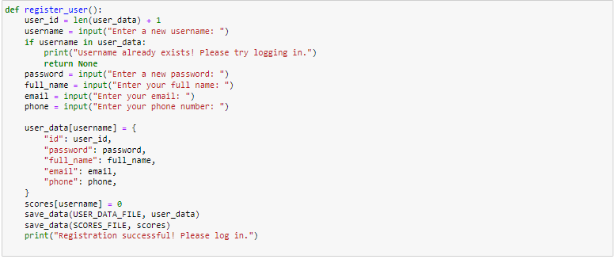

**Login**

The login system allows existing users to authenticate themselves using their credentials. Only users with valid credentials are allowed access to the game.

The **login_user()** function compares the entered username and password with data stored in **user_data.txt**. If valid, the user is granted access; otherwise, they are notified of invalid credentials.

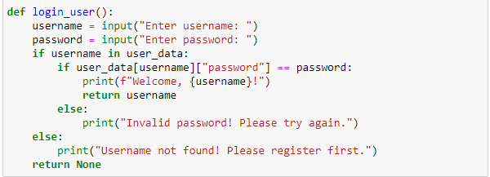

**Missing Vowels Game**

The Missing Vowels Game challenges users to guess scrambled words with missing vowels. Players must guess as many correct words as possible within a 2-minute time limit. The game ends automatically after the timer runs out.

The **play_game()** function generates random words from a predefined dictionary **WORDS_WITHOUT_VOWELS**. It uses **time.time()** to monitor elapsed time and ends the game if 2 minutes have passed.

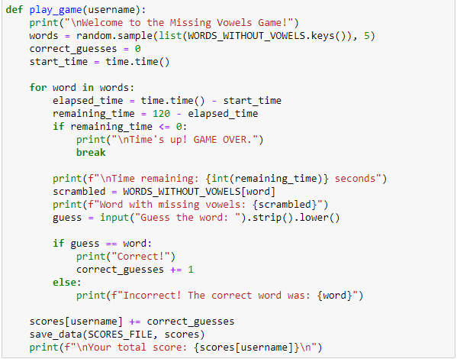

**Timer**

A 2-minute timer is implemented during the gameplay. The timer monitors elapsed time in real time, and if 2 minutes are exceeded, the game terminates automatically.

The game uses **time.time()** to track elapsed time against a 120-second limit. If the elapsed time exceeds this limit, the game stops.

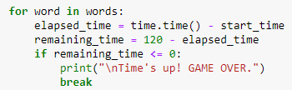

**Admin Panel**

The admin panel allows:

* View the leaderboard (user scores).
* View All User Information
* Edit user Information.
* Logout

The **admin_operations()** function provides options to view the leaderboard, view & edit user information. Admin credentials are hardcoded as admin/admin.

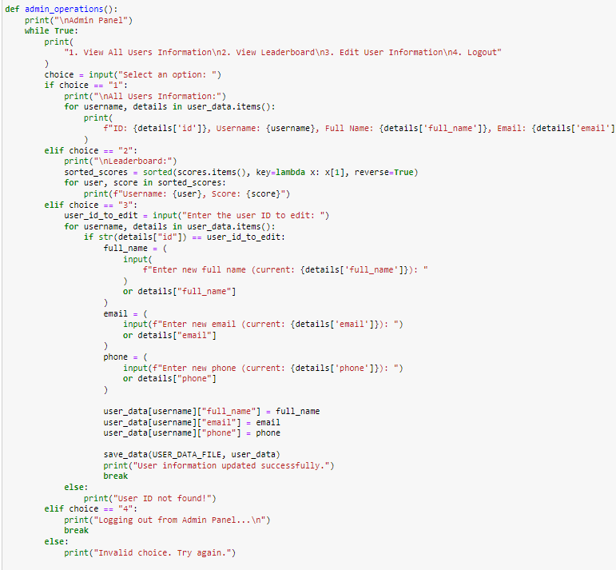

**Leaderboard**

The leaderboard displays all user scores in descending order. This functionality resides in the admin panel and dynamically fetches scores from the **scores.txt** file. Scores are loaded, sorted in descending order, and displayed to the admin using **sorted ()**.

