Collective Communication in MPI
Lab 3
Adi Ramanarayan
230905380 48
A2
Lab Exercises:
Q1. Program to find sum of factorials using scan and collective communication.
Program:
#include <stdio.h>
#include <stdlib.h>
#include <mpi.h>

long long factorial(int n) {
long long fact = 1;
for (int i = 2; i <= n; i++)
fact *= i;
return fact;
}

int main(int argc, char** argv) {
MPI_Init(&argc, &argv);

int rank, size;
MPI_Comm_rank(MPI_COMM_WORLD, &rank);
MPI_Comm_size(MPI_COMM_WORLD, &size);

int n;

if (rank == 0) {
if (argc < 2) {
fprintf(stderr, "Usage: mpirun -np <p> %s <n>\n", argv[0]);
MPI_Abort(MPI_COMM_WORLD, 1);
}
n = atoi(argv[1]);
}

MPI_Bcast(&n, 1, MPI_INT, 0, MPI_COMM_WORLD);

long long local_sum = (rank < n) ? factorial(rank + 1) : 0;

long long scan_sum;
MPI_Scan(&local_sum, &scan_sum, 1, MPI_LONG_LONG_INT, MPI_SUM, MPI_COMM_WORLD);

if (rank < n) {
printf("Rank %d: %d! = %lld\n", rank, rank + 1, local_sum);
}

if (rank == n - 1) {
printf("Sum of factorials (1! to %d!) = %lld\n", n, scan_sum);
}

MPI_Finalize();
return 0;
}
Output:
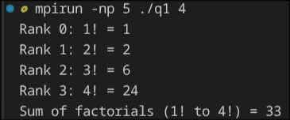

Q2. Program reads 3X3 matrix. Element is entered by user to be searched, in root. Count of total occurences of the element has to be found, using 3 processes.
Program:
//Program reads 3X3 matrix. Element is entered by user to be searched, in root using MPI. Count of total occurences of the element has to be found, using 3 processes.
#include <stdio.h>
#include <stdlib.h>
#include <mpi.h>

int main(int argc, char** argv) {
MPI_Init(&argc, &argv);

int rank, size;
MPI_Comm_rank(MPI_COMM_WORLD, &rank);
MPI_Comm_size(MPI_COMM_WORLD, &size);

if (size != 3) {
if (rank == 0) {
fprintf(stderr, "This program requires exactly 3 processes.\n");
}
MPI_Abort(MPI_COMM_WORLD, 1);
}

int matrix[3][3];
int element_to_search;
int local_count = 0;

if (rank == 0) {
printf("Enter elements of 3x3 matrix:\n");
for (int i = 0; i < 3; i++) {
for (int j = 0; j < 3; j++) {
scanf("%d", &matrix[i][j]);
}
}
printf("Enter element to search: ");
scanf("%d", &element_to_search);
}

MPI_Bcast(&element_to_search, 1, MPI_INT, 0, MPI_COMM_WORLD);
MPI_Scatter(matrix, 3, MPI_INT, matrix[rank], 3, MPI_INT, 0, MPI_COMM_WORLD);

// Each process searches its assigned row
for (int j = 0; j < 3; j++) {
if (matrix[rank][j] == element_to_search) {
local_count++;
}
}

int total_count;
MPI_Reduce(&local_count, &total_count, 1, MPI_INT, MPI_SUM, 0, MPI_COMM_WORLD);

if (rank == 0) {
printf("Total occurrences of %d in the matrix: %d\n", element_to_search, total_count);
}

MPI_Finalize();
return 0;
}
Output:
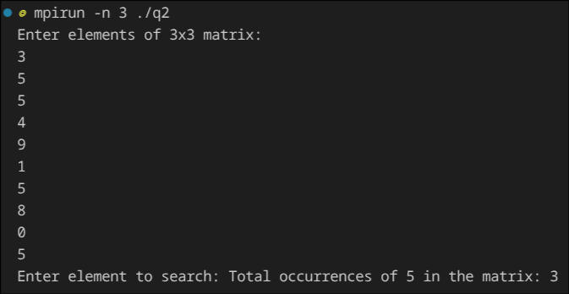

Q3.

