First things first – convince your company to buy [BizTalk 360](https://www.biztalk360.com/) – highly recommended, great product.

If you are out of luck for BizTalk 360 and want a free alternative to the esb portal and BAM portal, this tool aims to accomplish that.

*Now the disclaimer*

*I am not a UI person so bear with the design and if you find issues with the code or feel like you can help or have an idea – do reach out. Admittedly the portal can be better (SPA, angular, react and what not) but when I started this, I wanted to do a quick POC and then depending on how things went, refactor later.*

The hope is that this portal removes the need for installing the esb portal and encourages more organizations to adopt BAM as a monitoring tool.

As mentioned above there are two areas where the portal focuses on – ESB exception management portal and the BAM portal. There is also a third area which provides a subset of functionality of the BizTalk admin console for day to day ops.

**ESB Portal**

If you had to go through the [installation of the esb portal](https://social.msdn.microsoft.com/Forums/en-US/8c45dad8-4347-4046-baf6-c850ea89d9c3/has-anyone-successfully-installed-management-portal-for-biztalk-2013-esb-toolkit?forum=biztalkesb), you are probably not a fan of it. Even though Microsoft has stated that the esb portal is meant as a sample, its often used as a production monitoring tool - the hope is that this portal removes the need for installing the esb portal.

Admittedly this is an opinionated alternative and there have been decisions made which make this product slightly different from the esb portal. The database remains same with this portal adding a couple of tables and some rows into the Configuration table. Some of the differences are

1. This portal does not port over the UDDI or the registry portions of the esb portal
2. For now, there are no charts – it does provide a cleaner summary view by application but no charts
3. You cannot alter your alert subscription and make it time based eg send me alert only from 9am to 5pm is **not** supported.
4. There is no resubmission of messages – i have yet to see mass adoption of resubmits (in my experience and ideally inclusion of resubmits should allow for more protocols besides http – which makes it more complex for a phase 1 release)

With that said, the single most grievance against the portal, in my opinion, is the lack of “resolving” a fault. In my experience, the organizations that I have worked with do not resubmit via the portal let alone any http based adapter. Often the messages are resubmitted either through the source system or manually by a BizTalk administrator. What I wanted was the ability to mark these faults as “resolved” so that it is clear for other people and there is not duplication of effort.

There are two pages with interacting with faults.

The first page gives the fault summary for all the application based on the date time filter specified. There are three status defined for the faults.

1. Unresolved – any new fault is unresolved.
2. Resolved – once the fault has been fixed and resubmitted, an operator can mark the fault as resolved which would mean other people do not have to waste time researching the same fault.
3. Flagged – for those cases where the resolution has been determined but not implemented.

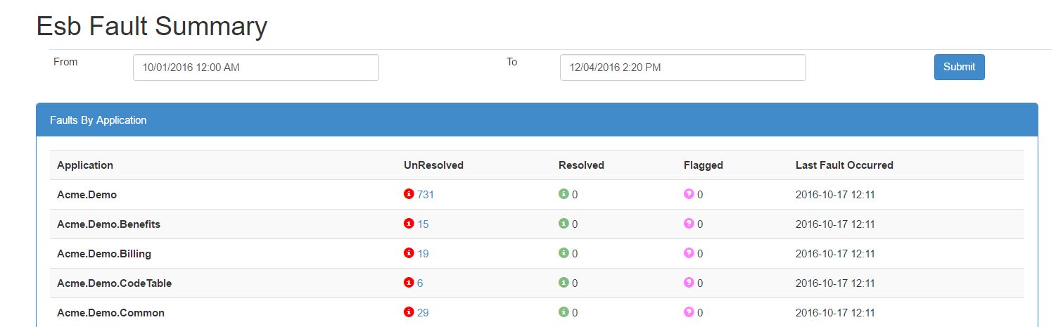

Each of the fault states are drillable and take you to the fault search page.

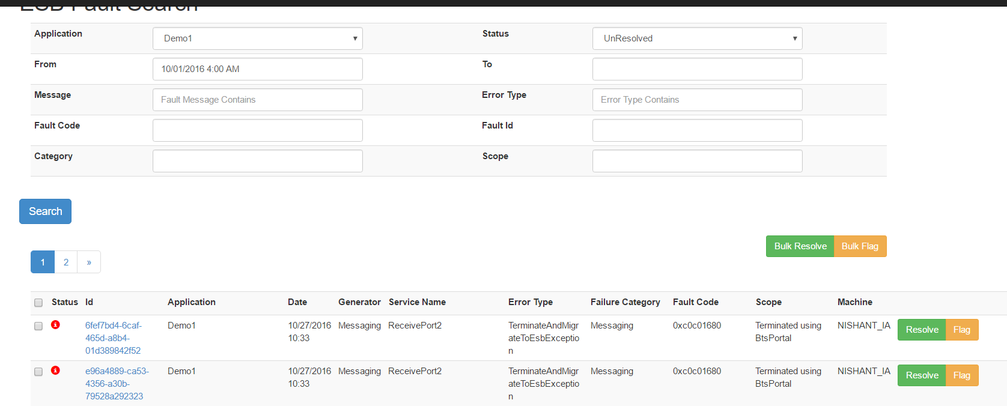

This page allows you to see the details of the fault and download/view the message in a manner like the esb portal

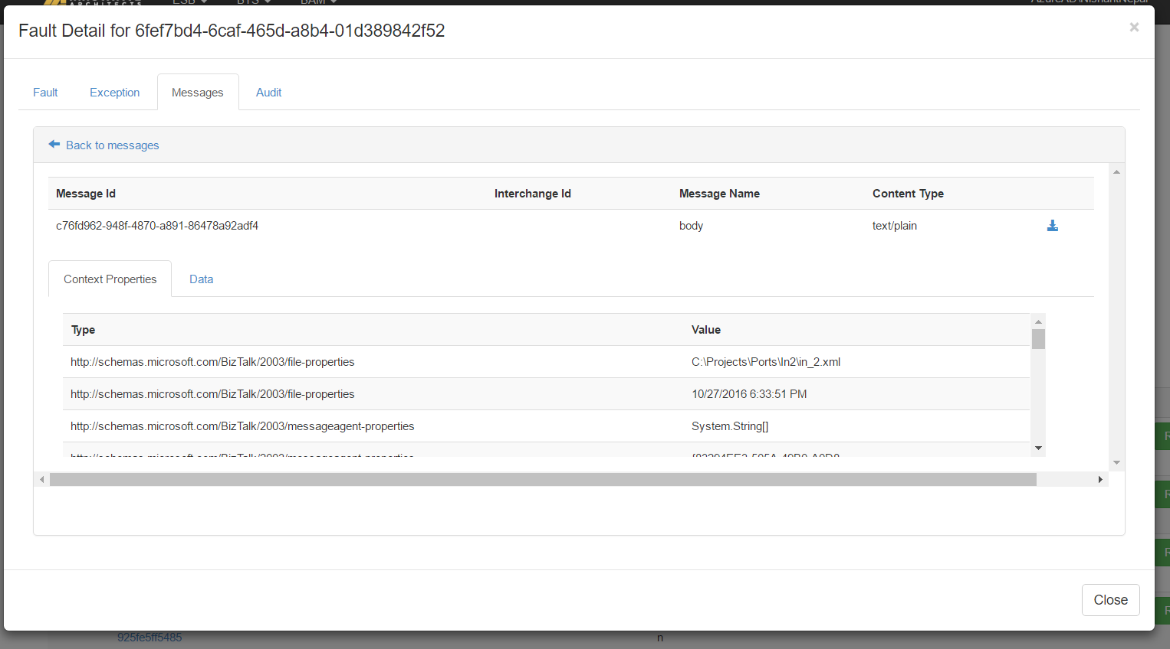

The difference in the bts portal is you can resolve or flag each fault (or in detail) and it moves to the designated queue.

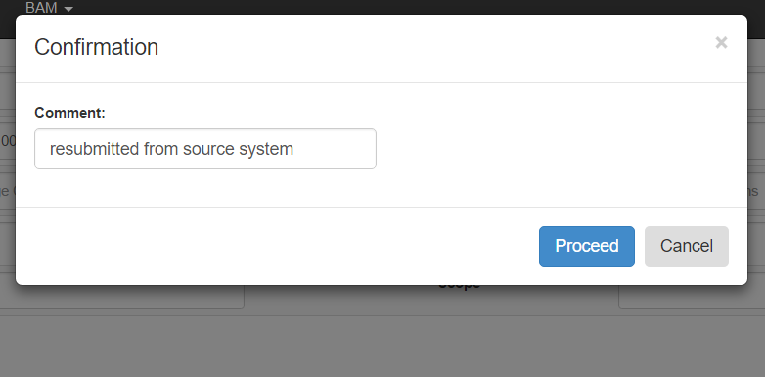

The other opinionated approach is towards the alerts mechanism. As mentioned above, this portal does not allow for schedule based email notifications per subscriber. It does however allow for a schedule (summary) alert per application in addition the regular transactional alert eg. send me the summary of all faults grouped by exception type and service name every 30 minutes.

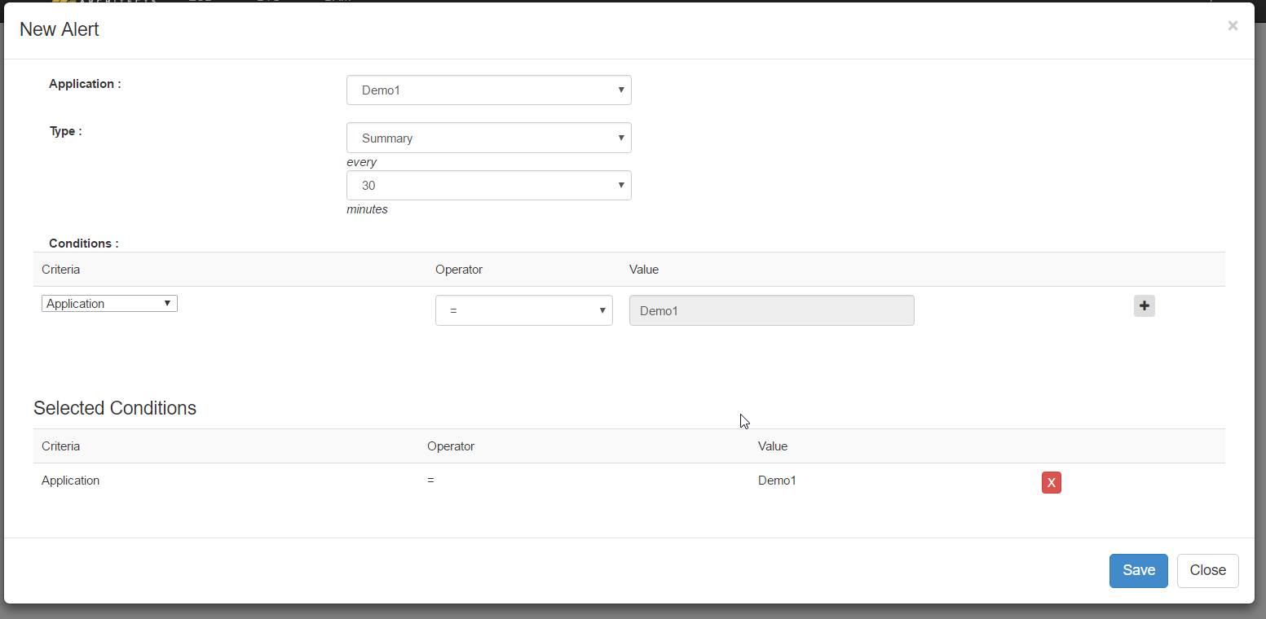

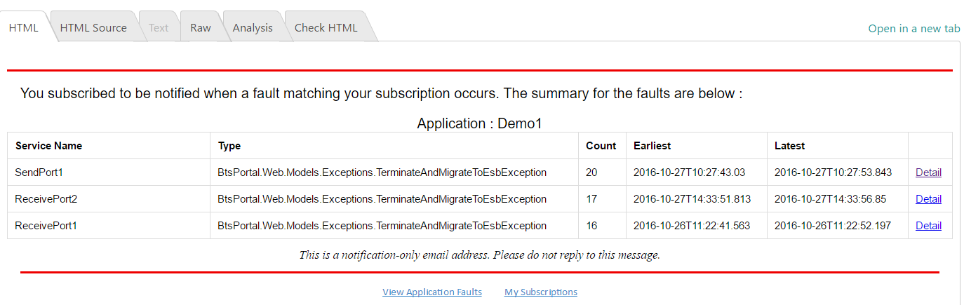

**BAM**

As many would agree, BAM is one of the most powerful yet least understood/applied technology in BizTalk. One reason may be lack of a modernish UI and this portal aims to hopefully attempt to solve that. You would still need to create your BAM definitions and deploy that but instead of using the BAM portal you can create customized views using this portal. As with the esb portal there are differences

1. This portal does not support linking of continuations etc
2. Cubes etc are not supported
3. This portal does not go query the bam web service and **does not respect(ignores)** the permissions set on the bam activity

The central idea for the portal’s bam section is that as developers, we know sql . Based on your sql the portal can either create an html form automatically or create a report. Previously for accomplishing these you had three options

1. If it fit in the bam portal, use the bam portal
2. Create a ssrs report
3. Write tsql and export results to excel.

The bam section is explained below with an example of a BAM activity created for an order process.

Let’s say your manager wants a report of all the orders that came into the system and the statuses of the orders till date i.e how many succeeded and how many failed.

As stated above, this tool drives based on tsql so once you write your tsql you can come to the portal and create a new view.

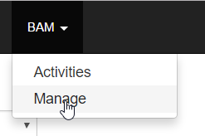

Paste your sql in the sql text box – if you have any order by clause paste it in the order by text box and save the form.

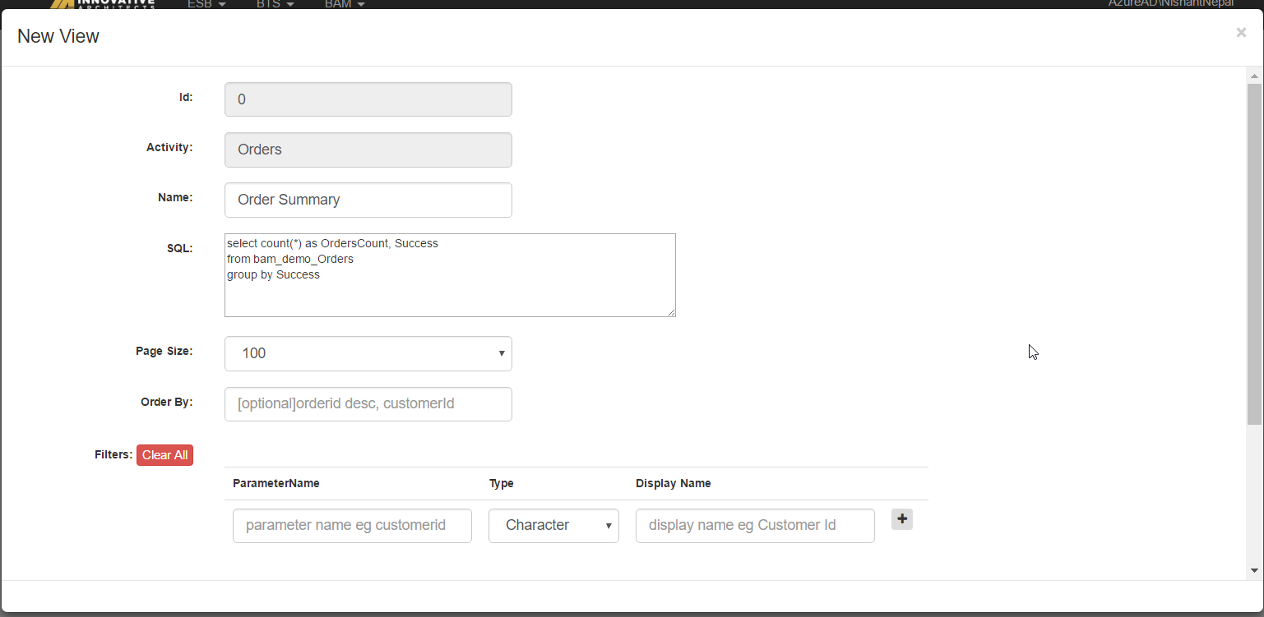

If you browse to the activities menu you can then see the data

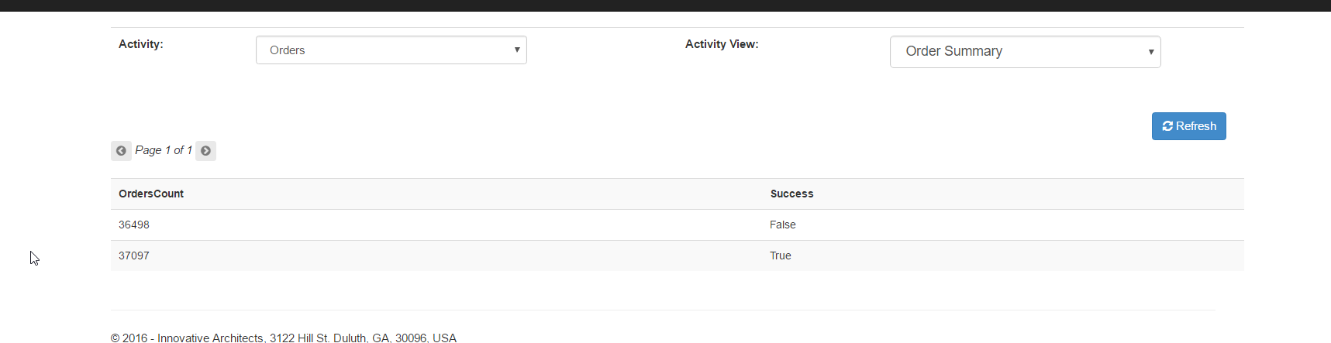

Now suppose your manager wants to see the orders only for the 120 days rolling (i.e. starting from 120 days past till today). Your query may look something like this

select OrderDate,count(*) as OrdersCount,

case Success

when 1 then 'Success'

else 'Failed'

end as Status

from bam_demo_Orders

where OrderDate > GETDATE()-120

group by OrderDate,Success

Assuming hypothetically that the query execution returns many rows and you are worried about performance on the UI and you want to implement server side paging. The framework takes care of this for you.

Firstly, choose the number of rows per page and then on the paging sql add the sql which returns the total number of rows for your query. So, for the above query it will be

select count(*)

from bam_demo_Orders

where OrderDate > GETDATE()-120

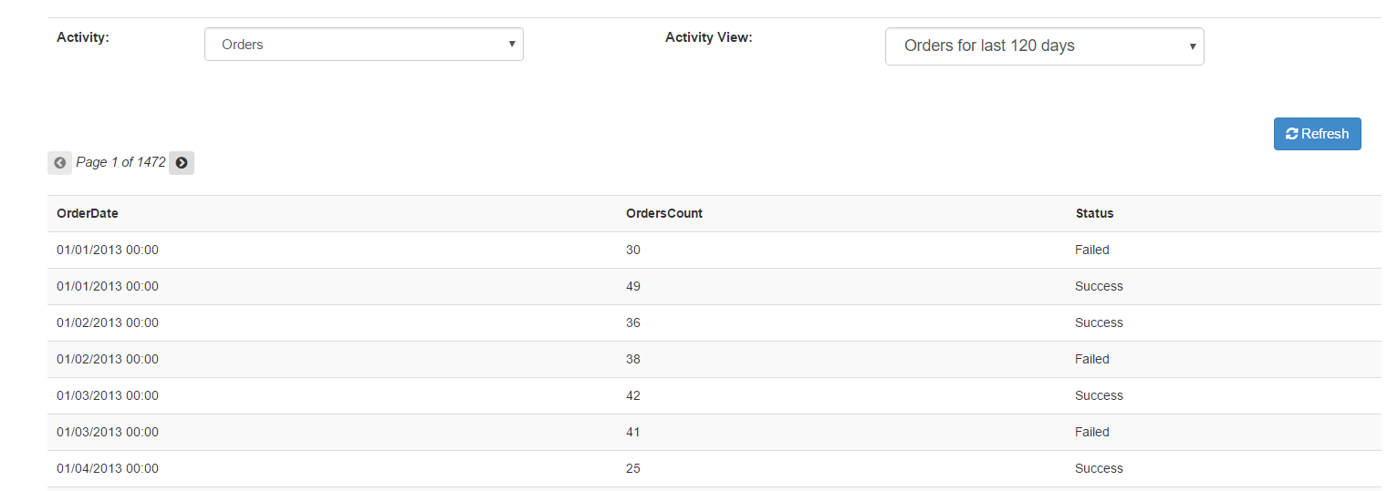

Lastly, let’s assume your manager wants the ability to search orders by order date and an optional order number. This is again trivial to set up.

Your query would be something like this

select * from bam_demo_Orders

where OrderDate = @orderDate

and OrderID = ISNULL(@orderId,OrderID)

the paging query would be this

select count(*) from bam_demo_Orders

where OrderDate = @orderDate

and OrderID = ISNULL(@orderId,OrderID)

and you would set up the parameters like the screen shot below

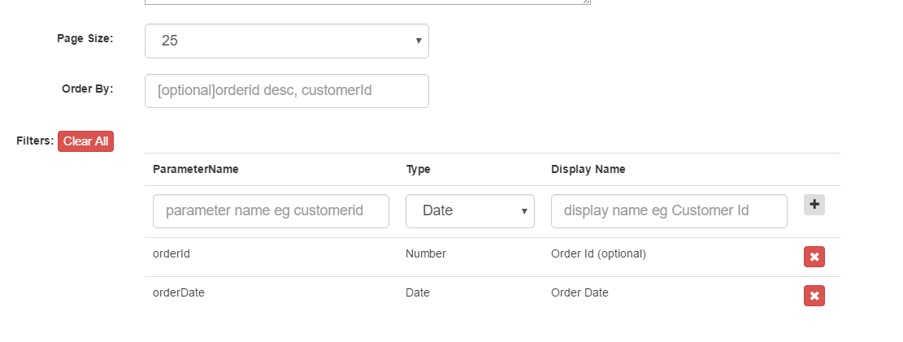

Now when you browse to the view, instead of preloading the data it will generate a form for you to enter the values(parameters)

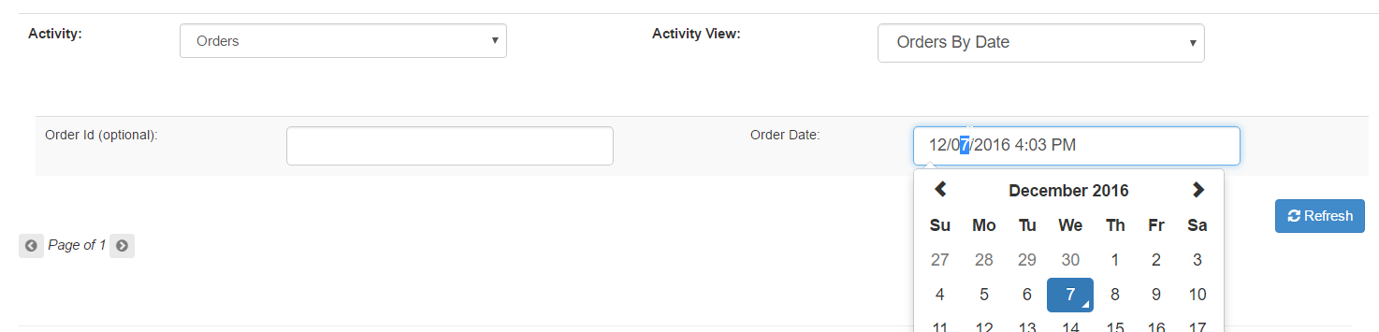

And after filling in, you can fetch your data.

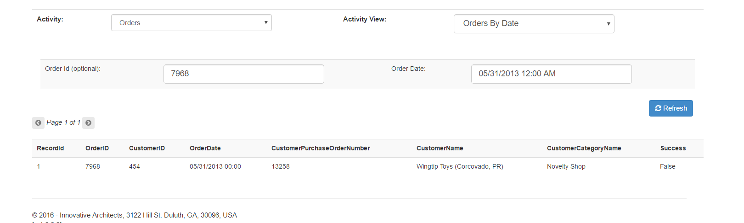

**BTS OPS**

This is the third section in the website and aims to help biztalk operations for day to day operations. In the dashboard there are 5 menus

1. Summary   
   Shows instances running and the earliest, latest per status with a drillable action per status

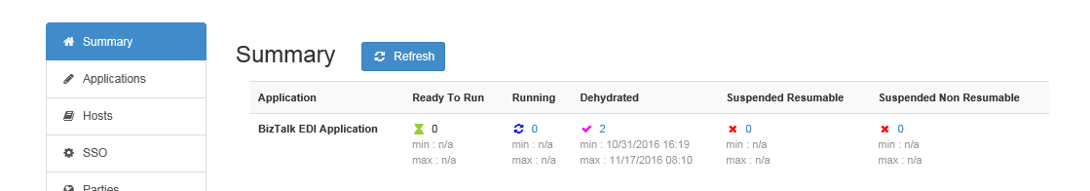

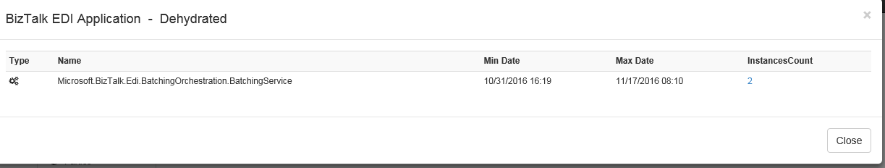

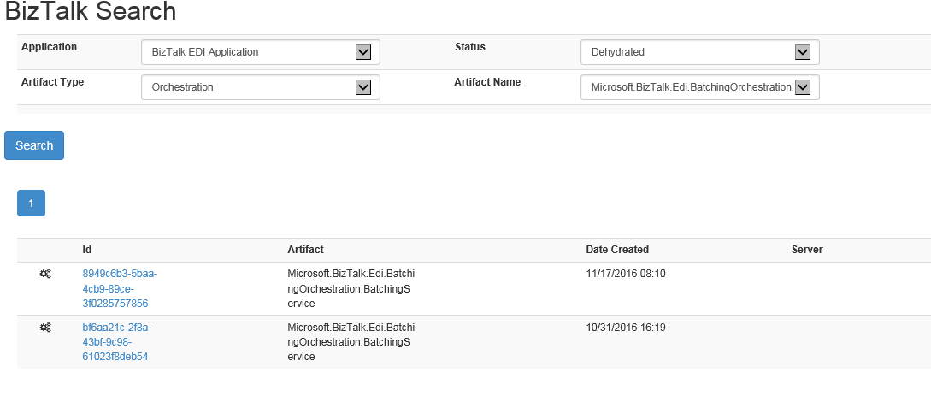

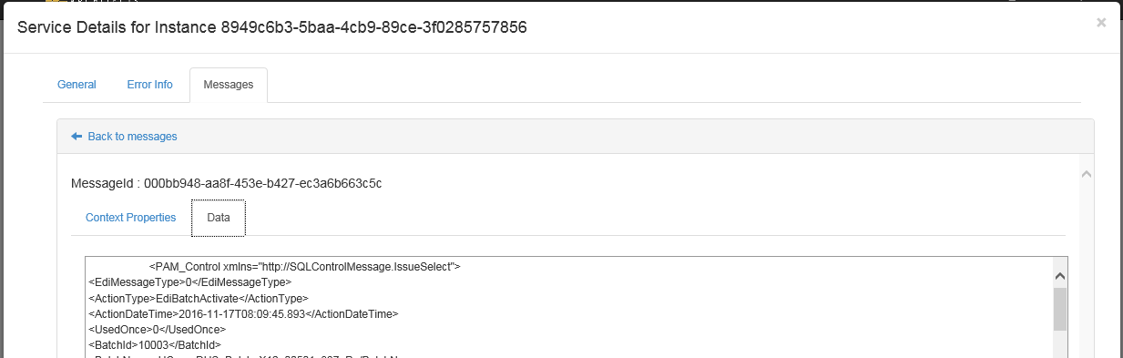

2. Applications

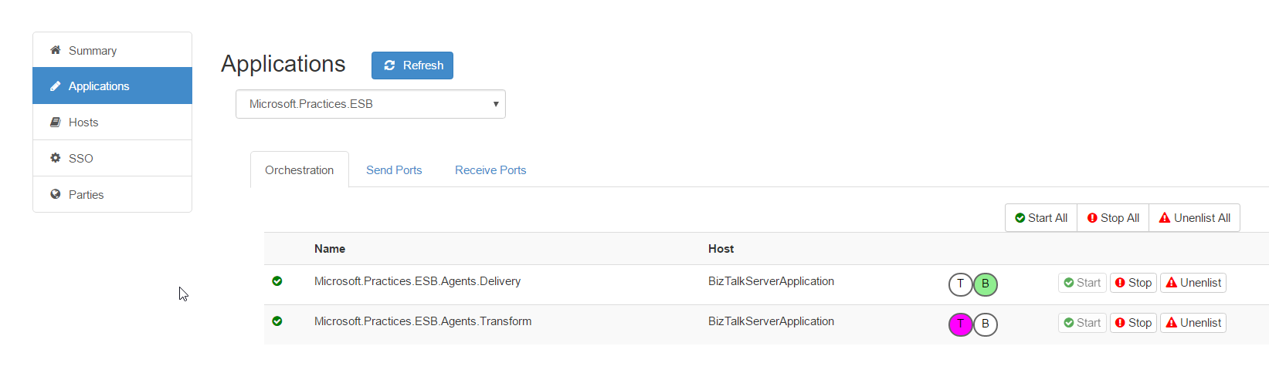

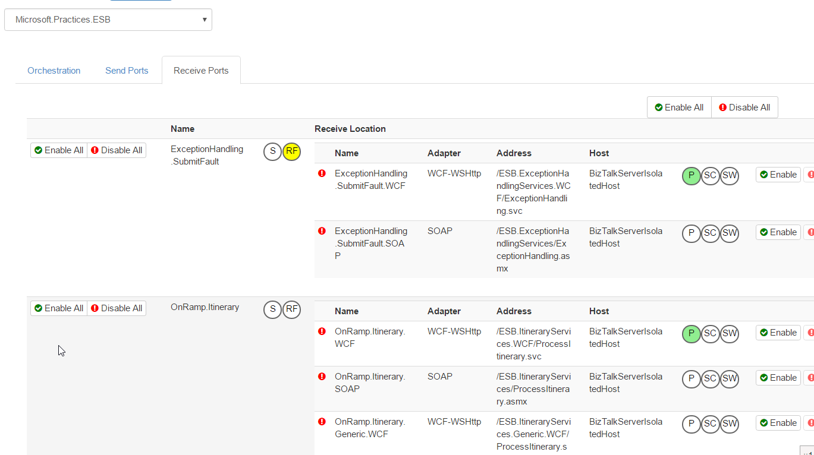

3. Hosts  
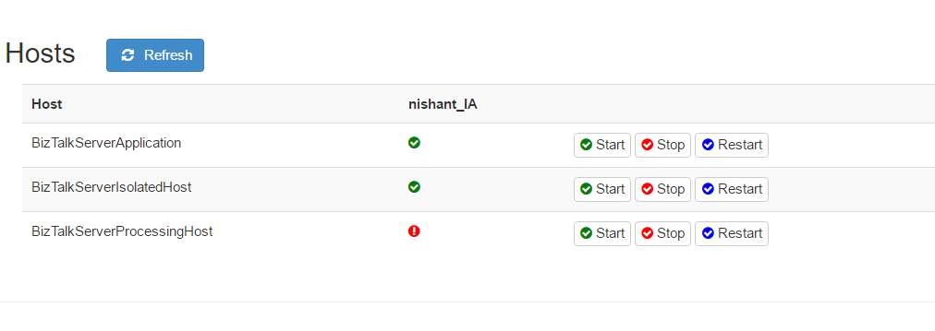

1. SSO

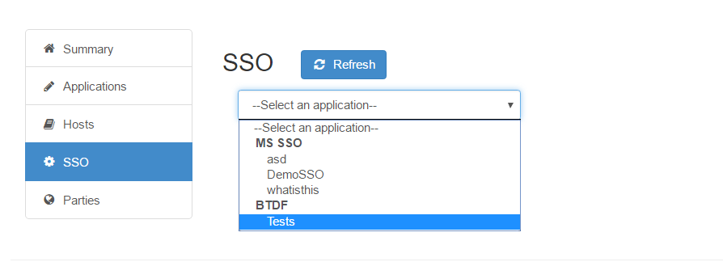

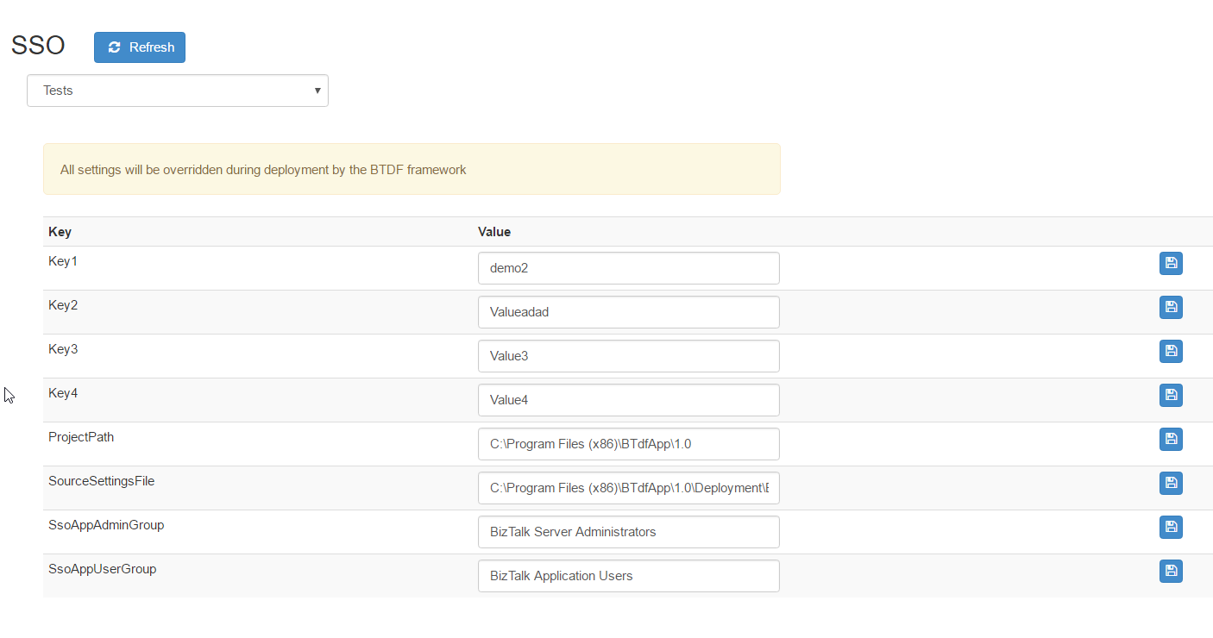

1. Parties – this needs to be cleaned up and more functionality can be added  
     
   