1. Unzip the binaries to a directory of your choosing
2. Run the two sql scripts inside the sql folder
   1. BtsPortalDb : Creates a sql database and a table for holding the BAM metadata
   2. Esb_Exception_DB_Updates : adds tables for the portal to the esb exception database
3. Install and configure the website
   1. Open IIS and create an application pool. The identity under which the app pool runs must be a user who has access to all the biztalk databases, api and esbexception database.  
      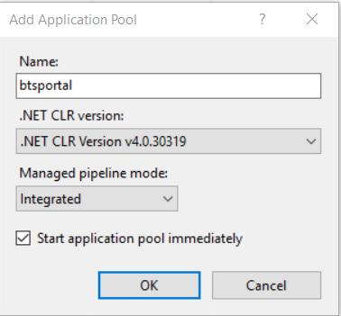

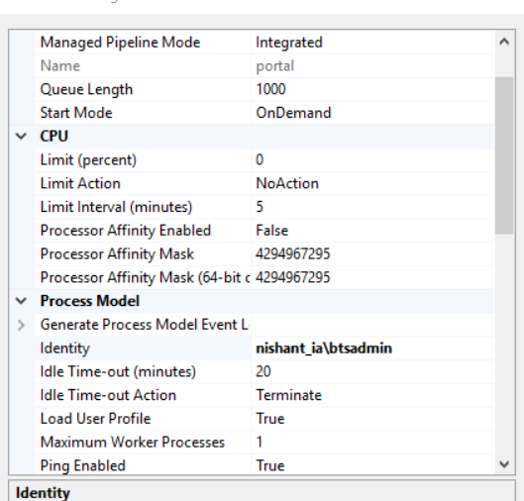

* 1. Create the web application  
     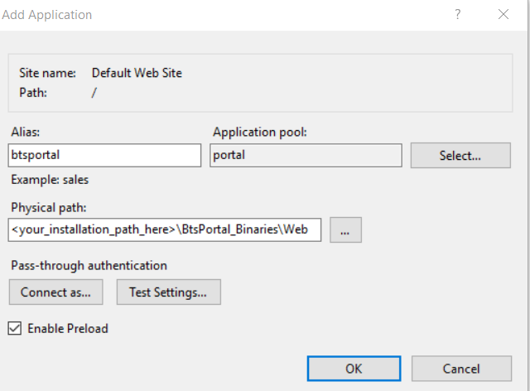
  2. Select the website and drill into the IIS-> Authentication  
     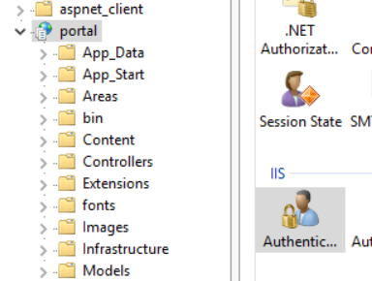

Make sure that windows authentication is enabled and anonymous disabled

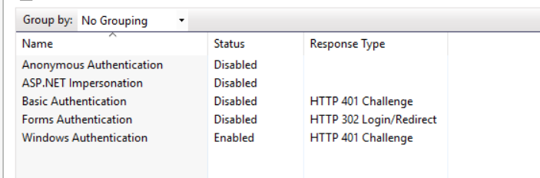

* 1. Modify the web.config file accordingly for the connection string settings  
     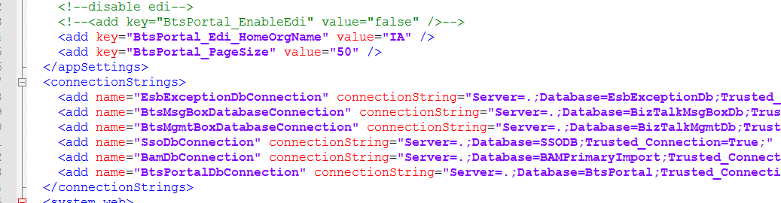
  2. At this point you can browse to the website.
  3. Go to the esb settings page and fill out the configuration for
     1. XsltSummaryPath : Path of the xslt file. Should be ~\BtsPortal_Binaries\Services\BtsPortal.Services.EsbAlert\Template\Email_Template_Summary.xslt
     2. XsltPath: Path of the xslt file. Should be ~\BtsPortal_Binaries\Services\BtsPortal.Services.EsbAlert\Template\Email_Template_Summary.xslt
     3. BtsPortalRootPath : Root path of the website you installed eg <http://localhost/portal> (no trailing “/”)
     4. Ensure these settings are set to true for receiving alerts : IsEmailEnabled, IsQueueEnabled, IsSummaryQueueEnabled, SMTP Server

1. Install the alert service
   1. From a command prompt (with administrative rights) navigate to ~\~\BtsPortal_Binaries\Services\BtsPortal.Services.EsbAlert
   2. Enter this command   
       BtsPortal.Services.EsbAlert.exe install
   3. When prompted enter the credentials for the user who has permissions to query the esb excption database and send emails.

Notes:

* To avoid frequent database roundtrips, the portal caches some lookup data in memory. The only way to flush the cache is to recycle the apppool. There are plans underway to provide an UI for this.
* Because of the above caching item, if you install the portal on two servers you will have to recycle the cache on both servers.